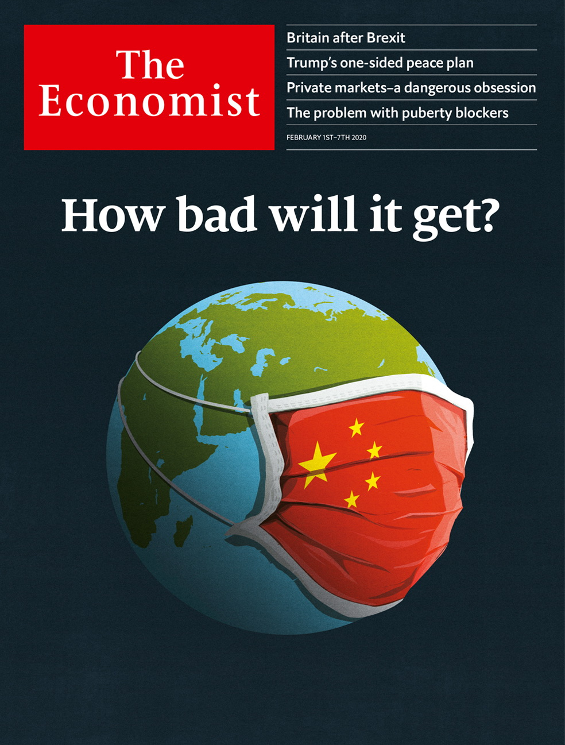

# Table of Contents

The world this week

Politics this week

Business this week

KAL’s cartoon

Leaders

Coronavirus: How bad will it get?

Britain after Brexit: Into the unknown

Donald Trump’s peace plan: Dead on arrival

Goldman Sachs: How the mighty have fallen

Puberty blockers: Pill-pushers

Letters

Letters to the editor: On one-nation Tories, chips, back pain, Boeing, disgust

Briefing

The special relationship: No longer such a smooth ride

United States

The presidential primaries: Who will be Donald Trump’s most forceful foe?

The politics of gender: Changing states

Vermont’s economy: The road not taken

The Iowa caucus: Progressives’ dilemma

The Supreme Court: Injunction dysfunction

Lexington: Voting with their eyeballs

The Americas

Poverty in Brazil: Left behind

Bello: Peru and the difficulty of reform

Incan culture: Knotty tale

Asia

South-East Asia’s special economic zones: Viva Laos Vegas

Thai boxing: Muay too young

North-eastern India: Bodos and don’ts

Civil liberties in Pakistan: Arresting the messenger

Banyan: No crater love

China

The Wuhan virus: Sealed off

Chaguan: The politics of pandemics

Middle East and Africa

Donald Trump’s peace plan: The sound of one hand shaking

Iraqi politics: Sadder and Sadr

Health care in Uganda: Why wait for death?

Locusts in Africa: Severe swarms

Europe

Italy’s regional elections: Salvini’s Sardine surprise

Hungary: In search of a David

Paris’s mayoral race: How not to do it

Energy: Greening Greece

China and Turkey: Bumps in the belt and road

Clubbing in Berlin: Strings of life

Charlemagne: The Brit awards

Britain

Brexit and regulation: Into the wide blue yonder

Euro-myths: Carry on commissioner

Fisheries after Brexit: A scaly problem

Immigration after Brexit: Points of departure

Trade deals: Third country stories

Rail nationalisation: Northern Fail

Television news: British Broadcasting Cuts

Judicial reviews: Trans: the pushback

Bagehot: The English problem

International

Coronavirus economics: Locked down

Coronavirus: Prepare for the worst, hope for the best

Business

Labour in Deutschland AG: Unseating an old idea

Labour in management: What’s American for Mitbestimmung?

Electric vehicles: Car stock racing

Deferred gratification: Corporate prosecutions

Luxury cast-offs: Not for sale

Bartleby: From the cradle to the Grove

Online governance: A court of public opinions

Schumpeter: An existential questioner

Finance and economics

Asset management: Privacy and its limits

Investment banking: Turntable

Poverty and privacy: Hidden costs

Inflation in the euro area: A fuller figure

Free exchange: Rummaging in the toolbox

Finance internship

Science and technology

The arrest of Charles Lieber: No small matter

Entomology: More than meets the eye

Forensic science: Whendunnit?

Climate change: The methane hunters

Marine science: Cyborg Cnidaria

Books and arts

Art and dissent: Pursued by a bear

Making movies: Forget it, Jake

Bygone civilisations: Secret gardens

Enigmatic fiction: Ghost in the machine

Johnson: A cup o’ kindness

Graphic detail

Obituary

Kobe Bryant: Love story

Economic Indicators

Economic data, commodities and markets



### Friday, January 31, 2020

|  |  |
| --- | --- |
| The world this week | 3 |
| Leaders | 5 |
| Letters | 1 |
| Briefing | 1 |
| United States | 6 |
| The Americas | 3 |
| Asia | 5 |
| China | 2 |
| Middle East and Africa | 4 |
| Europe | 7 |
| Britain | 9 |
| International | 2 |
| Business | 8 |
| Finance and economics | 6 |
| Science and technology | 5 |
| Books and arts | 5 |
| Graphic detail | 1 |
| Obituary | 1 |
| Economic Indicators | 1 |

|  |  |  |
| --- | --- | --- |
|  | Sections | Leaders |

The world this week

Politics this week

.

Business this week

.

KAL’s cartoon

.

|  |  |  |
| --- | --- | --- |
|  | Sections | Leaders |

|  |  |  |  |
| --- | --- | --- | --- |
|  | Articles | Sections | Next |

# Politics this week

Feb 1st 2020 |

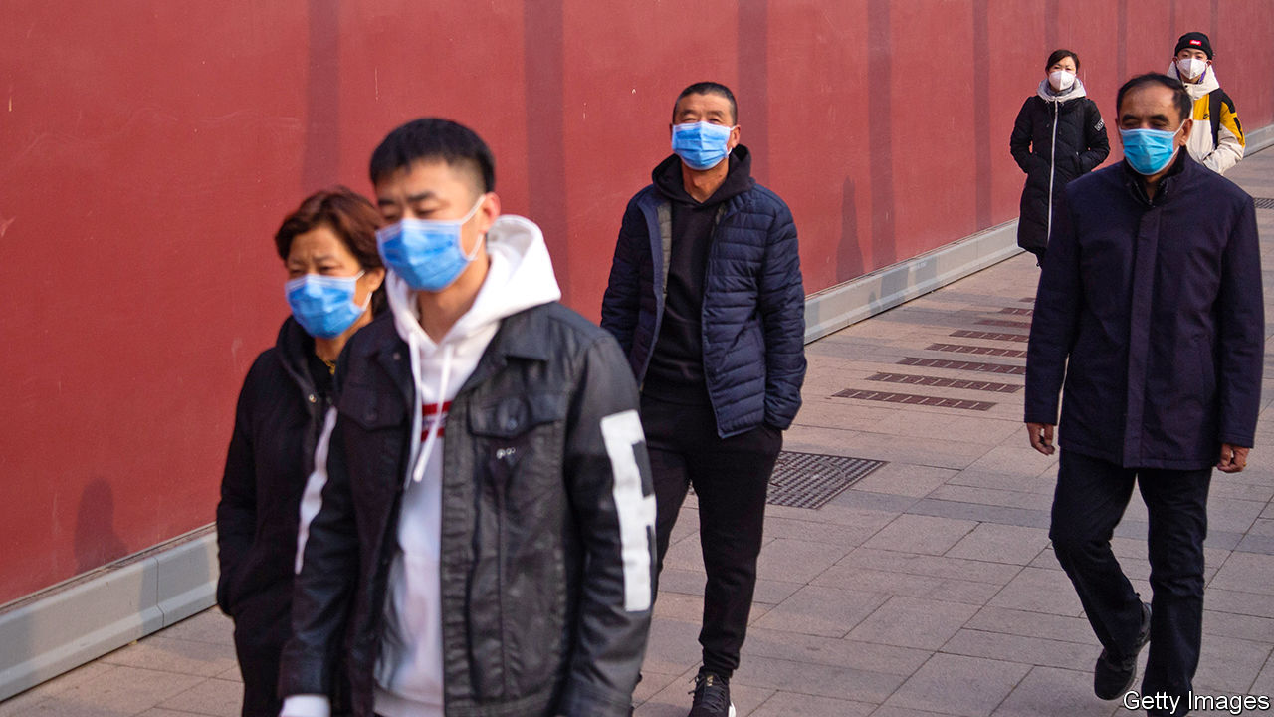

A new coronavirus continued to spread rapidly in China. Several large cities were locked down in Hubei province, whose capital, Wuhan, is where the virus broke out. Streets emptied; people stayed at home. However, Wuhan’s mayor said that 5m people had left the city before the quarantine was imposed: some for their usual Chinese New Year trips, others to escape the virus. Some airlines cancelled flights to and from China. See article.

Many countries, including America, Britain and Japan, took steps to evacuate their citizens from China. Some businesses scaled back or closed their operations in the country. Cases of Wuhan virus have been detected outside China. Human-to-human transmissions were reported in Germany, Japan, Vietnam and Taiwan. Stockmarkets shivered when it became clear that the disease is spreading rapidly; the S&P 500 had its worst day since October.

India partially restored internet access in the Kashmir valley, where it has been blocked since August. But the authorities are only allowing Kashmiris to visit 301 “whitelisted” websites. Social-media services remain banned and mobile-data speeds have deliberately been reduced. The government says the measures are needed to impede terrorism.

Authorities in Pakistan arrested Manzoor Pashteen, the head of the Pushtun Protection Movement, which has campaigned for justice for victims of military abuses. He has been charged with sedition, among other crimes. Several supporters protesting against his detention were also arrested. See [article](https://www.economist.com/node/21779158).

## Bolton wonderers

Democrats pushed their case for witnesses to give evidence in the impeachment trial of Donald Trump. They hoped to call John Bolton, the president’s former national security adviser, who has claimed in a forthcoming book that Mr Trump explicitly withheld military aid from Ukraine to press its government to investigate Joe Biden and his son. This claim is a central plank of the case against Mr Trump, which he denies. See [article](https://www.economist.com/united-states/2020/01/27/john-boltons-claims-jolt-donald-trumps-impeachment-trial).

Possibly to take his mind off the impeachment trial, and shore up his support among ardent pro-lifers, Mr Trump gave a speech at the annual March for Life anti-abortion rally in Washington, the first president to do so.

In a 5-4 vote, the Supreme Court let stand a new immigration rule that could stop legal migrants from becoming permanent residents if they use public-welfare programmes, such as food stamps. See [article](https://www.economist.com/node/21779118).

## Up the garden path

Donald Trump’s peace plan for Israel and the Palestinians gave Israel most of what it wanted, such as a green light to annex occupied lands in the West Bank straight away. The Palestinians got conditional promises of something like a state and billions of dollars in investment at some point in the future. They instantly rejected the deal. See [article](https://www.economist.com/node/21779119).

The American embassy in Baghdad was struck by three rockets, wounding three people. America has blamed Iran and its proxies for an increase in attacks on American forces and facilities in Iraq.

Heavy fighting broke out in Libya between forces loyal to the UN-backed government, which is supported by Turkey, and soldiers under the command of Khalifa Haftar, who is supported by Russia, Egypt and the United Arab Emirates. Despite an arms embargo, weapons are pouring in.

The biggest infestation of locusts for at least 25 years wrought havoc on east Africa. Heavy rains last year created ideal conditions for the pests. An adult locust can eat its own weight each day. See [article](https://www.economist.com/node/21779171).

## Never forget

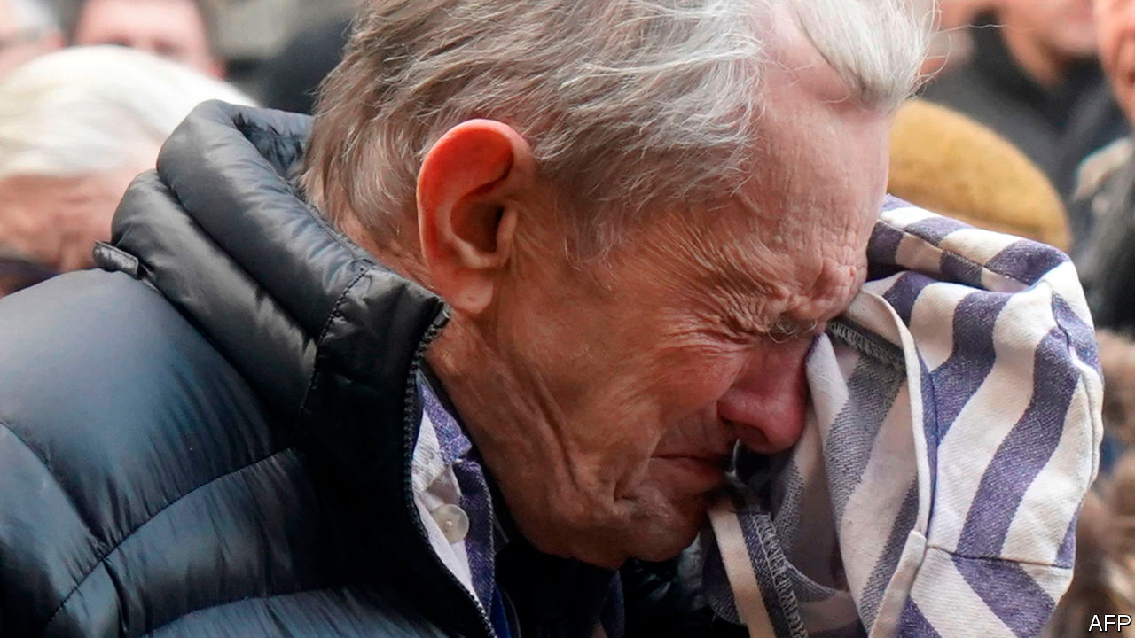

Holocaust survivors and international leaders gathered at the former Auschwitz death camp in Poland to mark the 75th anniversary of its liberation by Allied troops, amid calls to fight resurgent anti-Semitism. The presidents of Israel and Poland led the commemoration. About 1.1m people, mostly Jews, were murdered at Auschwitz-Birkenau, the Nazis’ biggest death camp. See [article](https://www.economist.com/europe/2020/01/26/an-anniversary-at-auschwitz-is-marred-by-disputes).

Regional elections in Italy were a setback for Matteo Salvini, leader of the populist Northern League. He had hoped to win a big victory in Emilia-Romagna, but did not. See [article](https://www.economist.com/node/21779122).

The German cabinet agreed to cut the country’s greenhouse-gas emissions to 55% of their level in 1990 by 2030. The plan aims to end reliance on coal by 2038. However, it undermines its own objectives by also shutting all nuclear plants by 2022. Coalmining regions are to get some €40bn ($44bn) in compensation. The nationalist Alternative for Germany party (AfD) had been making electoral gains in such places.

Britain prepared to leave the European Union on January 31st, after the European Parliament signed off Boris Johnson’s Brexit deal. It has taken three years of political instability (and three prime ministers) to move Britain into a transition period with the EU so that the details of separation can be finalised. The focus now shifts to a trade deal, but there are clear disagreements, over regulation for example, that are unlikely to be resolved within just 11 months. See article.

The Labour Party in Britain has learned little from its drubbing in December’s election, its worst result since 1935. The party’s ruling committee absolved Jeremy Corbyn, its leader, of any blame. Labour MPs on the campaign trail, and post-election polls, found that Mr Corbyn was by far the main reason voters were turned off by the party.

## Not such a popular force

The largest party in Peru’s congress lost most of its seats in an election. Popular Force, a centre-right party led by Keiko Fujimori, the daughter of a jailed former president, won just 7% of the vote. This boosted the current president, Martín Vizcarra, who dissolved congress in September because it failed to enact anti-corruption reforms. Ms Fujimori returned to jail amid an investigation into allegations of illegal campaign funding. See [article](https://www.economist.com/node/21779131).

Jeanine Áñez, Bolivia’s interim president, announced that she would run for the presidency in May. A conservative former senator, she became president after Evo Morales quit in November. Critics of Ms Áñez say she should not run for office while also, as interim president, overseeing the election.

Conservationists spotted three Bolivian Cochran frogs, the first time they have been seen in 18 years. The internal organs of the vividly green frogs are visible through their abdomens and they weigh less than 100 grams (3.5 ounces). They were spotted in Carrasco National Park near Cochabamba, the site of a hydroelectric dam that is under construction.

This article was downloaded by calibre from <https://www.economist.com/the-world-this-week/2020/02/01/politics-this-week>

|  |  |  |  |
| --- | --- | --- | --- |
|  | Articles | Sections | Next |

|  |  |  |  |
| --- | --- | --- | --- |
| Previous | Articles | Sections | Next |

# Business this week

Feb 1st 2020 |



The problems mounted at Boeing, as it more than doubled the cost it expects to incur from the grounding of the 737 MAX airliner, to $18.6bn. The aerospace company reported a net loss of $636m for 2019, its first annual loss in 22 years. The amount of debt it holds is ratcheting up. And it is cutting production of the Dreamliner. To cap it all, Boeing took a $410m charge in the fourth quarter because its Starliner unmanned spacecraft failed to dock with the International Space Station on its maiden voyage.

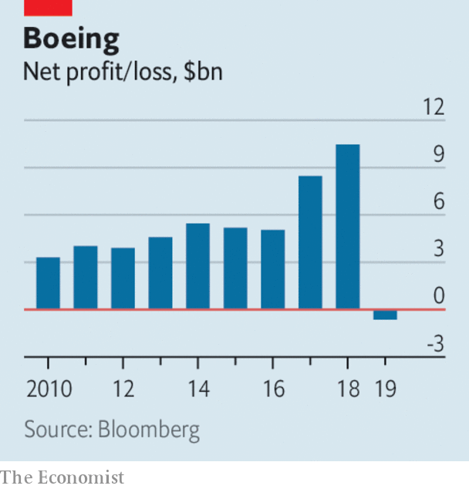

By contrast, Apple reported record quarterly sales and profit figures. Revenue was up by 9% in the last three months of 2019 compared with the same quarter a year earlier, to $91.8bn. That generated a net profit of $22.2bn. Sales of the iPhone rebounded after several quarters of moribund growth; Apple is expected to release its first 5G phones later this year. The company’s share price jumped, pushing its market capitalisation above $1.4trn.

Along with many other companies, Apple warned about the potential impact of the coronavirus on its business. It has mitigation plans to counter the loss of production from its suppliers in Wuhan, the centre of the virus, but is uncertain about its supply from elsewhere in China. Foxconn, which assembles most of Apple’s iPhones in China, saw its share price plunge. See [article](https://www.economist.com/node/21779144).

Jerome Powell, the chairman of the Federal Reserve, said that the spreading coronavirus would probably cause “some disruption” to the global economy, but that it was unclear how far that would extend. The Fed left its benchmark interest rate unchanged at a range of between 1.5% and 1.75%.

The Japanese government sent a strong signal that it remains committed to its programme of quantitative-easing and negative interest rates by nominating Adachi Seiji to the policy board of the Bank of Japan. Mr Adachi is an ardent reflationist, who wants to ease monetary policy even further in order to achieve the central bank’s 2% inflation target. But as in other countries, the financial industry is becoming louder in pointing out the drawbacks to its business of long-term negative rates.

## The quarterly pounder

McDonald’s said that like-for-like sales rose by 5.9% last year, the biggest such jump in a decade. The fast-food chain has revamped its menu and outlets, and has benefited from being included on a growing number of food-delivery apps.

Britain decided that it would not ban “high-risk vendors” from parts of its 5G network. Despite the generic language, the decision is mostly about Huawei, which will thus be able to continue supplying equipment despite an intense lobbying effort by American officials to block the Chinese firm on national-security grounds. Half-recognising that concern, Britain will monitor Huawei’s equipment and bar it from parts of the network deemed critical for security or safety. Elsewhere its market share will be limited to 35%. See [article](https://www.economist.com/britain/2020/01/28/britain-takes-a-third-way-on-5g-with-huawei).

Facebook provided details of Mark Zuckerberg’s “vision” to overhaul the oversight of content on the social-media platform. A new independent board will hear appeals from users who have had content taken down, for hate speech say. If Facebook ignores the board’s judgment it will have to explain why. The cost of spending more on privacy and security were in part to blame for a sharp rise in expenses in Facebook’s quarterly report. Revenues grew at the slowest pace since it became a public company in 2012. See [article](https://www.economist.com/node/21779156).

A bullish earnings report from Tesla delighted investors. The electric-car maker made its second consecutive quarterly profit, even if, at $105m, it was 25% lower than in the same quarter a year earlier. It also raised its production guidance and now expects to deliver 500,000 this year. The company’s share price has risen by 130% since October. See article.

Renault appointed Luca de Meo as its new chief executive, its second since the fall of Carlos Ghosn in November 2018. Until recently Mr de Meo used to run SEAT, a Spanish carmaker owned by Volkswagen. He starts his job at Renault in July.

## Northern Fail

In Britain it was announced that Northern Rail, is to be nationalised in March, following two years of chaos for passengers under the train company’s current operator. Coming soon after the bail-out of Flybe, this is the new government’s second big intervention in regional transport infrastructure. See article.

The share price of the company that owns Victoria’s Secret surged after it was reported that its chief executive might step down and possibly sell the lingerie retailer. Les Wexner has run L Brands for 57 years and is the longest-serving CEO of any S&P 500 company. Last year he faced embarrassing questions over his link to Jeffrey Epstein, a dead sex-trafficker who managed Mr Wexner’s financial assets.

This article was downloaded by calibre from <https://www.economist.com/the-world-this-week/2020/02/01/business-this-week>

|  |  |  |  |
| --- | --- | --- | --- |
| Previous | Articles | Sections | Next |

|  |  |  |  |
| --- | --- | --- | --- |
| Previous | Articles | Sections | Next |

# KAL’s cartoon

Feb 1st 2020 |

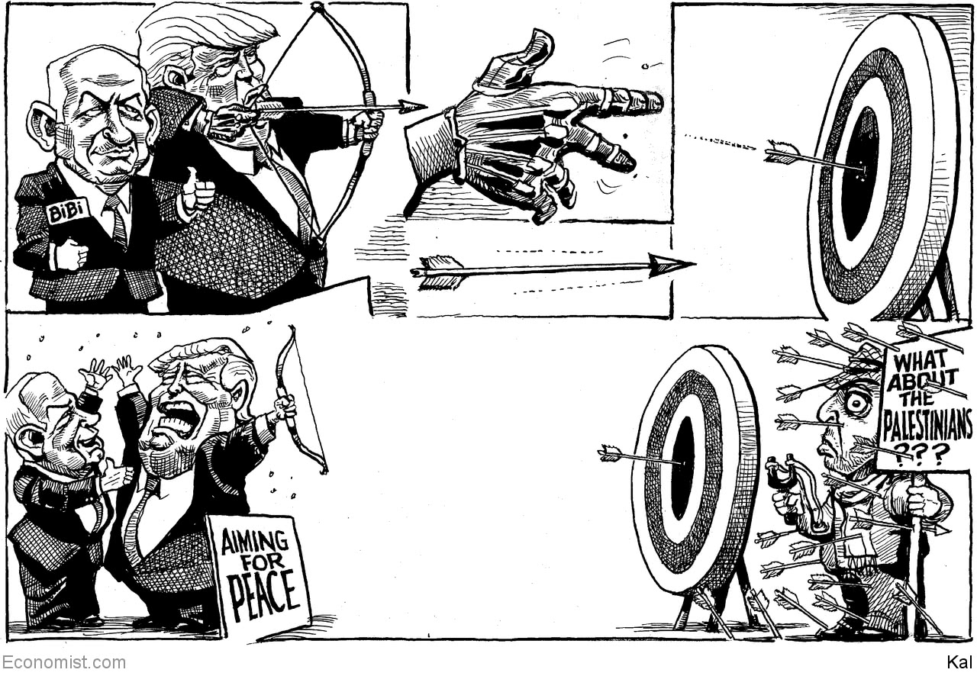

This article was downloaded by calibre from <https://www.economist.com/the-world-this-week/2020/02/01/kals-cartoon>

|  |  |  |  |
| --- | --- | --- | --- |
| Previous | Articles | Sections | Next |

|  |  |  |
| --- | --- | --- |
| The world this week | Sections | Letters |

Leaders

Coronavirus: How bad will it get?

.

Britain after Brexit: Into the unknown

.

Donald Trump’s peace plan: Dead on arrival

.

Goldman Sachs: How the mighty have fallen

.

Puberty blockers: Pill-pushers

.

|  |  |  |
| --- | --- | --- |
| The world this week | Sections | Letters |

|  |  |  |  |
| --- | --- | --- | --- |
|  | Articles | Sections | Next |

#### Made in China

# Will the Wuhan virus become a pandemic?

Probably. But public health services can help determine how severe it turns out to be

Jan 30th 2020 |

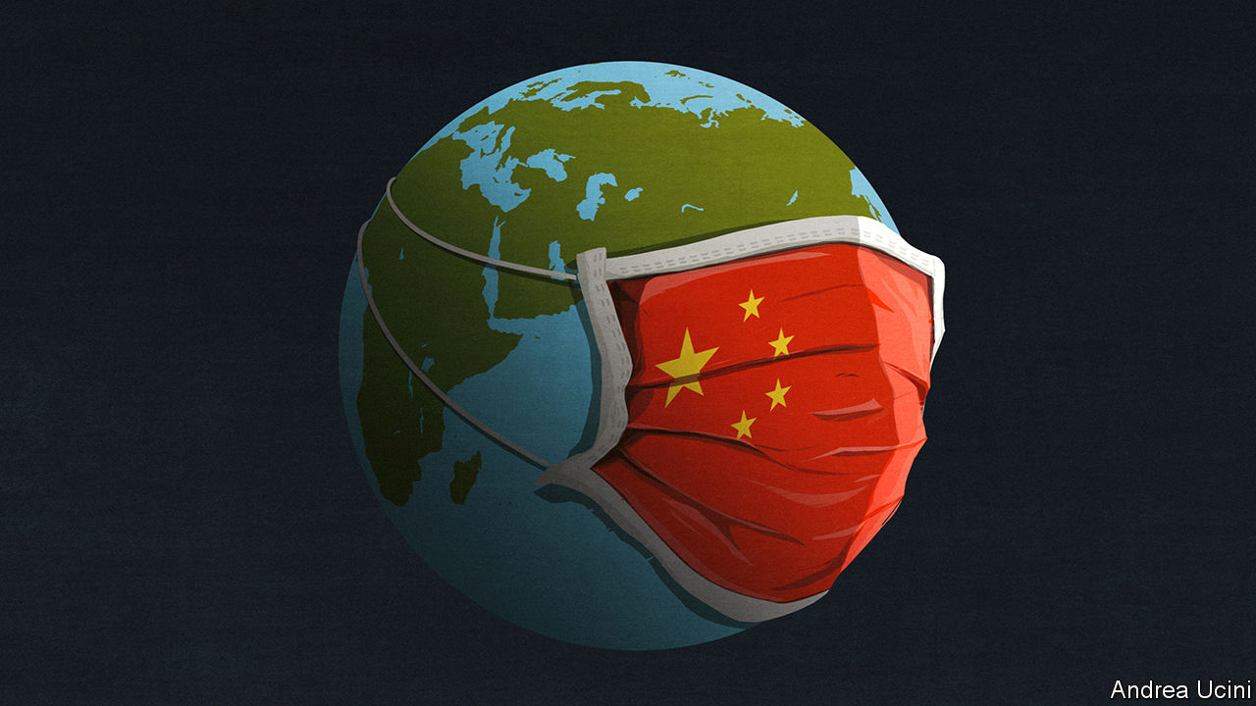

TWO THINGS explain why a new infectious disease is so alarming. One is that, at first, it spreads exponentially. As tens of cases become hundreds and hundreds become thousands, the mathematics run away with you, conjuring speculation about a health-care collapse, social and economic upheaval and a deadly pandemic. The other is profound uncertainty. Sparse data and conflicting reports mean that scientists cannot rule out the worst case—and that lets bad information thrive.

So it is with a new coronavirus, known as 2019-nCoV, which has struck in China. The number of reported cases grew from 282 on January 20th to almost 7,800 just nine days later. In that time four reported cases outside mainland China have multiplied to 105 in 19 territories. Doubt clouds fundamental properties of the disease, including how it is passed on and what share of infected people die. Amid the uncertainty, a simulation of a coronavirus outbreak by Johns Hopkins University in October, in which 65m people lost their lives, was put about as a prediction. It is not.

Those are the right questions, though: will the new virus become a global disease? And how deadly will it be? A definite answer is weeks or months away, but public-health authorities have to plan today. The best guess is that the disease has taken hold in China (see article) and there is a high risk that it spreads around the world—it may even become a recurrent seasonal infection. It may turn out to be no more lethal than seasonal influenza, but that would still count as serious (see article). In the short term that would hit the world economy and, depending on how the outbreak is handled, it could also have political effects in China.

The outbreak began in December. The repeated mingling of people and animals in China means that viral mutations that infect humans are likely to arise there; and mass migration to cities means that they are likely to spread between people. This virus probably originated in bats and passed through mammals, such as palm civets or ferret badgers, ending up in Wuhan’s wet market, where wild animals were on sale. Symptoms resemble flu, but can include pneumonia, which may be fatal. About 20% of reported cases are severe, and need hospital care; about 2% of them have been fatal. As yet, there is no vaccine or antiviral treatment.

The greatest uncertainty is how many cases have gone unrecorded. Primary health care is rudimentary in China and some of the ill either avoided or were turned away from busy hospitals. Many more may have such mild symptoms that they do not realise they have the disease. Modelling by academics in Hong Kong suggests that, as of January 25th, tens of thousands of people have already been infected and that the epidemic will peak in a few months’ time. If so, the virus is more widespread than thought, and hence will be harder to contain within China. But it will also prove less lethal, because the number of deaths should be measured against a much larger base of infections. As with flu, a lot of people could die nonetheless. In 2017-18 a bad flu season saw symptoms in 45m Americans, and 61,000 deaths.

Scientists have started work on vaccines and on treatments to make infections less severe. These are six to 12 months away, so the world must fall back on public-health measures. In China that has led to the biggest quarantine in history, as Wuhan and the rest of Hubei province have been sealed off. The impact of such draconian measures has rippled throughout China. The spring holiday has been extended, keeping schools and businesses closed. The economy is running on the home-delivery of food and goods.

Many experts praise China’s efforts. Certainly, its scientists have coped better with the Wuhan virus than they did with SARS in 2003, rapidly detecting it, sequencing its genome, licensing diagnostic kits and informing international bodies. China’s politicians come off less well. They left alone the cramped markets filled with wild animals that spawned SARS. With the new virus, local officials in Wuhan first played down the science and then, when the disease had taken hold, enacted the draconian quarantine fully eight hours after announcing it, allowing perhaps 1m potentially infectious people to leave the city first.

That may have undermined a measure which is taking a substantial toll. China’s growth in the first quarter could fall to as little as 2%, from 6% before the outbreak. As China accounts for almost a fifth of world output, there will probably be a noticeable dent on global growth. Though the economy will bounce back when the virus fades, the reputation of the Communist Party and even of Xi Jinping may be more lastingly affected (see article). The party claims that, armed with science, it is more efficient at governing than democracies. The heavy-handed failure to contain the virus suggests otherwise.

Outside China such quarantines are unthinkable. The medical and economic cost will depend on governments slowing the disease’s spread. The way to do this is by isolating cases as soon as they crop up and tracing and quarantining people that victims have been in contact with—indeed, if the disease burns out in China, that might yet stop the pandemic altogether. If, by contrast, that proves inadequate, they could shut schools, discourage travel and urge the cancellation of public events. Buying time in this way has advantages even if it does not completely stop the disease. Health-care systems would have a greater chance to prepare for the onslaught, and to empty beds that are now full of people with seasonal flu.

Despite all those efforts the epidemic could still be severe. Some health systems, in Africa and the slums of Asia’s vast cities, will not be able to isolate patients and trace contacts. Much depends on whether people are infectious when their symptoms are mild (or before they show any at all, as some reports suggest), because such people are hard to spot. And also on whether the virus mutates to become more transmissible or lethal.

The world has never responded as rapidly to a disease as it has to 2019-nCoV. Even so, the virus may still do great harm. As humans encroach on new habitats, farm more animals, gather in cities, travel and warm the planet, new diseases will become more common. One estimate puts their cost at $60bn a year. SARS, MERS, Nipah, Zika, Mexican swine flu: the fever from Wuhan is the latest of a bad bunch. It will not be the last. ■

This article was downloaded by calibre from <https://www.economist.com/leaders/2020/01/30/will-the-wuhan-virus-become-a-pandemic>

|  |  |  |  |
| --- | --- | --- | --- |
|  | Articles | Sections | Next |

|  |  |  |  |
| --- | --- | --- | --- |
| Previous | Articles | Sections | Next |

#### Uncharted waters

# Britain after Brexit

Now that Britain is sailing alone, Boris Johnson needs a lodestar. Liberalism offers one

Jan 30th 2020 |



NOT MUCH will change at 11pm on January 31st. Some 50p pieces proclaiming “peace, prosperity and friendship with all nations” will go into circulation to mark Britain’s departure from the European Union, but people, goods and services will continue to move freely between Britain and the EU, for the difficult business of making a deal on trade and migration has been left to the transition period that lasts until the end of this year.

Yet leaving the EU is a huge moment. Britain will be quitting the institutional structure that governs Europe’s single market, which will necessarily imply more friction in its trade relations with a club that takes almost half its exports. Britons will lose the automatic right they now have to live and work across the EU. Brexit has also administered a shock to the country. The nation has argued long and bitterly over the issue, and its ruling elite has suffered a blow. The unarguable outcome is the most powerful government in a generation, under Boris Johnson. Much now depends on how he responds.

The Economist did not advocate this outcome. Most of the changes that Mr Johnson’s government favours could have been accomplished without leaving the EU. System-wide shocks are usually a costly way to bring about change. Yet now that Brexit is definitely happening, the country should make the most of the chance to recalibrate the economy and reset its priorities.

The last couple of times Britain pressed the reset button, in 1945 and 1979, the programmes that it put into place to create the welfare state and replace socialism with Thatcherism had been long-planned. This time is different. Mr Johnson was focused entirely on leaving the EU and is now being buffeted by the storms that brew up swiftly in the affairs of state: he had to decide this week whether to bow to American demands that Britain keep Huawei, a Chinese company, out of its mobile-phone network (he did not), and must shortly make a call on whether a high-speed rail project to link the north of England to the south (HS2) should go ahead (it should).

Mr Johnson grasps the excitement of the moment, but so far he has shown himself no more than a brilliant opportunist. If his premiership is to leave its mark, it needs to be founded on a strategic vision, not tactical campaigning.

That vision should be based on liberalism. The belief in freedom as the underpinning of civilisation, in the state as the servant of the individual rather than vice versa, and in the open exchange of goods, services and opinions, arose in Britain. It fits naturally with a national character which suspects authority and tends towards pragmatism rather than idealism. It underpinned the country’s progress in the 19th and 20th centuries and spread to become the world’s dominant political philosophy. But it is now under threat, not least in Britain.

Brexit was born in part of the instincts to throw up barriers against the world. But within it was an ultra-liberal strand, which regarded the EU as too statist and parochial. Mr Johnson needs to unite the liberals and to persuade sceptics that a system based on free markets and free trade can work for them, too.

Abroad, liberalism means using Britain’s still-considerable muscle in the service of free trade and individual rights, whether in backing the World Trade Organisation or holding China to account for abuses in Xinjiang. Mr Johnson’s decision that the country should use Huawei’s equipment was, thus, right: liberalism means not going along with President Donald Trump’s attempts to drive China out of global technology supply chains.

Liberalism may also on occasion mean diverging from how the EU regulates business. In many areas, like manufacturing or food safety, following standards set in Brussels may be sensible even after Brexit, not least because the EU market is so valuable. In others it may be a bad idea to accept the EU’s rules. In financial services, competing EU financial centres may seek to use regulation to handicap the City. In science and technology, Britain’s instinctive approach to regulation, which tends to be principles-based rather than relying on precaution, may be better suited to fostering innovation than the EU’s.

At home, liberalism means making the system open to all comers. Beneath the Brexit vote lay discontent that sprang from the sense that an economic system which pretends to be open is actually based on cronyism, run by and for a glossy, overpaid London-based elite impenetrable to those who are poor, provincial and without a foot on the property ladder.

Mr Johnson’s mantra is “levelling up” by boosting growth in the regions. He should be talking about “opening up” to give everybody the opportunity to share in prosperity. That means encouraging social mobility by spending more money on children’s early years, allowing the construction of more houses so that younger people can have decent homes, running an energetic competition policy to keep incumbents on their toes and building roads and railways in areas that have been short-changed. HS2 should be part of that: although its estimated costs keep rocketing, the gains from boosting rail capacity and speed across Britain will outweigh them.

Neither should the agenda be purely economic. Self-determination is central to liberalism, but over the past 150 years, power has slowly leached away from the English regions to Westminster. Scotland and Wales were given considerable autonomy in 1999, but England is highly centralised. Brexit was England’s revenge on Westminster (see article) for giving special privileges to Scotland and Wales but ignoring the regions; and the consequence may yet be the break-up of the union. But whatever the fate of the union, a liberal government needs to decentralise power, not just because decisions are best made as close to the action as possible, but also because people need to feel they have power over their own destiny.

Britain’s future is full of uncertainty. No longer part of one of the great global blocs, it has to find a new role in the world. Pulled apart by the tensions within the union, its nations need to find a new accommodation. Shaken by the bitter arguments over Brexit, it has to mend its frayed social contract. The difficulties should not be underestimated. But when Britain previously reset its course, in 1945 and 1979, the choices it made helped reshape the world. It should aim to do that again.■

This article was downloaded by calibre from <https://www.economist.com/leaders/2020/01/30/britain-after-brexit>

|  |  |  |  |
| --- | --- | --- | --- |
| Previous | Articles | Sections | Next |

|  |  |  |  |
| --- | --- | --- | --- |
| Previous | Articles | Sections | Next |

#### Dead on arrival

# Donald Trump’s one-sided peace plan

The need for new leadership on all sides has never been so clear

Feb 1st 2020 |

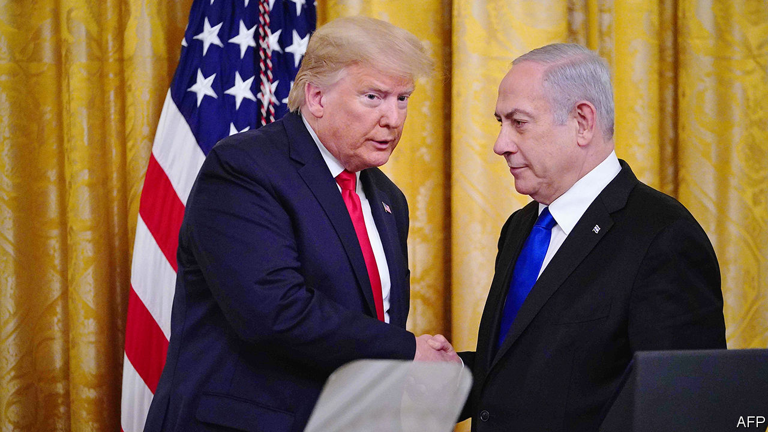

THE PROSPECT of peace between Israel and the Palestinians has grown so dim, it is easy to forget that President Donald Trump’s efforts to end the conflict began with much promise. The dealmaker-in-chief vowed to bring fresh thinking to the decades-old feud. “As with any successful negotiation, both sides will have to make compromises,” he told Binyamin Netanyahu, Israel’s prime minister, in 2017. Mr Trump’s meeting with Mahmoud Abbas, a few months later, ended with the Palestinian president gushing: “With you we have hope.”

What followed, though, was neither bold thinking nor any demand for sacrifices on both sides. Rather, Mr Trump showered Mr Netanyahu, a fellow populist, with political gifts. He recognised the disputed holy city of Jerusalem as Israel’s capital. His State Department declared that Israeli settlements in the West Bank are lawful. (Few legal scholars agree.) Mr Trump cut aid to the Palestinians, even for health and education, and closed their diplomatic mission in Washington. All this delighted his pro-Israel supporters back home, but enraged Palestinians.

Such is the context for Mr Trump’s unveiling of his long-awaited peace plan with Mr Netanyahu on January 28th (see article). It will not bring peace. But it may spell the end of the two-state solution—the idea that a Palestinian state and a Jewish one might agree to co-exist.

At a different time, under a different president, the proposal might have been the starting-point for more talks. Not an evenhanded starting-point, mind. The plan favours Israeli hardliners as no previous American plan has done. It lets Israel formally annex the settlements, hang on to the Jordan valley, maintain control of holy sites and reject Palestinian refugees. For the Palestinians, there are conditional promises of something like a state at some point in the future, with a capital on the outskirts of Jerusalem, plus billions of dollars of investment and an Israeli promise to freeze some settlement-building. If they negotiate, they might get a better deal, suggests the Trump administration.

The Palestinians do not believe it. If Mr Trump were serious about peacemaking, why did he try to woo only one side? No Palestinian leader could have accepted the deal, let alone one as weak as Mr Abbas. Mr Trump did not even invite him to the unveiling, which anyway seemed designed to distract Americans from impeachment (see [article](https://www.economist.com/node/21779096)), and Israelis from corruption charges against Mr Netanyahu. The prime minister appears eager to end the Palestinian dream of statehood. He has already asked his cabinet to vote on annexing parts of the West Bank, and is whipping up hawkish voters ahead of a tough election on March 2nd.

Should Mr Netanyahu win another term, he will undoubtedly move ahead with annexation. His main challenger, Benny Gantz, will face pressure to do the same if he is victorious. Far from easing the conflict, Mr Trump has pushed it down a perilous path. He has given Israel a green light to take so much territory that a coherent Palestinian state is all but impossible. And he offers no viable alternative to the two-state solution. That may soon leave Israel with a choice: give the Palestinians equal rights and watch as they multiply and outvote Jews, or treat them as second-class citizens and formally become an apartheid state.

The best that can be said of the Trump plan is that it acknowledges the Oslo peace process is moribund and a new approach is needed. But a successful peace deal means not only discarding what has not worked, but also coming up with what will: a plan that demands concessions from both sides as well as fair-minded leaders to implement it. This is not that plan. And Mr Trump, Mr Netanyahu and Mr Abbas are not those leaders. ■

This article was downloaded by calibre from <https://www.economist.com/leaders/2020/02/01/donald-trumps-one-sided-peace-plan>

|  |  |  |  |
| --- | --- | --- | --- |
| Previous | Articles | Sections | Next |

|  |  |  |  |
| --- | --- | --- | --- |
| Previous | Articles | Sections | Next |

#### Goldman Sachs

# How the mighty Goldman has fallen

The bank’s search for a new identity captures the changes in global banking

Feb 1st 2020 |



IN ITS PRIME Goldman Sachs was exceptional. Fifteen years ago, just before the global financial crisis, the bank easily outshone its Wall Street rivals—winning the most lucrative deals and making the most profitable trades. It printed money, both for shareholders and employees. Although the crisis imperilled the firm along with the rest of the banking industry, it navigated the chaos relatively well. Success allowed it to be haughty—while other banks engaged in the grubby game of sucking up to investors, Goldman remained secretive and enigmatic.

How times have changed. This week the firm held its first investor day, led by David Solomon, who took over as chief executive last year. It comes after a long period of underperformance. A dollar invested in Goldman in 2010 would be worth just $1.60 today. A dollar wagered on the S&P 500 would be worth $3.60, and on JPMorgan Chase, $4.10. Goldman has become a laggard.

Its predicament reflects two big changes in Western banking. One is the declining profitability of capital-markets activity, in large part the result of tighter rules, including higher capital requirements for riskier activity, penalties on lenders that rely on debt markets to fund themselves and tighter compliance regimes. The second is the rising importance of technology in the industry, as consumers and corporate borrowers shift to digital banking. This appears to give an immediate advantage to very large lenders that can support huge IT budgets, and to big tech platform firms that have vast numbers of customers who can be sold financial products, as is already the case in much of Asia.

Goldman has been on the wrong side of these trends. Consider its performance relative to JPMorgan Chase, a giant full-service firm. Goldman is still wrestling with past compliance mistakes—it is expected to pay billions of dollars in penalties for the 1MDB scandal in Malaysia. Its funding costs are higher than JPMorgan Chase’s (1.95% compared with 1.25% in 2018). Its ratio of expenses to revenues is worse. Not surprisingly, its return on tangible equity, a measure of profitability, was just 11% in 2019, compared with 19% for its rival. For Goldman’s shareholders the only consolation is that it has done better than Europe’s flailing banks—in the most recently reported quarter Barclays managed 10%, Credit Suisse 9%, and Deutsche Bank made a loss.

Mr Solomon’s new plan is, in part, to become more like JPMorgan Chase, with a broader range of services and funding. Goldman wants to expand Marcus, its fast-growing consumer arm, and also to build out its transaction-banking division that ships money around the world for companies. It plans to attract more deposits, which are typically the cheapest way to fund a bank. It has hired an army of tech experts. All this, Goldman hopes, will raise its return on tangible equity to 14%.

Goldman says it recognises the need for fundamental reform. It boasts of transforming its macho culture with a more diverse intake of recruits. But you can question how much it has really changed. It continues to allocate half its capital to its once-famed trading operation, despite its drab returns. And it still spends a lavish $12bn a year on rewarding its staff, even as the firm earned only $8bn for its shareholders in 2019. So far investors remain sceptical, with its shares priced at their book value.

If Goldman’s reinvention fails it may ultimately have to do a deal. Uniting Wells Fargo and Goldman, for example, would create something more like JPMorgan Chase (and with a similar-sized balance-sheet). In America regulators and some politicians are sceptical about bigger banks. In Europe, where the industry is more desperate, the mood has already changed, with matchmaking now encouraged. At least Goldman’s mergers-and-acquisitions advisers will be in on any action.■

This article was downloaded by calibre from <https://www.economist.com/leaders/2020/02/01/how-the-mighty-goldman-has-fallen>

|  |  |  |  |
| --- | --- | --- | --- |
| Previous | Articles | Sections | Next |

|  |  |  |  |
| --- | --- | --- | --- |
| Previous | Articles | Sections | Next |

#### Pill-pushers

# What to do about puberty blockers

Drugs offered to transgender children need to be used more cautiously

Feb 1st 2020 |



A RISING NUMBER of girls wish to be boys and boys wish to be girls and a rising number of them are taking drugs to block puberty. In Britain cases of children being treated for gender dysphoria by the National Health Service remain rare, but in the past decade they have climbed at a rate of 50% year on year (see chart). In America the number of gender clinics treating children has increased from just one in 2007 to perhaps 50 today.

This has bothered lawmakers. In America several states want to ban giving puberty-blocking drugs to children (see [article](https://www.economist.com/node/21779110)). In Britain the high court is considering the judicial review of a clinic which complainants believe has been handing out puberty blockers too freely (see [article](https://www.economist.com/node/21779170)).

The use of such drugs raises thorny questions about who decides what can happen to a child’s body and why. Put aside the culture wars, if you can. This debate should be settled in the interests of the child. Yet those can be very hard to discern.

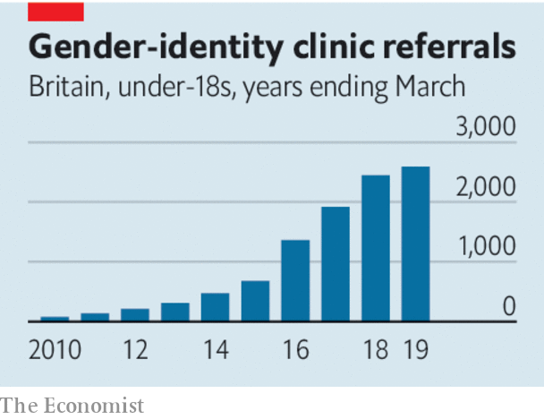

Puberty blockers prevent adolescents from developing secondary sexual characteristics like breasts or a beard. They almost always set off a cascade of interventions that involve “cross-sex” hormones and later may also include gender-reassignment surgery. The main purpose of puberty blockers is to bring comfort to people with gender dysphoria, by sparing them the experience of, say, becoming more like a woman if they are a girl who wishes to be a boy. They also make most future surgery less severe.

However, the combination of puberty blockers and cross-sex hormones also leads to irreversible changes which, if they start early in puberty, include sterility. About a dozen studies of gender-dysphoric children who did not take puberty blockers have found that most of them, if supported by counselling, are happy with their sex once they emerge from puberty. The share often cited is 85% and many of them turn out to be gay. One sign that something is wrong is that more people are “detransitioning”—re-identifying with their biological sex. Most of them are girls who wanted to be boys when they were in their teens. If they took puberty blockers and then cross-sex hormones early they would be sterile for life, even if they did not have hysterectomies.

As of now, there is no way to distinguish the 15% or so of children who will transition successfully from the 85% who might have been happy with the gender of their birth if they had received counselling alone. Some claim that withholding puberty blockers adds to the burden on vulnerable children with gender-dysphoria and may lead to higher rates of suicide.

Choosing whom to treat is a judgment of Solomon. The decision to intervene is made harder by a reckless disregard for data. The academic studies purporting to show the higher suicide risk among trans children are unconvincing. Clinics do not publish enough studies on the effects of various treatments on their patients. Too little research compares children who have had treatment with those who have not. The field needs a better understanding of the long-term effects of puberty blockers and cross-sex hormones. Every child who is treated should be enrolled in a long-term follow-up study.

This should be with their informed consent. But so should the treatment itself. Today children and parents are not always fully informed about the potentially grave consequences of starting on puberty blockers. Their effects are often described as largely reversible—and the effects of cross-sex hormones that are almost always taken with them are not.

To ban puberty blockers in all circumstances would be unjustified. Not only would it be harsh on some children, but it would also leave the issue permanently obscured for lack of new research. However, today’s rush into treatment smacks of a fad. Many adolescents feel unhappy with the way they were made. Transitioning will be solace for some. But for others it will be a dreadful mistake. ■

This article was downloaded by calibre from <https://www.economist.com/leaders/2020/02/01/what-to-do-about-puberty-blockers>

|  |  |  |  |
| --- | --- | --- | --- |
| Previous | Articles | Sections | Next |

|  |  |  |
| --- | --- | --- |
| Leaders | Sections | Briefing |

Letters

Letters to the editor: On one-nation Tories, chips, back pain, Boeing, disgust

.

|  |  |  |
| --- | --- | --- |
| Leaders | Sections | Briefing |

|  |  |  |  |
| --- | --- | --- | --- |
|  | Articles | Sections | Next |

#### On one-nation Tories, chips, back pain, Boeing, disgust

# Letters to the editor

A selection of correspondence

Feb 1st 2020 |

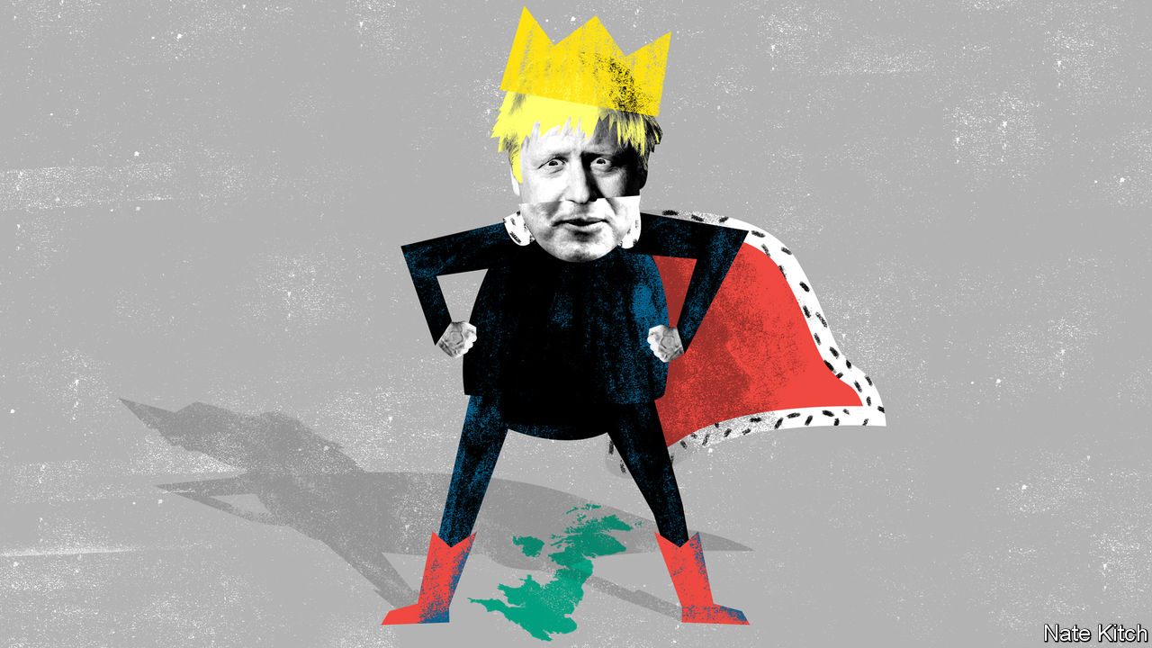

## The origins of one nation

Regarding [Bagehot](https://www.economist.com/britain/2020/01/02/boris-johnson-is-reinventing-one-nation-conservatism)’s column in the January 4th issue, Benjamin Disraeli’s “one-nation” conservatism was born as a convenient historical fiction. Disraeli denoted a commitment to healing a great social divide in his novel, “Sybil: or The Two Nations”. And in two famous speeches in 1872, Disraeli spoke of “elevating the condition of the people”. But it was Stanley Baldwin in 1924 who first used the famous phrase when he told the Conservative Party that “we stand for the union of those two nations of which Disraeli spoke…union among our own people to make one nation.” During the next five years, Neville Chamberlain, the most remarkable social reformer the Tories have ever had, gave substance to Baldwin’s vision.

Conservatives today would be proclaiming proudly that they were Baldwinian one-nation Tories if his reputation had not been so gravely damaged, very unfairly in my view, by the belief after 1939 that he had not rearmed Britain in the face of the Nazi menace. Nothing more might have been heard of one nation if a number of able, ambitious younger Conservatives, including Iain Macleod and Enoch Powell, had not adopted it as the name of a group they formed.

“One Nation” adorned a pamphlet that excited the party conference in 1950. Tory Central Office decided that this badge of moderate conservatism would be more effective if a great name from the past could be attached to it. Disraeli’s speeches from 1872 were now reprinted for the party faithful, and were quoted frequently by Tory leaders from Anthony Eden on. There has been a one-nation group of MPs almost constantly since then, formulating no more than mildly controversial policies to help counter “the almost traditional anti-intellectualism of the Tory party”, as The Economist put it (“[Class of 1950](http://media.economist.com/sites/default/files/pdfs/GP4100727994.pdf)”, December 25th 1954).

If Boris Johnson now gives real political substance to what has become an overused catchphrase, he will be recreating the Tories in the image of “Honest Stan” Baldwin. But will the ghost of Disraeli ever be laid to rest?

ALISTAIR LEXDEN  
House of Lords  
London

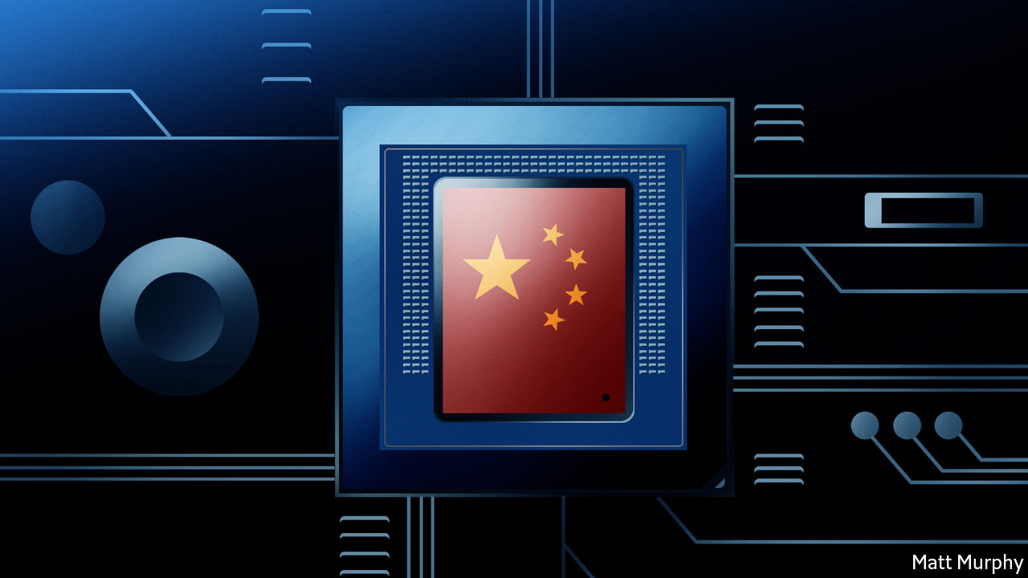

## Chinese chips

China’s shift from investing in chip manufacturing to chip design is long overdue, but it will take significant time to plug its intellectual-property gap ([Technology Quarterly](https://www.economist.com/technology-quarterly/2020/01/02/with-the-states-help-chinese-technology-is-booming), January 4th). That is the very piece of the puzzle that creates the most enabling value, within a chip and within the end product. China still imports a vast number of semiconductors, and import substitutes have had an impact only at the low end of the chip market and for some smartphones. China is still heavily reliant on chips from America for its data centres, and chips from Japan and Europe for cars. The intellectual property within such chips is highly patented. Even with the wind at its back, it will take China some time to develop the requisite IP and steer clear of the patent landmine. At the same time, American and British innovators will continue to advance the state of the art. It is the new great game.

WOZ AHMED  
Chief strategy officer  
Imagination Technologies  
Kings Langley, Hertfordshire



## Spinal trap

The personal and socioeconomic costs of joint pain (“[Backs to the future](https://www.economist.com/briefing/2020/01/18/back-pain-is-a-massive-problem-which-is-badly-treated)”, January 18th) are very much greater if you include the many millions of people suffering chronic knee and hip pain, which are very similar to back pain and similarly mismanaged by over medicalisation. Yet effective, low-cost, non-medical interventions are available that could easily be scaled up to help people with joint pain live better and do more. ESCAPE-pain is an evidence-based programme that helps people understand their problems and how physical activity can help. People who complete the programme often go from considering medication and surgery as the only options, to using lifestyle changes (losing a bit of weight, being a little more physically active) to control their pain.

This move toward integrated health and social care necessitates new ways of covering its costs. Some leisure companies charge a nominal fee for the programme, or a membership fee, or devise additional classes and activities for people who want to continue exercising after completing the programme. Some health-care commissioners have given local leisure firms contracts to provide ESCAPE-pain away from hospitals. This avoids unnecessary primary- and secondary-care consultations, thereby saving precious resources.

PROFESSOR MIKE HURLEY  
Centre for Applied Health and Social Care Research  
St George’s, University of London

As a recently retired doctor I agree that the overuse of opiates in particular has given many patients living with persistent pain the additional problem of opiate dependency, without relieving their symptoms. Harm from the overuse of imaging, particularly MRI, has its own acronym, VOMIT: Victim Of Medical Imaging Technology.

DOUGLAS SALMON  
Birmingham

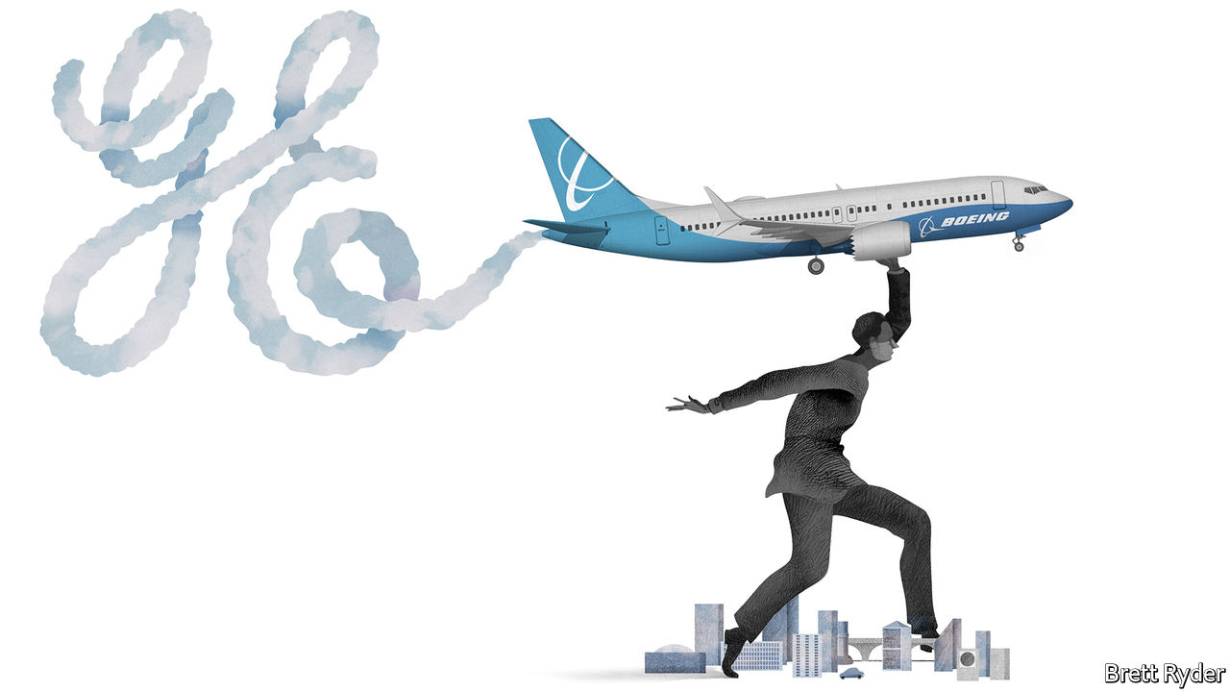

## A corporate legacy

The 737 MAX fiasco ([Schumpeter](https://www.economist.com/business/2020/01/11/the-last-ge-man), January 11th) was the ultimate result of running Boeing like a hard-nosed business rather than a great engineering firm. This was not its first blunder. When Airbus won the contract for the American air force’s aerial tankers, Boeing cried foul instead of sharpening its pencils for next time, got the contract reopened and won it in 2011. It has been a disaster, well over budget and still not ready for full production (the Airbus tanker has been in service since 2011).

And it was Boeing that started the spat with Airbus over subsidies. After the WTO makes a ruling this year both companies will lose out on sales, which will hurt Boeing more than Airbus because Boeing sells more to the EU than vice versa, and Airbus has an American assembly plant to get around some of the duties.

In 2016, Boeing became alarmed that Bombardier’s C Series aircraft had won a contract from Delta, and fought to kill it off through tariffs. Bombardier, a Canadian aircraft-maker, sold a majority stake in the C Series to Airbus, which converted it into the successful A220. Because of Boeing’s behaviour, the Canadian government cancelled a contract for Boeing fighter jets.

Will Boeing’s culture change under David Calhoun? The signs are not encouraging. Boeing offered the victims of the 737 MAX crashes $50m in total compensation. Dennis Muilenburg, Mr Calhoun’s predecessor, got a $60m payout. Not a good start to repairing Boeing’s reputation.

GRAEME SHELFORD  
Thetis Island, Canada



## Horrible history

I commend your article on the importance of culture in defining what is disgusting (“[Overcoming the yuck factor](https://www.economist.com/international/2020/01/09/what-a-museum-of-disgusting-food-reveals-about-human-nature)”, January 11th). Readers interested in the subject should turn to William Ian Miller’s superb book, “The Anatomy of Disgust”, published in 1997. Mr Miller provides such trenchant insights as “vomit may be more disgusting than faeces (only faeces is playing by the rules)”, and that “even in the Middle Ages, with its presumably high thresholds of disgust…one simply did not drink pus.”

JOHN HANSON  
Cambridge, Massachusetts

This article was downloaded by calibre from <https://www.economist.com/letters/2020/02/01/letters-to-the-editor>

|  |  |  |  |
| --- | --- | --- | --- |
|  | Articles | Sections | Next |

|  |  |  |
| --- | --- | --- |
| Letters | Sections | United States |

Briefing

The special relationship: No longer such a smooth ride

.

|  |  |  |
| --- | --- | --- |
| Letters | Sections | United States |

|  |  |  |  |
| --- | --- | --- | --- |
|  | Articles | Sections | Next |

#### The special relationship

# A weaker post-Brexit Britain looks to America

Good luck with that

Feb 1st 2020 | LONDON AND WASHINGTON, DC

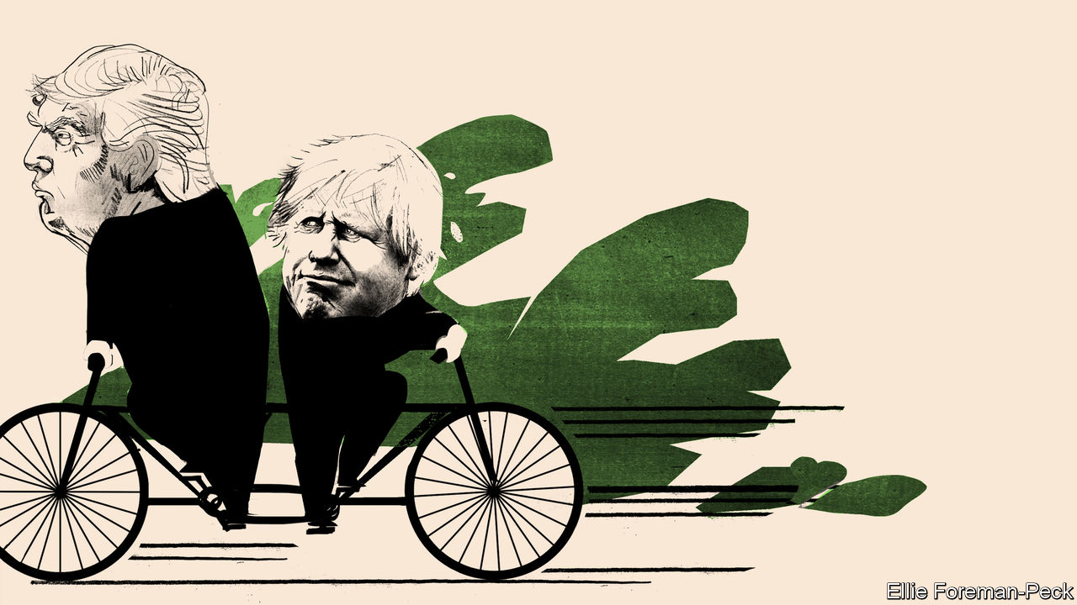

THE TITANS of Brexit have a tendency to gush over Britain’s bond with America. Before the referendum in 2016, Boris Johnson—now prime minister, then mayor of London—predicted that, outside the European Union, the thriving British would be “even better and more valuable allies of the United States”. Britain’s relationship with America had long been “special”, enthused Liam Fox as trade secretary in 2018. But Brexit provided a “once-in-a-generation opportunity to raise it to a new level”.

Yet in the week that Britain actually leaves the EU it finds itself at loggerheads with America on tax, trade and technology. If the British government persists with plans for a digital-services tax that would hit tech giants, America has said it will retaliate with punitive tariffs on British car exports. And despite heavy American lobbying and suggestions that the countries’ intelligence-sharing could be at risk, Mr Johnson decided on January 28th to allow Britain to buy 5G telecoms kit from Huawei of China. Mike Pompeo, America’s secretary of state, had warned against letting China “control the internet of the future”.

The decision on Huawei came two days before Mr Pompeo was due to join his British counterpart, Dominic Raab, in London for a public conversation on “the future of the special relationship”. At first glance, and despite the croonings of Brexiteers, that relationship appears to be in poor shape. Thomas Wright of the Brookings Institution, a Washington think-tank, describes it as “in its worst state since the Suez crisis” in 1956.

Mr Wright has catalogued many ways in which President Donald Trump “tormented” the previous government, under Theresa May. Although Mr Trump has a better rapport with Mr Johnson than he had with Mrs May, tensions have not disappeared. Meanwhile, competition for America’s attention has been growing. Under the energetic Emmanuel Macron, France emphasises that it is the “oldest ally” of the United States. China’s rise is also tugging America away from Europe.

All this adds to a sense of uncertainty, post-Brexit, about Britain’s status and role in the world. The so-called special relationship has always been lopsided: Helmut Schmidt, a German chancellor, once quipped that it was so special only one side knew it existed. But for nearly half a century, membership of the European club allowed the British to stop fretting too much about their influence in the world. They were “the bridge between the US and Europe”, as Tony Blair, one of the most enthusiastic proponents of the special relationship (and an ardent Remainer), put it as prime minister in 1997. Britain could wield influence on both sides of the Atlantic. Now that the bridge is breaking, questions about Britain’s power are back.

## Things have come to a pretty pass

After the second world war Britain struggled to find its place in America’s shadow. Winston Churchill envisaged Britain as part of three great circles among the democracies: the Commonwealth, the English-speaking sphere and a united Europe. In 1946, in a speech in Fulton, Missouri, he had proposed a “special relationship” with the United States, a “fraternal association” of English-speaking peoples involving not only kindred societies but military collaboration. Another prime minister, Harold Macmillan, patronisingly positioned Britain as playing Athens to America’s Rome, teaching a “vulgar, bustling” people how to run a rising empire.

None of this proved convincing. In 1962 Dean Acheson, a former American secretary of state, concluded that Britain had lost an empire but not found a role. Its attempt to find one away from Europe, based on a “special relationship” with America and on being the head of a Commonwealth, he said, was “about played out”.

Joining what was then the European Economic Community in 1973 offered something of a solution. As Ray Seitz, an American ambassador to London, noted in a valedictory speech in 1994: “If Britain’s voice is less influential in Paris or [Berlin], it is likely to be less influential in Washington.” In Mr Blair’s formulation: “Strong in Europe and strong with the US...There is no choice between the two. Stronger with one means stronger with the other.”

## Our romance is growing flat

Special or not, the relationship has often been fraught. Apart from the Suez debacle, friction arose between Harold Wilson and Lyndon Johnson over Wilson’s refusal to support the war in Vietnam. Even Margaret Thatcher and Ronald Reagan, who were so chummy that Reagan’s successor, George H.W. Bush, said “he was just smitten by her”, fell out over America’s invasion of Grenada in 1983.

Yet over the years, in several different spheres, America and Britain have grown closer. Some 28 Nobel prizes have been awarded jointly to people from the two countries. British actors, such as Daniel Craig, are as likely to play an American detective in Hollywood movies as American ones, such as Renée Zellweger, are to put on plummy British accents to play characters such as Bridget Jones.

The economic ties are especially deep. New York and London, the world’s top two financial centres, are rivals but they are also intertwined. Nearly a fifth of Britain’s exports go to America, more than double the share going to Germany, the next-biggest partner. America accounts for 15% of Britain’s total trade. American investment in Britain supports an estimated 1.5m jobs, and 1.3m vice versa. Britain attracts more than 10% of American foreign R&D.

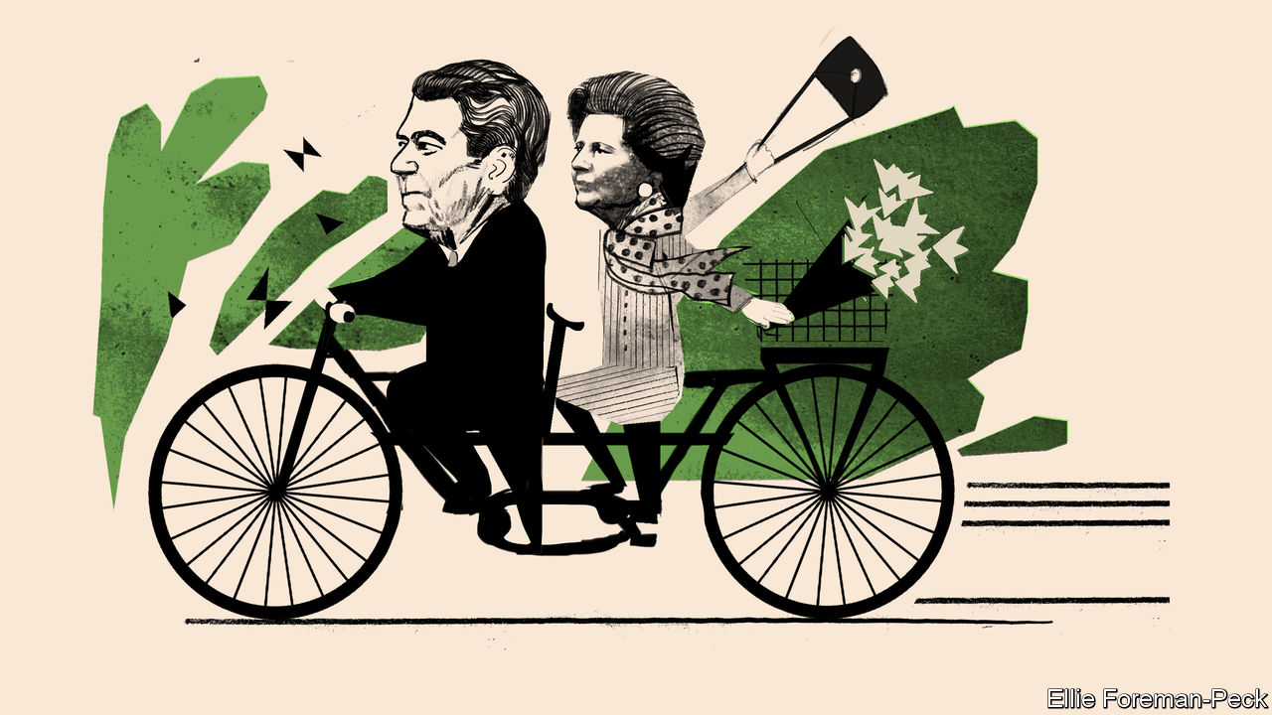

As much as anything, though, it is shared values and habits of co-operation that have bound Britain and America together. Britain, says Nicholas Burns, a former American ambassador to NATO, is “the country we trusted the most, and worked most closely with.” At the State Department, where British diplomats enjoy a level of access afforded no other country, Britain was “the most like-minded country” with America, and “the first port of entry” with the EU on many issues, according to Amanda Sloat, a Europe specialist who served there under the Obama administration. In an Emerson poll from October 2019, 40% of Americans saw Britain as their country’s most valuable ally and strategic partner, far ahead of next-placed Canada on just 22%.

This closeness has often been evident at the top, starting with the wartime partnership between Churchill and Franklin Roosevelt. Whether it was the free-market freedom-championing of Thatcher and Reagan or the war-fighting of Mr Blair and George W. Bush, British and American leaders have tended to act in tandem.

One of the questions facing the special relationship today is whether or not the same will apply for Mr Johnson and Mr Trump. They have a lot in common; perhaps unsurprisingly, they openly express admiration for one another. Yet other leaders, including Mr Macron, have learnt that it is unwise to place high hopes in a “bromance” with Mr Trump. And if Mr Trump expects that Mr Johnson will go along with his wishes on issues such as the Iran nuclear deal or relations with China he is likely to find himself disappointed.

Mr Johnson’s own instincts may even lean towards European positions on many issues, from climate change to Ukraine. As long as the Trump administration remains in place, “we appear to be more aligned with the Europeans on values and interests than with the United States,” suggests Sir Peter Westmacott, a former British ambassador to Washington. Federica Mogherini, until recently the EU’s foreign-affairs representative, expects continuity, too.

Huawei provided a first test of Britain’s post-Brexit policy. Now two other areas will come to the fore: defence and trade. Traditionally, the Anglo-American relationship has been deepest in military, nuclear and intelligence matters. Britain’s armed forces have fought alongside their ally in every major campaign of the past three decades. “The way we fight is nearly indistinguishable,” says Philip Breedlove, a retired American general who served as NATO’s Supreme Allied Commander Europe from 2013 to 2016.

Partly this is down to an unparalleled level of integration. Every major in the British Army goes through a course in America, and more than 1,000 British military and civilian defence staff are based across 29 American states. Some military assets are held virtually in common, while British defence firms are more closely involved than those of any other country in building the F-35 warplane. Britain also depends on America to build, sustain and defray the costs of its nuclear arsenal.

## You like tomato and I like tomahto

Their spooks lean heavily on one another, too. Britain’s signals-intelligence agency, GCHQ, and its American counterpart, the NSA, are bound by the Five Eyes pact, which includes Australia, Canada and New Zealand. Documents leaked by Edward Snowden, a former NSA contractor, showed that Britain had a sweet deal: America paid at least £100m to GCHQ in 2009-12 and 60% of Britain’s high-value intelligence was derived from the NSA. But the benefits are not one-sided. Michael Hayden, an ex-NSA director, once told his British counterpart that if Fort Meade, the NSA’s Maryland headquarters, was to suffer a catastrophe, he planned to entrust the machinery of American electronic espionage to Britain.

This strategic intimacy dates to the second world war. However, it is not immutable. Kori Schake of the American Enterprise Institute (AEI), a think-tank, warns that “Britain is perilously close to becoming just like any other Western military rather than the preferred partner of the US any time rules need enforcing.”

In recent years the sorest point has been British defence cuts. In 2015 Barack Obama demanded, in terms that would foreshadow Mr Trump’s rhetoric, that David Cameron, then prime minister, pay his “fair share”. General Ray Odierno, then head of the US Army, said that he was “very concerned” by the belt-tightening, which amounted to an 18% fall in real-terms spending over the previous five years.

Those warnings helped trigger a spending boost, but three years later James Mattis, then Mr Trump’s defence secretary, fired another shot across the bow of his British counterpart. “France and the US have concluded that now is the time to significantly increase our investment in defence,” he warned in a letter, adding ominously: “It is in the best interest of both our nations for the UK to remain the US partner of choice.” That prompted another hurried injection of cash, but Britain has struggled to keep up. The size of its armed forces has fallen for nine consecutive years. Brexit might lead to further reductions.

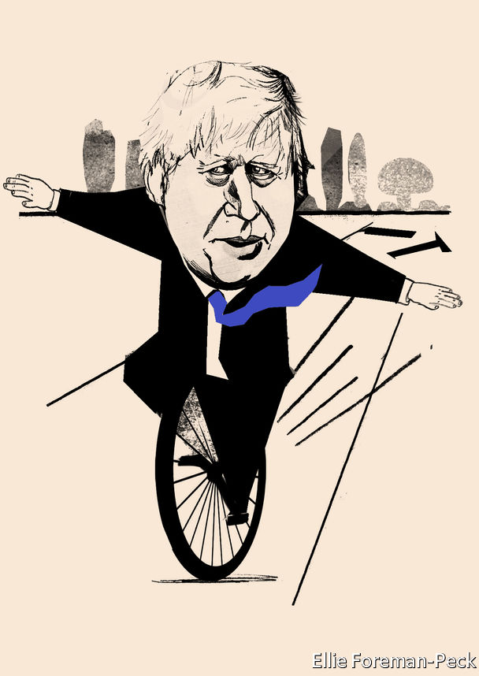

Still, American diplomatic and military insiders tend to pooh-pooh the idea that the relationship is in crisis, or that France could supplant Britain. “The UK is still our most capable partner militarily, and our most valuable partner politically,” says Rachel Ellehuus, who handled European and NATO policy at the Pentagon until 2018.

However there are some signs of wavering in Britain. On January 12th Ben Wallace, Britain’s defence secretary, questioned America’s reliability as a partner. Britain was “very dependent” on American surveillance and air cover, warned Mr Wallace. “We need to diversify our assets,” he added. British spending on American kit is already slated to run to $32bn over the next decade, around 7% of the defence budget each year.

But the options for diversification are limited. Brexit has left Britain cut out of a new European defence fund and a project to build a European satellite-navigation system. Going it alone is pricey: a proposed British-built alternative constellation would cost around £5bn. So Britain will have a lot to wrestle with as it conducts a comprehensive review of security, defence and foreign policy. Mr Johnson has promised it will be the most radical assessment since the end of the cold war.

## But oh, if we call the whole thing off

The other test of the special relationship, on trade, is likely to be similarly fraught; all the more so given the rancour in Congress over the Huawei decision. Tom Cotton, a Republican on the US Senate’s Armed Services Committee, tweeted that “I fear London has freed itself from Brussels only to cede sovereignty to Beijing.”

However, the desire for a deal is not in doubt. Both sides are aiming for a comprehensive free-trade agreement, which could dismantle non-tariff barriers. Negotiators share an interest in strong intellectual-property protection, recognition for each other’s professional qualifications and maintaining the free flow of data.

If Britain really wanted, it could probably get a deal in relatively short order. America has a template trade deal that it tries to push on all of its negotiating partners. David Henig of the European Centre for International Political Economy, a think-tank, reckons Britain could sign up to most of the text on tariff reductions and services without a hitch. As a gesture, the Americans could offer some special access to their public-procurement market.

Indeed, American officials have been helping to bring their British counterparts up to speed, in some cases informing them of stumbling-blocks in negotiations with the EU. The warmth stems only partly from a genuine wish to strengthen their relationship. It also reflects a desire to thumb American noses at the EU—and pull Britain away from its regulatory orbit.

In some crucial areas, Britain is going to have to choose between the American system of regulation and the European one. Take the issue of food standards, often simplified to a debate about chlorinated chicken. The EU bans its import on the basis of the precautionary principle, which says that there must be scientific evidence proving something is safe for it to be allowed. America flips that burden of proof; in order for a product to be banned there must be scientific evidence proving it is unsafe.

American negotiators scoff that the EU’S approach is “unscientific”. Regardless, if Britons opt for the American way, they may quickly find themselves embroiled in the EU’s non-tariff barriers for their own products. The EU has made it clear that any future free-trade deal with Britain will have to include provisions to prevent any “unfair competitive advantage” that Britain could get by undercutting its environmental and regulatory measures. To put it another way: if Britain wants to diverge from the EU’s standards and follow an American model instead, its market access to its biggest and closest neighbour will suffer.

If negotiators get bogged down, as they probably will, then they could aim instead for a quick and shallow deal, delivering political wins on both sides of the pond. Such a deal could defuse the dispute over digital-services taxes, or perhaps America’s complaints over Britain’s subsidies for Airbus, a European aircraft manufacturer.

Despite these potential hurdles, leaving the EU does not mean Britain has lost all its leverage with the country Iran dubbed “the Great Satan” to Britain’s “little Satan”. Britain can still draw on a depth of diplomatic capital that offers it clout. It remains in the G7 and the G20 and plays a big role in NATO. Britain has a wide network through the Commonwealth and earns influence as a major player in development aid. Not least, it retains one of the five permanent seats on the UN Security Council. As the country emerges from agonising over the Brexit negotiations, it can start to devote more energy to working out how to make the most of these assets under its new, semi-connected status with the continent.

Indeed, whatever the intrinsic merits of the Huawei decision—the British view was that security risks could be managed and that the alternative suppliers were not yet up to scratch—it dispels the idea that a weakened Britain leaving the EU will always bend to America’s will. When Britain ingratiates itself with America, things do not necessarily end well, as Mr Blair’s enthusiasm for the war in Iraq showed. A clear-headed view of the country’s national interests (which in the Huawei case include Britain’s wish for strong trade relations with China) serves it best.

Outside the constraints of the EU, Britain could have some scope to be more agile. Take sanctions. It is true that Britain is losing the ability to champion these through the EU. But it also no longer has to be bound by the need to thrash out lowest-common-denominator agreement. It could, potentially, take the initiative on its own.

## Then that may break my heart

Some would like to see Britain take the lead in areas where, for now, America seems to have lost interest, such as championing democracy. (Though that would mean standing up to China.) Because Britain knows America so well it has “a huge opportunity to help countries trying to deal with [it]...do it more nimbly and more strategically,” says Ms Schake of the AEI.

Britain could remain in the bridge business. The two countries may never regain the first-name closeness shared by “Ron” and Margaret or even George and Tony. But a different American administration could both rekindle something of that romance, as well as help its ally remain closely connected with the continent. For now, however, Mr Trump seems to favour a divide-and-conquer approach. And that threatens the ardour between Boris and Donald. ■

This article was downloaded by calibre from <https://www.economist.com/briefing/2020/02/01/a-weaker-post-brexit-britain-looks-to-america>

|  |  |  |  |
| --- | --- | --- | --- |
|  | Articles | Sections | Next |

|  |  |  |
| --- | --- | --- |
| Briefing | Sections | The Americas |

United States

The presidential primaries: Who will be Donald Trump’s most forceful foe?

.

The politics of gender: Changing states

.

Vermont’s economy: The road not taken

.

The Iowa caucus: Progressives’ dilemma

.

The Supreme Court: Injunction dysfunction

.

Lexington: Voting with their eyeballs

.

|  |  |  |
| --- | --- | --- |
| Briefing | Sections | The Americas |

|  |  |  |  |
| --- | --- | --- | --- |
|  | Articles | Sections | Next |

#### A primary quandary

# Who will be Donald Trump’s most forceful foe?

Data suggest that one Democratic candidate would do better than others against the president in November

Feb 1st 2020 | WASHINGTON, DC

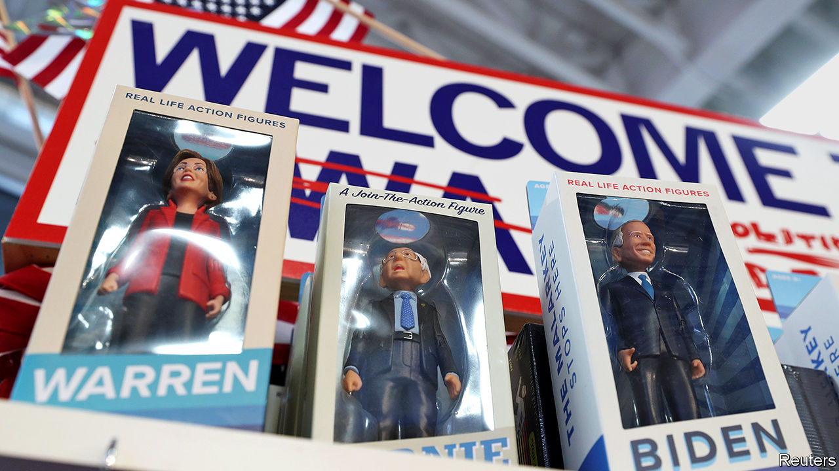

DEMOCRATS CAST their first votes in this year’s presidential primaries at caucuses in Iowa on February 3rd. Their ultimate goal is to nominate a candidate who can beat Donald Trump in November. That will not be easy. Despite much political tumult and an impeachment trial, the president still has a clear path to re-election.

Mr Trump is unpopular in national polls. Yet he is a stronger candidate than headline figures suggest. His approval ratings have hovered around ten percentage points below his disapproval ratings. Although since 1950 such an unpopular president has never won re-election, the historical relationship between a president’s approval and his share of the two-party vote suggests Mr Trump should still win about 49% of votes cast for Democrats and Republicans in November. The economy may help. The Federal Reserve forecasts GDP to grow by about 2% this year. Such an increase has been associated with past presidents winning about 50% of the vote.

Of course the electoral college, not the popular vote, determines who wins. Here, too, Mr Trump has an advantage. Because pivotal midwestern states such as Wisconsin and Michigan lean slightly more Republican than the nation as a whole, The Economist’s analysis of polling data suggests Democrats need to win the popular vote by about two-and-a-half percentage points to win the White House.

Democrats have thus placed a premium on selecting a candidate able to beat Mr Trump. Yet they disagree over who is best placed to do so. Candidates such as Elizabeth Warren and Pete Buttigieg have been at some points boosted and dogged by such questions of so-called “electability” over the course of the campaign. Joe Biden and Bernie Sanders have emerged as the top contenders in polls, their support elevated among working-class whites—the voters who swung rust-belt states toward Mr Trump and are likely to decide the election in November. But the two candidates’ electoral strategies differ significantly.

Mr Biden has taken the more traditional approach. In his view, Democrats will win by wooing back white working-class voters in midwestern states who deserted the party in 2016, while keeping black voters’ support. Mr Sanders hopes his populist message will resonate with disaffected Democrats, working-class voters and the young. Who is right? New political-science research and polling data suggest a moderate candidate popular with working-class whites would be best poised for victory.

Studies have found that ideologically extreme candidates can hurt a party’s performance. Andrew Hall and Daniel Thompson of Stanford University found that more extreme candidates for the House of Representatives between 2006 and 2014 increased turnout in their party, but galvanised the other party’s voters by four to ten percentage points more. Christopher Warshaw, a political scientist at George Washington University who has carried out similar studies, reckons that moderates hold similar advantages in presidential races.

Mr Trump may have benefited from this dynamic in 2016. According to the Co-operative Congressional Election Study (CCES), a 65,000-person poll overseen by Harvard University, voters thought Hillary Clinton was about twice as ideologically extreme as Mr Trump in 2016. This was due largely to his embrace of some positions considered unorthodox for Republicans, such as defending Social Security and Medicare.

Here, Mr Biden looks strong. YouGov’s polling reveals that Americans view him as the most moderate Democrat, on average. They perceive all the other major Democratic contenders as more extreme than Mr Trump (see chart).

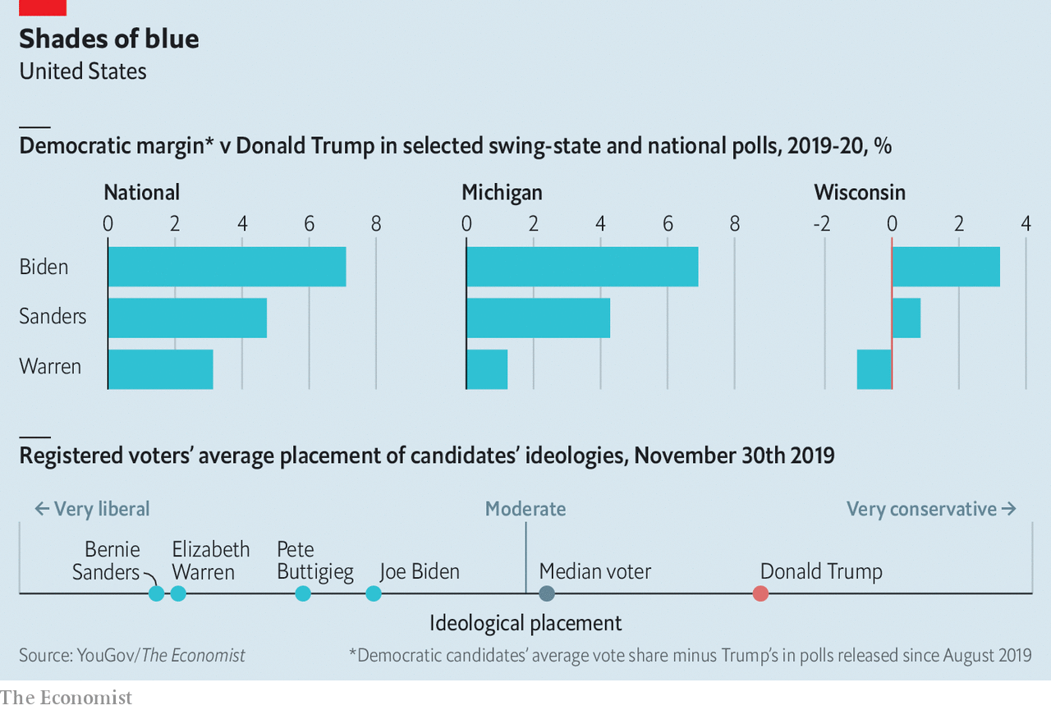

Mr Trump’s support from racially conservative whites may also help him. In an article published in 2019, Tyler Reny of UCLA, Loren Collingwood of the University of California, Riverside and Ali Valenzuela of Princeton University conducted a study of the CCES data to analyse the link between voters’ self-professed attitudes towards racial minorities and their voting behaviour. The authors found that “white voters with racially conservative or anti-immigrant attitudes” switched votes to Mr Trump at a higher rate than those with more liberal views on these matters.

Mr Biden could win back some of these people. Alexander Agadjanian of MIT studied the attitudes of nearly 3,000 Democratic voters and found those with “racially resentful” views—disagreeing, for example, that slavery and discrimination have made progress difficult for African-Americans—were 27 percentage points likelier to vote for Mr Biden than for his opponents.

Mr Trump also benefited in 2016 by attacking economic and political elites. Justin Grimmer and William Marble of Stanford studied the attitudes and turnout of different voting blocs, finding that poverty and low educational achievement—proxies for the lower rungs of America’s class hierarchy—were associated with higher support for Mr Trump. According to their analysis, low-income white people living in closely contested states were more than ten percentage points more likely to vote for Mr Trump than for Mr Romney. They found that voters who had dropped out of high school were both around 20 points more pro-Republican and more likely to turn out in 2016 than in 2012. Polling data suggest that poorer Americans are likelier to harbour resentment toward political leaders. They may have been attracted to Mr Trump’s anti-elite messaging.

This presents Mr Sanders with his biggest advantage. Mr Biden’s history in Washington may evoke the same rage against elites as Mrs Clinton did in 2016. Despite years in the Senate, Mr Sanders is seen as an outsider and working-class champion. He may be less off-putting to voters looking for a candidate to reform Washington.

## The proof is in the polling

This research suggests, then, that Mr Biden could perform better than his competitors against Mr Trump. He is more moderate than Mr Sanders, so both more likely to attract swing voters and less likely to motivate Republicans to vote against him. His strength with both black and racially conservative white voters could make a big difference in swing states. Recent polling from the New York Times and Siena College suggests that 6% of the electorate would vote for Mr Biden—but not for Elizabeth Warren—against Mr Trump.

His advantage is evident in polls. According to The Economist’s analysis of publicly released polling data, Mr Biden performs better against Mr Trump than his competitors, nationwide and in swing states. Although polls of the general election conducted this early before a contest are not perfect, they are still helpful.

Mr Biden is not faultless. He is uninspiring on the stump and in debates. His Washington ties may inspire resentment from voters sceptical of elites. His candidacy would also represent a safety-first strategy for the Democrats at a time when many in the party desperately want to push a much more progressive economic, racial and social agenda. Yet for all that he still appears to be the Democrats’ best option in a contest against Mr Trump. ■

This article was downloaded by calibre from <https://www.economist.com/united-states/2020/02/01/who-will-be-donald-trumps-most-forceful-foe>

|  |  |  |  |
| --- | --- | --- | --- |
|  | Articles | Sections | Next |

|  |  |  |  |
| --- | --- | --- | --- |
| Previous | Articles | Sections | Next |

#### Gender dysphoria

# A new push to ban medical treatments for transgender children

State legislators are seeking to make puberty blockers, cross-sex hormones and gender reassignment surgery illegal

Feb 1st 2020 | WASHINGTON, DC



JAMES YOUNGER’S mother believed he should wear dresses and grow his hair long because he considered himself a girl. His father claimed the seven-year-old was perfectly content with trousers, short hair and being a boy. Almost every detail of the couple’s vicious custody battle was fought over their child’s gender identity. After his mother won, culture warriors piled in.

Ted Cruz, a senator from Texas, said the child was “a pawn in a left-wing political agenda”. A host of Republican politicians shared posts from a #ProtectJamesYounger social-media campaign. In October a judge awarded James’s parents joint custody, barring them from speaking publicly about the case. Since then its effects have rippled beyond one unhappy family. Lawmakers in a number of states say the Youngers’ row has prompted them to try to pass laws banning medical interventions that bring transgender children closer to the sex with which they identify.

On January 29th South Dakota became the first state to vote for such a bill in its lower chamber. It needs to be approved by the Senate and governor to become law. At least five others have drawn up bills which would make it illegal to perform gender-reassignment surgery on children and to prescribe puberty blockers and cross-sex hormones for them.

The chief motivation of such lawmakers is political. Some cite the Texan custody case as an inspiration for their bans. But no seven-year-old child is prescribed puberty blockers or undergoes gender-reassignment surgery. To suggest as much—as some right-wing commentators have—is more rallying cry than reality check.

The danger of making trans rights an issue in the culture wars is that it prevents a discussion of the dangers of prescribing blockers and sex hormones for children who suffer from gender dysphoria, the distress caused by feeling that one’s sex at birth and gender identity do not match.

Data on all aspects of transgender medical interventions are poor. No one knows how many children have been prescribed these drugs. Little is known about how they have fared since. But in the past decade there has been a surge in the number of children treated as trans. Clinics serving them have mushroomed. In 2007 there was one. Today there are perhaps 50. Waiting lists at many are long and lengthening.

Anecdotal evidence suggests that standards of care have failed to keep pace. The biggest concern is that children put on blockers—first prescribed between the ages of 9 and 14 to suppress the action of sex hormones—and later, testosterone or oestrogen, do not first undergo sufficiently comprehensive evaluations.

Guidelines from the World Professional Association for Transgender Health say such interventions should follow “extensive exploration of psychological, family and social issues”. That seems elementary. There is no medical test for gender dysphoria. Research suggests that most children who identify as the other sex eventually grow out of it. They are also more likely to suffer from anxiety and depression. Untangling all of this and establishing whether a child is likely to go on feeling that they are in the wrong body—a guess, at best—poses significant challenges for children, parents and their doctors.

Laura Edwards-Leeper, a professor of psychology at Pacific University in Oregon who helped found America’s first transgender clinic for children in Boston, reckons the “vast majority” of children on blockers or sex hormones have not undergone proper assessments. This, she says, is because of a shortage of mental-health professionals with the necessary training and the desire of doctors to provide care for a group that has long been denied it.

This carries the obvious risk that patients will regret transitioning. No one knows how many people fall into this category. A small number of those put on blockers and sex hormones have since “detransitioned”. The most outspoken among them are lesbians who say that had they been encouraged to explore gender non-conformity—the idea, for instance, that women can be butch—rather than transgenderism, they would not have taken testosterone. Others say mental-health problems caused their gender dysphoria and cross-sex hormones were prescribed as the solution.

A second, related problem concerns the way blockers are sold to patients and their families. Developed in the 1980s to treat premature puberty, they have transformed transgender health care since they were first used for this purpose in the late 1990s. Doctors attest that they save adolescents who feel desperate about developing the “wrong” sex characteristics from enormous distress. Blockers can forestall more traumatic interventions later: the removal of breasts, or the shaving of an Adam’s apple. Their effects are largely reversible. Doctors who prescribe them routinely refer to blockers as a “conservative” measure.

Yet few children seem to step off the treatment path that blockers set them on. The great majority go on to sex hormones. Given the inadequacy of many pre-treatment evaluations, this seems unlikely to be wholly the result of sound diagnoses.

Puberty blockers also have other side-effects. Over time, they can affect bone density. This means that doctors are keen to move patients who want to continue treatment onto sex hormones within a few years. But many of the effects of these are irreversible, including infertility. Paul Hruz, an endocrinologist at Washington University School of Medicine in St Louis, says interrupting puberty may have other harmful effects. A surge of hormones during puberty may help put adolescents at ease with their birth gender. Puberty blockers would prevent that process.

Few doctors worried by these problems are prepared to speak about them openly. That is unsurprising given how inflammatory the issue has become. When Lisa Littman, a professor of behavioural and social sciences at Brown University, published a paper in 2018 in which she noted that most transgender children were teenage girls with no history of gender dysphoria—a phenomenon she called “rapid-onset gender dysphoria”—she was denounced as transphobic.

In such a polarised environment, bills proposing blanket bans of puberty blockers are likely to be counterproductive. They may push advocates for early intervention to further extremes. A better approach would be twofold. A neutral assessment of the existing data on the use of blockers, hormones and their effects would help patients and their families make decisions. Most existing research has been undertaken by those working in the field. At the same time, clinics should ensure that children in transgender clinics undergo comprehensive mental-health evaluations.

For all this to happen there needs to be an acknowledgment of the dangers of starting children on often irreversible treatments. At present, that is unimaginable.■

This article was downloaded by calibre from <https://www.economist.com/united-states/2020/02/01/a-new-push-to-ban-medical-treatments-for-transgender-children>

|  |  |  |  |
| --- | --- | --- | --- |
| Previous | Articles | Sections | Next |

|  |  |  |  |
| --- | --- | --- | --- |
| Previous | Articles | Sections | Next |

#### The road not taken

# As wages grow across America, one state is left behind

Vermont attracts tourists and students. What is holding it back?

Feb 1st 2020 | MONTPELIER

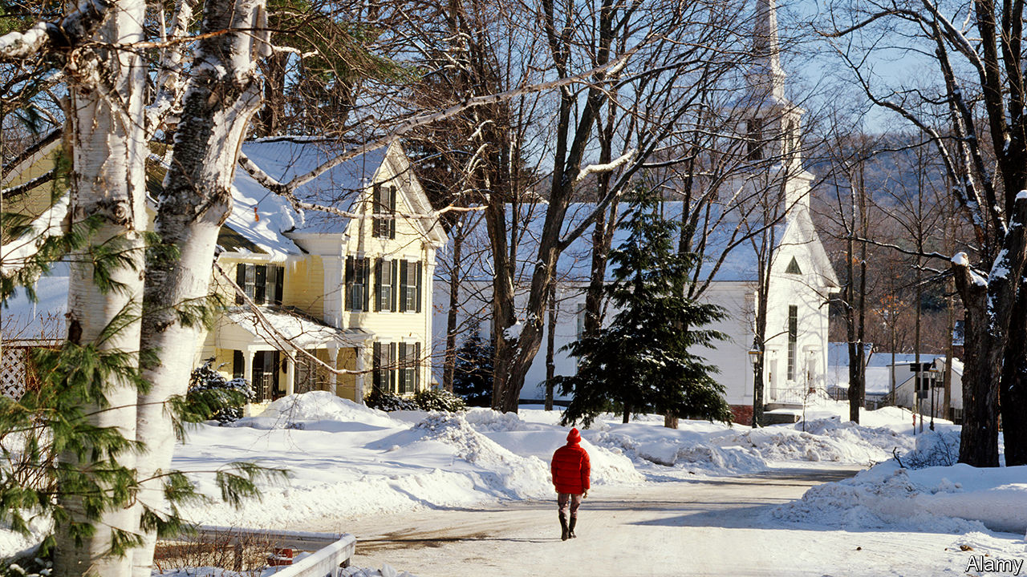

FOR YEARS after the global financial crisis of 2007-09, America’s wage growth was frozen. Earnings have recently been rising at a faster rate. The latest figures point to year-on-year growth of around 3% in nominal terms. But not all states have shared the gains. On both a per-hour and per-week basis, Vermont has seen the weakest wage growth of any state in the past decade, despite a rapid rise in the minimum wage and low unemployment. Real wages remain lower than they were when the last recession ended (see chart). What has Vermont got wrong that much of the rest of America has got right?

Weak earnings growth is in part the product of a relatively weak economy. In the past decade Vermont’s GDP has grown at two-thirds the rate of America’s. Critics point to a mountain of red tape and regulation. The state comes close to the bottom of various indices of “economic freedom” produced by libertarian think-tanks. These may be rough and ready but, when it comes to the regulation of land, small-government types may have a point.

A recent working paper from the Bank of England shows that in many parts of America building houses has become more difficult since the mid-2000s. Tough zoning laws may partly be to blame. The paper’s results suggest that it is now about as hard to build in Burlington, the biggest city in Vermont, as in San Francisco. Constraining Burlington’s growth weighs on the economy. People find it hard to move there because it is too expensive, so they are stuck in less productive jobs elsewhere.

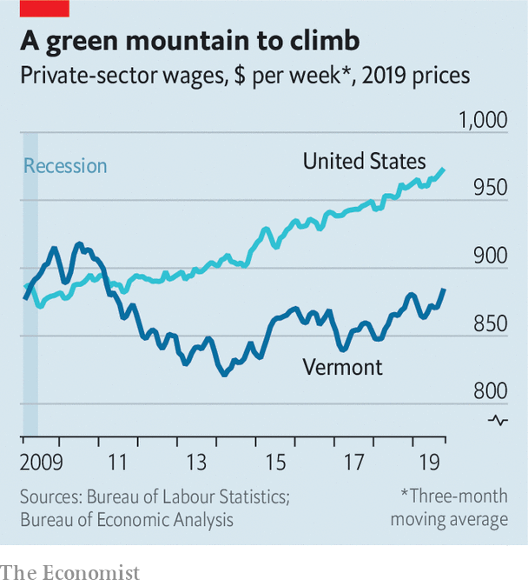

Yet it is wrong to blame Vermont’s wage woes on policy alone. The state has raised its minimum wage by 36% since 2009. The higher pay floor has supported earnings at the bottom—apparently with little negative impact on jobs. Vermont’s unemployment rate is below America’s average. The most important reason why Vermont has missed out on wage gains may be the structure of its economy.

Low-paid folk have lately done fairly well out of America’s labour market. Since 2015 the wages of high-school dropouts have risen twice as fast as those of workers with advanced degrees as firms in service industries have competed for workers and minimum wages have risen. Pay-packets in blue-collar jobs have also swelled. The booming energy sector, in particular shale oil, takes much of the credit for that. The top five oil-producing states contributed 23% of America’s GDP in 2009, but have accounted for 30% of countrywide GDP growth since then.

Vermont’s minimum wage rises have affected relatively few people, however. And the state lacks blue-collar workers. Highly educated but not high-income, it is often seen as a destination for hippies trying to get away from it all. Montpelier, the capital, is bursting with hot-yoga studios and shops selling “Eat More Kale” T-shirts. Production of more traditional types of energy is scarce. In 2014 a big nuclear plant closed. And the state produces no oil.

Could its wage growth pick up? If the jobless rate continues to fall, complaints about labour shortages are likely to get louder. Activists are pushing for faster increases in the minimum wage. But Vermont is ageing rapidly. Meanwhile, one of its big industries, education, faces growing competition from other states. Like an enthusiastic yogi, Vermont’s wages could stay floorbound for some time.■

This article was downloaded by calibre from <https://www.economist.com/united-states/2020/02/01/as-wages-grow-across-america-one-state-is-left-behind>

|  |  |  |  |
| --- | --- | --- | --- |
| Previous | Articles | Sections | Next |

|  |  |  |  |
| --- | --- | --- | --- |
| Previous | Articles | Sections | Next |

#### Progressives’ dilemma

# Assessing Elizabeth Warren and Bernie Sanders in Iowa

For all the overlap between the two candidates, they differ markedly—on the trail and off

Feb 1st 2020 | CEDAR RAPIDS AND FOREST CITY

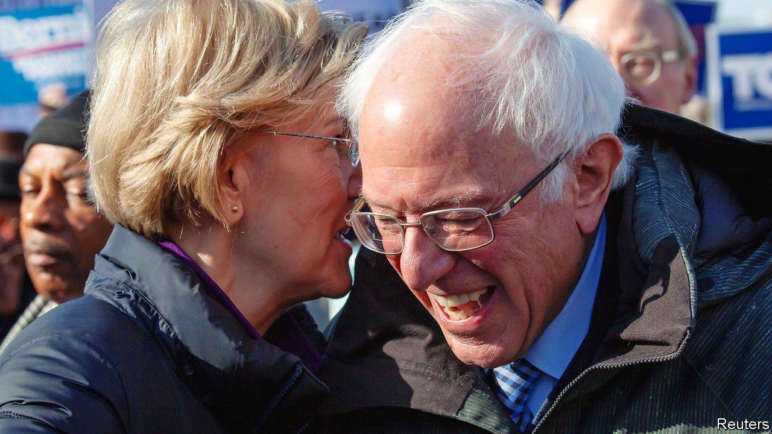

THE WEEK before Iowans caucus is inevitably frenetic. Candidates leave no hand unshaken and no corner of the state unvisited. Over bowls of (surprisingly delicious) Spam risotto, Kurt Meyer, the Democratic Party chairman of three rural counties in northern Iowa, needs two hands to count the candidates who have held events at his lovely riverside home, near the Minnesota border and precisely nothing else.

Six days before the caucus, in the county two west of Mr Meyer’s, a Bernie Sanders house party felt like a quiet church revival. The field organiser, referring frequently to “this movement”, asked the roughly 15 people attending to introduce themselves and tell the rest of the room what attracted them to Mr Sanders. More than half of them praised his “authenticity” and “consistency”. A truck driver preparing to caucus for the first time—like several others there—said that Mr Sanders “campaigns on the same principles every time…We can believe what he’s saying.”

Two days earlier in Cedar Rapids, a rally with Elizabeth Warren had the feel of a policy seminar delivered by an enthusiastic teacher to an engaged crowd. Organisers raffled off the right to ask questions. (They were deeply on-brand: “When we call your number, shout, ‘Persist!’, and we’ll get you a microphone.”) After a stump speech about her modest upbringing in Oklahoma, Ms Warren fielded questions about health care, energy policy and her viability, giving paragraph-length answers to each of them. Like Mr Sanders, she railed against “the most corrupt administration in history”. Unlike him, she also praised capitalism and free markets. For all the overlap between the two candidates, they differ markedly in their strengths, appeal, governing philosophies, bases of support and the implications of their success for the Democratic Party.

Last autumn, Ms Warren nearly overtook Joe Biden in national polls. But since releasing her “Medicare for All” plan, she has stumbled. Mr Sanders’s recent rise appears to have come at her expense. Still, they have a pragmatic detente. While Amy Klobuchar struggles to conceal her contempt for Pete Buttigieg, and Kamala Harris (now retired) kicked Mr Biden for opposing school busing, Mr Sanders and Ms Warren have consistently praised each other. They realise that if one falters, the other wants to pick up those voters with as little lingering bitterness as possible.

Although their voter pools overlap, they are not identical. Ms Warren does better among better-educated and older voters; Mr Sanders leads the Democratic pack among voters under 30, which explains his campaign’s focus in Iowa on first-time caucus-goers. Their support among black and white voters is roughly similar. Mr Sanders has a wide lead among Latinos, which augurs well for his chances in Nevada and the two biggest Super Tuesday prizes, California and Texas. Each is the top second choice for the other’s supporters, though there seem to be more Bernie-or-bust than Warren-or-bust voters.

That mirrors their relationship with the Democratic Party and politics more broadly. Ms Warren was an apolitical Republican before her work on bankruptcy pushed her leftward. She has since won two elections as a Democrat and worked closely with a Democratic administration to create a new federal agency, the Consumer Finance Protection Bureau.

Though Mr Sanders signed a pledge affirming that he is a Democrat in early 2019, just one day earlier he filed paperwork to run for Senate as an independent, which is how he has successfully contested all 11 of his federal elections. Though he aligns his positions with the Democrats’ progressive history, he calls himself a democratic socialist. That makes many in the party nervous. Although Republicans will call any Democratic nominee a “socialist”, only one—the guy who honeymooned in the Soviet Union, and who has boasted, in defiance of all electoral evidence, that Americans “would be delighted to pay more in taxes”—hangs the label on himself.

Asked how he plans to pass policies in a divided government, Mr Sanders often falls back on the rhetoric of revolution and movement-building, as though holding a few rallies in Kentucky—a state he is unlikely to win—will either force Mitch McConnell to negotiate or cause the scales to drop from his eyes. This may be partly a negotiating ploy. Ro Khanna, among his staunchest congressional supporters, insists that Mr Sanders “would take progress over the status quo”, but believes “we shouldn’t compromise with the process before it’s even begun”.

Yet exciting people with talk of revolution and then leading them into political gridlock risks creating a generation of disaffected voters. Ms Warren is also spoiling for a fight, as she rarely fails to mention, but she has a technocratic appeal that Mr Sanders lacks.

Her message and style seem to be more palatable to a broader swathe of Democrats. Barack Obama recently warned that America “is less revolutionary than it is interested in improvement…the average American doesn’t think that we have to completely tear down the system.” Mr Sanders and his supporters may disagree. But rousing those least likely to vote while alienating much of his own party—not to mention the independents and disaffected Republicans whom Democrats need to retake the White House—is a strategy with unparalleled downside risk.■

This article was downloaded by calibre from <https://www.economist.com/united-states/2020/02/01/assessing-elizabeth-warren-and-bernie-sanders-in-iowa>

|  |  |  |  |
| --- | --- | --- | --- |
| Previous | Articles | Sections | Next |

|  |  |  |  |
| --- | --- | --- | --- |
| Previous | Articles | Sections | Next |

#### Injunction dysfunction

# The Supreme Court votes to allow a green-card wealth test

The 5-4 decision could deny permanent legal status to immigrants deemed likely to need food stamps

Feb 1st 2020 | NEW YORK

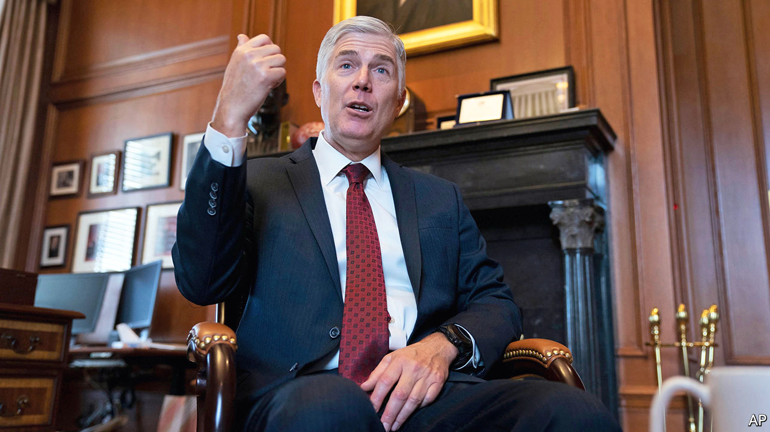

THE SUPREME COURT has often been a friendly forum for Donald Trump’s administration when its immigration policies have foundered in the lower courts. In 2018, the justices blessed the third iteration of Mr Trump’s ban on travel from predominantly Muslim countries. The next year they allowed the president to move forward with asylum restrictions and to divert federal money for a wall on the Mexican border. On January 27th the Supreme Court voted to permit a new wealth test for green-card applicants while litigation on the matter continues.

The latest decision, like two of the other three, split the justices 5-4. For 130 years the government could deny permanent legal status to immigrants at risk of becoming a “public charge”. But a rule that originally barred only a handful of destitute immigrants could, under the revision announced last August, rope out hundreds of thousands of immigrants. Those who are deemed likely to need food stamps, Medicaid or housing assistance over 12 of the next 36 months—after considering family size, English proficiency, credit score and income, among other factors—would be ineligible for a green card.

Before the Trump administration could implement the change on October 15th, it was blocked in a federal district court in New York. The move has “absolutely no support in the history of US immigration law”, Judge George Daniels wrote, and is “repugnant to the American dream”.

After an appeals court allowed Judge Daniels’s injunction to stand, the Trump administration asked the Supreme Court to step in. The court granted the request without comment. But Justice Neil Gorsuch, joined by Justice Clarence Thomas, expressed frustration with the phenomenon of district judges issuing injunctions that apply universally across the country.

In his four-page statement, Justice Gorsuch noted that two circuit courts had lifted similar injunctions against the revised wealth test and that an injunction in Illinois applied only to in-state green-card applicants. But Judge Daniels’s move, Justice Gorsuch complained, involved “a single judge” who “enjoined the government from applying the new definition to anyone”, anywhere, without regard to “participation in this or any other lawsuit”.

These injunctions “share the same basic flaw”, in Justice Gorsuch’s eyes, in that they dictate how the government must treat people “who are not parties to the case”. Judicial interventions that have an impact on everyone from coast to coast affected by a government programme are “patently unworkable” and sow chaos, Mr Trump’s first Supreme Court appointee argued. He also characterised them as “a sign of our impatient times”.

Howard Wasserman, a law professor at Florida International University, agrees with Justice Gorsuch’s reasoning but wonders why he chose this moment to attack universal injunctions. Justice Gorsuch probably would have opposed even a narrower injunction, Mr Wasserman reckons. Further, a more suitable case raising the question will be before the court in the spring. That case involves carve-outs to the contraception mandate in the Affordable Care Act, better known as Obamacare.

Mila Sohoni, a professor at the University of San Diego law school, speculates that Justice Gorsuch’s missive may be designed as a warning to judges “to be more cautious in issuing such broad injunctions” and an invitation to the Department of Justice to keep up its “aggressive” efforts against injunctive overreach.

But contrary to Justice Gorsuch’s claim that the use of broad injunctions “has proliferated only in very recent years”, Ms Sohoni’s forthcoming article in the Harvard Law Review traces the practice back to the 19th century. It is not “some late-blooming efflorescence of post-Warren Court judicial hubris”, she writes. There is a debate to be had regarding when universal injunctions are appropriate, says Amanda Frost, a law professor at American University, but it is “almost laughable” to argue that they are unconstitutional. Ms Frost says administrative law explicitly allows judges to invalidate regulations “as to everyone, not just the plaintiff”.■

This article was downloaded by calibre from <https://www.economist.com/united-states/2020/02/01/the-supreme-court-votes-to-allow-a-green-card-wealth-test>

|  |  |  |  |
| --- | --- | --- | --- |
| Previous | Articles | Sections | Next |

|  |  |  |  |
| --- | --- | --- | --- |
| Previous | Articles | Sections | Next |

#### Lexington

# Voting with their eyeballs

The biggest indictment of Donald Trump’s sham trial is that most Americans have ignored it

Feb 1st 2020 |

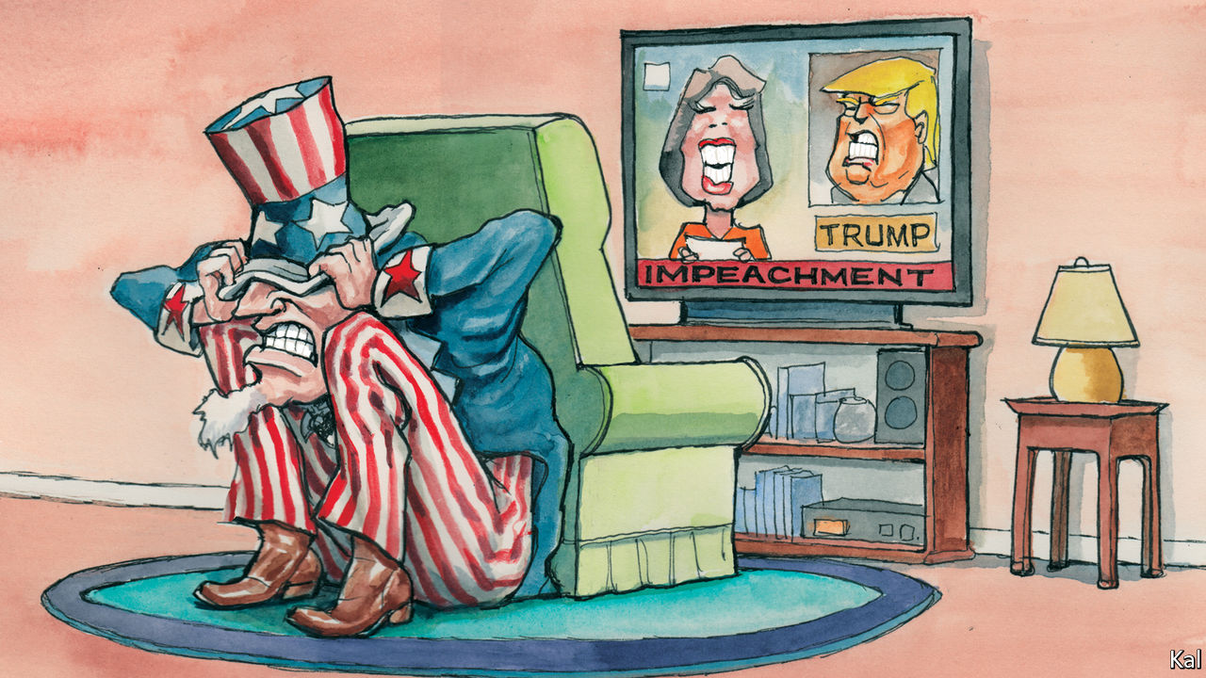

FOR METROPOLITAN trendsetters and the masses, the impeachment trial of Andrew Johnson was the great event of 1868. The Senate galleries were crammed for it, with “the most lovely as well as the most distinguished ladies of Washington...in daily attendance”, according to one record. Police officers meanwhile struggled to control the crowds that heaved outside the Capitol, “continually asking questions, making appeals and muttering threats”. Entering the Senate this week, by contrast, your columnist spotted a single, lonely protester wearing a sign that read: “Donald Trump is going to pee on you.”

Considering the passions that the president stirs, for and against, most Americans’ lack of interest in his trial may be its most remarkable feature. The public gallery has been half-empty for most of it. The few dozen anti-Trump protesters who have gathered outside the Senate are nothing to the hundreds who flocked to Justice Brett Kavanaugh’s confirmation hearing. The trial’s opening two days drew a modest prime-time TV audience of 7.5m. That is similar to the audience for Bill Clinton’s trial, once an increase in average viewership is factored in, though Mr Trump’s is taking place in a far more feverishly politicised environment. It is also more popular than Mr Clinton’s trial was. Only a minority of Americans thought Mr Clinton should have been impeached for lying about sex; a small majority think Mr Trump should be sacked for trying to extort personal favours from his Ukrainian counterpart.

Even Republican senators who denounce Mr Trump’s impeachment as a “political sham”, in the phrase of James Inhofe of Oklahoma, seem slightly piqued by the public’s disregard. Quizzed on the thin showing in the gallery, the Oklahoman hyper-partisan told one newspaper he was “really surprised…because this is kind of historic”. He shouldn’t have been. The reason most Americans find Mr Trump’s trial tedious is because they know how it will end: with the president, though guilty—as even some Republicans acknowledge in private—nonetheless acquitted by them.

A last-ditch wrangle—as this column went to press—over whether Mitch McConnell might allow testimony from John Bolton, a former national security adviser, would make that scarcely less likely. It raises no prospect of the requisite 20 Republicans joining the Democrats in a vote to remove Mr Trump. Immaterial to the outcome, the kerfuffle is therefore mainly indicative of the extent to which the Republican Senate leader has otherwise controlled the trial and so predetermined its outcome.

Mr McConnell claims to have modelled it on Mr Clinton’s trial, which relied almost exclusively on evidence sent up by the House of Representatives. Yet the circumstances of the two trials are quite different. The evidence against Mr Clinton was gathered during a nine-month-long criminal probe, backed by a grand jury, which allowed its investigators to secure the testimonies of nearly a hundred witnesses, thousands of documents, and a sample of the president’s blood. The evidence against Mr Trump consists of an edited White House transcript of a phone call between him and Volodymyr Zelensky, testimonies from the handful of mostly mid-level officials who were prepared to defy the administration’s non-co-operation order, and the president’s Twitter account.

Additional evidence against Mr Trump is available—including a leaked account by Mr Bolton, first reported by the New York Times, which appears to demolish the president’s defence. But, as Mr Trump’s lawyers noted this week, it is inadmissible. Testimony from the former national security adviser, a plain-speaker with a grudge against Mr Trump and a book to sell, would be more informative—and probably fraught for some, such as Vice-President Mike Pence, allegedly complicit in Mr Trump’s ruse. Yet a single explosive testimony would probably leave little mark on Mr McConnell’s whitewash. The fact that a few moderate Republicans may demand to hear from Mr Bolton should be understood in that context. Were they also to request testimony from Mr Pence, half a dozen other cabinet members and, naturally, the president, it would look like a serious bid to uncover the truth and confront their voters with it. Inviting only Mr Bolton, on the legally irrelevant basis that he is willing to testify, would look like virtue-signalling to the independent voters they fear to alienate.

It is of course no mystery why that is as much as they may be willing to contemplate. To stand against the president is suicidal in the Trump cult their party has become. Mr Bolton, a feared baby-eating bogey of the left for over three decades, has already been denounced on Fox News, his former employer, as a “tool for the left”. It should also be acknowledged, as is so often the case, that while Republicans may be setting new records for shamelessness, the Democrats are not blameless either.

Chuck Schumer is also trying to extract political benefit from the trial, by trying to force Republicans up for re-election this year to make embarrassing defences of the president. Having largely achieved this, some suspect, he may be quietly willing to bring the trial to its inevitable conclusion rather than risk damage to his party by prolonging it. In that case, neither party would be committed to its oath to try the president and hold him to account.

## Running down the Capitol

No wonder Americans seem disengaged from the Senate trial. Indeed, though you would not know it from the polished grandeur of its atriums, or the lofty bonhomie with which its members, of both parties, still hail each other there, the Senate is an institution hurtling towards irrelevance. Its tradition of debate is long dead. Under Mr McConnell, it barely passes bills; this Congress could be the most unproductive in half a century. And meanwhile the populist furies that propelled Mr Trump, and which he has done so much to exacerbate, are not dissipating. Dissatisfaction with democracy was reported this week to have increased by a third in America since the 1990s. It will have gathered more steam last month.■

This article was downloaded by calibre from <https://www.economist.com/united-states/2020/02/01/voting-with-their-eyeballs>

|  |  |  |  |
| --- | --- | --- | --- |
| Previous | Articles | Sections | Next |

|  |  |  |
| --- | --- | --- |
| United States | Sections | Asia |

The Americas

Poverty in Brazil: Left behind

.

Bello: Peru and the difficulty of reform

.

Incan culture: Knotty tale

.

|  |  |  |
| --- | --- | --- |
| United States | Sections | Asia |

|  |  |  |  |
| --- | --- | --- | --- |
|  | Articles | Sections | Next |

#### Left behind

# Bolsa Família, Brazil’s admired anti-poverty programme, is flailing

Economic recovery is not yet helping the poor

Feb 1st 2020 | BELÁGUA, MARANHÃO

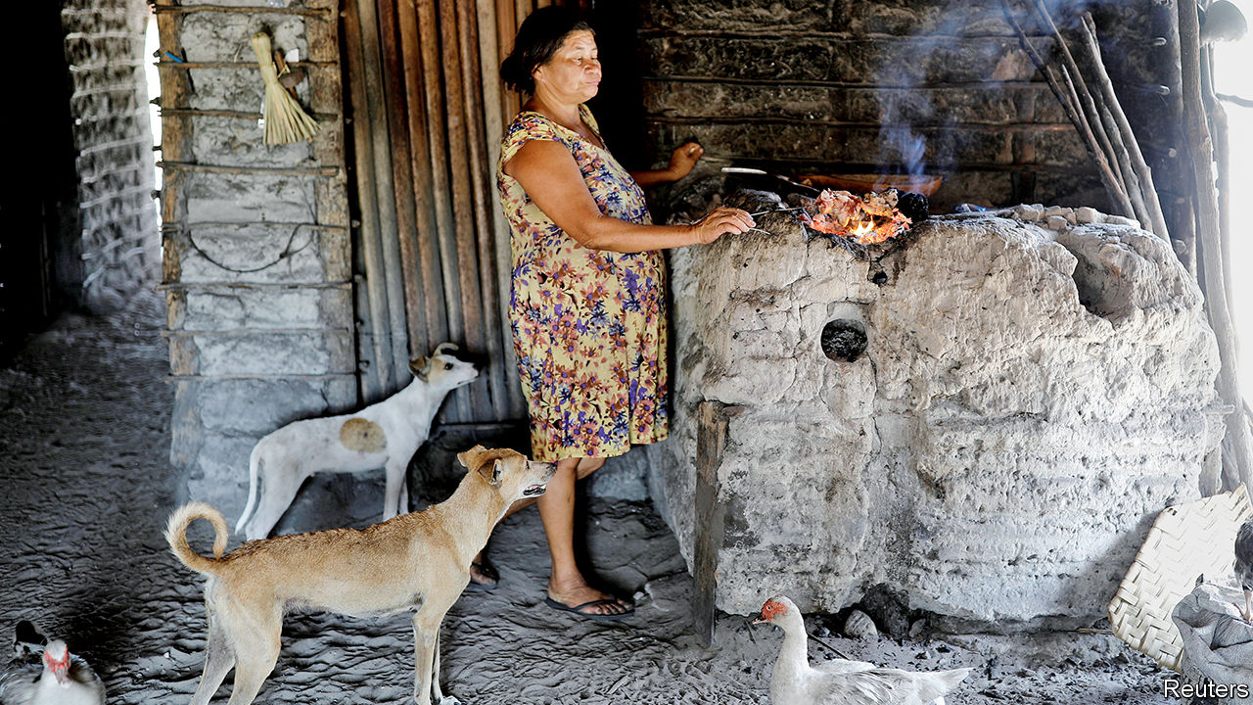

LAST YEAR Natália Ribeiro sent her five-year-old daughter to live with relatives because she could not afford to feed her. She had tried to sign up for Bolsa Família (Family Fund), a conditional cash-transfer programme that supports millions of poor Brazilians. That includes 80% of families in Belágua, a town of 7,000 people in Maranhão, the poorest state. Ms Ribeiro should have been a shoo-in. She has no income. Her three children get regular health check-ups and will go to school, she promises. That is a precondition for receiving the monthly benefits, which start at 89 reais ($21). She has been waiting since May. “I want a better life for my little ones,” says the 24-year-old, who has long eyelashes like the baby in her lap and the toddler playing with a piece of wood on the floor.

In June last year Brazil’s populist government, which had taken office five months before, slowed the acceptance of new beneficiaries and started cancelling payments to existing ones. The number of families admitted to Bolsa Família has dropped from 275,000 a month to fewer than 2,500. The number receiving benefits has fallen by 1m. The government says that 700,000 are on the waiting list, which may be an underestimate.

To critics of Jair Bolsonaro, Brazil’s president, this is evidence of his indifference to poverty. Mr Bolsonaro once called Bolsa Família beneficiaries “ignorant wretches”. As a candidate he tried to reassure them by promising 13 “monthly” payments in 2019 (copying the Brazilian tradition whereby formal workers get an extra month’s pay at Christmas). His government did not budget for that extra payment, however, so it has had to cut the number of beneficiaries.

The economy minister, Paulo Guedes, vows to fight poverty in a different way from earlier, left-wing administrations. While trimming Bolsa Família, the government is making much bigger cuts to spending that benefits prosperous Brazilians. Smaller deficits and less debt will encourage economic growth by holding down interest rates. That will create jobs, which are better than handouts, Mr Guedes argues.

But the government’s treatment of its flagship safety-net programme raises doubts. Growth alone is unlikely to banish poverty. Nor will it reduce inequality, which has been stratospheric for over a century. In 2018 the average income of the richest 1% of Brazilians was 33.8 times that of the poorest 50%, a ratio surpassed only in Qatar. The Gini coefficient, another measure of inequality, was 0.53 in 2017, on a scale where zero is perfect equality and 1 means that one person has all the income. Among large democracies, only South Africa does worse.

It does not have to be this way. Brazil has a big state. Taxes are a third of GDP, about the average for a rich country (which Brazil is not) and far above the Latin American average of 23%. The state’s hefty resources could be used to lift up the poor. Public pensions, welfare payments and other transfers are a whopping 23% of Brazil’s GDP, even higher than in most rich countries. But unlike in Europe, where taxes and transfers greatly reduce inequality, in Brazil they are “hardly redistributive”, says Mansueto Almeida, the treasury secretary. According to data compiled by the University of Pernambuco, in 2015 taxes and transfers reduced the average Gini coefficient in OECD countries from 0.47 to 0.31. In Brazil they cut inequality by only half as much.

The reason is that handouts are skewed towards the well-off. More than four-fifths of Brazilian transfers are pension benefits, compared with half in the European Union. Public pensions in Brazil are extremely regressive: just 2.5% of the cash goes to the poorest quintile, while the richest gets more than half. That group also benefits from tax loopholes not available to the poor. Servants of the state, who earn more than private-sector workers with similar qualifications, are especially cosseted. Last year a congressman billed taxpayers 157,000 reais for cosmetic dentistry. Some judges earn more in a month than those in rich countries make in a year.

Bolsa Família, by contrast, goes directly to the poor. Under Luiz Inácio Lula da Silva, a left-wing president from 2003 to 2010, it grew into the world’s largest conditional cash-transfer programme. The benefits are paid mostly to women via a chip card. More than 30m Brazilians escaped poverty between 2003 and 2014, thanks to Bolsa Família, other pro-poor policies and a commodity boom. In Belágua, most people now eat two meals a day instead of one. Houses are made of cinder-block, not banana leaves. “You don’t see kids working in the fields anymore,” says Zé Raimundo Santos, the president of the agricultural co-operative.

Bolsa Família was especially important in rural towns like Belágua, where money had barely circulated, says Maria Ozanira da Silva e Silva of the Federal University of Maranhão. Women could buy food on credit in Belágua’s first shops. Children spent more time in school and less time sick at home. Programmes such as Minha Casa, Minha Vida (My House, My Life) subsidised the construction of 4m houses, including Ms Ribeiro’s. In the election in 2018 all but 295 voters in Belágua voted for the presidential candidate of Lula’s Workers’ Party.

But Belágua remains poor. Though its name means “beautiful water”, the road from São Luís, Maranhão’s capital, is often too muddy in the rainy season and too sandy in the dry season for ordinary cars to pass. The local government is the only employer. Some households split one job paying the minimum wage of 1,039 reais a month four ways. Most families earn a pittance grinding cassava into tapioca flour. The work is gruelling. Mr Santos looks 70 but is 50.

When Brazil’s worst-ever recession began in 2014, progress stopped and in some areas went into reverse. GDP per Brazilian dropped by 10% from 2014 to 2016. The number of unemployed nearly doubled to 14.2m, 13.7% of the workforce, from 2014 to 2017. Although the economy is recovering, 11% of the labour force remains unemployed. At the end of 2018 the number of people living on less than $1.25 a day reached 8.2m, the highest since 2007 (see chart).

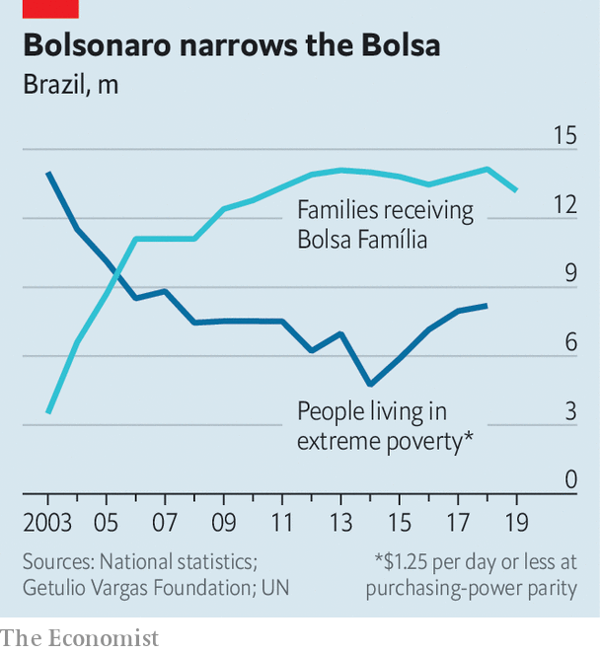

Mr Bolsonaro is dismantling what Mr Guedes calls the “machine of perverse income transfers” by reforming pensions. Minimum retirement ages (of 65 for men and 62 for women) and other measures will save the government 855bn reais over ten years. Thanks to low inflation and a fall in interest rates the government will pay 100bn reais, 1.3% of GDP, less to creditors in 2020 than it did last year, says Mr Guedes. The economy grew by 0.6% between the second and third quarters of 2019, and the number of unemployed people fell below 12m for the first time since the second quarter of 2016. Mr Guedes takes this as proof that pro-growth austerity is working.

But the government has let police and army officers keep their lavish pensions. It has not touched tax breaks for privileged industries and the rich, worth 4% of GDP each year. Instead it has picked on Bolsa Família, which in 2020 will cost just 0.4% of GDP. Unlike most government spending (including salaries and the health and education budgets) it is not automatically adjusted for inflation. Since 2014, the average benefit has fallen in real terms.

In Belágua The Economist spoke to half a dozen families that have spent at least six months on the waiting list or have lost benefits. They include a family of nine; a 20-year-old mother and her underweight newborn; and three adolescents who dropped out of school because they could not afford uniforms.

In December the government suggested that it would increase Bolsa Família’s budget by 16bn reais and rename the programme “Renda Brasil” (Brazil Income). But the economy ministry balked at the cost. Perhaps the government could spare 4bn reais, it said. Under a new budget rule, any increase in spending has to be matched by a cut somewhere else.

The Bolsa Família squeeze is the most important contributor to the recent increase in inequality, according to a study by economists at Fundação Getulio Vargas, a university in São Paulo. “We pulled away the safety net when it was needed most,” says Marcelo Neri, the study’s lead author.

The government could save 9% of GDP by cutting wasteful spending further, eliminating tax breaks and narrowing the gap between public- and private-sector pay, says Arminio Fraga, a former central bank governor. It could spend that money to reduce the fiscal deficit, boost spending on infrastructure, health, education and Bolsa Família, and cut the tax burden. So there is ample room to make public spending both more progressive and more effective.

But Mr Bolsonaro seems unserious about some things that might help the poor. He dropped plans for a childhood literacy programme and recently named a sceptic of evolution to regulate universities. If the economic recovery doesn’t reach poor Brazilians quickly, they could stage mass protests, as people have in other Latin American countries, warns Flávio Dino, the left-wing governor of Maranhão.

Maria marched only as far as the welfare office in São Luís, which told her in December that her monthly Bolsa Família benefit of 360 reais had been cancelled. A computer failed to register that she and her seven children had moved in June to a new town to escape her violent boyfriend. She has been waiting for months for the government to fix the mistake. “Bolsa Família is the father of my children,” she used to say. The joke does not make her smile now. ■

This article was downloaded by calibre from <https://www.economist.com/the-americas/2020/02/01/bolsa-familia-brazils-admired-anti-poverty-programme-is-flailing>

|  |  |  |  |
| --- | --- | --- | --- |
|  | Articles | Sections | Next |

|  |  |  |  |
| --- | --- | --- | --- |
| Previous | Articles | Sections | Next |

#### Bello

# The difficulty of reforming Peru

An election vindicates but doesn’t strengthen Martín Vizcarra

Feb 1st 2020 |

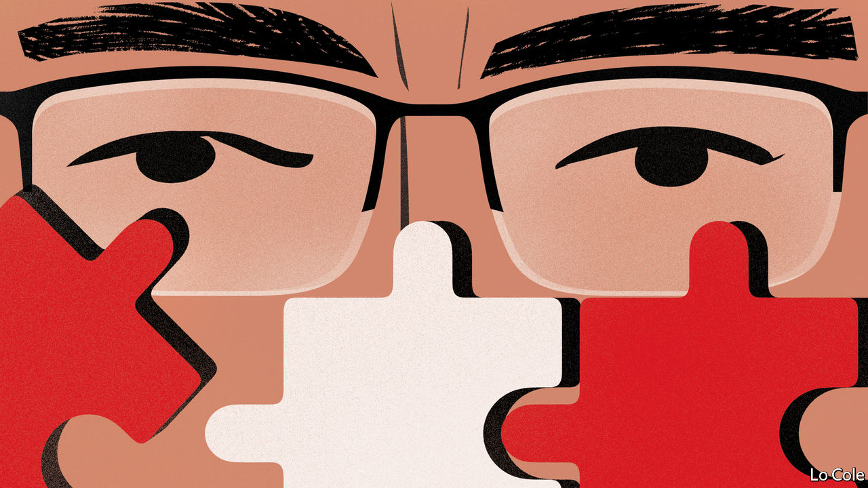

IT WAS THE most popular thing any Peruvian president has done in a long time. Facing a serially obstructive congress widely seen as defending corrupt interests, in September Martín Vizcarra decreed its dissolution. This was constitutionally questionable and set a worrying precedent. But in political terms, the outcome of an election held on January 26th to replace the dissolved congress vindicated Mr Vizcarra. It also highlighted the weaknesses of Peru’s political system, and has not made his project of institutional reform any easier.

Mr Vizcarra, who was elected as vice-president in 2016, took over the top job almost two years ago when Pedro Pablo Kuczynski resigned over conflicts of interest. He inherited a battle with congress, dominated by the opposition led by Keiko Fujimori, the daughter of a former president. When leaked phone calls revealed apparent collusion among some judges and opposition lawmakers, Mr Vizcarra successfully appealed for public support in a referendum on reforms of the judiciary and politics.

That gave him the initiative, but only for a while. To break the deadlock Mr Vizcarra proposed calling an early general election. Ignoring this, the fujimoristas went ahead with a rushed vote to appoint new justices to the constitutional tribunal. The president claimed that this amounted to a (second) denial of confidence in his government. Under Peru’s semi-parliamentary constitution, that is grounds for the dissolution of congress. In January the tribunal upheld by four votes to three the constitutionality of the president’s action.

The voters inflicted a crushing defeat on the fujimoristas, who slumped from 36% of the parliamentary vote in 2016 to 7%. Two smaller allied parties failed to enter the new congress. That is the extent of the good news for Mr Vizcarra. The election marked an exacerbation of Peru’s political fragmentation. Nine parties obtained the minimum 5% of the vote required to win seats in the legislature but none got much more than 10%.

On paper, centrist parties will be the largest contingent, though the right is also strong. Two newcomers offer some cause for disquiet. The Agrarian Front, a party linked to a millenarian Old Testament cult, won at least 15 of the 130 seats. And 17 were taken by the party of Antauro Humala, a proto-fascist former army officer (and brother of a past president) serving a 19-year jail sentence for an assault on a police station in 2005 in which six people died.

Their success is, in different ways, a protest against the Lima political establishment. Neighbouring countries have seen sometimes violent street protests in recent months. In Peru, the dissolution of congress and the jailing of several former presidents over accusations of corruption (none of which has yet been proved) have taken some of the sting out of popular anger. On January 28th a judge remanded Ms Fujimori for a second time over accusations of irregularities in campaign finance in 2011.

Perhaps, too, the flexible nature of Peru’s political culture provides resilience. But it might make reform harder. After the recent confrontations both public opinion and many politicians favour co-operation. But Mr Vizcarra has only a year or so to complete the task of institutional reform he set himself before the general election in April 2021.

The government has already set up a new body, picked on merit, to oversee judicial appointments. Several measures approved by the outgoing congress are aimed at cleaning up, and solidifying, political parties. Some are useful. They include tightening up rules on campaign finance, steps to cut the cost of politics and, from 2021, the shutting down of parties that fail to cross the 5% threshold. Pending are a tighter definition of parliamentary immunity and, perhaps, the addition of a senate to Peru’s small single-chamber legislature.

The election offers few pointers to the 2021 presidential contest. “Everyone is weak and anything can happen,” says Alberto Vergara, a political scientist. By championing the fight against corruption, Mr Vizcarra has achieved the rare feat for a Peruvian president of remaining popular. Now more may be needed. The government is trying to improve health care and rural roads but is dogged by union pressures to raise public-sector salaries and business opposition to higher taxes (which raise revenue of just 14% of GDP). A new political system may yet emerge. But if Peru is to continue to enjoy economic growth and to avoid a Chilean-style social explosion it also needs a stronger and more effective state.

This article was downloaded by calibre from <https://www.economist.com/the-americas/2020/02/01/the-difficulty-of-reforming-peru>

|  |  |  |  |
| --- | --- | --- | --- |
| Previous | Articles | Sections | Next |

|  |  |  |  |
| --- | --- | --- | --- |
| Previous | Articles | Sections | Next |

#### Knotty tale

# The mystery of quipus—Incan knot records

In a small Peruvian town, the Incas’ method of record keeping survives

Feb 1st 2020 | LIMA

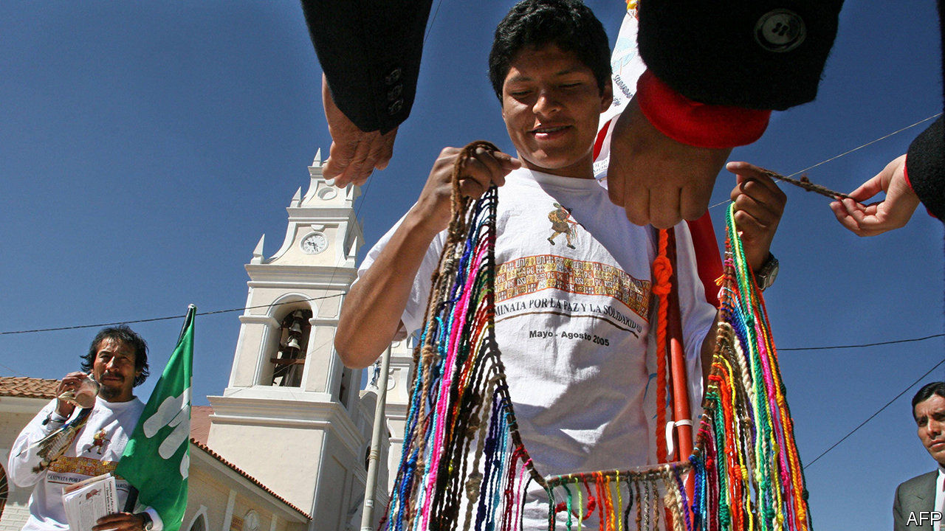

SAN ANDRéS DE TUPICOCHA starts every year by swearing in new leaders, like many small towns in Peru. Instead of giving the office-holders a sash or medal it gives them a quipu, a coloured skein of knotted cords.

Quipus, or khipu, which means knots or talking knots in Quechua, were used to administer the vast empire of the Incas, which lasted for about a century until 1533. No one alive knows just how. San Andrés, in the highlands near Lima, is the last place in Peru where quipus have an official role, and that is ceremonial. “They represent who we are,” says Tito Rojas, president of one of the town’s ten communities. In December Peru’s government declared its ritual of bestowing them on community leaders like Mr Rojas to be part of the country’s cultural heritage.

The town’s quipus are thought to date from after Peru’s independence from Spain in 1821. They were used until the mid-20th century to record attendance at meetings, says Roy Vilcayauri, a former mayor. But the last person who could read that set died in 1990.

Scholars have been trying to puzzle out what messages are encoded in the knotted tally cords, which are usually made from dyed alpaca wool (they can also contain fibres from llamas, vicuñas and cotton). The type of knot, their number and their spacing conveyed numerical information. The placing of principal and subsidiary cords could show family or tribal relationships.

Quipus’ main use was as a management tool, says Gary Urton, who set up the Khipu Database Project at Harvard University. From the Incan capital in Cusco to the empire’s outer reaches in present-day Argentina, Ecuador and Colombia, quipus helped officials keep track of tax collection, command armies and maintain census records. The Incas had no written language. Quipus are the only documentary record of their life that does not come from Spanish chroniclers. Mr Urton has recorded the characteristics of more than 1,000 quipus in digital form and spent 30 years trying to understand them.

Nowadays the largest collection of quipus, around 350, is in Berlin’s Ethnological Museum. Some 500 others are in Peru and Chile. To see quipus perform any function beyond serving as objects of study or curiosity, you will have to spend a new year in San Andrés de Tupicocha.■

This article was downloaded by calibre from <https://www.economist.com/the-americas/2020/02/01/the-mystery-of-quipus-incan-knot-records>

|  |  |  |  |
| --- | --- | --- | --- |
| Previous | Articles | Sections | Next |

|  |  |  |
| --- | --- | --- |
| The Americas | Sections | China |

Asia

South-East Asia’s special economic zones: Viva Laos Vegas

.

Thai boxing: Muay too young

.

North-eastern India: Bodos and don’ts

.

Civil liberties in Pakistan: Arresting the messenger

.

Banyan: No crater love

.

|  |  |  |
| --- | --- | --- |
| The Americas | Sections | China |

|  |  |  |  |
| --- | --- | --- | --- |
|  | Articles | Sections | Next |

#### Viva Laos Vegas

# South-East Asia is sprouting Chinese enclaves

“Special economic zones” bring lots of Chinese investment and workers, but little benefit

Feb 1st 2020 | GOLDEN TRIANGLE SPECIAL ECONOMIC ZONE

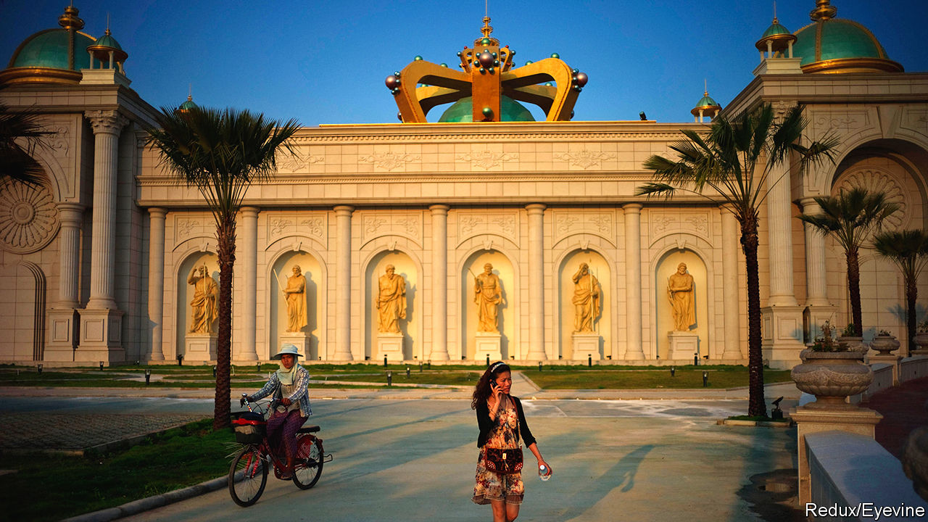

IN A REMOTE part of northern Laos, the bamboo forest gives way to cranes. A city is being carved out of jungle: tower blocks cloaked in scaffolding loom over restaurants, karaoke bars and massage parlours. The beating heart of Golden Triangle Special Economic Zone (so called because it sits at the point where Laos, Myanmar and Thailand converge) is the casino, a palatial confection featuring faux-Roman statuary and ceilings covered in frescoes. “Laos Vegas” does not cater to Laotians, however. Croupiers accept only Chinese yuan or Thai baht. Street signs are in Chinese and English. The city’s clocks are set to Chinese time, an hour ahead of the rest of Laos.

Over the past decade, China has become one of the biggest investors in South-East Asian countries: in 2018 it was the source of nearly 80% of foreign direct investment in Laos. Some of this capital is flowing along well-worn routes to places like Mandalay, a city in Myanmar where there is a long-established Chinese community. But much of it is flooding into “special economic zones” (SEZs) to take advantage of assorted incentives such as faster permitting, reduced tax or duties and looser controls on the movements of goods and capital.

Chinese businesses don’t need much convincing. The Chinese government began encouraging them to invest abroad in the 2000s. The Belt and Road Initiative, China’s giant scheme to develop infrastructure abroad, has accelerated the trend. In addition to railways, highways and pipelines, it promotes SEZs, which “are now a preferred mode of economic expansion for China”, says Brian Eyler of the Stimson Centre, an American think-tank. Under the banner of belt and road, 160 Chinese companies have poured more than $1.5bn into SEZs in Laos, according to Land Watch Thai, a watchdog. Between 2016 and 2018 China invested $1bn in one SEZ alone: Sihanoukville, a city on Cambodia’s coast.

Where Chinese capital goes, labour follows. In Mandalay the Chinese have swelled from 1% of the population in 1983 to 30%-50% today. In places with SEZs the shift has been even sharper. In 2019 the governor of the surrounding province told the Straits Times newspaper that the number of Chinese in Sihanoukville had soared over the previous two years to almost a third of the population. The economic clout of Chinese migrants grows with their numbers. In Mandalay 80% of hotels, more than 70% of restaurants and 45% of jewellery shops are owned and operated by ethnic Chinese, according to market research conducted in 2017.

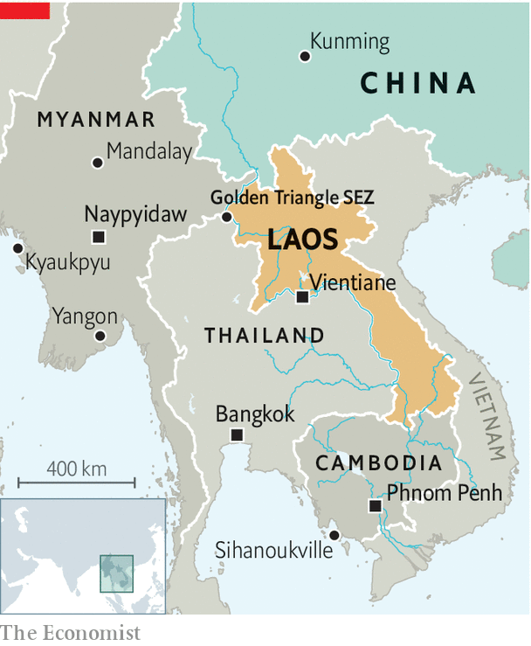

The influx of migrants has fuelled anti-Chinese sentiment across the region. But poor South-East Asian governments court Chinese investors anyway because they hope Chinese money will kick-start their economies. In some respects the investment has borne fruit. In Laos foreign investment has contributed to effervescent GDP growth, which averaged 7.7% a year over the past decade.

But in a study of SEZs in 2017 Focus on the Global South, a think-tank headquartered in Bangkok, concluded that the “legislative and governance structures” underpinning SEZs in Cambodia and Myanmar “have been skewed toward the interests of investors and against those of locals and the environment”. Alfredo Perdiguero of the Asian Development Bank agrees that SEZs in Laos, Cambodia and Myanmar “have not yet been able to spread the benefits” to the broader economy.

In part this is because Chinese companies tend not to hire locals. By 2018 Laotian workers had secured just 34% of the jobs created by all 11 SEZs in Laos—a far cry from the 90% the government had promised. Chinese firms argue that local workers lack skills, but civil society groups in Myanmar respond by pointing to a technical college near Kyaukpyu, a Chinese-inspired SEZ and port; nobody from the college has been hired to work there, according to a report published last year.

There is little local sourcing of other inputs, either. The garment factories of Sihanoukville SEZ, for instance, import their cloth, buttons and thread. The Chinese workers and visitors in South-East Asia’s SEZs often patronise Chinese-owned shops and restaurants, and circumvent sales taxes by paying for goods and services via Chinese apps like Alipay. “The money doesn’t even leave China essentially,” says Sebastian Strangio, author of a forthcoming book on China’s growing influence in South-East Asia. That, along with the tax breaks, mean there is little benefit for host governments: in 2017 the Laotian exchequer raised just $20m from its SEZs—less than 1% of its revenue.

## Extraterritorial and unreasonable

As is common with big developments in the poorer countries of South-East Asia, locals are seldom consulted about the construction of SEZs. Golden Triangle SEZ was built over the rice paddies of Ban Kwan village; over 100 households were forced to relocate against their will. And then there is the question of law enforcement within the SEZs, whose light regulation can be as attractive to criminals as to legitimate businesses. In 2018 American authorities declared that the Golden Triangle SEZ was a hotbed of “drug trafficking, human trafficking, money laundering, bribery and wildlife trafficking”. They called the company that operates the SEZ a “transnational criminal organisation” and placed sanctions on its chairman, Zhao Wei. He denied the accusations, calling the move “unilateral, extraterritorial, unreasonable and hegemonic”. Many South-East Asians might say something similar about the way the region’s SEZs are run. ■

This article was downloaded by calibre from <https://www.economist.com/asia/2020/02/01/south-east-asia-is-sprouting-chinese-enclaves>

|  |  |  |  |
| --- | --- | --- | --- |
|  | Articles | Sections | Next |

|  |  |  |  |
| --- | --- | --- | --- |
| Previous | Articles | Sections | Next |

#### Muay too young

# Despite a tragedy, children continue to compete in Thai boxing bouts

And tourists are still watching eagerly

Feb 1st 2020 |



THE DEATH of Anucha Thasako was supposed to change everything. After several sharp blows to the head during a Thai boxing bout in 2018, the scrawny 13-year-old fell to the floor, unconscious. The referee rushed to his side, to no avail. There was no doctor in attendance. Anucha died soon afterwards from a brain haemorrhage. He had been boxing since the age of eight, and had taken part in around 170 fights.

The footage of the deadly bout, which circulated widely on social media, stirred uproar. The government, which had anyway been considering restrictions on child boxing, pledged to rush through a bill to ban children under 12 from participating in formal competitions and to oblige those between 12 and 15 to wear protective headgear. But the plan quickly lost steam.

Participants and fans protested loudly, arguing that the only way to prepare for a career in Thai boxing or muay thai, which dates to at least the 18th century, is to start young. Eliminate child boxing, they argued, and the whole sport would atrophy. The government no longer talks of tightening the rules for young boxers. Gongsak Yodmani, the head of the Sports Authority of Thailand, describes child boxing as standard practice. The authority’s official tally shows only 635 boxers below the age of 15, although others put the number of children who train and compete informally as high as 100,000.

For some children, boxing is a route out of poverty. Those participating in public fights earn 300-500 baht ($10-16) a bout when they are starting out, says Samart Payakaroon of the Muay Thai Naiyhanomtom Association, a lobby group. Professional boxers can earn thousands of dollars a match. Muay thai “is a very honourable way to escape poverty”, says Chatri Sityodtong, the founder of One Championship, a martial-arts promoter.

But doctors say that blows to the head from “the art of eight limbs”, which involves punching, kicking, kneeing and elbowing, may stunt children’s development and increase the risk of Parkinson’s and Alzheimer’s. A study from Mahidol University found that boxers under the age of 15 had lower IQs than average; those who had been fighting the longest were furthest behind. The study’s lead author, Jiraporn Laothamatas, considers putting children in the ring a form of child abuse.

One force helping sustain the sport, underage bouts included, is tourism. The Tourism Authority of Thailand energetically promotes muay thai. Foreigners tend to snap up the most expensive seats in the biggest stadiums, looking for a slice of Thai life. Many may not realise how young some of the fighters they are watching are—although the weight categories should give them an inkling. Anucha was competing in the under-41kg division. ■

This article was downloaded by calibre from <https://www.economist.com/asia/2020/02/01/despite-a-tragedy-children-continue-to-compete-in-thai-boxing-bouts>

|  |  |  |  |
| --- | --- | --- | --- |
| Previous | Articles | Sections | Next |

|  |  |  |  |
| --- | --- | --- | --- |
| Previous | Articles | Sections | Next |

#### Bodos and don’ts

# A restive corner of India is becoming more peaceful

But for every group that is placated there are new malcontents

Feb 1st 2020 | DELHI

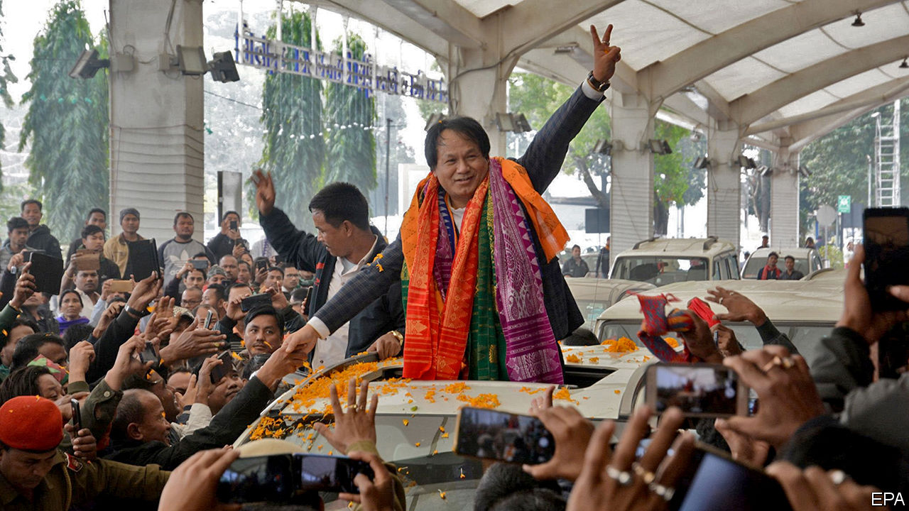

HOW TO DIVIDE India into administrative units is a question that has vexed all its governments. For a time the main focus was to rationalise, as hundreds of feudal “princely” states were swept into the bigger provinces of the Indian republic. But since 1960 the number of states and territories has been rising, as different groups have successfully lobbied for their own unit, on the basis of language, ethnicity or administrative convenience. There were 20 in 1956; now there are 36.

Few areas have seen as much upheaval as the north-east, an ethnically mixed region of 50m people that was almost cut off from the rest of the country by the creation of East Pakistan (now Bangladesh) in 1947. It began as a single state, Assam, plus two principalities, Manipur and Tripura. It has since splintered into seven states, as Arunachal Pradesh, Meghalaya, Mizoram and Nagaland have been hived off Assam (see map). The region is still replete with disgruntled factions, however: it has spawned more than 125 insurgencies since the 1950s. Their varied struggles for statehood, independence or simply to clobber rival groups—many of these micro-conflicts have pitted “natives” against migrants—have left perhaps 40,000 dead.

Only recently have years of patient carrot-and-stick efforts by the central government, helped by better intelligence, tougher military tactics and stronger co-operation from neighbouring Bangladesh and Myanmar, begun to pay off. Casualties have declined steeply, from a high of almost 1,700 deaths in 2000 to just 17 last year. That has allowed the government to exempt some states from a controversial law that protects soldiers from prosecution for human-rights offences, and prompted the army to begin shifting resources away from internal security.

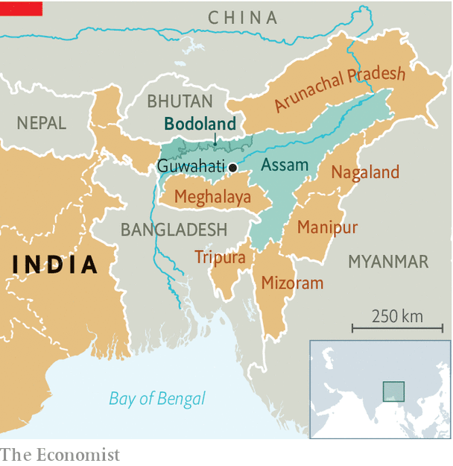

Underpinning all this has been a series of peace agreements with assorted rebel groups. Ongoing talks with insurgents in Nagaland have made significant progress, with at least one of the state’s main guerrilla factions agreeing to lay down arms. In Assam some 644 fighters from various groups recently surrendered their guns. And in January alone Mr Modi’s government inked two important deals. One, in Tripura, allows for the resettlement in the state of some 34,000 ethnic Bru refugees from neighbouring Mizoram. This should end a 23-year stand-off, as the destitute Brus had rejected efforts to send them back to areas from which they had been violently expelled.

Of bigger import is a deal signed on January 27th with several factions of the National Democratic Front of Bodoland. For Bodos, who speak a language related to Tibetan and Burmese and who number some 1.3m, the terms look generous. In exchange for some 1,500 rebels laying down arms, the Bodos will get a sweeping amnesty, an extra $225m in government funding, more schools, colleges and sports facilities, and a much fuller form of autonomy within their homeland in the western part of Assam, along India’s border with Bhutan. What is more, the boundaries of Bodoland will be redrawn, village by village, to ensure Bodos form a majority within it.

The deal is also good for Mr Modi. Government sources reckon the Bodo insurgency has left some 4,000 dead since 1987, including 88 killed in a series of bomb blasts in the state capital, Guwahati, in 2008. The violence also rendered tens of thousands of non-Bodos homeless as waves of refugees fled repeated massacres that targeted Bengali-speaking Muslim farmers in the floodplains of the Brahmaputra River and rival tribal groups in the hills. Aside from putting a stop to such mayhem, the deal will almost certainly prompt a large vote swing among the small but influential Bodo community towards Mr Modi’s Bharatiya Janata Party (BJP). Its hold in Assam has weakened in recent months due to protests against a controversial new citizenship law. With state elections looming in 2021, the BJP is resorting to “vote-bank” politics.

Of course, the Bodoland deal is clearly not so good for non-Bodos who, despite the insurgents’ efforts at ethnic cleansing, constitute up to two-thirds of the population of the Bodoland region as currently defined. Naba Kumar Sarania, who represents the region in the national parliament, told the Hindu newspaper: “We are not against the peace process, but this accord has ignored the interests of the other ethnic communities in the area.” ■

This article was downloaded by calibre from <https://www.economist.com/asia/2020/02/01/a-restive-corner-of-india-is-becoming-more-peaceful>

|  |  |  |  |
| --- | --- | --- | --- |
| Previous | Articles | Sections | Next |

|  |  |  |  |
| --- | --- | --- | --- |
| Previous | Articles | Sections | Next |

#### Arresting the messenger

# A prominent critic of Pakistan’s army is hauled into court

Meanwhile, the abuses he complained about have gone unpunished

Feb 1st 2020 | ISLAMABAD

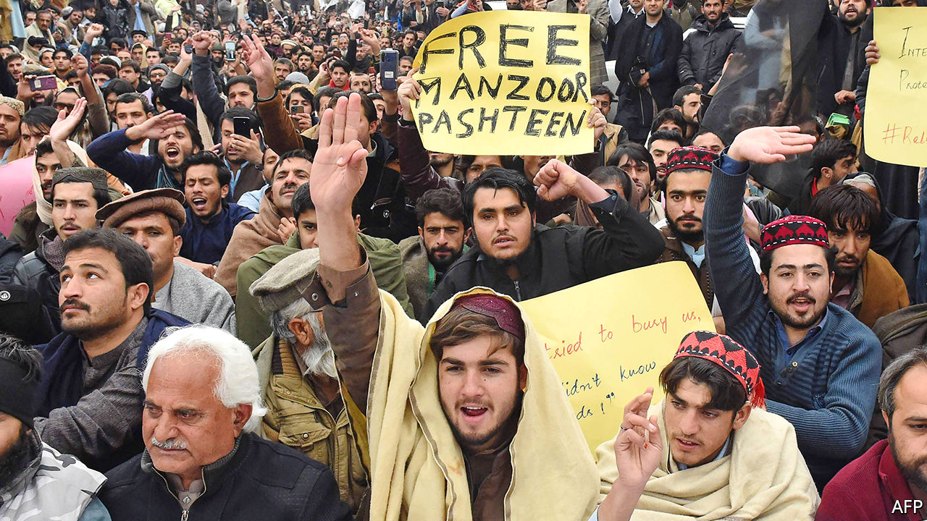

IN THE EARLY hours of January 27th a charismatic former veterinary student was arrested in Peshawar. Manzoor Pashteen was accused of conspiracy, sedition, stoking ethnic hatred and attacking Pakistan’s state and constitution. Missing from the list was his true crime: criticising the army. The 25-year-old is the founder of a group called the Pushtun Protection Movement (PTM), which has accused the security services of persecuting ethnic Pushtuns in various ways, ranging from harassment at checkpoints to kidnappings and extrajudicial killings.

Pushtuns’ grievances have their roots in the insurgency of the Tehrik-i-Taliban Pakistan (TTP)—the Pakistani arm of the Taliban. The Pakistani army had originally supported the Taliban’s quest for power in neighbouring Afghanistan, and had allowed its fighters to use Pushtun areas on Pakistan’s side of the border as a haven. The militants duly recruited and proselytised within Pakistan, helping to spawn the TTP, which launched a bloody terror campaign. The army’s counteroffensive turned Pushtun areas into a war zone. Towns and villages were flattened; hundreds of thousands of people were displaced. And even when peace returned, the army still treated Pushtuns with suspicion.

When a young Pushtun trader was killed by police in Karachi in suspicious circumstances in 2018, tens of thousands of Pushtuns began joining Mr Pashteen’s rallies. The PTM demanded the removal of mines and unexploded bombs in Pushtun regions, a reduction in raids and checkpoints, and due process for the many Pushtun youths abducted, tortured or killed by the army and police. “It has taken us almost 15 years of suffering and humiliation to gather courage to speak up, and to spread awareness about how the military trampled our constitutional rights through both direct action and a policy of support for the militants,” Mr Pashteen said last year.

Such open criticism of the army is unheard-of. Mere mention of the PTM can induce apoplexy in the top ranks. Its complaints detract from the hard-fought victory over the TTP. Thousands of troops died in the campaign, which has led to a dramatic improvement in security.

Moreover, the army says it has tried to fix the problems the PTM has raised. It claims to have become less heavy-handed at checkpoints and is building schools and markets to help revive shattered towns.

But the generals are more adept with sticks than carrots. Journalists have been told to stop reporting on the PTM. Senior officers have stated ominously that its time is up. In May the army shot into a crowd of PTM supporters heading to a sit-in, killing at least 13. (The soldiers said they were fired on first.) Two PTM-supporting parliamentarians were arrested and spent four months in detention.

The trigger for Mr Pashteen’s arrest may have been the fresh campaign of rallies that the PTM recently initiated. He has been denied bail, and PTM members protesting his detention have themselves been arrested. For the most part, Pakistan’s courts seem unconcerned about the abuses that Mr Pashteen has railed against. But daring to complain about the army’s impunity—now that is a serious offence. ■

This article was downloaded by calibre from <https://www.economist.com/asia/2020/02/01/a-prominent-critic-of-pakistans-army-is-hauled-into-court>

|  |  |  |  |
| --- | --- | --- | --- |
| Previous | Articles | Sections | Next |

|  |  |  |  |
| --- | --- | --- | --- |
| Previous | Articles | Sections | Next |

#### Banyan

# Taal volcano is a reminder of Asia’s vulnerability to natural forces

And of the constant temptation to ignore the risks

Feb 1st 2020 |



NEARLY TWO weeks after Taal volcano’s first eruption in over 40 years, the Philippines Institute of Volcanology and Seismology has lowered its threat assessment a notch, and local residents have begun to stream back to their homes in jeepneys, pickups and on the backs of motorcycles. When Taal roared to life on January 12th, the plume of steam and ash it sent 32,000 feet into the air was so vast it generated its own weather system, with thunder and lightning. As the falling cinders turned day to night, tens of thousands of evacuees fled for hastily created evacuation centres a safe distance from Taal’s spite.

Usually, Taal is a draw. The volcano has made its own island in the middle of Taal lake, which occupies the caldera of a much bigger volcano which exploded aeons ago. The surrounding slopes are forested. Papayas and vegetables thrive on village plots by the shore. The lake itself provides livelihoods to those farming tilapia fish. More jobs come from catering to visitors from Manila who flock to the lake, or to the resort town of Tagatay on an overlooking ridge, for the fresh air, sweeping views and grilled fish. The country’s capital is just two hours’ drive to the north.

Yet these times are hardly usual. The eruption seems to have caused a lot of the lake’s water to evaporate. One part of the lake, though, is now a metre deeper, since the whole caldera has tilted sharply. Taal’s ash has turned a vast area a monotone grey. Rain following the eruption has hardened the ash to concrete. The tin roofs of villagers’ houses have buckled, trees have lost their main branches and the tomatoes and aubergines in Rosa’s garden have shrivelled to nothing. But life is nothing if not, well, pigheaded. Rosa says she and her husband, a retired soldier, had no choice but to stay, despite the loss of electricity and water: Biggie, their sow, was about to farrow. Fourteen piglets now snuffle around their mother. Girlie, from one of the worst-hit villages on the west side of the lake, cries with joy to find that the food she left out for her family’s dog and kitten have sustained them.

The repair teams from the electricity board, villagers chipping the ash off roofs and even young scientists returning to their lakeside observatory in Talisay to get the solar panels for their sensors working again—life has a yen for normality, too. Not the volcano, however. The earthquakes following the eruption have fallen in number and severity, and an alarming build-up of magma appears to have diminished. But that, says Paolo Reniva, a geologist, says little about how the volcano will behave in future. He expects Taal’s current cycle of activity to last months or years. At the back of all the geologists’ minds is the eruption of 1754. That blast had the force of a nuclear bomb, and the jargon they use to describe it is similar: “ballistic projectiles” fell over seven kilometres away; the “base surge”, a mixture of gas and fragments moving at up to 100m a second, reached up to 20km away. No one died from the direct effects of the eruption on January 12th; a 1754-style explosion, in contrast, would be catastrophic.

This is not what those trying to resume their lives want to hear. The current threat assessment of 3 on a scale of 0 to 5 risks being viewed as normal by locals. And just as President Donald Trump downplays climate change, so populist Filipino politicians downplay nature’s forces. President Rodrigo Duterte promised evacuees he would “pee on that damned volcano”. The vice-mayor of Talisay, Charlie Natanauan, a local businessman who is campaigning to unseat the mayor (his brother, as it happens), goes further by urging locals not to believe the “idiot” scientists. Taal is not going to explode again, he insists, because he knows its history; if he’s wrong, he adds, then throw him into the crater. What’s more, the scientists’ warnings about poisoned tilapia are off-the-mark too, and he will eat as many fish as needed to prove it. It goes down a storm with locals.

Sitting on a veranda by the lake, next to a gold-painted statue of himself toting a rifle and pistol, Mr Natanauan lays out his plans. They include a canal cutting through to the sea so that luxury yachts can travel up it; modernist glass resorts; and firework shows to put any eruption to shame. How, Banyan asks, do his ideas fit with the volcano’s even more sweeping and whimsical plans? Pah, Mr Natanauan says dismissively, the next time Taal causes trouble, we’ll all be dead. Behind him, dozens of dead tilapia float upside down, slapping against his jetty. Just beyond, the volcano gently steams.

This article was downloaded by calibre from <https://www.economist.com/asia/2020/02/01/taal-volcano-is-a-reminder-of-asias-vulnerability-to-natural-forces>

|  |  |  |  |
| --- | --- | --- | --- |
| Previous | Articles | Sections | Next |

|  |  |  |
| --- | --- | --- |
| Asia | Sections | Middle East and ... |

China

The Wuhan virus: Sealed off

.

Chaguan: The politics of pandemics

.

|  |  |  |
| --- | --- | --- |
| Asia | Sections | Middle East and ... |

|  |  |  |  |
| --- | --- | --- | --- |
|  | Articles | Sections | Next |

#### Sealed off

# Tough quarantine measures have spread across China

In Hubei province, a population the size of Italy’s is under lockdown

Jan 30th 2020 | WEIJI VILLAGE, HENAN

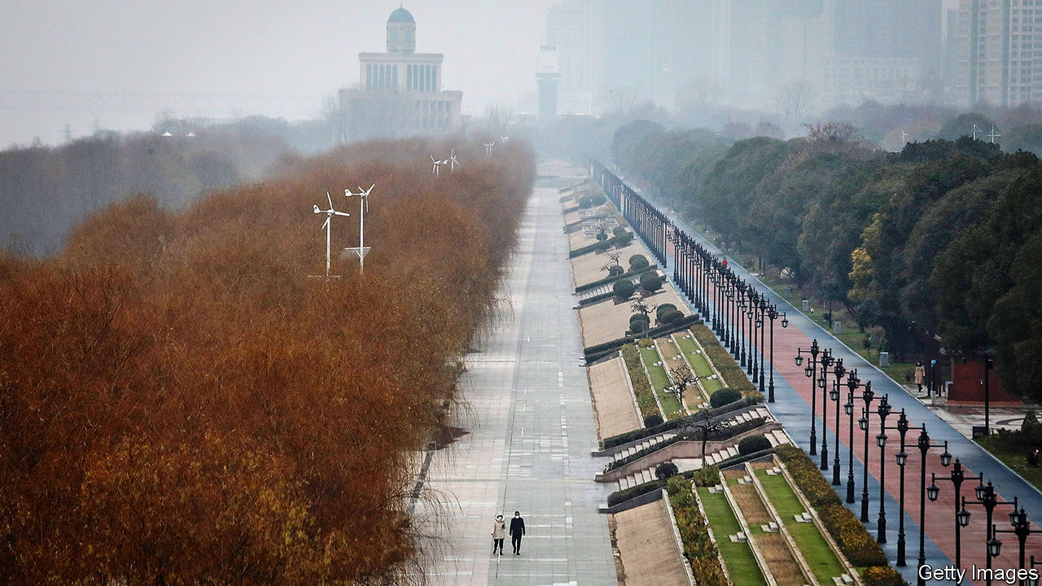

WEIJI VILLAGE is a bleak spot in winter, even without the disease-control roadblock just up the road complete with medical staff in blue protective suits, using pistol-shaped electronic thermometers to check the foreheads of drivers and passengers for signs of fever. The village’s colour palette ranges from the grey of the sky to flat green fields of winter wheat and the brown of mud-filled potholes so deep that ordinary cars cannot pass. China is full of rural scenes like this one, in a forgotten corner of Henan province. Weiji’s only distinction is that it is a border village, a short walk from Hubei, an inland province of nearly 60m people (roughly the population of Italy) that has been all but sealed off from the outside world to slow the spread of a dangerous new coronavirus.

Chinese cities brim with migrant workers from villages like Weiji, hauling bricks on building sites or delivering fast food on electric mopeds. During China’s rapid growth of the past 40 years, such people have helped spread wealth to the countryside. They send money back to home villages with taps on a smartphone app—for China is way ahead of the West when it comes to mobile payments—and return in person for the lunar new year, laden with gifts of city-bought clothes and fancy foods. Not this year, however.

About 200 migrants from Weiji work in Hubei’s capital, Wuhan, the city where the virus was discovered (pictured, under lockdown). Because some returned to the village for the new year, which began on January 25th, Weiji was dragged into a vast quarantine operation that has trapped tens of millions of Chinese in their homes, grounded some international flights, halted long-distance bus services and closed the country’s largest tourist sites. The virus-control campaign explains a splash of colour on Weiji’s almost-empty main street, a red banner urging locals to be tested. It reads: “Find It Early! Treat It Early! Medical Fees All Free!”

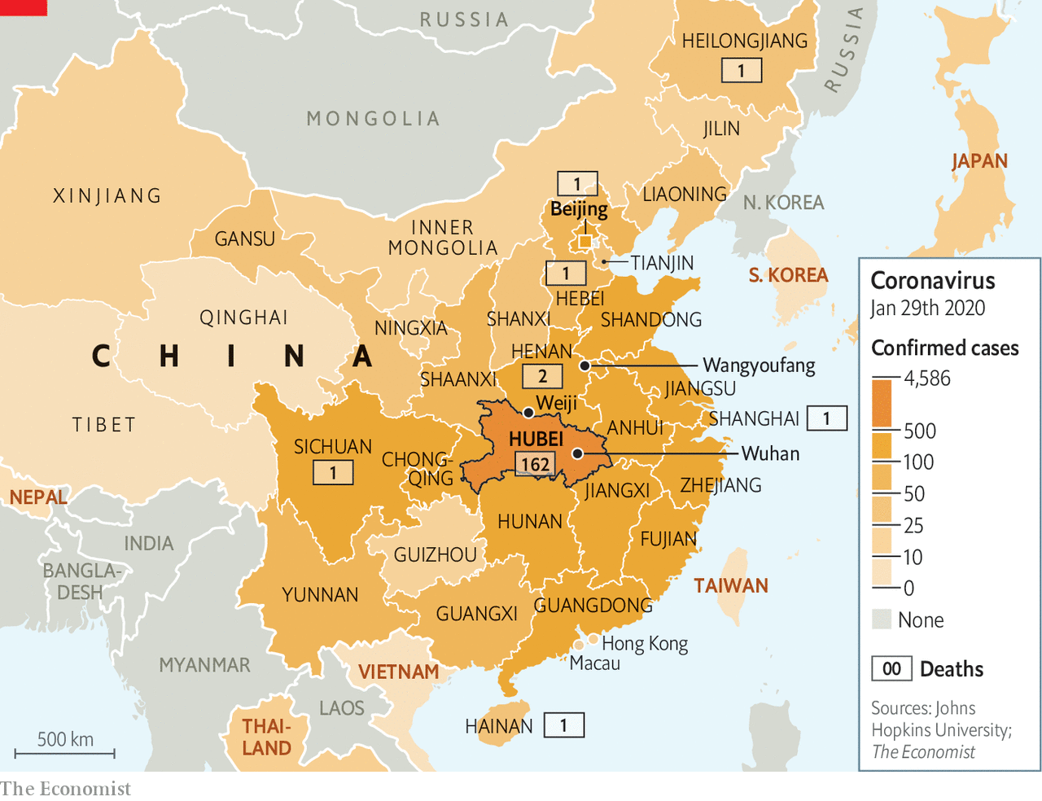

That encouraging, cajoling sign is buttressed by a dose of coercion. The village’s fresh-faced Communist Party chief, who wears a smart black windbreaker, describes instructions from higher-ups. Cars with Hubei number plates are to be turned away, and migrants returning from that province sent back. Those who made it home to Weiji before controls were imposed on January 20th must submit to temperature checks twice a day and remain indoors in their family homes, with no visitors allowed. Foreign experts may debate the medical efficacy of mass quarantines, but locals describe a sense of comfort from doing something to fight what President Xi Jinping calls a “devil” virus.

A farmer and grandfather of two points to government notices fluttering on shuttered shop fronts. Officials have said that staying at home is “the biggest contribution one can make”, he explains. Unbidden, another local offers a patriotic commentary to the foreign reporter in his village. When the government tells the Chinese people to make sacrifices for the country, they listen, he booms. “It’s different from your Western countries.”

Many villages have shut themselves off from outsiders using barricades made of freshly-dug earth, lumps of concrete or, in one case, a parked tractor (an example outside the village of Wangyoufang, southern Henan, is pictured). At one such roadblock, old men in disposable face-masks sit at a wooden office desk, a pot of thermometers in front of them. The campaign is an odd mix of high and low technology. Henan police questioning this reporter were able to summon up his photograph and details by tapping his Chinese telephone number into a mobile device. But electronic thermometers gave very different readings in the space of a few seconds—an alarming flaw when even a hint of fever at a checkpoint can result in 14 days of quarantine.

## Mao had it easy

The virus’s spread is straining a public health system that lags other Chinese infrastructure (under-staffed, ill-equipped hospitals sit next to gleaming high-speed railway stations). It is also a giant test for an authoritarian, one-party political system designed in a simpler China, when most workers toiled for the state or rural collectives, rarely moved around and relied on state and party news outlets to learn what was going on.

Today bullet trains criss-cross the country. Affluent urbanites use lunar new year to take foreign holidays. Even villagers in Weiji admit to reading criticisms of the government’s crisis response on such social-media platforms as Weibo or WeChat, though censors still race to delete any posts chiding Mr Xi and other national leaders. Posts rebuking lower-level authorities are being allowed more often than usual. When Hubei Daily, a party newspaper, warned readers to refrain from rumour-mongering, it triggered a sardonic backlash. “I can only trust the punctuation marks in Hubei Daily,” grumbled a commentator on Weibo. Police have punished actual rumour-spreaders, such as a man detained in south-eastern China for three days for (falsely) messaging friends about an infected stranger roaming his village. In contrast, eight “rumour-mongers” punished by Wuhan police, in a case announced on January 1st and covered prominently by state media, were in fact doctors sharing early tidings of a strange new virus in a medical WeChat group. In a rare intervention, the Supreme People’s Court posted an online article on January 28th lamenting the silencing of those doctors.

Schooled in the idea that they live in an all-knowing surveillance state, Chinese netizens have reacted with surprise as the virus campaign reveals the authorities’ blind spots. The websites of big state newspapers have published lists of more than 100 flights and trains taken by infected people, urging fellow-passengers to seek medical tests. How come the authorities cannot find passengers in a split second, asked a Weibo user, adding: “Aren’t we all 2020-big-data-high-tech now?”

China’s response to the virus has been unmistakably authoritarian, involving the locking down of Hubei’s cities, and mandatory orders to stay indoors for a fortnight for those who leave Hubei and head to such centres as Shanghai. But it is not totalitarian. Unlike in the Mao era, when blind loyalty was demanded from citizens, the party has at times responded to public anger with a hint of understanding. In a much-discussed state television interview, Wuhan’s mayor, Zhou Xianwang, offered to resign if the public wished. Still, his mea culpa contained an unsubtle jab at his masters in Beijing. Acknowledging that the city had held back information about the outbreak, Mr Zhou noted that he needed superiors’ permission to disclose news of an infectious disease.

The principle of quarantine is rarely challenged, even in Wuhan. Residents reached by telephone describe a mix of community spirit, such as bakeries offering free food to medics, a mass singing of the national anthem out of apartment windows as well as some grumbling about confusing and draconian local decisions. In a city of 9m people (the mayor says another 5m left, just before the quarantine was imposed, because of the holiday and the virus) taxis are now the only public transport. They can no longer be hailed on the streets, however, or summoned through an app. They have been commandeered by the city. Duties include “emergency runs” such as ferrying the sick to hospitals, says Wang Jie, a retired taxi driver. Rides are free. The city pays drivers 600 yuan ($86) a day, more than double what they make in normal times. Still, many fear being infected, says Ms Wang. Most have to buy their own protective masks, goggles and gloves.



Ignore the welcome sign

Hundreds of expatriates left Wuhan on chartered airliners this week. Philippe Klein, a French doctor serving the city’s expatriate community (Wuhan is home to big French car factories), is staying put. Dr Klein, whose clinic is attached to the Union Hospital, describes exhausted local doctors being relieved by military medics, and by volunteer doctors from other provinces. The number of new patients seeking testing had been growing each day but has now stabilised, he says. Hospital bosses hope that the epidemic will peak in Wuhan around February 8th. If disease prevention began slowly, one reason was the cost of being tested, which put some locals off. Now the state will pay. It has built field hospitals to house those who test positive. “Overall, I am optimistic,” says Dr Klein.

Lu Xiaoyu, an academic who works in Australia but who flew back to Wuhan for the lunar new year, says morale is rising. Fine weather on January 28th brought residents out of their homes. Neighbourhood food shops have reopened, sparing people from stressful trips to large supermarkets. A lingering concern involves discrimination against Wuhan folk both inside and outside China. “We have turned into refugees,” he worries. Such concerns are well-founded. On January 27th several dozen people from Shanghai refused to board a plane in Japan when they realised that a small contingent from Wuhan was aboard. (Their accent gave them away.) The incident went viral on China’s social media. Many netizens backed the Shanghainese.

The virus has given new energy to localist sentiment within the protest movement in Hong Kong, where anti-mainland prejudice lurks alongside a yearning for greater political freedom. Bowing to public pressure, Hong Kong’s government is denying entry to Hubei residents and those recently in the province. That did not stop someone posting online bomb threats and demands to seal the mainland border, shortly after police found three small, home-made explosive devices.

Chinese leaders insist that one-party rule is vital for stability and progress. The world will judge, in due course, whether their brand of bossy, secretive authoritarianism helped to stop a pandemic, or let the coronavirus spread out of control. Already, the crisis is revealing a country which talks a lot about unity and is capable of great feats of national mobilisation, but which is easily divided and painfully low on trust. That is an ailment for which party bosses seem to have no cure. ■

This article was downloaded by calibre from <https://www.economist.com/china/2020/01/30/tough-quarantine-measures-have-spread-across-china>

|  |  |  |  |
| --- | --- | --- | --- |
|  | Articles | Sections | Next |

|  |  |  |  |
| --- | --- | --- | --- |
| Previous | Articles | Sections | Next |

#### Chaguan

# Xi Jinping wants to be both feared and loved by China’s people

The coronavirus may change that

Jan 30th 2020 |

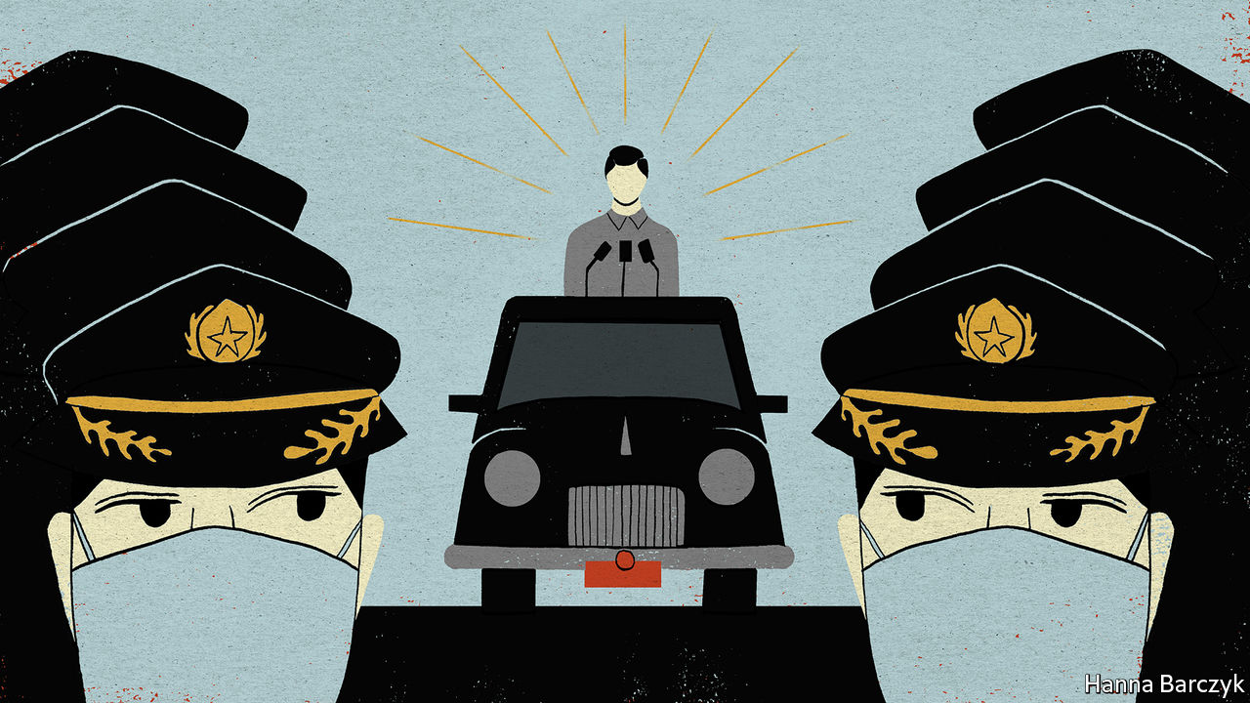

IF CENSORS IN communist-led regimes are good for anything, it is spurring creativity. With a new coronavirus stalking China, netizens have been heaping praise on “Chernobyl”, an American-made television drama about the Soviet Union’s worst nuclear disaster. Their aim is to sneak discussion of the outbreak onto China’s tightly policed internet. In less hectic times censors would swiftly stamp out such impertinence. For the parallels with the reactor explosion in 1986, and the official cover-up that followed, are painful for China’s Communist Party bosses, whose system of government was cribbed from Soviet designs. But pointed comparisons keep popping up on China’s social media. One urges Chinese viewers to learn from “Chernobyl” that a free flow of information offers more security than aircraft-carriers, Moon landings and other signs of superpower might. Another contrasts a soothing interview granted to state television by the governor of Hubei, the province where the epidemic began, with a speech by the hero of “Chernobyl”, a Soviet scientist, about the costs of official lies.

Parallels are likely to continue in the real world. Back in the 1980s, Kremlin leaders scapegoated local officials and engineers, coolly blaming them for the disaster and denying a wider cover-up. In recent days, Chinese state media have dropped heavy hints that the mayor of Wuhan, the industrial city where the virus was first detected, will lose his job. When Li Keqiang, China’s prime minister, was appointed to oversee virus-control work, cynics suggested that his role was to take the fall should the outbreak spark a pandemic—in effect, to protect President Xi Jinping.

As it happens, censors should be relieved that Chinese netizens are focusing on the ills of Soviet collective leadership. It would be more dangerous if online critics were to start exploring a historical parallel closer to home, namely the way that in Chinese history natural disasters undermined an emperor’s claim to rule. More than one dynasty fell after catastrophes signalled that Heaven had withdrawn its favour. It was not only seen as ineptitude when a ruler was unable to protect his people from floods or famine—or, as in the second century during the Han dynasty, from repeated outbreaks of disease (probably smallpox and measles) that killed perhaps a third of the population. Such bungling showed that the emperor lacked virtue and deserved to be overthrown, people said.

Modern-day Chinese may not believe that a rampaging coronavirus signals divine anger with Mr Xi. Still, the party chief has a great deal at stake in this crisis, precisely because large claims are made about his wisdom, which is now taught in schools and studied by party members as Xi Jinping Thought. Every day, state media credit Mr Xi with personally guiding China to ever-greater prosperity, modernity and global clout. No leader has amassed such individual power since Mao Zedong, or been so lavishly praised. Chinese intellectuals accuse Mr Xi of claiming the mantle of an emperor. They point to Mr Xi’s speeches praising traditional Chinese culture, and lauding codes of morality and deference to imperial authority, as handed down by Confucius and other sages.

The result is an awkward hybrid. On the one hand, officials make claims about the efficiency of collective party leadership that would be familiar to any Soviet apparatchik. To them, populist insurgencies sweeping the West are proof that multiparty elections, a free press and other forms of democratic accountability are sources of chaos and dysfunction. As they describe it, China’s system is a meritocracy that selects highly competent experts to run the country, with a track record of correcting their own mistakes. Yet at the same time, the party’s propagandists lay claim to a very different form of legitimacy, involving the people’s love for and trust in one man, Mr Xi. So sweeping is their praise of him that it leaves essentially no room for the idea that Mr Xi could make a serious mistake.

This convoluted claim to legitimacy can be heard in the context of the current coronavirus outbreak, as leaders insist that their system of government is ideally suited to tackling the disease. On January 28th Chinese leaders hosted the head of the World Health Organisation (WHO), a UN body that played an invaluable role in demanding transparency in 2003 after China’s initial cover-up of the extent of an outbreak of Severe Acute Respiratory Syndrome (SARS), which led to many avoidable deaths. Wang Yi, the foreign minister, assured the WHO’s boss, Tedros Adhanom Ghebreyesus, that China would be more resolute this time thanks to “the strong leadership of the party Central Committee with Comrade Xi Jinping as the core and the strong advantages of the socialist system”, as well as its experience of SARS.

## Unaccountable, even to Heaven

It is too simplistic to assume that all bad things that happen in China must harm Mr Xi. The virus outbreak could end swiftly, amid worldwide praise for the bravery of China’s doctors and nurses, the self-discipline of the public and the resolve of Chinese leaders, albeit after a slow start. If the crisis does not end well, scapegoats will be found, and underlings punished. That alone would not have to shake Mr Xi’s authority, which can always be shored up with repression, still greater ideological discipline and nationalist propaganda. But a botched response to the virus would lay bare tensions inherent in the party’s hybrid claims to legitimacy.

Mr Xi’s China is two things at once. It is a secretive, techno-authoritarian one-party state, ruled by grey men in unaccountable councils and secretive committees. It also claims to be a nation-sized family headed by a patriarch of unique wisdom and virtue, in a secular, 21st-century version of the mandate of Heaven. If forced to choose between those competing models, bet on cold, bureaucratic control to win out. For Mr Xi and his team learned their own lesson from the Soviet Union’s fall, five years after the Chernobyl disaster. Expressions of public love for Mr Xi, the “People’s Leader”, are all very well. But keeping power is what counts. ■

This article was downloaded by calibre from <https://www.economist.com/china/2020/01/30/xi-jinping-wants-to-be-both-feared-and-loved-by-chinas-people>

|  |  |  |  |
| --- | --- | --- | --- |
| Previous | Articles | Sections | Next |

|  |  |  |
| --- | --- | --- |
| China | Sections | Europe |

Middle East and Africa

Donald Trump’s peace plan: The sound of one hand shaking

.

Iraqi politics: Sadder and Sadr

.

Health care in Uganda: Why wait for death?

.

Locusts in Africa: Severe swarms

.

|  |  |  |
| --- | --- | --- |
| China | Sections | Europe |

|  |  |  |  |
| --- | --- | --- | --- |
|  | Articles | Sections | Next |

#### Steal of the century

# Donald Trump gives Israel the green light to annex occupied lands

His proposal may not bring peace, but could still have a lasting effect on the conflict

Jan 30th 2020 | BEIRUT AND JERUSALEM

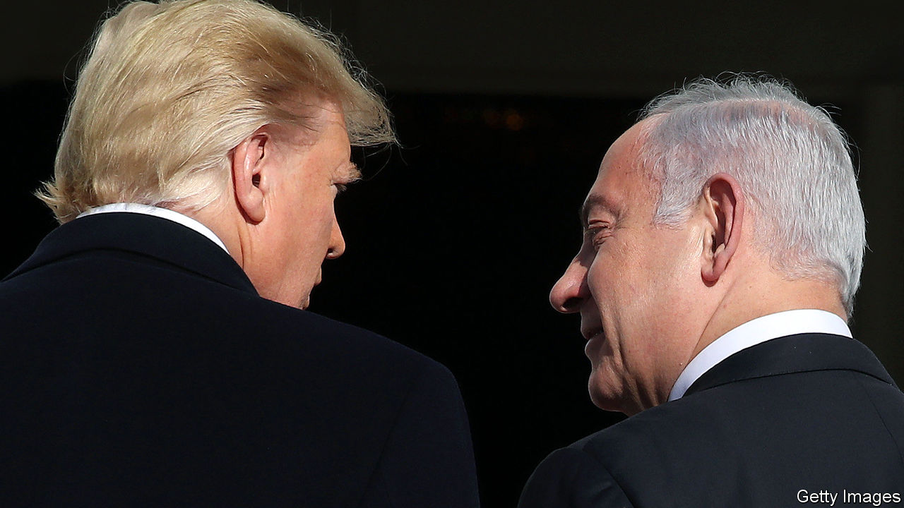

FOR MONTHS they said the timing was simply wrong. Members of the Trump administration, led by the president’s son-in-law, Jared Kushner, worked for two years on a plan to solve the decades-old conflict between Israel and the Palestinians, finishing last year. Then they waited for an opportune moment to release it.

On January 28th that moment arrived. Never mind that Israel was headed for its third election in less than a year, with a prime minister, Binyamin Netanyahu, facing trial for bribery, fraud and breach of trust. Or that, while Donald Trump unveiled the plan at the White House, senators at the other end of Pennsylvania Avenue listened to arguments in his impeachment trial. Or that the Palestinians had not spoken to America in two years.

The plan Mr Trump’s administration presented was unexpectedly detailed, with more than 50 pages of proposals and maps. But as a blueprint for a two-state solution it was dead on arrival. It would not give the Palestinians a sovereign state immediately; that might come only later, after they built a government that satisfied both Israel and America. They would retain only about 75% of the West Bank, divided into three cantons linked by highways; a tunnel would connect it to Gaza, and to two remote plots of land in the western Negev desert swapped in exchange for Israeli settlements, which would remain in place (see map).

## This land is your land

Israel would keep control of the Jordan valley and most of Jerusalem. The Palestinian capital would be established in a few grim neighbourhoods, such as Abu Dis and Shuafat, that sit on the other side of a hulking concrete separation barrier. No Palestinian refugees would be allowed to return to Israel, only to Palestine or unnamed Muslim countries that would accept up to 50,000 each. Israel would commit not to build new settlements in the land allocated for a future Palestine for four years; in return, though, it received an implicit American recognition of its claims to the rest of the West Bank. Mr Netanyahu declared that Mr Trump was “puncturing this big lie” that Jewish settlements in the West Bank were illegal. His cabinet may begin voting in early February to annex some of the American-allocated land.

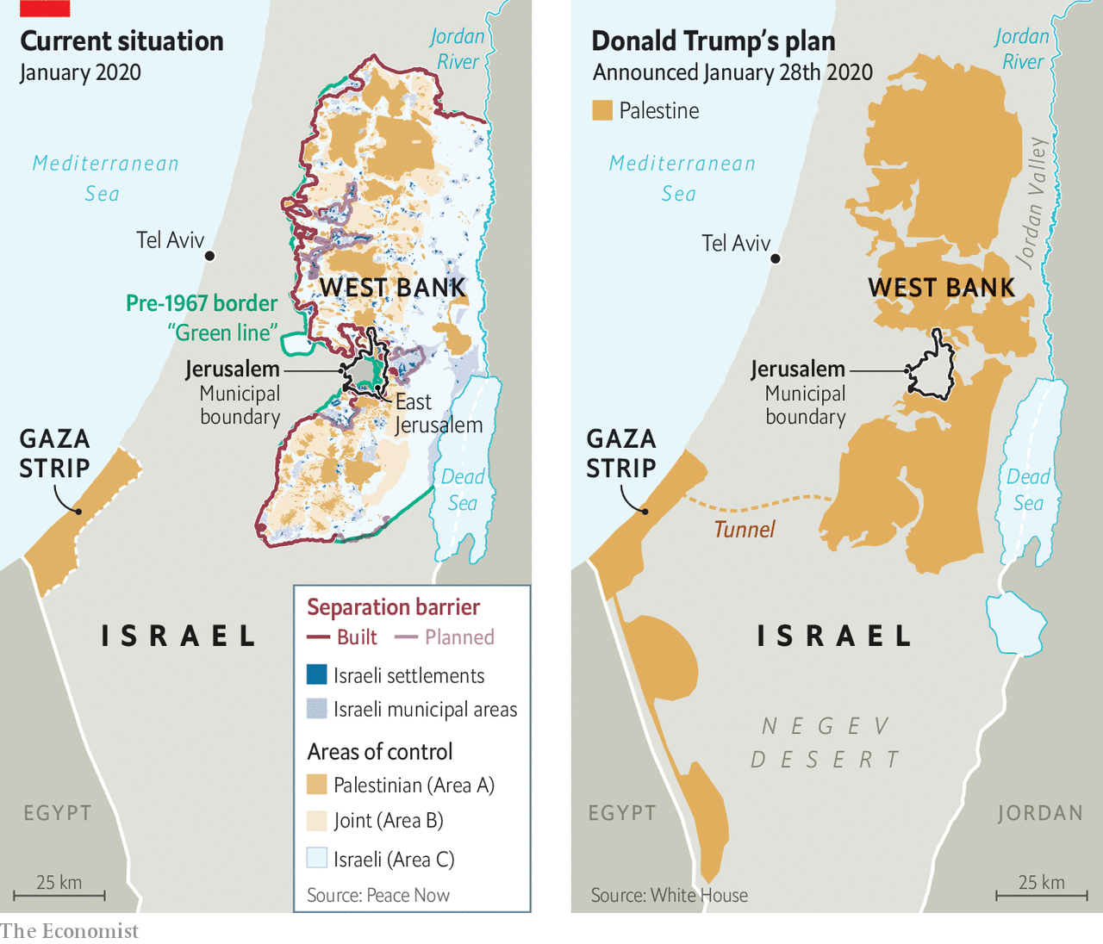

The Palestinians rejected the proposal outright. It will end up “in the dustbin of history”, says the president, Mahmoud Abbas. His reaction should be no surprise. There is much to criticise about the decrepit Mr Abbas, now in the 16th year of what was meant to be a four-year term. But no Palestinian leader could accept a deal that in effect cedes Jerusalem and relegates his people to further statelessness. Far from a good-faith effort to solve the conflict, Mr Trump’s plan was a sop to hawkish ideologues in Jerusalem and Washington.

Perhaps it was never meant to be more. On March 2nd Israelis will go to the polls again. The previous two elections, in April and September, left Mr Netanyahu without a majority for his coalition of right-wing and religious parties. By presenting the plan now, so close to the vote, Mr Netanyahu’s American backers hope it will dominate the campaign and energise his Likud base. He seems to need the help: polls so far show a slow but continuing erosion of his support. Hours before the plan was unveiled, Israel’s attorney-general filed formal charges against the prime minister in a Jerusalem court.

Over the next five weeks Mr Netanyahu will use the plan as his main platform (and a welcome distraction from his legal trouble). His allies are pushing for a swift vote on annexing parts of the West Bank. “What is postponed until after the election will never happen,” says the defence minister, Naftali Bennett. But legal concerns may slow the process: the cabinet plans to ask the attorney-general if an interim government can approve such a drastic step. (Mr Kushner hopes Israel waits until after the election.) The cabinet cannot vote on implementing the full Trump plan, because that calls for relinquishing territory, which under Israeli law requires a referendum.

Regardless of the delays, mere talk of annexation could benefit Mr Netanyahu politically. His main challenger, Benny Gantz, ran on a vaguely centrist platform in the past two elections, absorbing parts of Israel’s “peace camp”. That won him a plurality of seats in September, but he too failed to form a coalition. In recent weeks he has moved sharply to the right, hoping to attract disgruntled Likud voters. Mr Gantz says he too would implement the Trump plan. Some members of his Blue and White party are more cautious. If they balk at annexation, Mr Netanyahu will paint them as weak and unpatriotic, liable to miss a “historic opportunity” that he likens to David Ben-Gurion’s decision in 1948 to declare Israel’s independence.

The Palestinians see all this not as an opportunity but a disappointment, one both historic and predictable. For a time they were guardedly optimistic about Mr Trump. Despite his pro-Israel campaign rhetoric, some Palestinian officials hoped an unconventional president might take an unconventional approach to diplomacy. His special envoy at the time, Jason Greenblatt, held a well-received listening tour of the West Bank in 2017, meeting Palestinian leaders and ordinary citizens.

But the relationship suffered a lasting rupture in December 2017, when Mr Trump broke decades of precedent and announced that he was moving America’s embassy from Tel Aviv to Jerusalem. The Palestinians claim part of Jerusalem as their future capital; most countries keep their embassies in Tel Aviv, arguing that to do otherwise would prejudge the status of the city. The following year Mr Trump closed the Palestinian diplomatic mission in Washington. He has also cut all American aid to the Palestinians. Relations have not been this bad since 1987, when America labelled the Palestine Liberation Organisation a terrorist group.

Mr Kushner and his aides did not seem to mind; they came to view the Palestinians more as a nuisance than a negotiating partner. Their plan would impose immediate costs on the Palestinians, with the benefits (such as a proposed $28bn in aid, none of which has yet been pledged) coming years, perhaps decades, in the future.

Instead they proposed an “outside-in” approach: encourage other Arab states to embrace the plan, then hope they would press the Palestinian leadership to accept it. This was always a far-fetched idea. Jordan has rejected the plan. The Gulf states, which have worked hard to court Mr Trump, will not want to anger him by publicly criticising it. Ambassadors from Bahrain, Oman and the United Arab Emirates attended its release (Saudi Arabia was notably absent). But they are unlikely to do much to promote a proposal that the Palestinians have so firmly rejected.

On the eve of his inauguration, Mr Trump expressed almost preternatural confidence in his son-in-law, a property developer with no diplomatic experience. “If you can’t produce peace in the Middle East, nobody can,” he told Mr Kushner. Perhaps no one can. Mr Kushner is unlikely to bring peace, but his plan may still bring lasting change. If Israel annexes large parts of the West Bank, it will be all but impossible for the Palestinians to establish a viable state. The two-state solution, on which decades of American peacemaking had been built, has long been a fading dream; it would finally be buried. Mr Trump may yet go down in history, not for making a deal, but for making one impossible. ■

This article was downloaded by calibre from <https://www.economist.com/middle-east-and-africa/2020/01/30/donald-trump-gives-israel-the-green-light-to-annex-occupied-lands>

|  |  |  |  |
| --- | --- | --- | --- |
|  | Articles | Sections | Next |

|  |  |  |  |
| --- | --- | --- | --- |
| Previous | Articles | Sections | Next |

#### Sadder and Sadr

# Muqtada al-Sadr, Iraq’s most volatile cleric, stakes his claim to power

But plenty of obstacles lie in his path

Feb 1st 2020 |

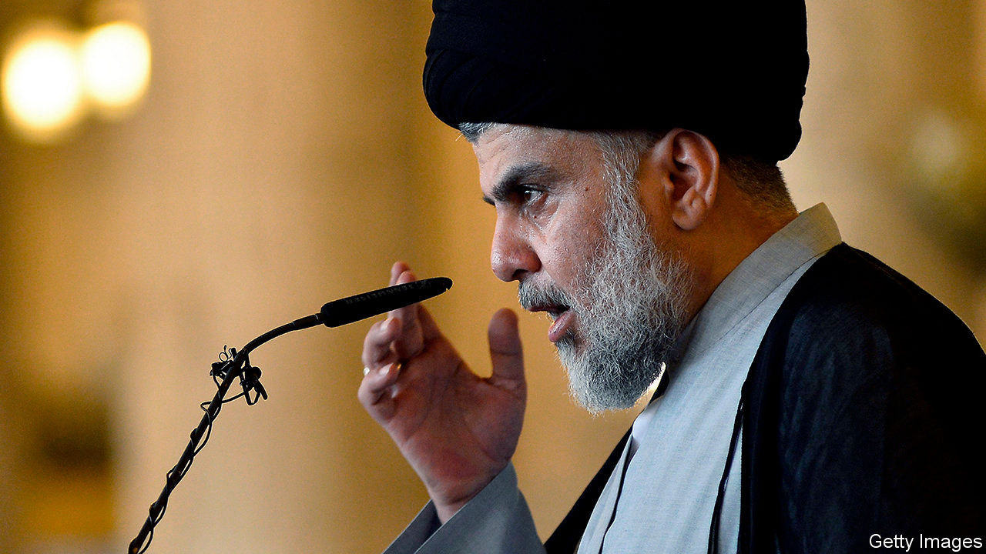

THE HENCHMEN of Muqtada al-Sadr, Iraq’s most capricious—and perhaps most powerful—cleric, not only participated in the anti-government protests that have rocked Baghdad and other cities for months, they defended them. Others who joined the demonstrations stood a good chance of being frisked by Mr Sadr’s men, who looked out for troublemakers. Together with the mainly Shia crowds they demanded a new political system, one not dominated by a small elite, and a fairer distribution of the country’s oil wealth.

But on January 25th Mr Sadr ordered his followers to withdraw, blaming the hostile behaviour of the protesters towards his men. A crackdown on the protesters who remained appeared imminent. Over 600 people have been killed since the unrest began in October. As expected, the police cleared the streets in some cities. The protesters, though, have not gone home. There are more now.

With Mr Sadr throwing his weight behind the establishment, Iraq’s battle lines are clearly defined. The politicians and clerics who champion Shia political Islam, and who are backed by Iran, face protesters calling for a secular, non-sectarian government free of Iranian influence. The result is stalemate and stagnation. Adel Abdul-Mahdi, the prime minister, resigned last year, but he carries on as a caretaker (unconstitutionally, say some). The ruling parties have mulled many possible successors. Each name elicits guffaws from the crowds in the street.

Mr Sadr hopes to fill the post with a loyalist. Ever since America toppled the dictatorship of Saddam Hussein in 2003, the cleric has sought power. He styles himself a local hero who endured American sanctions and Saddam, while other elites lived the high life abroad. That has given him clout on the street, which he occasionally cashes in for a seat at the table. In 2016 he led a large rabble that occupied parliament. Last year the political bloc that he leads, called Sairoun, won the most seats in parliamentary elections.

Mr Sadr is also eyeing two other important positions. The commander of the Popular Mobilisation Force (PMF), Abu Mahdi al-Mohandis, was killed in the American drone strike on Qassem Suleimani, Iran’s top commander, on January 3rd. The PMF co-ordinates Iraq’s powerful Shia armed groups; Mr Sadr would like to control it. He has been meeting PMF commanders. Last month he made a show of his strength by recalling his Mahdi Army.

But the post he most covets is head of Iraq’s clergy. Currently Grand Ayatollah Ali al-Sistani, a respected 89-year-old, sits atop the clerical establishment. Mr Sadr, half his age, has had a go at him before. The Mahdi Army seized the holy city of Najaf, the seat of Mr Sistani, in 2004—until America’s army forced it out. Today followers of Mr Sadr predict he could mount a theological challenge. Though just a hujjat al-islam, or junior cleric, he has spent over a decade in the cloisters of Qom, Iran’s clerical capital, improving his scholastic credentials and ties with Iran’s rulers.

Mr Sadr may hope to become Iraq’s version of a supreme leader. But it will be a bumpy ride to the top. Some in his ranks seethe at his betrayal of the protesters. Sheikh Asaad al-Nasari, a close associate, declared he would remain on the street. The protesters, for their part, detect disarray in the governing ranks. They sound emboldened. “Without Suleimani the militias are sheep without a shepherd,” says Faiq al-Sheikh Ali, a liberal parliamentarian who claims to be the protesters’ choice for prime minister. He wants American forces to stay in Iraq to keep Iran out.

Both sides hope to exhaust the other, but they might end up exhausting ordinary Iraqis. Business is grinding to a halt. With oil prices low, the budget deficit is widening. Fears are mounting about the government’s ability to pay salaries. Meanwhile, President Donald Trump threatens to seize Iraq’s foreign assets and impose sanctions if the government persists with its request for American troops to leave. He has allowed Iraq to bypass American sanctions on Iran and buy its gas and electricity. The waiver expires in mid-February. It might not be renewed, particularly if militias continue to lob rockets at America’s embassy in Baghdad, as they did on January 26th. Iraq is desperate for some calm. But continued unrest is more likely. ■

This article was downloaded by calibre from <https://www.economist.com/middle-east-and-africa/2020/02/01/muqtada-al-sadr-iraqs-most-volatile-cleric-stakes-his-claim-to-power>

|  |  |  |  |
| --- | --- | --- | --- |
| Previous | Articles | Sections | Next |

|  |  |  |  |
| --- | --- | --- | --- |
| Previous | Articles | Sections | Next |

#### Why wait for death?

# How a Ugandan hospital delivers health insurance through burial groups

The insured are healthier, and their finances are too

Feb 1st 2020 | KISIIZI



A SICK PERSON would once have to sell land or cows to pay hospital bills, says Owen Orishaba, a teacher in the Kigezi highlands of Uganda. But now “a goat can solve your problem.” Four years ago he joined a community health-insurance scheme managed by Kisiizi Hospital, a church-run institution. With 45,000 members, it is the largest of its kind in the country. Its success illustrates a wider truth: to deliver services to poor, rural people, begin with the systems they have built themselves.

In principle, Ugandans can get free health care at public clinics. In practice, government health centres are short of money, medicine and staff. The state accounts for only 15% of health spending, with another 42% coming from donor aid. Almost all the rest comes straight out of people’s pockets at private or faith-based facilities. Uninsured patients sometimes run from their beds to evade bills, says Moses Mugume, an administrator at Kisiizi Hospital. Even as he talks, a tearful woman, who is not in the insurance scheme, is brought into his office after being caught doing so.

How to reduce the burden on patients while generating steadier funding for the hospital? The answer lay in the hills. For generations, villagers had carried the sick down from the steep slopes and thick banana groves on an engozi, a stretcher made from vines and bamboo. They also pooled their savings to cover burial costs and to support bereaved relatives. As Mr Mugume tells it, the hospital went to these informal societies and asked them a question: “Why do you wait for death to occur? Why don’t you prevent death?”

In 1996 the hospital began enrolling engozi groups in health insurance. Group leaders register members and collect premiums, which range from 11,000 to 17,000 shillings ($3-4.50) per person a year. Members make a small co-payment to access services, such as 3,000 shillings for a basic examination or 40,000 shillings to deliver a baby. Chronic conditions are not covered, to keep costs down. Group enrolment is a way to enlist the strong alongside the sickly.

The impacts are not just financial. Patients with insurance are less likely to be admitted to hospital than those without. That is because they show up earlier, when their conditions are more easily treated. A study by Emmanuel Nshakira-Rukundo and colleagues at the University of Bonn estimates that child stunting falls by 4.3 percentage points for every year that a household is in the scheme.

The cost still puts off the very poorest. Only about a quarter of the hospital’s patients are insured. But Kisiizi shows the potential to build on institutions which, as Mr Nshakira-Rukundo puts it, “emanate from a place of social solidarity”. In neighbouring Rwanda five-sixths of the population are enrolled in state-run health insurance delivered through local groups. By contrast the Ugandan government’s plan for a national health-insurance scheme, currently before parliament, says little about community models. Schemes like that at Kisiizi could continue alongside state initiatives, says Walimbwa Aliyi, a health official, but are too thinly spread to be the basis for it.

This article was downloaded by calibre from <https://www.economist.com/middle-east-and-africa/2020/02/01/how-a-ugandan-hospital-delivers-health-insurance-through-burial-groups>

|  |  |  |  |
| --- | --- | --- | --- |
| Previous | Articles | Sections | Next |

|  |  |  |  |
| --- | --- | --- | --- |
| Previous | Articles | Sections | Next |

#### Severe swarms

# East Africa is reeling from an invasion of locusts

Prescient warnings failed to prevent the crisis

Feb 1st 2020 |



“LET MY PEOPLE go, so that they may worship me. If you refuse to let them go, I will bring locusts into your country tomorrow.” So said God, rather vengefully, according to Moses and Aaron. But although the locust infestation wreaking havoc on east Africa is of biblical proportions, it is not a portent of end times, said experts at a press conference in Nairobi this month. Still, the finger-length bugs spell big trouble for the countries most affected.

It is the worst locust invasion in decades for Kenya, Ethiopia and Somalia. One enormous swarm, recently over north-eastern Kenya, contains nearly 200bn of the creatures and occupies a space in the sky three times the size of New York City. There are dozens of swarms in Kenya alone. And the UN’s Food and Agriculture Organisation (FAO) warns that the number of locusts could increase 500-fold by June, when it is hoped that drier weather will check their spread.

The insects eat a lot. A swarm the size of Paris consumes the same amount of food in one day as half the population of France. Crops such as millet, sorghum and maize are a big part of their diet, making life even harder for the 12m or so people in Ethiopia, Kenya and Somalia who are already hungry (see map). Northern Uganda and South Sudan are also at risk; swarms are just 200km away and moving fast.

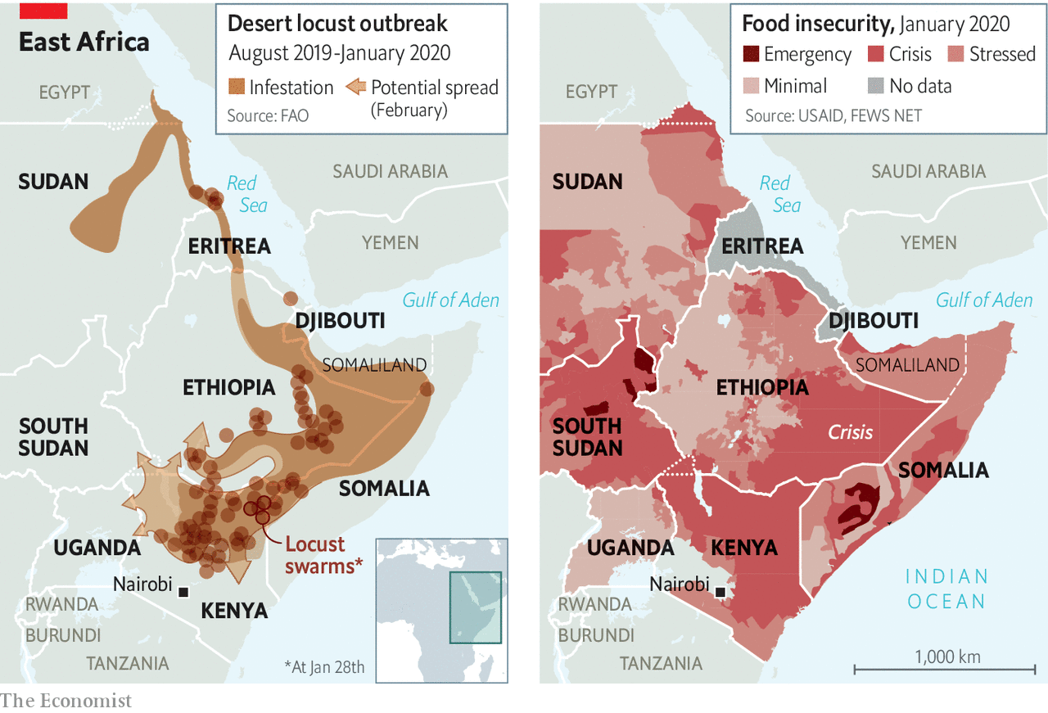

Tempting as it may be to blame God, there are more obvious culprits. The swarms were first noticed a year and a half ago in the Arabian peninsula. Last July the FAO warned that they “could migrate from Yemen in the autumn to the Horn of Africa and reach Kenya by the end of the year, unless urgent preventive and control measures are established in the region.” They weren’t. The organisation appealed to rich countries for funds to contain the bugs. But little cash arrived.

Soon the locusts had reached Ethiopia, where some farmers lost their entire crop. In September the government there asked the FAO for help in raising $2m to control the pests. By November they were asking for $6m. Again, little arrived. As the swarms reached Kenya this month, the UN appealed for $70m to pay for, among other things, the aerial spraying of insecticide in east Africa. The cost of containment may yet prove higher.

Killing the bugs early is vital. Locusts live for just three to five months, but they multiply quickly. In favourable conditions each generation will be about 20 times larger than the last. Tracking them gets tougher, too. Swarms can travel 150km in a day. But they can be managed with surveillance and spraying, particularly if they are doused when still young and hopping, and before the population booms. At that stage spraying from cars or on foot can be reasonably effective.

Early action is also cost-effective. The last big locust crisis, in north-west Africa, lasted from 2003 to 2005 and caused an estimated $2.5bn worth of damage to harvests. Getting it under control cost almost $600m, with donors footing much of the bill. That is enough to cover preventive measures in the same region for 170 years, say experts.

But prevention does not attract much funding. “This is a Catch-22,” says Keith Cressman, the Senior Locust Forecasting Officer at the FAO. “Donors are interested in funding big emergencies, big problems.” And governments, unlike locusts, move slowly. In rich countries insurers often press governments to take preventive actions. In Africa few farms are insured, so there is less pressure. Once the swarms take flight, affected countries often lack the capacity and expertise to control them.

Preventive measures have also been hindered by conflict in Yemen and Somalia, where gaining access to some areas for spraying was deemed too dangerous. Meanwhile, extreme weather has given the locusts six legs up. Last year there were eight cyclones over the northern Indian Ocean, the most since 1976. These brought heavy rains to parts of the Arabian Peninsula and Horn of Africa. The resulting vegetation gave the insects plenty to munch on.

As the planet warms, climate models suggest that the weather in the Horn of Africa will become less predictable, making it harder to anticipate locust infestations. That seems all the more reason to invest in tracking and control measures, and to make sure that action is taken quickly. Several international organisations are building systems that trigger the release of aid from an existing pot when forecasts of drought, another bane of east Africa, grow dire. The same could be done to stop locusts before they get off the ground. ■

This article was downloaded by calibre from <https://www.economist.com/middle-east-and-africa/2020/02/01/east-africa-is-reeling-from-an-invasion-of-locusts>

|  |  |  |  |
| --- | --- | --- | --- |
| Previous | Articles | Sections | Next |

|  |  |  |
| --- | --- | --- |
| Middle East and ... | Sections | Britain |

Europe

Italy’s regional elections: Salvini’s Sardine surprise

.

Hungary: In search of a David

.

Paris’s mayoral race: How not to do it

.

Energy: Greening Greece

.

China and Turkey: Bumps in the belt and road

.

Clubbing in Berlin: Strings of life

.

Charlemagne: The Brit awards

.

|  |  |  |
| --- | --- | --- |
| Middle East and ... | Sections | Britain |

|  |  |  |  |
| --- | --- | --- | --- |
|  | Articles | Sections | Next |

#### Salvini’s Sardine surprise

# Regional elections in Italy buttress the government

Another blunder by the populist leader of the Northern League

Feb 1st 2020 | ROME

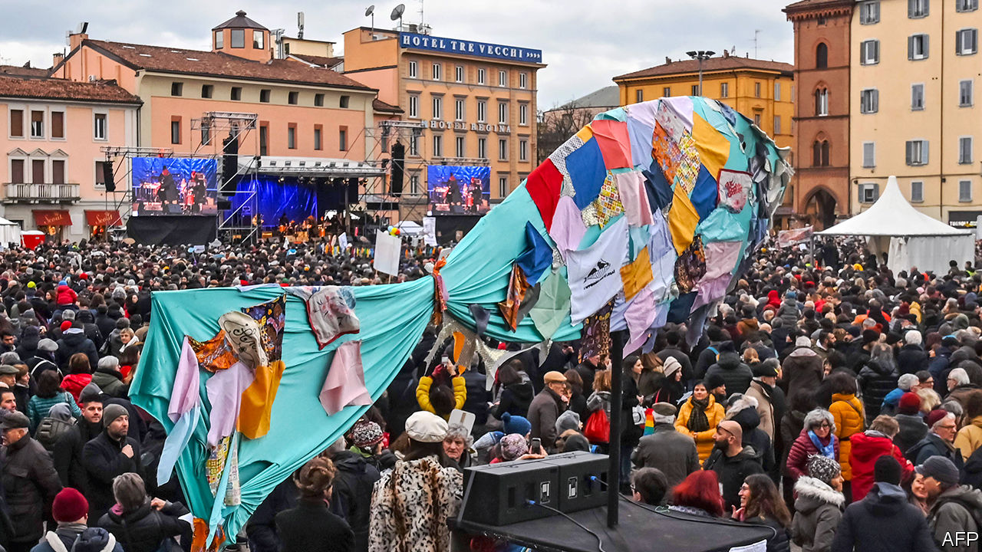

IT IS PROBABLY the most famous of modern Italian political aphorisms. “Power wears out those who do not have it,” quipped the late Giulio Andreotti, a long-serving prime minister. His words had a special relevance this week for Matteo Salvini, leader of the right-wing Northern League, as he pondered the results of his second big miscalculation in five months. On January 26th the League’s candidate for governor failed to conquer the region of Emilia-Romagna in a vote that Mr Salvini had touted as a referendum on whether he should lead Italy.

Mr Salvini has only been out of power since August last year. Until then he was one of two deputy prime ministers in the first cabinet of Giuseppe Conte, a technocrat; he wielded a decisive influence over policy as head of the party that has led in the polls since mid-2018. But then he torpedoed the coalition government in a bid to force an election, hoping it would give him an outright parliamentary majority and untrammelled powers. His rivals responded by forming a new coalition without him.

His latest big miscalculation was to put himself at the front of a campaign he should have known would be harder to win than it seemed. Emilia-Romagna, which stretches from central into northern Italy, has drifted rightwards in recent years. The left lost there in the general election in 2018 and the European election in 2019. But it has deep roots in a region the now-defunct Italian Communist Party (PCI) chose as a showcase for its moderate “Eurocommunism”. The incumbent governor, Stefano Bonaccini, who cut his political teeth in the PCI’s successor party, is widely regarded as heading an effective administration. A poll conducted last December showed that two-thirds of voters in Emilia-Romagna viewed it positively. And almost twice as many expressed confidence in Mr Bonaccini as in his League challenger. Mr Salvini’s advisers presumably warned him of similarly daunting findings.

Two other factors played a role in the League’s emphatic defeat (its candidate finished more than seven percentage points behind Mr Bonaccini). The first could not have been foreseen: the eruption onto the scene of a new movement, the so-called Sardines, a group of young, left-leaning activists who set out to best Mr Salvini at his own game of packing city squares (hence their name). They succeeded repeatedly, doubtless convincing some voters who might otherwise have abstained to cast their ballots for Mr Bonaccini and the centre-left Democratic Party (PD). The turnout shot up to 68%—30 points more than at the previous regional election in 2014. The Sardines’ role in bringing out the left-wing vote earned them an “immense thank you” from the PD’s national leader, Nicola Zingaretti.

The second factor, if not foreseeable, was certainly avoidable. In a region known for its moderation, Mr Salvini mounted his usual, xenophobic campaign. Stunts such as having video cameras record him asking a Tunisian immigrant over the intercom of his apartment block if he was a drug-peddler grabbed headlines, but not apparently very many hearts and minds in tolerant Emilia-Romagna.

In another regional ballot in the southern region of Calabria the right stormed to victory. But that was scant consolation for Mr Salvini, since the new governor is from Silvio Berlusconi’s Forza Italia party, which nowadays represents a less populist and Eurosceptic form of conservatism than the League’s. Calabria is anyhow special, a region in which political choices are heavily conditioned by the pervasive influence of its mafia, the ’Ndrangheta.

Mr Salvini’s air of invincibility dissipated last summer. But now his headstrong approach is being openly mocked. Elsa Fornero, a minister in Mario Monti’s technocratic government of 2011-13, and author of a labour-market reform Mr Salvini wanted to scrap, asked mischievously if he was foolish, or just pretending to be.

The League leader’s chances of returning to power nevertheless remain solid. Both the latest elections were disastrous for the Five Star Movement (M5S), notionally the senior partner in Mr Conte’s second government, which also includes the PD. The M5S has almost a third of the seats in parliament and the power to decide on legislation. Yet its candidates scraped 7% in Calabria and a pitiful 3% in Emilia-Romagna. They were scarcely helped by the resignation four days before polling of the movement’s leader, Luigi Di Maio, largely in response to its dismal showing in earlier ballots and the disarray that had created.

The M5s was set up to challenge the established parties, resists being called a party itself and claims to transcend the division between right and left. Inevitably, it has found itself ill at ease in power, and all the more so now it is in coalition with the mainstream PD. Since the general election in March 2018, 24 of the M5S’s 331 lawmakers have deserted it in parliament.

What happens now is unclear. Mr Zingaretti proposed that the Five Stars formally join the PD in an electoral alliance that already includes other, smaller groups. But his offer was implicitly rejected by the M5S’s stopgap leader, Vito Crimi. The movement is to hold a congress in March to decide whether to take a new direction.

That sets a leisurely timetable given the pace at which the M5S is disintegrating. The governing coalition is safe in the lower house where it has a majority of 24. But in the Senate, the Five Star defections have already left it two seats short of a majority and dependent on the support of assorted regionalists and independents.

The PD is more compact. But that is largely because it has lost almost 40 of its parliamentarians to Italia Viva, a group set up last year by a former prime minister, Matteo Renzi. Italia Viva is not yet a party and remains in the government’s orbit. But Mr Renzi, who has been wooing the more moderate wing of Forza Italia, remains a wild card. Against this background, Mr Salvini’s best course may be to sit tight and do only as much as necessary. But it is one the League’s hyperactive, publicity-hungry leader will find hard to follow. ■

This article was downloaded by calibre from <https://www.economist.com/europe/2020/02/01/regional-elections-in-italy-buttress-the-government>

|  |  |  |  |
| --- | --- | --- | --- |
|  | Articles | Sections | Next |

|  |  |  |  |
| --- | --- | --- | --- |
| Previous | Articles | Sections | Next |

#### Unite or die

# The plight of Hungary’s opposition

Taking on Viktor Orban will be no easy matter

Feb 1st 2020 | BUDAPEST



IN THEORY VIKTOR ORBAN, who has ruled Hungary with a rod of iron since 2010, ought to be running scared. In October he suffered the humiliation of losing control of the capital, Budapest, as well as ten of the 23 other county-level cities in the country. That happened because Hungary’s perennially fractured opposition for once managed to unite, holding a primary election in Budapest to decide on a single contender and elsewhere forming pacts to achieve the same goal.

Now plans are afoot to pull off the same trick at parliamentary elections that are due in 2022. If that happens, Mr Orban’s ruling party, Fidesz, could lose its current huge majority. Mr Orban is already sounding chastened: his new year’s message was largely about mundane issues like education and health, a far cry from his usual ranting about enemies within and without.

Still, those plans for 2022 involve a very big “if”. Agreeing on a few mayoral candidates is one thing: doing the same for each of the country’s 106 single-member constituencies, as well as drawing up a joint party list for the 93 proportionally elected MPs, is a lot harder. If the dozen or so opposition parties run separate lists, quirks that favour big parties in the electoral system Mr Orban rammed through in 2012 will continue to hammer them. Hardest of all, of course, will be to choose a candidate to be prime minister.

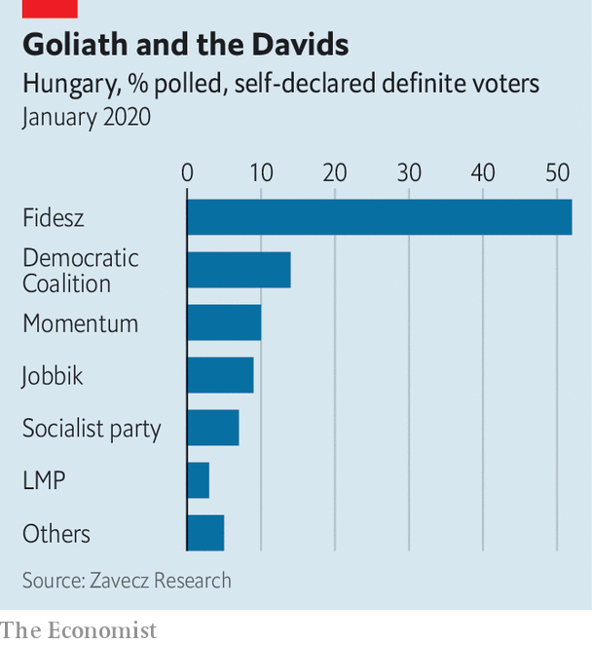

Who might it be? One obvious possibility is Gergely Karacsony, the newly ensconced mayor of Budapest. Looking every bit the university lecturer he used to be, dressed down in jeans, jacket and open-neck shirt, the 44-year-old Mr Karacsony has a platform to campaign from. But Mr Orban is already tying him in knots, linking money for the city to the construction of a new stadium for the World Athletics Championships in 2023, which the mayor said on the campaign trail that he did not want to build. Besides, Mr Karacsony insists that he doesn’t want the job, and would rather complete his term. His Dialogue party is tiny outside the capital.

Some instead look for a return of a former prime minister, Ferenc Gyurcsany, who leads the largest opposition party, Democratic Coalition. Largest, though, is a relative term. In recent polls it struggles to get far into double figures, while Fidesz manages around 50% in most polls. Mr Gyurcsany’s chaotic time as prime minister is not remembered fondly by most Hungarians, and even he admits that he is “a very polarising person, very much loved, and very much hated”. Instead, he says, “we need an integrator.” He offers his wife, Clara Dobrev, as a possible prime minister. She is currently a vice-president of the European Parliament, having scored a remarkable success at the head of the Democratic Coalition’s list in last year’s Euro-election. Mr Orban refers to her, incorrectly, as “Mrs Gyurcsany”. She, too, may be reluctant to put herself forward.

The woman to watch is less well known. Anna Donath is just 32, and is also an MEP, in her case for Hungary’s most interesting new party, with the pleonastic moniker Momentum Movement. Momentum was the big surprise in the European election; founded only in 2017, it won just under 10% of the vote. Insiders, however, worry that she may not want to run, either.

The real problem is that Mr Orban does not really look beatable in 2022. He has shrugged off his difficulties with the rest of the EU over Hungary’s erosion of the rule of law (a task made easier because Poland is now behaving worse). The economy is booming; it grew by around 5% last year. Corruption ought to be his Achilles’ heel. Last week Transparency International, a watchdog, rated Hungary the second-most corrupt country in the EU, beaten only by Bulgaria. “But,” sniffs one diplomat, “as long as incomes are going up, Hungarians don’t seem to care.” ■

This article was downloaded by calibre from <https://www.economist.com/europe/2020/02/01/the-plight-of-hungarys-opposition>

|  |  |  |  |
| --- | --- | --- | --- |
| Previous | Articles | Sections | Next |

|  |  |  |  |
| --- | --- | --- | --- |
| Previous | Articles | Sections | Next |

#### One party, two candidates

# Emmanuel Macron may be about to lose in Paris

He won 90% of the Parisian vote in 2017. But his party is in disarray

Feb 1st 2020 | PARIS

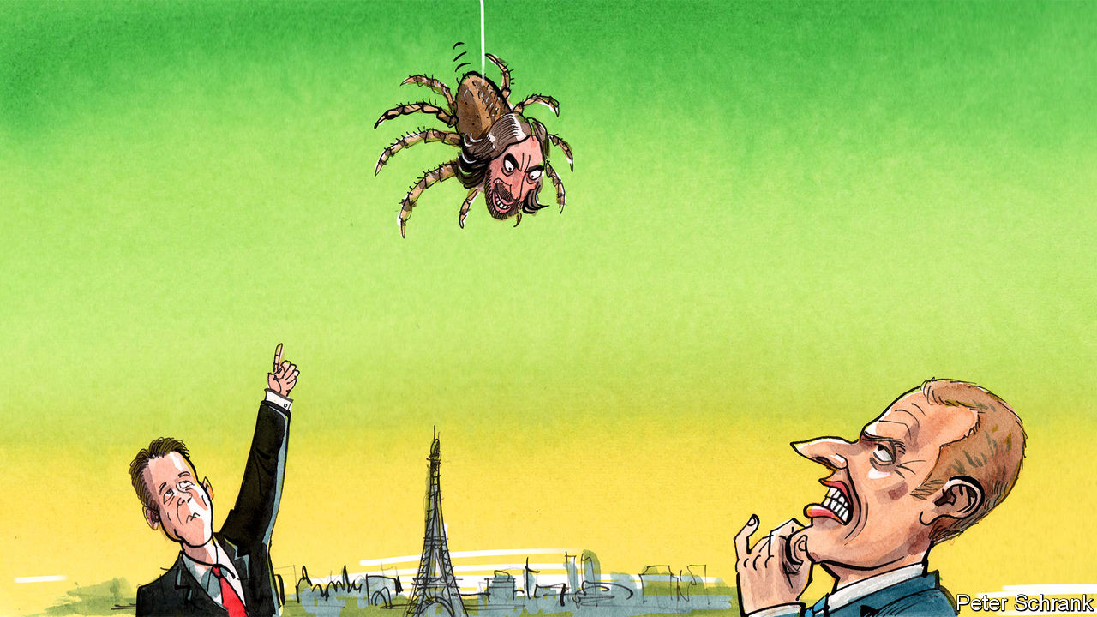

IF THERE IS one city that should be a natural habitat for Emmanuel Macron and his centrist party, it is Paris. Home to the country’s liberal elite, as well as to bike-sharing eco-types who applauded the president’s pledge to “make our planet great again”, the French capital is a world away from the rural roundabouts of the anti-Macron gilets jaunes. In the second round of the presidential election in 2017, fully 90% of the city’s voters backed Mr Macron. Yet, thanks to internal rivalry and mismanagement, his party is currently making a hash of the race for mayor of Paris.

The capital, along with all other municipalities, goes to the polls for two rounds of voting on March 15th and 22nd. In a bid to dislodge Anne Hidalgo, the sitting Socialist mayor of Paris, Mr Macron’s party, La République en Marche (LREM), finds itself with, in effect, not just one candidate but two. The first, Benjamin Griveaux, is the official nominee. The other, Cédric Villani, failed to secure the party nomination but insists on staying in the race anyway.

Both Mr Griveaux and Mr Villani are LREM deputies, elected for the first time in 2017. Mr Griveaux is one of the original “Macron boys”: a co-founder of En Marche, the party Mr Macron launched to win the presidency, and a campaign insider who was propelled directly into government. Mr Villani is a prize-winning mathematician, known for his signature three-piece suit and spider brooches, who has published research papers on such topics as collisional kinetic theory. It was something of a coup for En Marche to have coaxed him into running for parliament.

Last July, when the LREM investiture committee picked Mr Griveaux as the official candidate, however, Mr Villani refused to stand down. The selection process was flawed, he said; he also defended his right to “liberty”. The upshot has been to split the LREM vote. Polls now suggest that Mr Griveaux could come third in the first round of voting, behind both Ms Hidalgo and Rachida Dati, the centre-right Republican candidate, with Mr Villani trailing in fifth. A second-round vote would then keep Ms Hidalgo in the job.

Efforts are afoot to try to broker a peace and persuade Mr Villani to give up. Mr Macron even summoned him to the Elysée palace, but Mr Villani emerged to declare that he had “a major divergence” with the president. On January 29th, after much internal soul-searching, LREM decided to expel Mr Villani from the party. Disappointingly for the president, he says he will continue his campaign as an independent.

Further realignments are possible, including one around the Greens’ candidate, David Belliard. Making Paris greener is the one idea all the candidates agree on. For his part, Mr Griveaux says that his “door remains open”, should Mr Villani change his mind about running. But time is running out. History teaches that France’s presidents, like its Bourbon kings, often struggle to impose their will on Paris, an unruly city that famously does not take kindly to decisions imposed from on high. ■

This article was downloaded by calibre from <https://www.economist.com/europe/2020/02/01/emmanuel-macron-may-be-about-to-lose-in-paris>

|  |  |  |  |
| --- | --- | --- | --- |
| Previous | Articles | Sections | Next |

|  |  |  |  |
| --- | --- | --- | --- |
| Previous | Articles | Sections | Next |

#### Cleaning up Greece

# Why many Greek greens oppose wind power

Windmills spoil the view

Feb 1st 2020 | KOZANI AND KARDITSA

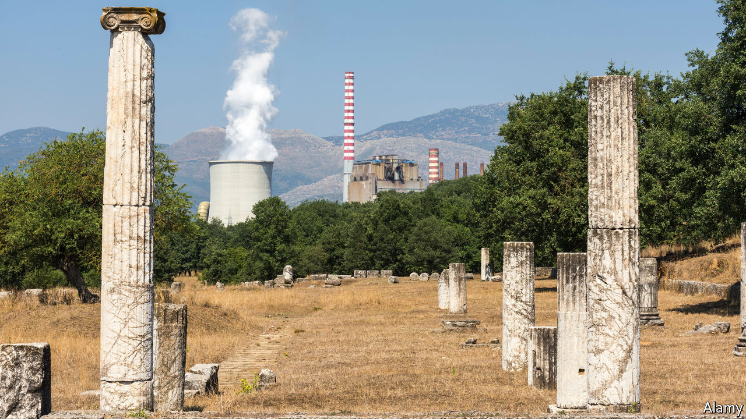

A CLUSTER OF state-owned power plants in north-western Greece have been spewing smoke and toxic ash over nearby villages for decades. The plants are fuelled by lignite, a dirty brown coal extracted from open-pit mines that scar the local countryside. Studies have shown that mining communities suffer above-average rates of lung disease and cancer, yet jobs in other sectors are scarce in a region with chronically high unemployment.

Changes may be on the way. Kyriakos Mitsotakis, the new centre-right prime minister, has promised to shut down all of Greece’s 14 lignite-fired power stations by 2024. (Another lignite station currently under construction will be converted to run on natural gas.) Fleets of wind turbines and solar panels will be rolled out across rehabilitated mining areas. Mr Mitsotakis is anxious to boost Greece’s green credentials: at present its annual carbon-equivalent emissions are a third higher than those of Portugal, a similar-sized EU member state.

Despite being blessed by abundant sunshine and strong winds that blow year-round across the Aegean sea, Greece is still a clean-energy laggard. That is mostly due to PPC, the state electricity utility, which has stuck to lignite to save money, rather than switching to natural gas and renewables. In 2017 some 70% of homes and businesses consumed electricity that was produced at PPC’s lignite-fired power stations. This year the figure may fall to 50%: small private suppliers that run natural-gas-fired plants have picked up customers fleeing PPC after Mr Mitsotakis’s government hiked its electricity prices.

The prime minister has set himself a remarkably ambitious target: renewable sources are to cover 35% of Greece’s energy needs by 2030. That would mean tripling current wind and solar output, at a cost of around €40bn ($44bn). Consultants predict a bonanza for foreign investors: Chinese, American, Spanish and Italian companies already own Greek wind and solar installations and are acquiring licences to build more.

Oddly, they will face strong opposition from Greece’s increasingly active environmental movement. It takes up to seven years for a licence for a wind park to be granted; many applications are rejected by specialist judges at the council of state, Greece’s highest legal body.

Battles loom over plans to allow offshore wind parks to be built in the Aegean and Ionian seas, while increasing the size of onshore parks. Greece’s environment is “too fragile” to sustain such big projects, says Apostolos Pantelis, a hill-walker campaigning against plans to build wind parks on mountain ridges in the remote Agrafa region, a refuge for rare griffon vultures, brown bears and wolves.

Increasing numbers of hikers, mostly well-heeled northern Europeans, visit places like the Agrafa thanks to a successful new system of marking footpaths across mainland Greece and the islands. They stay in small hotels in almost deserted villages, prompting hopes that such places can be revived as destinations for “soft” tourism.

Mr Pantelis fears building wind parks would destroy the Agafra’s appeal. New roads would erode the mountainsides and noisy, 200m-high turbines would scare away its wildlife. He says that “people used to think wind energy would be beneficial for tourism. But it just ruins the view.” ■

This article was downloaded by calibre from <https://www.economist.com/europe/2020/02/01/why-many-greek-greens-oppose-wind-power>

|  |  |  |  |
| --- | --- | --- | --- |
| Previous | Articles | Sections | Next |

|  |  |  |  |
| --- | --- | --- | --- |
| Previous | Articles | Sections | Next |

#### Asia minor, and major

# Why Chinese road signs cause outrage in Istanbul

Turks resent China’s oppression of Muslim Uighurs

Feb 1st 2020 | ISTANBUL

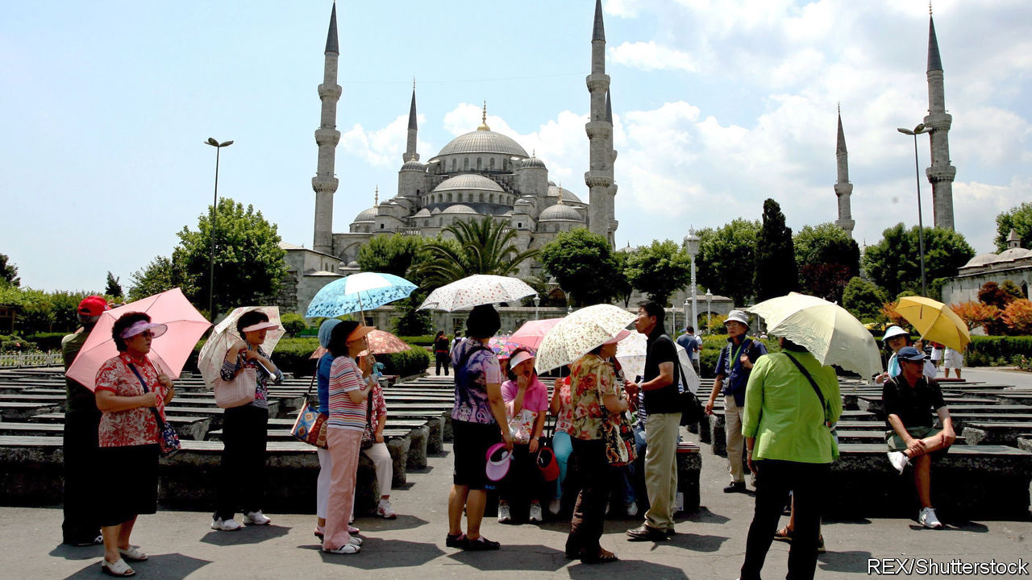

A FEW MONTHS ago commuters in Istanbul were treated to an unusual sight. Overnight, the names of some metro and tram stops, especially in parts of the city popular among foreign tourists, appeared in Chinese characters. Angry about China’s treatment of Turkic-speaking Uighurs in Xinjiang province, protesters ripped down some of the signs. They covered others with stickers reading: “Murderer China” or “Freedom for East Turkestan” (the name for Xinjiang preferred by Uighur separatists).

Ekrem Imamoglu, the opposition mayor, explained that the signs had been installed as part of an agreement between Istanbul and China’s embassy, and that the arrangement was temporary. The signs vanished as fast as they had appeared.

China’s footprint in Turkey is growing. The annual influx of Chinese tourists has climbed from about 60,000 a decade ago to over 400,000 last year. China has helped build Turkey’s first stretch of high-speed rail, Huawei is helping it build a 5G mobile network and Chinese investors have snapped up Turkish marble quarries to kit out luxury flats back home. Last year China’s central bank provided Turkey with $1bn under a currency-swap agreement. Rumours swirl that Chinese cash will soon pour into the country under the Belt and Road Initiative, a project to connect the world to China by building roads, railways and other infrastructure. So far, it hasn’t.

The oppression of the Uighurs seems to be the main obstacle. Last year Turkey was the only large Muslim country to complain about China locking up perhaps 1m of them for such offences as growing beards or being pious Muslims. In response, China temporarily closed its consulate in Izmir, a big coastal city. Turkey had crossed one of the Chinese government’s red lines, says Guo Changgang of the Centre for Turkish Studies at Shanghai University. Since then Turkey has trodden more carefully. Last June, after opposition deputies called for an inquiry into the repression of Uighurs, The ruling party voted down the proposal. During a subsequent trip to China President Recep Tayyip Erdogan took a softer line on the internment camps.

China will not stay away from Turkey for long. It is a market of 80m people and a gateway to Europe and the Middle East. Some day, Chinese contractors eager to join the reconstruction of war-ravaged Syria will also look to Turkish ports and cement producers for help. “Turkey has the resources and the suppliers,” says Altay Atli of Koc University in Istanbul. “The Chinese simply have to come here.”

Turkey has struggled to attract foreign investment in the past few years, largely as a result of tensions with America and Europe, over such things as its friendliness to Russia, the purchase of Russian missiles and human rights. Some in government advocate cosying up to China as well as Russia. But China is unlikely to bail out Turkey’s economy. Of the total stock of foreign investment in Turkey between 2002 and 2018, some 75% came from Europe; the Chinese share was around 1%.

At his newly opened Beijing Hotel, close to Istanbul’s main entertainment and shopping district, Jackie Cheng watches a group of Chinese guests trickle out of the main entrance, past a restaurant that serves respectable Chinese fare, and into a tour bus. Mr Cheng arrived in Turkey two decades ago, made his fortune dealing in textiles and souvenirs, and opened Istanbul’s first Chinese hotel last year. Business has been good, he says. He plans to open branches elsewhere in Turkey. Asked what might help bring in more tourists and investors from the old country, he mentions government support and simpler procedures for getting a residence permit. “But one thing that’s really needed right now”, he says, “are more signs in Chinese.” ■

This article was downloaded by calibre from <https://www.economist.com/europe/2020/02/01/why-chinese-road-signs-cause-outrage-in-istanbul>

|  |  |  |  |
| --- | --- | --- | --- |
| Previous | Articles | Sections | Next |

|  |  |  |  |
| --- | --- | --- | --- |
| Previous | Articles | Sections | Next |

#### Strings of life

# Berliners fear “club death”

But nightlife in the world’s clubbing capital is changing, not dying

Feb 1st 2020 | BERLIN



HALF PAST seven on a chilly Monday evening is hardly clubbing prime-time. Yet on January 27th a formidable queue extended outside Griessmuehle, a gritty techno spot in Berlin’s Neukölln district, from whose walls emanated hearty 4/4 kick drums. The party had been going since Sunday under the rubric “Is this the end?”, for on February 3rd Griessmuehle must close; the building’s Austrian owners wish to convert it into offices. The Club Commission, a lobby group, reckons 24 Berlin clubs may face closure. Some, like KitKat, an entry-level fetish den in Mitte, are as much part of the city’s fabric as the Brandenburg Gate.

Hand-wringing over Clubsterben (“dying clubs”) is nothing new in a growing city where the pressures of gentrification have long rubbed up against the fly-by-night world of clubbing. Yet the threat to Griessmuehle touched a nerve, uniting ravers and politicians behind a #saveourspaces hashtag. Official support for a €168m ($185m) industry that attracts tourists and investment is now obligatory in perennially hard-up Berlin.

Gentrification in Berlin started late but now has a “feeling of velocity”, says Luis-Manuel Garcia of the University of Birmingham. The glittering array of protections that private tenants enjoy in Germany do not extend to businesses. Commercial landlords may jack up rents abruptly or keep club-owners dangling on rolling six-month contracts. What to do? “Frankly, we don’t have that many tools,” accepts Georg Kössler, a Green in Berlin’s parliament. Lutz Leichsenring of the Club Commission says federal building law should recast clubs as “cultural institutions”, providing them with the same benefits as theatres and galleries.

Yet “it would be hard to claim that clubs are genuinely threatened,” says Will Lynch, the Berlin-based editor of Resident Advisor, a dance-music website. Next to the precipitous decline in cities like London, the turnover in Berlin looks more like churn; about 90 clubs have closed since 2010 but 77 have opened.

Thrill-seekers are rarely left disappointed by Berlin’s many nocturnal temptations, unless they are turned away by a grumpy bouncer. Some beloved institutions have gone; others have now become a bit too slick for old-timers’ tastes. But Berghain, the jewel in no-curfew Berlin’s clubbing crown, raves on, its future secured by ownership of the building. Even Griessemuehle may find a new home elsewhere. The threats are real. But rumours of Clubsterben may have been exaggerated.

This article was downloaded by calibre from <https://www.economist.com/europe/2020/02/01/berliners-fear-club-death>

|  |  |  |  |
| --- | --- | --- | --- |
| Previous | Articles | Sections | Next |

|  |  |  |  |
| --- | --- | --- | --- |
| Previous | Articles | Sections | Next |

#### Charlemagne

# After Brexit, who will be the British of the EU?

There are lots of contenders for the New Brit awards

Feb 1st 2020 |



BRITAIN WAS an awkward member of the EU. It joined late, complained lots and has now become the only country ever to leave. Yet beneath the cantankerous caricature, Britain played a useful role. It championed a liberal vision of the EU and was a bulwark against dirigisme. British diplomats gummed up projects of which they were sceptical, such as a common defence policy, and accelerated those which they supported, such as the single market. Contrary to its self-image, Britain rarely stood alone in the EU. Britain was the noisiest advocate of policies that are commonly (but quietly) held across many member-states. Even with the Brits outside the bloc, those views will still be there. But the messengers will change. Who will they be? Welcome to the Brit awards, where your columnist will name the New Brits.

Sorting through the contenders is no easy job. There are so many. Take the EU’s budget negotiations, which will come to a head this year. Britain was far from alone in its determination to curb EU spending. Rebates, whereby some countries receive back a chunk of what they put in, loom largest in British Eurosceptic lore, but other countries have secured them, too. A proposal in 2018 to do away with the cash carousel led to howls in Dutch, German, Swedish and Danish. Britain had exactly the same policy goals as other net contributor countries; it just had the loudest voice. Since then, Austria, Sweden, Denmark and the Netherlands have teamed up to turn up the volume. This skinflint foursome proudly refer to themselves as the Frugal Four. Any one of them could take the New Brit award for best Brussels belt-tightener.

Discomfort about the idea of the EU as a military power goes well beyond London. Germany does not want anyone to think it is throwing its weight around. On many issues, it prefers to remain in the back seat; when it comes to defence, it climbs into the boot. Any proposal that undercuts NATO’s role as Europe’s defender makes German diplomats sweat; never mind their peers in the Baltic states, for whom NATO is the only thing that keeps Russian tanks at bay. Poland is even touchier. It has greeted attempts to forge a more European defence strategy by embedding itself ever deeper into America’s military nexus, slyly suggesting that a garrison on Polish soil could be called “Fort Trump”. Poland easily wins the New Brit award for defending the status quo on defence.

Beyond a few holdouts in the European Parliament, European federalism, the bête noire of British Eurosceptics from the moment Britain joined, has died a quiet death. EU wallahs may busy themselves with plans for a grand-sounding conference on the future of Europe later this year. But it will be a far cry from the constitutional convention of 2001-3, at which former French presidents and other grandees cooked up a European constitution (which was then rudely rejected by French and Dutch voters). Any suggestion of a similar effort this time round makes diplomats choke. Referendums, they have noticed, can be disruptive. The New Brit award for dreading federalism goes to everyone.

Liberal member-states have already clubbed together in the face of a more state-centric approach to the economy advocated most prominently by France. Dubbing themselves the New Hanseatic League, ministers from the Baltics, the Nordics, Ireland and the Netherlands now meet regularly to stave off statism (the Germans occasionally show up, too). Brexit has shaken the Dutch out of their political dysmorphia, in which the euro zone’s fifth-biggest economy tended to behave as if it were the size of Malta. As the de facto leader of the new league, the Netherlands wins the New Brit award for defending free markets from the French.

A Utopian fantasy still exists in some quarters that an EU without Britain will be more coherent. As the largest country outside the euro and the Schengen passport-free travel zone, Britain did stick out. But the EU will hardly be one-size-fits-all, even with the biggest constitutional kink ironed out. Denmark has opt-outs from the euro and justice and home-affairs policies. Ireland is not a member of the passport-free Schengen zone and has a common law legal system, unlike the civil law in the rest of the bloc. Special treatment abounds even when not written into law. Iron rules on fiscal discipline seem curiously flexible whenever France is involved. Visegrad countries (Hungary, Poland, Slovakia and the Czech Republic) created their own opt-outs on migration policy by simply ignoring laws. Technically all countries bar Denmark are obliged to join the euro. Yet Sweden seems in no rush. Poland is five years from joining the common currency—and always will be, goes the saying. The EU will remain a constitutional camel rather than a thoroughbred even without Britain.

## And the big winner is…

The fact that the Brit awards attract so many entries suggests that Britain was not such an odd man out. Once Britain has left, the EU will still have a rain-sodden, low-tax, English-speaking island in the north-west: Ireland. It will still host a former imperial power with a tendency to write geopolitical cheques it cannot honour: France. Likewise, anyone who thinks Britain was the only country with a morbid determination to bring up the second world war should glance at Polish politics. Perhaps Britain was a normal EU country after all.

Still, there can only be one overall winner. The Netherlands would be an obvious choice, given the similar policies of the British and Dutch governments. But the Dutch sit happily in the euro zone, as the Brits never would. Poland, like Britain, is outside the euro and recoils from European defence integration. Britain, however, was generally a constructive partner in the EU, which cannot be said of the current Polish government. This leaves one candidate. Liberal on trade, yet miserly when it comes to the EU’s budget, this country also enjoys opt-outs on a Britannic scale. Congratulations, Denmark! It is a long time since Danes ruled half of England, but the two nations have much in common. ■

This article was downloaded by calibre from <https://www.economist.com/europe/2020/02/01/after-brexit-who-will-be-the-british-of-the-eu>

|  |  |  |  |
| --- | --- | --- | --- |
| Previous | Articles | Sections | Next |

|  |  |  |
| --- | --- | --- |
| Europe | Sections | International |

Britain

Brexit and regulation: Into the wide blue yonder

.

Euro-myths: Carry on commissioner

.

Fisheries after Brexit: A scaly problem

.

Immigration after Brexit: Points of departure

.

Trade deals: Third country stories

.

Rail nationalisation: Northern Fail

.

Television news: British Broadcasting Cuts

.

Judicial reviews: Trans: the pushback

.

Bagehot: The English problem

.

|  |  |  |
| --- | --- | --- |
| Europe | Sections | International |

|  |  |  |  |
| --- | --- | --- | --- |
|  | Articles | Sections | Next |

#### Brexit

# Britain’s regulatory-divergence dilemma

There will be costs to diverging from EU regulation. But there will be benefits, too

Jan 30th 2020 |



BRITAIN’S DEPARTURE from the EU, says Sir Bernard Jenkin, a Conservative MP, reminds him of an experiment his grandfather once carried out on a pet pike. He put a glass wall in the middle of the fish’s tank, thus halving its swimming space. After ramming the glass, “thunk, thunk” for a while, the fish adapted to its diminished quarters. But when the wall was removed, it continued making tight circles in half of the tank: it never grasped that its freedom had been restored.

On January 31st Britain leaves the EU. It goes into a sort of limbo—a transition period—until the end of 2020, when in dozens of areas, from trade, migration, environmental rules and farming to financial services, data policy, regional subsidies and state aid, the country’s freedom to run its own affairs will be constrained only by its ambitions to do deals with other countries. The big question, says Sir Bernard, an enthusiastic Brexiter, is whether it can remember how to roam.

Boris Johnson, the prime minister, is bent on taking full advantage. There will be crowd-pleasing changes—taking back control of the VAT regime will allow the Treasury to remove the levy on tampons, for instance—and weightier divergences. Earlier this month Sajid Javid, the chancellor of the exchequer, made clear that there will be no alignment with EU regulations once Britain is out of the single market and customs union, adding that there would be winners and losers.

The riposte from Brussels to Mr Javid’s remarks was swift. Ursula von der Leyen, president of the European Commission, repeated that greater regulatory divergence would necessarily mean a more distant trading partnership with the EU. The government’s own economic analysis of Brexit last year put the long-term loss in GDP per person of a close relationship (like Norway’s) at some 1.4%, against a loss of 4.9% for a more distant one. The difference is a proxy for the cost of regulatory divergence.

British manufacturers protested. The car and aerospace industries, chemicals and pharmaceuticals firms, the Confederation of British Industry (CBI) and Unite, the biggest trade union, all talked of the adverse consequences of divergence. Ministerial promises only to diverge when that is in Britain’s interests do not much reassure them. The only way to avoid customs, rules of origin and regulatory border checks is to make legally binding commitments to observe all current and future EU rules, which the government has rejected.

Some 80% of the auto industry’s output is exported, and over half those exports go to the EU. Regulatory divergence would mean cars (and car parts) being subject to compliance checks in both directions, increasing costs and delays. Some 60% of the chemicals industry’s output goes to the EU.

But there is bound to be divergence. Regulation is the expression of public attitudes to business and the state; since those are different all over the world, Britain’s rules will become increasingly British. And there could be benefits as well as costs.

Regulation in Britain tends to be based on principles, rather than prescription; the country’s common-law system builds on it over time. European regulation, by contrast, is more codified, which leads to a lot of prescriptive detail. The very word “directive” strikes fear into executives, says Helena Morrissey, a City financier. Financial firms get snarled up in detailed EU rules. The cost to the British asset-management industry of obeying the revised Markets in Financial Instruments Directive, which came into force in 2018, for example, is an estimated €2.5bn ($2.75bn). The burden of regulation falls especially heavily on small firms, discouraging enterprise.

Britain’s new freedom to regulate flexibly and nimbly will be invaluable, says Rishi Sunak, chief secretary to the Treasury and a rising star in government. A particular opportunity, says the boss of a London-based exchange, would be to adopt America’s regime for regulating derivatives, considered the best in the industry. The EU recognises it, so London could ask to be treated in the same way, he says.

Two of the buzziest areas of finance are fintech and sustainable finance. The City has a better chance of getting ahead in those areas if it has its hands on its own regulatory levers, says Jonathan Hill, a Conservative politician and former financial-services commissioner for the EU. One approach likely to be used more widely is the “regulatory sandbox”: rather than banning an innovation or approving it for use across the system, regulators allow it to be used on a limited scale and monitor its effects. If the risks seem low, the new practice is allowed wider application.

Britain’s different political priorities are also likely to show up in regulatory divergence. Britons have, for instance, a softer spot than most Europeans for their fellow creatures; hence rumours that Mr Johnson is planning to ban exports of live farm animals for slaughter.

Of more economic significance is the divergence in attitudes to finance. The long campaign to introduce a financial transactions tax has more takers in the EU than in Britain. And hostility to wealth is probably more pronounced within the EU than in Britain, hence one of the most disliked pieces of EU regulation—a cap on bankers’ bonuses introduced in 2014, which forces banks to raise the proportion of their costs that are fixed, thus potentially making profits more volatile.

The EU’s instincts, meanwhile, are more protectionist than Britain’s. Britain is, for instance, already moving away from the EU requirement that only airlines 50% owned by local companies have unrestricted rights to fly within the EU. And the noises coming out of the commission about the need to foster local tech titans suggests that the gap on this front may widen.

In science, too, Britain is likely to diverge from Europe. Britain’s empirical approach to intellectual life makes it more permissive, while the “precautionary principle”, for which the continent has more time, tends to be inhibitive. In July 2018, for instance, the European Court of Justice (ECJ) ruled that plants obtained by modern forms of mutagenesis, of which gene-editing is an example, fall under the EU’s GMO directive from 2001. The GMO legislation, because it is complicated and expensive to comply with, amounts to a de facto ban. Sir Mark Walport, chief executive of UK Research and Innovation, attributes this hostility to GMOs in part to personal beliefs about the legitimacy or otherwise of fiddling with nature. “Now we can work in the context of UK society which in general thinks very positively about science.”

Britain is leaving the EU just as the bloc gets ready to clamp down on artificial intelligence (AI). It may impose laws for developers in what it considers high-risk sectors such as health care and transport. Many people will welcome the EU taking a robust stance on controversial AI products like facial recognition. But some worry that Brussels is rushing to regulate AI without stopping to consider the trade-offs. Post-Brexit, Britain will write its own regulations on AI and on data. Eventually there will be three regimes in the world—the EU’s, America’s and China’s. Britain’s rules could end up closer to those of America than the EU.



London’s tech industry is also excited about what a trade deal with America might bring in the field of digital services, says Nicole Sykes, head of EU negotiations for the CBI. “We could create a more stable environment for technology firms large and small,” says Stephen Booth, director of Open Europe, a Eurosceptic think-tank.

The globalist wing of the Brexit movement is keen to boost the country’s competitiveness by lightening social, economic and environmental rules. Business will have plenty of suggestions. Many dislike the requirement that obliges them to hire temporary workers after a short period of time. Smaller businesses in particular could be awarded more exemptions from labour regulations.

This worries the EU, which is particularly concerned that there should be a “level playing field”. On environmental protection, Brussels calculates that British industry could save €4.7bn a year if it departed from the EU’s rules on industrial emissions and pollution.

Yet Mr Johnson seems unlikely to go for much of this sort of deregulation. He is not that sort of Tory, and cutting labour and social protections would rile British voters—especially in the poorer areas where the Conservative Party has just made big gains. Although Britain originally got an opt-out from the Social Chapter of the Maastricht Treaty, it has sometimes gone above and beyond what Brussels wants: it has given temporary workers more rights and parents more leave than the EU demands. The green movement is strong in Britain, and will keep a protective watch on environmental regulation. The government is reportedly inclined to toe the EU line and keep most of the massive REACH law that regulates chemicals. “There are plenty of things you might want to do in your dark free-market heart but the public doesn’t want it,” says Robert Colvile, director of the Centre for Policy Studies, a Conservative think-tank.

Focused as it is on boosting growth in England’s peripheries, the government seems more likely to diverge from EU state-aid rules than from social, environmental and labour protections. Mr Johnson has put the creation of ten “freeports”, that for customs purposes are legally outside Britain, high on the agenda. Freeports can offer zero tariffs, low taxes and loose regulation. America has 250 free-trade zones. The EU claims to have 85 customs-free zones but in reality there isn’t much to them. Mr Sunak says EU single-market regulations and state-aid law have stopped Britain from using such zones properly. “The EU makes it very hard to make them seamless and really exciting,” he says.

## Going free range

The biggest arguments are going to be around fisheries (see [article](https://www.economist.com/britain/2020/02/01/britains-fisherfolk-fret-about-being-sold-down-the-river-yet-again)) and agriculture. Farmers and fishermen, who voted enthusiastically for Brexit, make up a tiny proportion of GDP—0.6% and less than 0.1% respectively—but their travails will loom large: Scarry’s Law, formulated over a decade ago by this newspaper and named after Richard Scarry, a children’s illustrator, states that politicians mess at their peril with groups that feature in children’s books—farmers, fishermen, train drivers and suchlike.

The EU’s approach to farming is unpopular among an impressively wide range of people. Some dislike the fact that the common agricultural policy (CAP) has shovelled vast subsidies to a tiny sector, many of whose members are landed gentry; others that it depresses the price of agricultural products, thus impoverishing developing countries. Environmentalists regard automatic payments for agricultural land as an incentive to clear wildlife habitats and cut down trees. Farmers dislike the EU’s tight rules on the use of pesticides.

The government’s new agriculture bill proposes public subsidies for farmers who promote public welfare. They will in future be paid for things like improving animal welfare and air and water quality. But their future looks uncertain. Within the EU, farmers benefited from the power of the French agriculture lobby, which ensured that tariffs were high and the CAP swallowed up more than a third of the EU’s budget. British farmers do not have that sort of clout. Declining subsidy is not the only risk they face: American farmers want access to British markets for their chlorine-washed chicken or hormone-filled beef. British farmers fear that they may find themselves sacrificed to the need for a trade deal.

Sectoral worries aside, surveys suggest that business sentiment soared after the election result. A CBI survey of manufacturers published on January 22nd reported the biggest positive swing in confidence since the poll was first taken in 1958. Manufacturers’ absolute confidence level is now as high as it was in 2014 when the economy was emerging from recession.

This surge of animal spirits is down partly to the defeat of a left-wing Labour Party and partly to greater clarity about Britain’s future relationship with the EU. But it also springs from a hope that the government will not just throw off EU rules, but also improve the way it works with business. “We’ve got to park the past and make the best of what we’ve got,” says Sir Roger Carr, chairman of BAE Systems, a defence firm. The hardest part of Brexit—negotiating a full trading relationship with the EU—is still to be achieved, but British business appears ready to be bolder than the pike. ■

This article was downloaded by calibre from <https://www.economist.com/britain/2020/01/30/britains-regulatory-divergence-dilemma>

|  |  |  |  |
| --- | --- | --- | --- |
|  | Articles | Sections | Next |

|  |  |  |  |
| --- | --- | --- | --- |
| Previous | Articles | Sections | Next |

#### The press

# Brexit spells farewell to the media’s euromyth

A staple of tabloid journalism is no more

Jan 30th 2020 |

EUROCRATS HARRUMPHED about British journalists’ “euro-myths”—ludicrous stories about supposed EU regulations forcing cows to wear nappies or outlawing the Sunday roast. They also got the joke. When Boris Johnson, as master of the genre in his first career as a journalist, claimed that the EU was about to ban a beloved British snack, Martin Bangemann, a German official, milked it for laughs. “I’ve never even heard of prawn cocktail crisps,” he chortled.

There were three main categories of myth. Some were nonsense, such as the Daily Express’s claim in 2010 that the EU was planning to force member states to liquefy corpses and pour them down the drain (it was a suggestion made by Belgian undertakers to avoid the carbon emissions from cremations). Another sort claimed that some symbol of British identity—brandy butter, car-boot sales and English acorns—was about to be banned. In 1992 the EU’s London office started a webpage devoted to debunking such claims. But in many cases it had to admit there was more than a grain of truth. When British newspapers reported a plan to outlaw the radioactive green used to colour frozen mushy peas, it turned out that they were partly correct; the crisps, similarly, were briefly illegal (because of a British clerical error).

A third, more sinister sort of euro-myth described cunning plans to force European or other ideologies on Brits, whether by accepting sharia law or changing all “.co.uk” domain names to “.eu”. A steady drip-feed of such stories may have hit home. This sub-genre, popular with the pro-Brexit press, reached its zenith in the five years before the referendum in 2016.

Still, most people, it seemed, were able to tell euro-myth from euro-reality. In 2016 YouGov found that only a tenth of Britons believed that the bloc planned to ban the sale of rhododendrons. Only 14% believed it wanted to change “Bombay mix” to “Mumbai mix”.

The supply of euro-myths will decline after Brexit, for Britain’s newspaper culture is unique in the EU in its appetite for mocking bureaucracy and petty rules, says Geoff Meade, a Press Association veteran of Brussels. But the demand among the nation’s hacks for this type of story will persist, so they will hunt for absurdities closer to home. Whitehall’s mandarins should watch out.

This article was downloaded by calibre from <https://www.economist.com/britain/2020/01/30/brexit-spells-farewell-to-the-medias-euromyth>

|  |  |  |  |
| --- | --- | --- | --- |
| Previous | Articles | Sections | Next |

|  |  |  |  |
| --- | --- | --- | --- |
| Previous | Articles | Sections | Next |

#### Fisheries after Brexit

# Britain’s fisherfolk fret about being sold down the river—yet again

Brexit presents them with a scaly problem

Jan 30th 2020 |

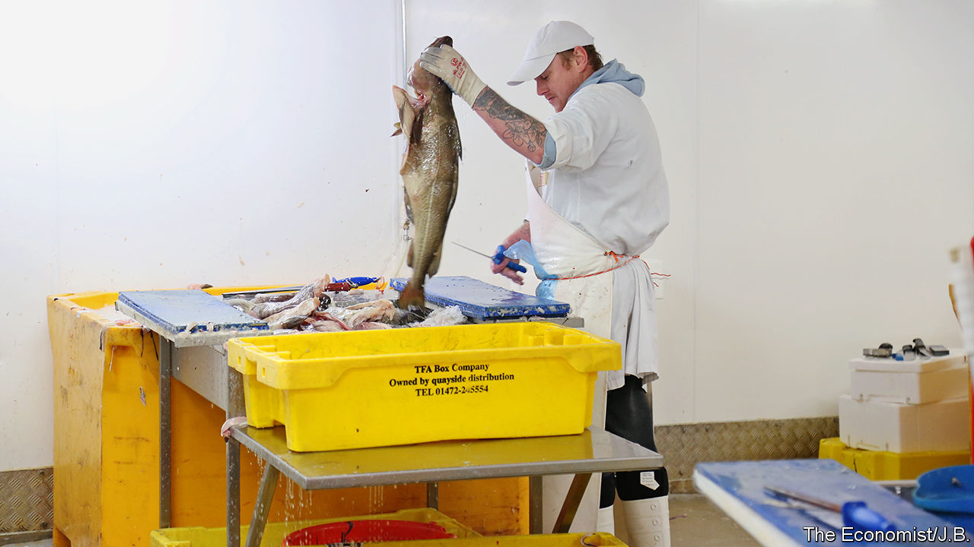

BREXIT’S NEW freedoms resound especially with fishermen who felt betrayed when Britain joined the common fisheries policy (CFP) in 1973, giving up fishing rights to other European countries. Michael Gove, in charge of EU negotiations, believes the CFP destroyed his father’s Aberdeen fishing business. The appeal of taking back control of Britain’s fish post-Brexit, as Iceland did in the 1970s, is strong.

Britain’s seawaters give it a strong card. Yet it is not an easy one to play. One reason is that fish have a pesky habit of swimming across boundaries. Another is catching and eating habits. Two-thirds of the fish landed in Britain is exported, mostly to the EU. But most of the fish eaten in Britain is imported, mostly caught (often by Brits) in EU waters. Trade barriers would disrupt both sides.

Next are historic rights for EU countries, many of which long predate the CFP. Some arise because EU businesses bought British vessels and their quotas. Removing these rights might entail litigation and compensation. Also fish-processing, which could face tariffs after Britain leaves the CFP, has become a big business in ports like Grimsby—and it depends on the unfettered import and export of fish caught all over Europe.

The biggest problem is politics. Barrie Deas of the National Federation of Fishermen’s Organisations says Britain should follow Norway’s example by adjusting allowable catches in its favour and settling quotas annually with the EU. But he fears political polarisation. Ireland’s Leo Varadkar has suggested Britain might have to give up control so as to get better terms elsewhere. France’s Emmanuel Macron has said that, if it rejects open access to its waters, Britain will not get a trade deal. Since fisheries account for less than 0.1% of Britain’s GDP, compared with 4% for cars or 7% for financial services, fishermen may be right to worry about being traded away once more.

This article was downloaded by calibre from <https://www.economist.com/britain/2020/01/30/britains-fisherfolk-fret-about-being-sold-down-the-river-yet-again>

|  |  |  |  |
| --- | --- | --- | --- |
| Previous | Articles | Sections | Next |

|  |  |  |  |
| --- | --- | --- | --- |
| Previous | Articles | Sections | Next |

#### Points of departure

# The British government wants to reshape immigration after Brexit

But the new system will probably look quite like the old one

Jan 30th 2020 |

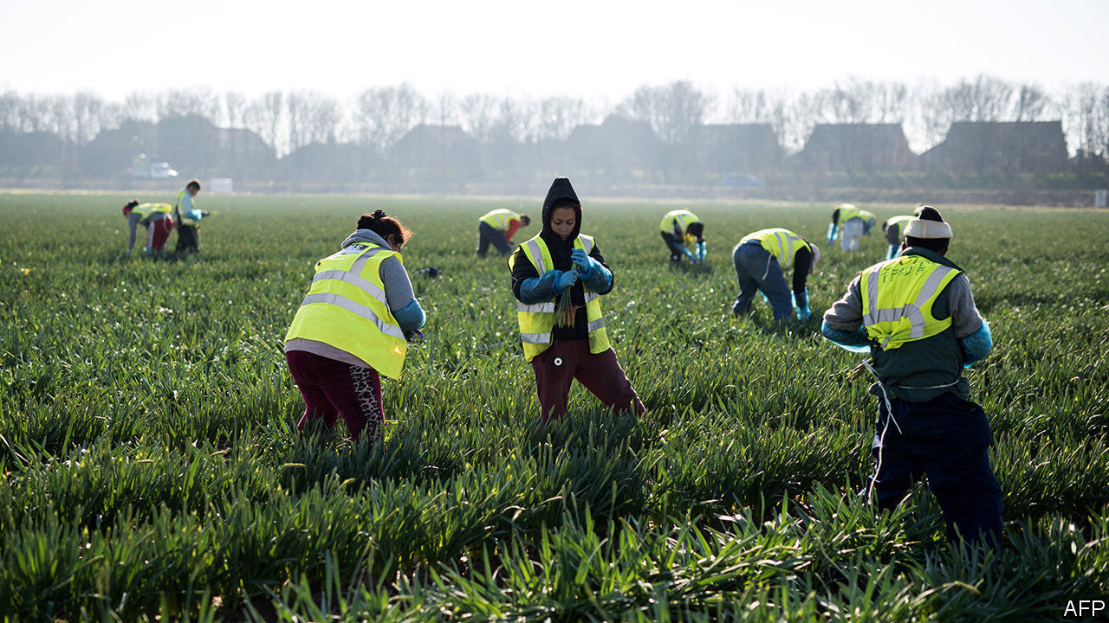

ONE PHRASE has cropped up again and again in Britain’s migration debate since 2005. That was the year Tony Blair, running for his third term as prime minister, promised an Australian-style points-based immigration system. As down under, marks could be awarded for, say, qualifications, linguistic ability or relative youthfulness. The idea is popular on the right, too: Nigel Farage, one of the architects of Brexit, often talks about it.

Britain’s membership of the European Union meant such a scheme could never be applied to all arrivals. Its rules allowed any citizen of another member state to move to Britain, regardless of their characteristics. In some years, the bloc supplied most of Britain’s newcomers. But Brexit changes the calculus. Boris Johnson, the prime minister, has promised to end freedom of movement and reshape immigration. His home secretary, Priti Patel, tasked the Migration Advisory Committee, an official panel of wonks, to look to Australia.

Yet the committee’s report, published on January 28th, is unenthusiastic. It emphasises that other countries with points, like New Zealand and Canada, only use them in parts of their immigration system. The authors argue that the current system for recruiting long-term workers from abroad—under which non-European migrants must have a job offer—already provides workers with the right skills, so there is no need for additional filtering. Nor do points-based systems guarantee the desired type of migrant. The report explains that when Britain used a similar approach to recruit talented migrants from outside the EU between 2002 and 2006, it awarded high scores to those with a PHD, an MBA or for GPs. But only 2.8% of successful applicants had a PHD, 2.3% an MBA, and 0.5% were GPs.

The committee essentially proposes that all applicants should be processed under the current system for migrants from outside the EU, with a few tweaks, including allowing them to take up jobs that require the equivalent of A-level qualifications, not only degrees. Most potential migrants would need a job offer with a prospective salary above the bottom quartile of the range for that role and above a threshold for all eligible jobs, which would fall by 15% to £25,600 ($33,300), to reflect the broader range of eligible jobs. There would be some exceptions to the threshold, such as health-care workers. A points system could be used to rank applicants without a job for a separate visa for “exceptionally talented” people, which currently admits several hundred migrants a year.

The committee acknowledges that tighter restrictions on European immigrants would dent economic growth and employment levels. Firms starved of cheap labour would have to generate more from existing resources, though the committee expects only slight increases in productivity. But the lower salary threshold would at least make it easier to recruit non-European workers, says Ian Robinson of Fragomen, a law firm. “It will mean less contorting what a person is paid to fit the system.”

The government can choose to ignore the report. Within hours of its publication, it reaffirmed its commitment to introduce a points-based system. But there is not much time for big changes. A complex new system would mean retraining Home Office staff and tweaking IT systems by the time the transition period—during which Britain and the EU apply the same rules—ends in December. The government is more likely to accept most of the committee’s recommendations but nevertheless call it a points-based system. As Alan Manning, the committee’s chair, writes, such branding “is, forgive the pun, pointless”. ■

This article was downloaded by calibre from <https://www.economist.com/britain/2020/01/30/the-british-government-wants-to-reshape-immigration-after-brexit>

|  |  |  |  |
| --- | --- | --- | --- |
| Previous | Articles | Sections | Next |

|  |  |  |  |
| --- | --- | --- | --- |
| Previous | Articles | Sections | Next |

#### Doing trade deals

# Post-Brexit Britain may find trade deals hard to negotiate

Small may be beautiful

Jan 30th 2020 |

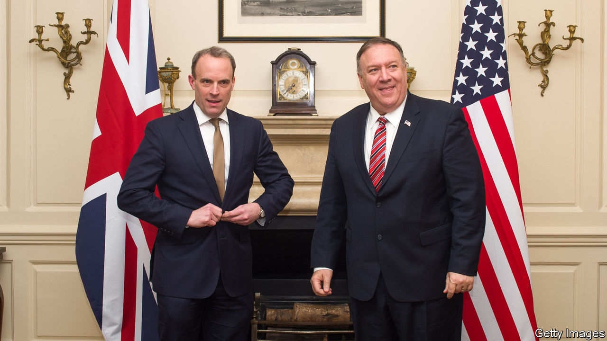

THE AMERICAN reaction to Britain’s decision to give China’s Huawei a role in its 5G network was a foretaste of the difficulty of post-Brexit trade negotiations. Republican senators said it would make a bilateral trade deal more problematic.

Britain already has its work cut out simply replicating existing EU deals with South Korea, Mexico, Canada and others. The numbers are not encouraging. Brexiteers note that 90% of world growth will be outside the EU over the next decade. Yet the government’s own analysis finds that the combined benefit of free-trade deals with America, Canada, Japan, Australia and other big countries would add less than 0.5% to GDP, a small fraction of what will be lost through more trade friction with the EU.

Where to focus? America, the biggest market for exports, is an obvious candidate. Until the Huawei decision the Trump administration was positive about a quick deal. Brexiteers like it as it would make it hard to switch back to the EU. Yet America’s priorities of opening up food markets and drug prices do not appeal to consumers (or the government). A row over digital taxes may also hamper a deal.

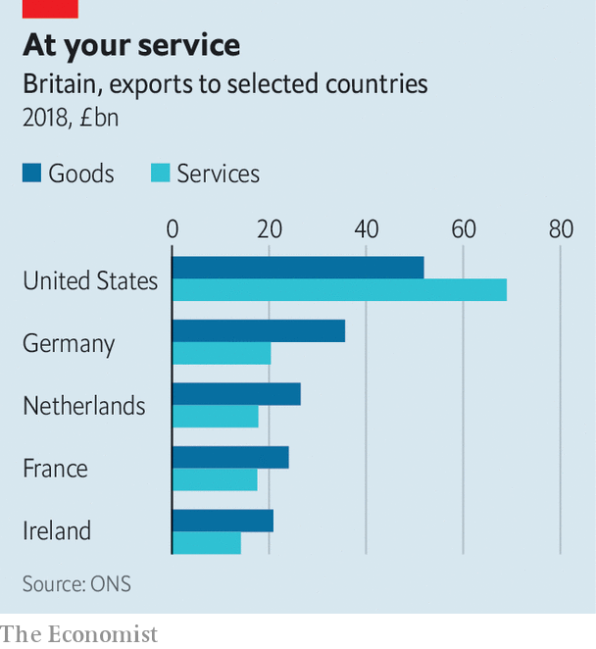

America requires any deal to lapse if its partner negotiates with China, and Chinese deals are one-sided. India is more promising, but its government is not trade-friendly and it sees easier visas for Indians as a precondition. Sam Lowe of the Centre for European Reform think-tank points to Japan, Australia and New Zealand as partners that might set a template for other deals. The government is keen on Japan, though one concern is that it cannot do better than the EU since the terms of the EU’s deal requires it to get the same benefits.

Most politicians favour full free-trade agreements. Yet Peter Mandelson, a former EU trade commissioner, says FTAs don’t come free, don’t cover all trade and take ages to agree. So it may be sensible to focus on removing specific barriers or on mutual recognition. It may be easier to do this for financial services with America than get a full FTA. Liam Fox, a former trade secretary, cites the removal of a Chinese tariff on Northern Irish milk as an example.

Sectors matter too. Big companies can deal with tariffs, trade and customs barriers quite easily, but small firms find it harder. Efforts to help them could pay dividends. A new report from the UK trade policy observatory at Sussex University and the Federation of Small Businesses proposes new information centres and helplines specifically designed to encourage small firms to cope with trade red tape.

Above all is the idea of looking at services, not goods. Non-tariff barriers matter more than tariffs, and they affect services most. David Henig, a trade economist, notes that services account for 80% of Britain’s GDP and 40% of its exports, a share that is growing fast. Yet progress towards freer global trade in services has been glacial. America and Britain are, respectively, the world’s biggest and second-biggest exporters of services. Could they team up to push greater liberalisation? ■

This article was downloaded by calibre from <https://www.economist.com/britain/2020/01/30/post-brexit-britain-may-find-trade-deals-hard-to-negotiate>

|  |  |  |  |
| --- | --- | --- | --- |
| Previous | Articles | Sections | Next |

|  |  |  |  |
| --- | --- | --- | --- |
| Previous | Articles | Sections | Next |

#### Railways

# Britain’s government renationalises Northern Rail

Angry commuters mean this is likely to be the first of several

Feb 1st 2020 |



COMMUTERS IN THE north of England have had a miserable year. In the year to October 2019 just over half Northern Rail’s trains arrived on time and passenger satisfaction was, understandably, lower than with any other operator. On January 29th the government lost patience with the firm and announced that Arriva Rail North, the franchise’s operator, would be stripped of its franchise on March 1st, five years ahead of schedule. Under the “operator of last resort procedure”, the service will then be run by a publicly owned company on an arm’s length basis for an unspecified length of time. The East Coast Mainline was taken over in a similar way in 2018 and remains in public hands. Northern is unlikely to be the last firm that finds itself targeted by the transport secretary.

On many measures Britain’s railways look to be in good shape; both passenger numbers and freight volumes have grown at a decent clip while fares, at least for tickets bought in advance, are mid-priced by European standards. But when it comes to commuter services, punctuality rates lag behind international peers, season tickets are pricey and train cancellation rates high. For the 10% of Britons who commute to work by rail, the fact that the country operates a decent freight system is scant consolation for their regular morning delays. As services have deteriorated and reliability fallen, rail has become a live political issue. More than 50% of Britons now support renationalising the whole sector and Northern Rail’s failings anger voters in the northern English seats which turned Tory for the first time in the 2019 election.

Arriva argues that the poor service was beyond its control. It blames a prolonged industrial action by the RMT trade union and delayed or cancelled infrastructure projects. More than half of all rail delays in Britain are caused by problems with infrastructure, such as signalling, which is already operated by the government. Passenger numbers have doubled since the mid-1990s, without the needed investment to expand services. The result has been overcrowding and often poor reliability on many lines. But whoever is actually responsible, commuter anger tends to be directed at the operating companies. TransPennine Express, Greater Anglia and South Western Railway are all now seen as at risk of nationalisation.

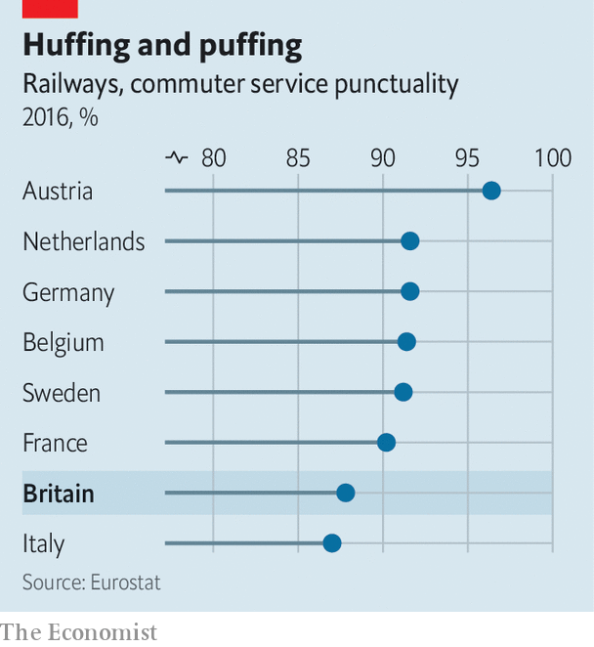

A government white paper on rail, setting out a new strategy for the network, has, much like a commuter rail service, been subject to frequent delays. The direction of travel, though, seems clear. Grant Shapps, the transport secretary, has spoken of the need for a “fat controller” sitting at the centre of the system providing more direction. The current system of franchises, according to Keith Williams, who chairs the panel that will produce the white paper, “has had its day”. It looks set to be replaced by the concession model already operated by London Overground and Merseyrail. Under that model, while a private operator physically runs the trains in return for a flat fee, other decisions and ticket-price levels are set by a public body. Revenue and financial risks are carried by the public sector rather than the operator.

Implementing this will take years. In the meantime, more ad hoc nationalisations of failing franchises are likely.■

This article was downloaded by calibre from <https://www.economist.com/britain/2020/02/01/britains-government-renationalises-northern-rail>

|  |  |  |  |
| --- | --- | --- | --- |
| Previous | Articles | Sections | Next |

|  |  |  |  |
| --- | --- | --- | --- |
| Previous | Articles | Sections | Next |

#### British Broadcasting Cuts

# The BBC performs painful internal surgery

It will cover fewer stories and attempt to reduce duplication

Jan 30th 2020 |

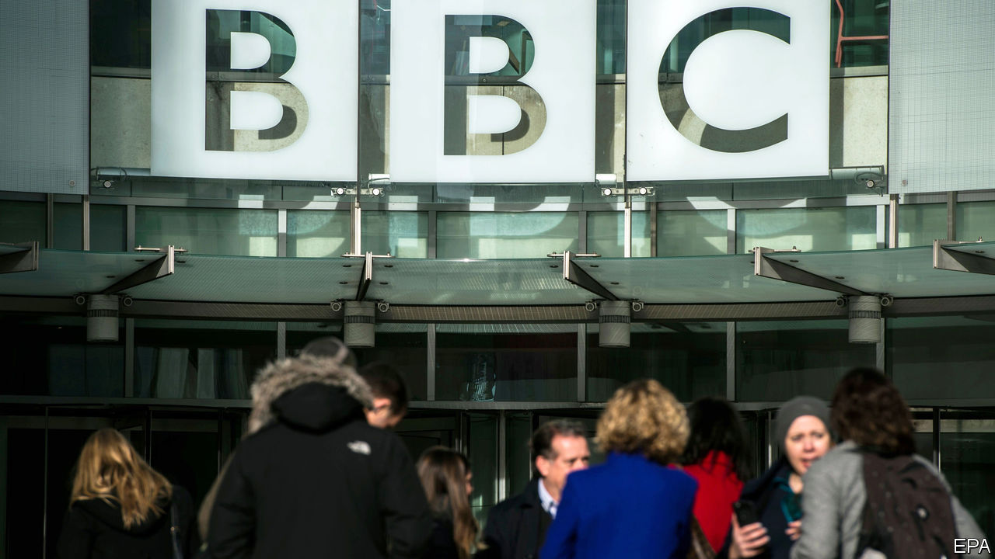

IN JULY 1954 the BBC launched its first daily television news programme. The newsreader did not appear on screen because, he said, of the fear that he “might sully the stream of truth with inappropriate facial expressions.” Sir Ian Jacob, the organisation’s director-general, grasped the moment’s importance, though, noting that “this is a start on something we regard as extremely significant for the future.”

Six decades later, the corporation offers straight news (three times a day), mid-morning news analysis (the Victoria Derbyshire Show), evening news analysis (Newsnight), 24-hour news (on a dedicated channel), a wry look at the news (Have I Got News For You), news for children (Newsround), a weekend news chat show (with Andrew Marr), a show to debate the news (Question Time), as well as plenty more online and on radio.

The BBC’s bosses have decided that this results in too much duplication. On January 29th Fran Unsworth, the head of current affairs, announced sharp cuts to the organisation’s newsgathering operations. Some 450 jobs will be scrapped (out of 6,000 or so in news), the number of presenters will be reviewed, radio news will be slimmed down and, as leaked earlier, the Victoria Derbyshire Show will go altogether. The current approach of covering about 100 news stories a day is simply “overwhelming” to the public, Ms Unsworth argued. The aim is to stop different programmes doing the same things. Teams will be expected to produce packages for a range of programmes. Output will become more homogenous.

The decision reflects the BBC’s tight budgets. Last year it received £3.7bn ($4.8bn) from the licence fee, which all television watchers must by law purchase—a lot of money, but also a real-terms cut of about a fifth since 2010. On top of this fall in revenue, from June this year the BBC must foot the bill for a free licence for over-75s, which the government formerly took care of. Although it has decided to restrict free licences only to households where at least one person receives an old-age benefit, the giveaway is still expected to cost around £250m a year by 2021-22. Altogether the BBC needs to cut spending by £800m by 2022, of which news is expected to deliver £80m. But things could get worse: the government has ordered a review of whether the licence fee should remain compulsory. Gary Lineker, one of the organisation’s most prominent presenters, this week argued it should not.

And then there is the BBC’s uncertain future. In order to justify the existence of the licence fee, the BBC must demonstrate that it can reach all parts of society. Nearly eight in ten over-65s use BBC One as their main news source; just a third of 16- to 24-year-olds do. Estimates suggest that 16- to 34-year-olds spend roughly the same amount of time (around two-and-a-half hours a week) with Netflix as with BBC television. Their main source of news is the internet. In an attempt to adjust to this reality, the BBC has invested in podcasts and streaming, but not to the extent needed to challenge the American giants. In cutting its news offering, the organisation risks weakening its provision in an area where it genuinely does lead the world, to chase viewers it has little hope of reaching. ■

This article was downloaded by calibre from <https://www.economist.com/britain/2020/01/30/the-bbc-performs-painful-internal-surgery>

|  |  |  |  |
| --- | --- | --- | --- |
| Previous | Articles | Sections | Next |

|  |  |  |  |
| --- | --- | --- | --- |
| Previous | Articles | Sections | Next |

#### Judicial review

# A pushback against trans activism in Britain

Three groups of people have applied for judicial reviews

Feb 1st 2020 |

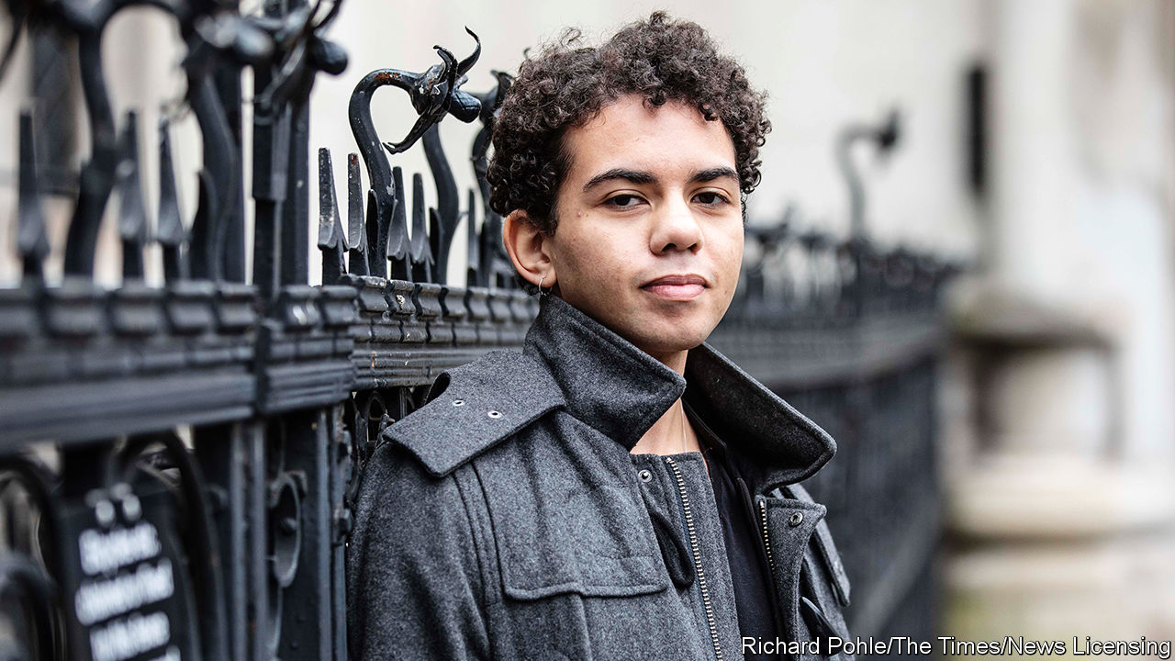

FOR SOME years now, schools, the NHS and the police have been accommodating the needs and concerns of transgender people. GIDS, Britain’s only gender identity clinic for children, based at the Tavistock NHS trust, has been making it easier for trans teenagers to transition medically. But now some critics of the moves are pushing back, claiming that GIDS is giving children puberty blockers too liberally, and that attempts by other bodies such as the police to combat transphobia are leading to an attack on free speech.

Three groups of people have recently applied for judicial reviews, the legal means to challenge public bodies. On January 22nd, a 23-year-old woman, Keira Bell (pictured), joined one of these lawsuits. She charges that GIDS is performing “experimental” treatment on children by giving puberty blockers and cross-sex hormones to more than 1,000 children and teenagers, including herself, some as young as 11. She had a double mastectomy, and subsequently detransitioned.

The number of referrals to GIDS has risen more than 30-fold in the past decade, reaching 2,590 in 2018-19. Yet there are no long-term studies that show the impact of puberty blockers, and there is concern that many kids with mental health issues or on the autism spectrum are pushed towards using them. Critics point out that they are the same drugs used to chemically castrate sex offenders. The head of GIDS, Paul Jenkins, said last year that puberty blockers are “reversible” but an NHS review has challenged his wording. And Carl Heneghan, the professor of evidence-based medicine at Oxford University, said last year, “Given the paucity of evidence, the off-label use of drugs…in gender dysphoria treatment largely means an unregulated live experiment on children.”

Supporters of Ms Bell say transgender activist groups such as Mermaids are encouraging liberal prescription of puberty blockers. “Mermaids are not medical professionals. They are a lobby group pushing for earlier medical intervention to prevent the natural development of children’s bodies,” says Stephanie Davies-Arai of Transgender Trend, an activists’ group. Mermaids denies exerting any pressure on clinics. “We have seen great distress caused to some children with the onset of puberty, and in some cases hormone blockers can go a considerable way to alleviating that distress,” said a spokesman.

An earlier judicial review was brought by Harry Miller, a 54-year-old small business owner and former policeman. Last year he retweeted a joke about trans women; shortly afterwards, he says, a police officer called him and said, “We need to check your thinking.” Mr Miller says he told the officer that “‘1984’ is a dystopian novel not a how-to manual.”

Mr Miller’s actions were logged as a “non-crime hate incident”, and thus might show up on a police background check carried out by a prospective employer. Police guidelines say that such incidents must be recorded when a complaint is made “irrespective of whether there is any evidence to identify the hate element”, and there is no chance of appeal.

The review is challenging the guidelines on the grounds that they do not adhere to the Equality Act of 2010, which bans discrimination on the basis of nine “protected characteristics”. The guidelines only recognise five: disability, race, religion, sexual orientation and, crucially, “transgender”. Mr Miller points out that “sex” has been omitted and that although “gender reassignment” is a protected characteristic, “transgender” is not. “So if you are a woman and I call you a bitch, you are not protected,” he says. “But if you are a man who identifies as a woman and I call you a bitch, then you are protected. It is madness.”

Mr Miller believes that advocacy groups, especially Stonewall, have undue influence over public bodies. “These organisations are lobby groups,” he says, “Yet their advice is being taken as impartial.” Stonewall would not answer specific questions but said that it “will continue to work with schools, employers, communities and policymakers until no one has to face this abuse in their everyday life.” The judge’s ruling is expected within weeks.

The third application for judicial review is being brought by two parents and a teacher in Oxfordshire, who say the guidance being used for primary schools is “unlawful and damaging to children”. One of the parents, Victoria Edwards, says the guidelines used in her local school, the Oxfordshire Trans Inclusion Toolkit, written in association with Allsorts and Gendered Intelligence, two other transgender lobby groups, “places the rights of trans identified children above the rights of all other children and staff”. It advises schools to allow boys who identify as girls to use girls’ changing rooms, toilets and dorm rooms on residential trips. A spokesperson for Oxfordshire County Council said “We utterly refute the suggestion that we are failing to safeguard children.”

The impetus for these legal challenges comes from several directions. Some feminists worry that the rise of trans rights poses a threat to safe spaces for women; the judicial reviews suggest sizeable parts of the country may agree. A Populus poll in 2018 asked if a person born male, identifying as a woman but still possessing male genitalia should be free to use a female changing room where women are undressing; 59% said no and 14% said yes. The experiences and scars of detransitioners like Ms Bell may reinforce doubts about the direction of travel. ■

This article was downloaded by calibre from <https://www.economist.com/britain/2020/02/01/a-pushback-against-trans-activism-in-britain>

|  |  |  |  |
| --- | --- | --- | --- |
| Previous | Articles | Sections | Next |

|  |  |  |  |
| --- | --- | --- | --- |
| Previous | Articles | Sections | Next |

#### Bagehot

# Brexit and English nationalism

The Tories need to put the genie of English nationalism back in the bottle

Jan 30th 2020 |

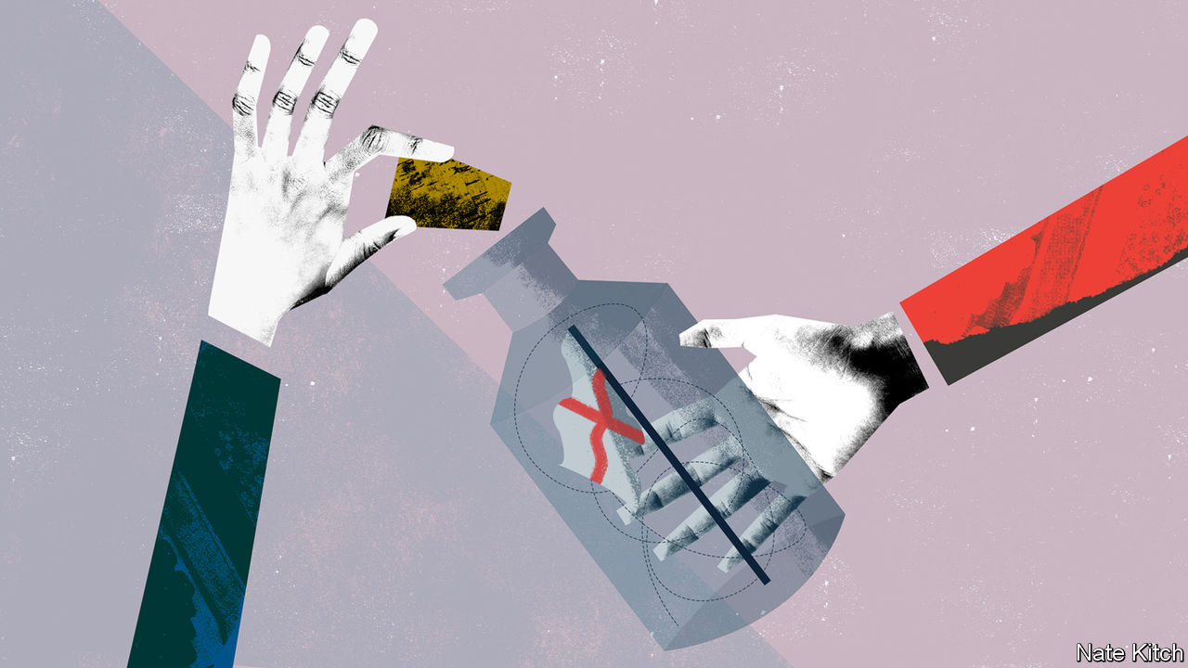

BREXIT IS A Rorschach blot into which everybody reads their own preoccupations; one of the few interpretations universally accepted is that it was a triumph of English nationalism. The English voted in favour of Brexit by a big margin while the Scots and Northern Irish voted against. The Welsh, who also voted in favour, did not play a large part in the campaign, which was run by self-consciously English politicians: Jacob Rees-Mogg with his double-breasted suits and Edwardian vowels; Nigel Farage with his pint and fag; Sir John Redwood and his excruciating attempt, as Welsh secretary, to mouth the words of the Welsh national anthem. The whole thing was saturated in English iconography, from the flag of St George to the white cliffs of Dover.

If foreigners are confused by the distinction between Englishness and Britishness, that is hardly surprising, because the confusion is deliberate. For centuries, as the senior partner in “our island story” in terms of both size and power, the English used “England” as a synonym for “Britain”. J.R. Seeley, a great Victorian historian, entitled his history of the British Empire, “The Expansion of England”. George Orwell’s essay on the national mood during the Blitz is “England, your England”. The Scottish and Welsh put up with being marginalised because they did well out of empire, industry and the Labour Party. It was when they stopped putting up with it that English nationalism, too, grew teeth.

Although thanks to a combination of geography and religion English nationalism has been around since Henry VIII declared that “this realm of England is an empire” that didn’t have to bow to a foreign pope, in its modern form it has been forged by three great blows to the national psyche. The first was the loss of empire, which lent it its dominant tones: an elegiac sense of loss of past greatness and fury at power that has been wrongly snatched away. The second is the rise of Scottish and Welsh nationalism, which won the smaller nations parliaments. This not only made it impossible to keep using “England” to mean “Britain” but also gave birth to the English question. Why should the Scots and Welsh have a parliament and not the English? Why should England continue to subsidise such ungrateful satraps?

But it was Europe’s determination to transform itself from a trading bloc into a political union that most infuriated the English nationalists. Eurosceptics such as Sir Bill Cash were convinced that Europe was bent on castrating Parliament and subordinating English common law. Andrew Roberts, a Tory historian, published a novel about the heroic struggle of the English Resistance League against a European Reich that had renamed Waterloo Maastricht Station and forbade women from shaving their armpits.

Euroscepticism and English nationalism proved self-reinforcing. Mr Farage succeeded in distilling English nationalism into an insurgent party, with the misleading name of UKIP (he seldom went north of the border) and the revealing slogan “we want our country back”. The three and a half years of parliamentary stalemate after the referendum result further stoked the fires of English nationalism. The Daily Mail summoned all the fury of Middle England against “traitors”. Mark Francois, the Captain Mainwaring of the European Research Group of MPs, railed against Germans on television. Mr Rees-Mogg talked of “vassalage”.

In its new form, it is a dangerous concoction. It has destabilised geopolitics by robbing the EU of one of its biggest members. It has divided the British Isles and exposed constitutional problems that wise statesmen have done their best to conceal. Britain has always been a peculiar multinational kingdom because one of its component parts, England, accounts for 84% of its population and more than 85% of its income. Brexit has thrown this contradiction into sharp relief and revealed growing weariness with the union. In 2018 a poll showed that three-quarters of Tory voters would accept Scottish independence and the collapse of the Northern Ireland peace process as a price for Brexit.

For Scottish nationalists, the fact that Scotland voted to remain constitutes irresistible grounds for holding another referendum. If the government agrees to one, they might well win, particularly given that Britain’s reckless decision to leave the EU has neutralised the Unionists’ strongest argument, economic prudence; if it doesn’t, the belief that they were dragged unwillingly out of the EU will continue to fester. In Ireland the Unionists feel betrayed by Boris Johnson’s decision to, in effect, put the border in the Irish Sea. That weakens Ulster’s links with the mainland at a time when the demographic tide is turning against the Protestants.

The Tories need to repair the damage that their flirtation with English nationalism has caused. This means folding English nationalism into the wider carapace of British nationalism and forging a broader patriotism that can appeal to all sides of the Brexit argument. The party brings some distinctive resources to this battle. The Conservatives’ commitment to the Union is enshrined in its official name, the Conservative and Unionist Party. Mr Johnson is loved by provincial Tories but was a successful mayor of London. He demonstrated that there was no contradiction between hanging on a zip wire waving tiny Union flags and reaching out to ethnic and sexual minorities. The government is already mulling over a host of projects designed to bring a fractured United Kingdom back together: embracing a global and forward-looking version of Brexit; making the border in the Irish Sea as invisible as possible; devolving power to the English regions. But none of this will work if the Conservative Party does not return the more bellicose advocates of English nationalism—Rees-Mogg, Francois, Cash and their ilk—to the obscurity from which they came.

Noisy English nationalists are enjoying their moment of triumph this weekend with “Independence Day” shenanigans on the white cliffs of Dover. Mr Johnson must make this their last hurrah and engage in his greatest piece of political alchemy to date: turning English nationalism back into British patriotism. ■

This article was downloaded by calibre from <https://www.economist.com/britain/2020/01/30/brexit-and-english-nationalism>

|  |  |  |  |
| --- | --- | --- | --- |
| Previous | Articles | Sections | Next |

|  |  |  |
| --- | --- | --- |
| Britain | Sections | Business |

International

Coronavirus economics: Locked down

.

Coronavirus: Prepare for the worst, hope for the best

.

|  |  |  |
| --- | --- | --- |
| Britain | Sections | Business |

|  |  |  |  |
| --- | --- | --- | --- |
|  | Articles | Sections | Next |

#### Locked down

# China’s coronavirus semi-quarantine will hurt the global economy

It may affect industries from tourism to plastic flowers

Jan 30th 2020 | SHANGHAI

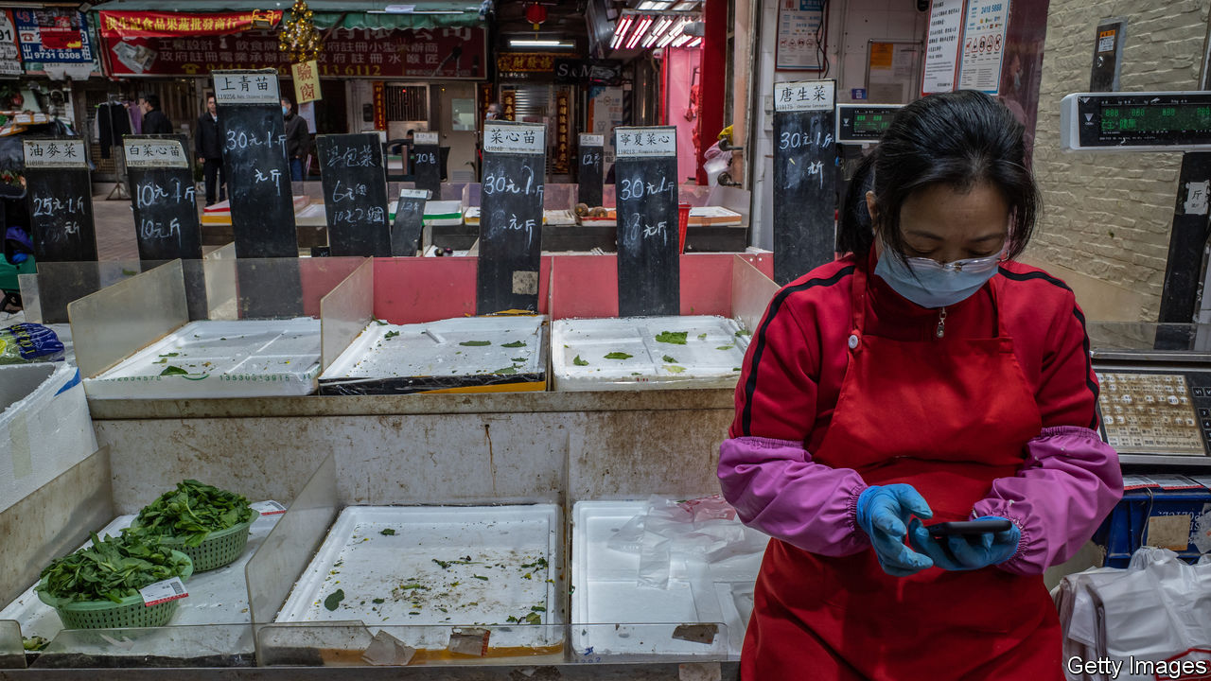

THE YU GARDEN, a 16th-century complex of pavilions and ponds in the heart of Shanghai, is all gussied up for the Chinese new-year holiday. Its walkways are bedecked with colourful lanterns, its stalls laden with dumplings, its entrances flanked by dozens of security guards to handle crowds. Just one thing is missing: people. Fearful of coronavirus, they are staying home. “I’ll be doing well if I make a few sales today,” says Li Xinming, manager of a silk-scarf shop. Last year Yu Garden attracted 700,000 visitors during the holiday week, peak season for it and its merchants. This year, Mr Li says his losses might wipe out his earnings for months to come.

The question for China, and for the many companies and countries around the world linked to its economy, is whether Mr Li’s travails are indicative of a much broader problem. The obvious reference point is China’s battle with SARS, another coronavirus, in 2003. Growth slowed sharply at the height of the epidemic but rebounded swiftly after it was contained. Other recent epidemics have reinforced the impression that economists should not be overly worried, so long as good doctors are on the job. Neither avian flu in 2006 nor swine flu in 2009 dimmed the global outlook.

Yet even flint-hearted investors are wondering whether the new epidemic might be worse. Stocks in Hong Kong have fallen by nearly 10% as reported infections have steadily increased. Tremors have also rippled through global markets.

The concern is less the severity of the virus, which seems less lethal than SARS, but rather the nature and potential duration of China’s efforts to bring the outbreak under control. And disruption in China, the world’s second-biggest economy, has global consequences. “It’s not the disease, it’s the treatment,” wrote analysts with Gavekal Dragonomics, a consultancy. The World Bank has estimated that as much as 90% of the economic damage from epidemics stems from people’s fear of associating with others, which leads offices and stores to close. In China, this is being magnified by the government’s policy of isolating affected areas and limiting interpersonal contact throughout the country. While public-health experts debate whether this is the right approach, economists will count the costs.

The most direct impact is being felt in Hubei province. First Wuhan, its capital, was placed under quarantine. Then the rest of the province, home to nearly 60m people, was locked down, too. Apart from food trucks and medical supplies, little can enter its cities and villages, and few are permitted to leave. Such a large-scale isolation is unprecedented as a public-health strategy. Economic activity of just about any kind, short of hospital care and movie streaming, has ground to a halt. Hubei generates 4.5% of China’s GDP, so the closure will leave a hole.

Other cities in China may not be under quarantine but that is what life feels like for their residents. Instead of getting together with family and friends, attending temple fairs and going to restaurants—all, depending on where one lives, staples of the holiday—people have shut themselves in. The government has encouraged them to avoid crowds; many need little prodding.

That will be a drag on consumption. The extent of the damage will depend on how long it takes to stop the virus, but the timing is already rotten. Last year retail sales exceeded 1trn ($144bn) yuan during the new-year week, a third more than an average week. This year, sales are sure to fall well short of that.

Some industries are being hit especially hard. The holiday accounted for 9% of China’s box-office revenues last year. This year almost all of the country’s 11,000 cinemas are closed. Spending on domestic tourism during the new-year week reached more than 500bn yuan last year, about 8% of the annual total. This year, fearful of the virus, people have cancelled trips.

There are also worries about how the virus will affect factories and offices. Several major economic centres, including Shanghai and Guangdong province, have extended the new-year holiday by a week, telling companies to wait until February 10th to restart. Chinese businesses are always slow to get back up to speed after the holiday. The extra week will make them slower, even if some firms such as Tencent, a tech giant, let employees work from home. Moreover, tens of millions of migrant workers, back in their hometowns for the holiday, may wait for the epidemic to recede before crowding onto trains and buses to return to their jobs.

## I feel your pain

One crucial difference compared with SARS is China’s importance for the rest of the world. In 2003 China generated 4% of global GDP. Last year, it was 16%. The slowdown in consumption and the disruption to production will not stop at its borders.

Countries accustomed to big-spending throngs of Chinese tourists face a brutal stretch. China’s government has ordered all tour groups to be suspended until the virus is contained. In Thailand, authorities expect the number of Chinese visitors will fall by 2m to 9m this year, reducing tourism revenue by some $1.5bn. Share prices of airlines have plunged; past epidemics have caused huge, if temporary, drops in passenger traffic, and China is the world’s biggest outbound international travel market.

Companies that have hitched themselves to China’s fast-growing middle class are also vulnerable. Starbucks has temporarily closed more than half of its 4,292 cafés in China. Footfall in those still open is scarce, with some posting signs that patrons may only enter if they are wearing face masks. Sales of masks are, indeed, a rare bright spot for companies such as 3M. Disney closed its resort in Shanghai for the new-year holiday, one of its busiest weeks of the year (adding insult to injury, China has just entered the Year of the Rat and the Chinese term for rats also refers to mice, a fine marketing opportunity for a brand built around them).

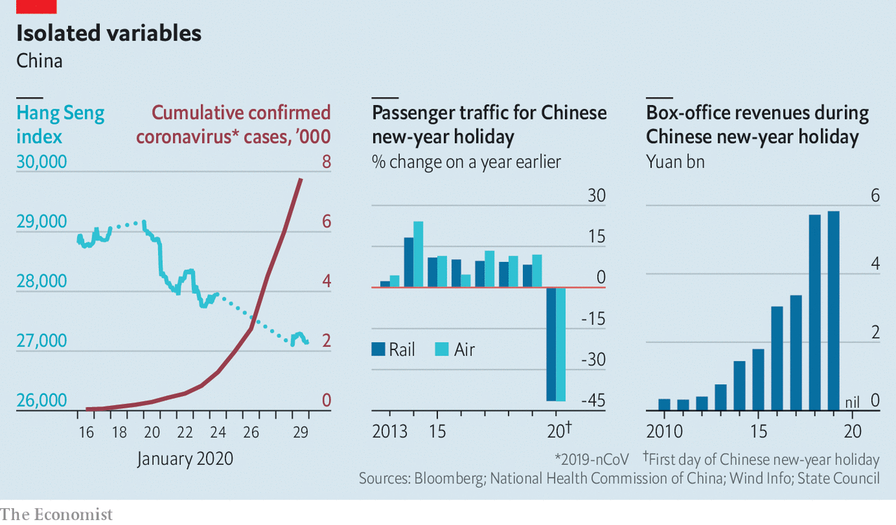

Factory closures will cascade through the global economy. Wuhan is a manufacturing hub, especially for autos. Nissan, Honda and General Motors have plants there. Bloomberg ranks Wuhan 13th out of 2,000 Chinese cities for its role in supply chains. One local company, Yangtze Optical Fibre and Cable, is the biggest maker of the wires that carry data around the planet.

Even if work stoppages elsewhere in China are milder, they will affect a wide range of sectors. Some are vital; roughly 80% of active ingredients for all medicines come from China. Others are less so; China supplies 90% of the world’s plastic flowers. Shares in Foxconn, which makes phones for Apple, have fallen by 10%.

Many companies were already working to reduce their reliance on China’s factories because of its trade war with America. The virus is a powerful reminder that, politics aside, a diversified base of suppliers is a good insurance policy. But the past year provided a lesson in how difficult that is; despite the tension with America, China’s share of global exports actually increased. Companies will struggle to find substitutes for its manufacturing muscle.

Adding it all up, the Chinese economy is in for a grim start to the Year of the Rat, and this will cast a shadow globally. Chen Long of Plenum, a consultancy, thinks China’s growth could slouch to 2% year-on-year in the first quarter, its weakest in decades, down from 6% in the final quarter of 2019. But he expects a strong rebound when the country gets back to normal. People long cooped up will flock to shops and restaurants. Factories will rush to make up for lost time. To give the recovery a push, officials will increase infrastructure spending.

The unknown is when normality might resume. In Yu Gardens, Mr Li could not wait. With business way down, he has told the three assistants in his silk-scarf shop to stay at home, unpaid—typical for small businesses in China. The death toll from the coronavirus is rising. And the whole country is paying a price.■

This article was downloaded by calibre from <https://www.economist.com/international/2020/01/30/chinas-coronavirus-semi-quarantine-will-hurt-the-global-economy>

|  |  |  |  |
| --- | --- | --- | --- |
|  | Articles | Sections | Next |

|  |  |  |  |
| --- | --- | --- | --- |
| Previous | Articles | Sections | Next |

#### Prepare for the worst

# How do you contain a global epidemic such as coronavirus?

Health officials and doctors can only do so much to stop the spread of diseases

Jan 30th 2020 |



“MADE IN CHINA” is a label the country’s government would prefer to be associated with slick technology. Its trending export at present, however, is 2019-nCoV, the new coronavirus that struck in the Chinese city of Wuhan in December. The virus has now spread to at least 16 countries. As The Economist went to press, the World Health Organisation (WHO) and China had confirmed almost 7,800 infections and 170 deaths, almost all in China.

When a new infectious disease begins to spread, decisions on how to stop it are based on patchy data that change by the hour. This is “the fog of war” phase, says David Heymann of the London School of Hygiene and Tropical Medicine. Health officials have to make decisions quickly and with uncertain information, says Jeremy Farrar of the Wellcome Trust, a charity.

They must first determine the deadliness of new viruses. The first cases diagnosed are usually among the worst because those people are ill enough to go to hospital. Zika is a mosquito-borne virus that commonly causes nothing more than mild flu-like symptoms. But the first recorded cases were mostly mothers who contracted the infection during pregnancy and whose babies were born with brain damage as a result. As health officials start actively trying to identify infected people, milder cases are added to the total.

As a result, early estimates tend to overstate the danger of new diseases. That is happening now with the Wuhan virus. At the end of January, reported deaths represent about 2% of confirmed infections. Around 20% of those reported to be infected become severely ill, suffering from pneumonia and respiratory failure. But modelling by Gabriel Leung and Joseph Wu at the University of Hong Kong suggests as of January 25th that the number of infections in Wuhan was closer to 44,000 (with a range of 20,000-78,000). Most of those infections will be mild, so the death rate for the virus could be as low as 0.1%—no deadlier than the common flu in America.

Officials must then gauge how contagious a new virus is. As growing numbers arrive in hospitals, patterns emerge. If it turns out that most of the newly infected people are health-care workers and relatives of the sick, that would probably mean that the virus is transmitted through close rather than casual contact, so stemming its spread should be easier. Experts must next determine how it is passed from person to person. The common cold spreads through virus-laden droplets from coughs and sneezes that travel only a few metres. Influenza and measles are far more contagious because they ride on airborne particles—so a sneeze can infect an entire room.

It is not yet clear how the Wuhan virus is transmitted. The WHO thinks that, like the one that causes Severe Acute Respiratory Syndrome (SARS), it hitches a ride on droplets. It is also unclear how often those who are infected but show no symptoms can spread the virus to others. Some infections in China and Germany seem to have been the result of this kind of transmission. If so, contagious people could be unknowingly infecting others for days. Both SARS and Middle East Respiratory Syndrome (MERS), another lethal coronavirus, had “superspreaders”—patients with unusually high viral loads, who are exceptionally infectious. In South Korea in 2015 a patient with MERS infected 81 people during a 58-hour stay at a hospital emergency room.

The threat of a global pandemic will put to the test the preparedness plans that countries and big cities have in place. These feature a worst-case scenario, usually the arrival from abroad of a hypothetical strain of influenza that is both very deadly and highly contagious—a rare combination of features that set apart the Spanish flu which swept the world in 1918, killing 20m-50m people.

City authorities and hospitals routinely carry out drills to test their readiness for such a scenario. In some cases officials huddle in a conference room and plan what they would do. On January 24th New York City’s top officials held such a drill for the Wuhan virus. In other exercises, doctors and health officials don protective gear and get out on the streets to practise their response. To test its system, New York City routinely uses “mystery patients” who show up at hospitals pretending to have symptoms of “notifiable diseases” that doctors are supposed to report to public-health departments.

When an outbreak starts to cross borders, as is now happening with the Wuhan virus, the knee-jerk reaction is to set up airport health-checks for passengers arriving from outbreak hotspots. But many health experts think such tests are a waste of time and money. In Canada, screening for SARS at airports in 2003 detected no instances of the disease; that year SARS killed 774 people, including 44 in Canada.

The theatrics of airport checks suit politicians, who are anxious to be seen to be responding to worried citizens. It is more useful to the public to provide those arriving at airports with information explaining what to do if they develop symptoms, says Agoritsa Baka of the European Centre for Disease Prevention and Control.

Efforts are better spent boosting infection-prevention measures at hospitals, says Ms Baka. Health workers are often among the first to be infected by a new virus, which they pick up from patients. They then pass it on to their families and other patients. In the global SARS outbreak in 2002-03 about a third of those infected were health workers.

The best way to nip an outbreak in the bud is for disease detectives to locate those infected. The goal is to prevent them from passing the virus to others, by isolating them in hospitals and at home. Most countries ask people to quarantine themselves voluntarily. Some will demand court orders to enforce such rules if people rebel.

When an outbreak grows from a few clusters of cases into an epidemic, cities may go further in their efforts to keep people apart. Japan and some European countries close schools for short periods if flu seasons look as though they will be particularly bad. In 2009 Mexico City shut down bars, cinemas, churches and football stadiums for 13 days to try to stop the spread of swine flu.

Locking down large areas, as China is currently doing with the entire province of Hubei, with a population of nearly 60m, is untested in modern times. Such efforts can backfire. One lesson from the Ebola outbreaks in west Africa is that if those under quarantine are not cared for and do not feel that the suffering they are enduring for the common good is respected, they will try to evade the quarantine, says Jeremy Konyndyk of the Centre for Global Development, a think-tank in Washington. That makes matters worse because in an outbreak it is crucial to know who is infected, where they have been and where they are going. A heavy-handed attempt to quarantine West Point, a settlement of 70,000 people in Monrovia, Liberia’s capital, during the Ebola outbreak in 2014 was abandoned after residents responded with riots. By contrast, a similar but well-organised quarantine in Sierra Leone, in which traditional leaders were brought on board first, did not meet resistance.

If China’s drastic measures help delay epidemics of the Wuhan virus in other countries by a few months, that could make a huge difference, says Dr Farrar. Hospitals in Europe and America will be better placed to handle a surge of infections in late spring, compared with February when they are overwhelmed by the peak in cases of the seasonal flu. Such a delay could also be crucial for testing a vaccine for the Wuhan virus. Several are already in the works in China, America and Australia. Dr Farrar reckons a vaccine could be ready for clinical trials in 6-12 months.

When it is clear that an epidemic cannot be controlled, authorities go into mitigation mode. That involves setting up places to care for patients when hospitals overflow, and systems to identify which patients should be treated first when medical supplies run short. But few countries put such measures in place in advance. China is frantically building extra hospitals in Wuhan to accommodate the current surge in numbers of patients.

Sometimes no preparation can suffice. “It will not be possible to halt the spread of a new pandemic influenza virus, and it would be a waste of public-health resources and capacity to attempt to do so,” admits Britain’s flu pandemic preparedness strategy. At that point, officials are left hoping for the best. ■

This article was downloaded by calibre from <https://www.economist.com/international/2020/01/30/how-do-you-contain-a-global-epidemic-such-as-coronavirus>

|  |  |  |  |
| --- | --- | --- | --- |
| Previous | Articles | Sections | Next |

|  |  |  |
| --- | --- | --- |
| International | Sections | Finance and ... |

Business

Labour in Deutschland AG: Unseating an old idea

.

Labour in management: What’s American for Mitbestimmung?

.

Electric vehicles: Car stock racing

.

Deferred gratification: Corporate prosecutions

.

Luxury cast-offs: Not for sale

.

Bartleby: From the cradle to the Grove

.

Online governance: A court of public opinions

.

Schumpeter: An existential questioner

.

|  |  |  |
| --- | --- | --- |
| International | Sections | Finance and ... |

|  |  |  |  |
| --- | --- | --- | --- |
|  | Articles | Sections | Next |

#### Unseating an old idea

# Deutschland AG rethinks workers’ role in management

As the idea of “co-determination” gains fans elsewhere, its birthplace is having second thoughts

Feb 1st 2020 | BERLIN

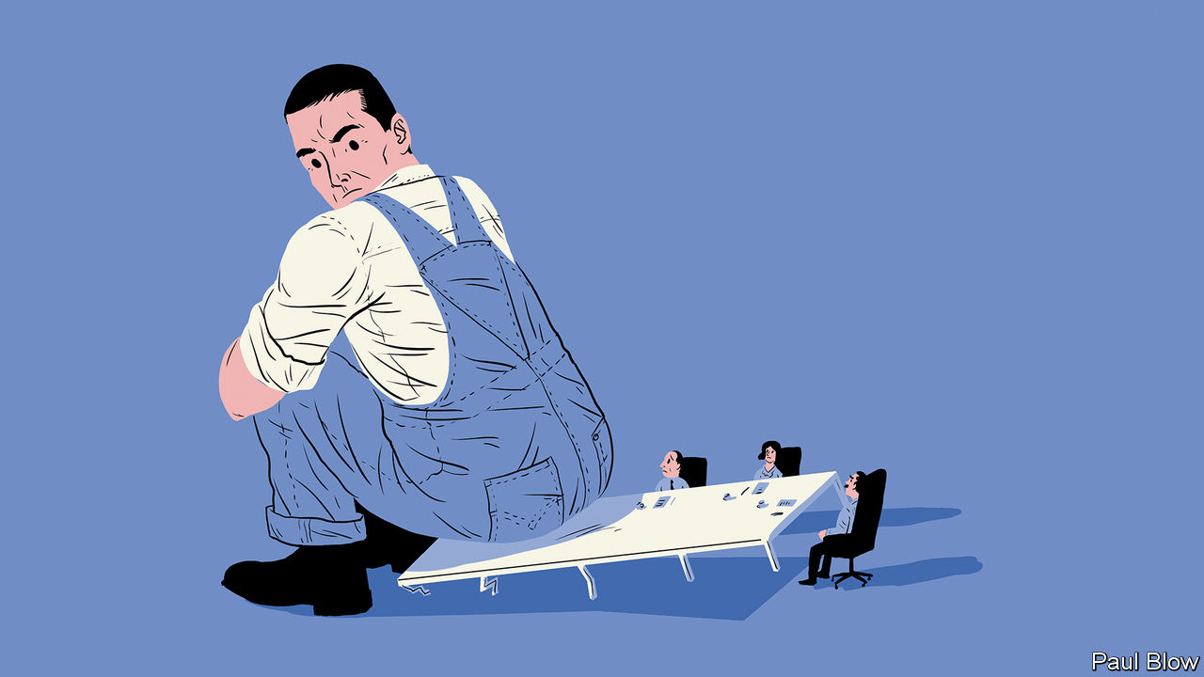

ONE HUNDRED years ago, on January 13th 1920, thousands took to the streets of Berlin, waving red flags and chanting slogans demanding more power for workers as lawmakers in the Reichstag debated a bill on works councils. Placards called, in Gothic script, for volle Mitbestimmung. The “full co-determination” the protesters desired amounted to nothing short of an equal say for workers and bosses in company management. The security police killed 42 and injured more than 100 in the young Weimar Republic’s bloodiest episode to date. Friedrich Ebert, the president, declared a state of emergency.

In the past century German bosses, long opposed to the idea, have made their peace with it. Co-determination has become a defining feature of German capitalism. And an appealing one, across the West’s political spectrum. France’s centrist president, Emmanuel Macron, mutters about wanting more of it. Theresa May set up a commission to look into how it might work in Britain while she was the Conservative prime minister. Most volubly, Elizabeth Warren, a progressive senator from Massachusetts vying for the Democratic presidential nomination, has a bill that would, among other things, reserve 40% of board seats of companies with revenues over $1bn for workers’ representatives. Many Americans wouldn’t mind; Civic Analytics, a data firm, finds majorities of both Democratic and Republican voters in favour of allowing employees at big firms to elect representatives to the board of directors.

As other advanced economies toy with the notion, however, parts of Deutschland AG are asking whether it is fit for the times. To some captains of German industry, the answer is no longer a docile natürlich.

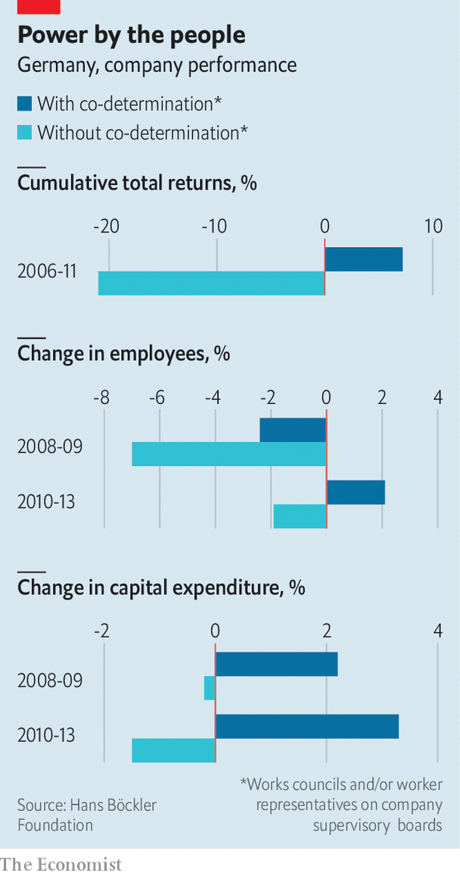

German co-determination comes in two varieties, enshrined in a law from 1976 passed after relations between labour and bosses soured in the wake of that decade’s oil crisis. Workers in any firm with more than five employees can by law form a works council that co-decides some issues, like working hours or maternity leave, with management and co-operates with trade unions in industry-wide collective bargaining. At firms with 500-2,000 employees, worker and union representatives get a third of seats on the supervisory board, which in Germany’s two-tier board structure oversees the management board. (In those with more than 2,000 workers employees can nominate half of supervisory-board members.)

These days only around 10% of firms with more than five employees have a works council, chiefly because nine in ten German companies have one to 20 employees, who can talk to the boss directly. But the biggest 28,000 firms still have one. In 2016, the latest year for which figures are available, 641 German firms had supervisory boards with equal worker representation, down from 767 in 2002.

## Boon or boondoggle?

Defenders of co-determination argue that it underpins many of German business’s virtues. Its globally admired apprenticeship system “would not exist without co-determination”, says Anke Hassel of the Hertie School of Governance; the works councils sustain it because they see it as an investment in the workforce and push companies to hire apprentices. More importantly, co-determination soothes industrial relations during downturns. In the dark days of the global financial crisis of 2007-09, when demand for German manufacturers’ products dried up, the system made it easier for the two sides to engineer a compromise: employees kept their jobs in exchange for agreeing to fewer hours (and so less pay) and thriftier holiday benefits. Productivity improved. When the recession ended in 2010 firms were immediately able to ramp up production.

A study published in October by the Hans Böckler Foundation, the trade unions’ think-tank, concluded that companies with labour representatives on supervisory boards did considerably better during the financial crisis and its aftermath than those without. They sacked fewer workers and reinvested more. Their cumulative total returns between 2006 and 2011 were also 28 percentage points higher. Co-determination, the reports’ authors conclude, “prevented short-sighted decisions by management”.

Armed with such numbers, and jolted by fears of what globalisation and digitisation might mean for German workers, unions are demanding more of it. Rainald Thannisch of the DGB, an umbrella group for German organised labour, wants equal representation for workers on supervisory boards at any firm employing more than 1,000 people (and one-third of the seats at firms with 250 employees). Legal loopholes that allow companies to avoid co-determination, such as being owned by a foundation, must be closed, Mr Thannisch says, and penalties for employers who prevent workers from forming a works council enforced more stringently.

Although they mostly accept co-determination’s peacemaker role in industrial relations, German bosses bridle at such proposals. Two-thirds of those who run firms with equal worker representation on the supervisory board see even the current version of co-determination as a handicap to doing business, according to the BDA, an employers’ association. Talk to chief executives and many gripe how works councils and bloated supervisory boards slow decision-making and add costs (since works-council members are paid for every hour they deliberate among themselves and with management). This, they add, discourages bold leadership and puts off foreign investors. It may tempt managers to buy labour’s support, as some of Volkswagen’s did in 2005 by creating a slush fund for the carmaker’s powerful works council to secure favourable votes in decisions on the firm’s restructuring (the executives responsible were prosecuted). Nor is it necessarily fair to all employees. One boss of a company in the DAX 30 index of Germany’s biggest listed firms notes wryly that co-determination ignores German multinationals’ foreign workers, whose interests may differ from domestic ones.

All this explains why companies that can avoid co-determination try to do so. Many in the Mittelstand, as Germany’s medium-sized export powerhouses are collectively known, convert into a Societas Europaea (SE), a public company registered under European Union corporate law that is exempt from co-determination rules, before reaching the 500-employee threshold for worker board membership. (Converters must keep co-determination if they had more than 500 workers before the conversion.) Some flee abroad, for example transforming themselves into a British plc.

Günzburger Steigtechnik, a maker of ladders in Bavaria, has more than 350 staff but no works council. Employees are involved in big decisions, insists Ferdinand Munk, the boss, whose family has owned and run it for four generations. The company pays attention to workers’ special needs—such as organising an employee’s shift around the care of his ailing wife—without badgering by a works council. A formal structure, Mr Munk thinks, would only slow things down. He says that co-determination is “actually counterproductive” in an age where speed and nimbleness are of the essence. Mario Ohoven, head of the Mittelstand association, calls it “out of date”.

Most employers concede that co-determination played a constructive role in the decades after the war. But times have changed. The world is overtaking German corporate giants. Only one, SAP, a software-maker, is among the world’s 100 biggest companies. Apple’s $1.4trn market value is roughly that of the entire DAX 30. Co-determination may not be the sole reason. European countries which do not embrace it hardly do better. But as cars go electric and manufacturing goes digital, German industry faces drastic restructuring—including of its biggest companies’ vast workforces. Bosses who agree with Mr Ohoven will be ever less timid to say so. ■

This article was downloaded by calibre from <https://www.economist.com/business/2020/02/01/deutschland-ag-rethinks-workers-role-in-management>

|  |  |  |  |
| --- | --- | --- | --- |
|  | Articles | Sections | Next |

|  |  |  |  |
| --- | --- | --- | --- |
| Previous | Articles | Sections | Next |

#### What’s American for Mitbestimmung?

# Most of the world has yet to embrace co-determination

Few countries outside Europe mandate works councils or worker representatives on boards

Feb 1st 2020 |

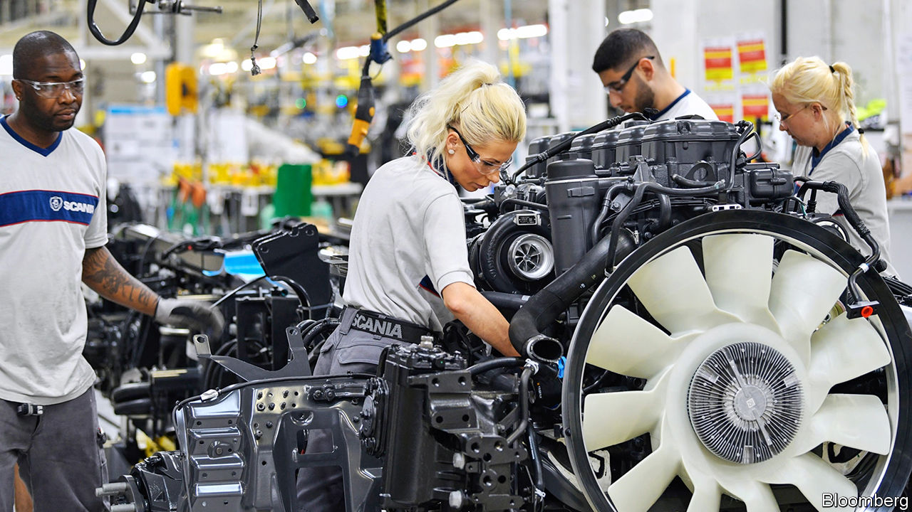

WORKS COUNCILS and worker representatives on boards are a German invention. But Mitbestimmung has spread throughout Europe. Nineteen of the EU’s 27 post-Brexit members—all bar Belgium, Bulgaria, Cyprus, Estonia, Italy, Latvia, Lithuania and Romania—have some “co-determination” in the private sector, at state-run firms or both. So does Norway, which is not in the EU.

Rules differ. In Sweden workers have the right to be represented on boards of firms with more than 25 employees. In Luxembourg the threshold is 1,000. Seats reserved for workers range from one in Croatia to half the board in Slovenia. In Norway and Sweden workers’ representatives sit on firms’ sole management board. Their Austrian and Slovakian counterparts are members of the supervisory board, the upper tier in two-layer board structures like Germany’s.

Outside Europe the practice has not taken hold (South Korea is a rare exception). In many countries unions play the role of works councils. America’s Wagner act of 1935 prohibits the formation of any form of employer-employee committee that has the power to decide on working conditions and labour-management relations, observes Steffen Müller at the Halle Institute for Economic Research. Some American unions oppose co-determination for fear of being usurped.

America’s private-sector unions have seen membership collapse in recent decades, leading to renewed interest in co-determination. The idea faces resistance—and not only from employers. In 2014 workers at a Volkswagen plant in Tennessee voted against being represented by the United Auto Workers, one of America’s biggest labour unions, which had planned to introduce a German-style works council at the plant. Local Republican leaders convinced enough workers that this would hurt jobs by deterring other businesses from investing in Tennessee.

This article was downloaded by calibre from <https://www.economist.com/business/2020/02/01/most-of-the-world-has-yet-to-embrace-co-determination>

|  |  |  |  |
| --- | --- | --- | --- |
| Previous | Articles | Sections | Next |

|  |  |  |  |
| --- | --- | --- | --- |
| Previous | Articles | Sections | Next |

#### Car stock racing

# Tesla is proving itself as a carmaker

But is its tech-like valuation justified?

Feb 1st 2020 |

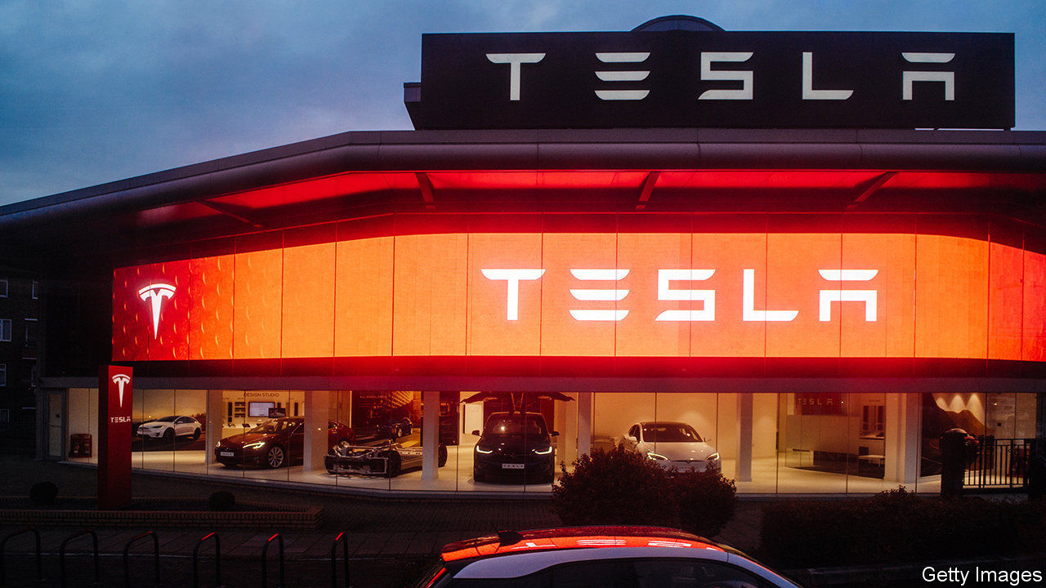

IN ITS QUEST to “accelerate the world’s transition to sustainable energy” Tesla is different to other carmakers. Their mission is less to change the planet and more to make and sell as many cars as possible. Despite its technological lead in electric cars, Tesla has struggled with the mundane task of mass-producing vehicles. Of late, however, the firm has started to hit production targets. It is even turning a profit. That such milestones seem modest by car-industry standards has not stopped investors from swooning. Tesla’s market capitalisation surpassed $100bn in January and is now only exceeded by one other carmaker, Toyota, a Japanese giant. It is worth more than Germany’s Volkswagen, which made more than 10m cars last year, 30 times as many as Tesla. It has lapped premium rivals like BMW (with a market value of $47.5bn) and Daimler ($51.2bn).

The latest indication that Tesla is at last making an impression as a manufacturer came with its fourth-quarter results, unveiled on January 29th. After years of losses the firm made an operating profit—of $359m—for the second quarter in succession (though it still lost money for the year). Its boss, Elon Musk, was uncharacteristically restrained but noted revenues in 2019 of nearly $20bn without spending cash on advertising. Earlier in the month Tesla also revealed delivery numbers that pleased analysts and seemed to show that the firm has put behind it what Mr Musk had called “production hell” around the Model 3, its first mass-market car.

Profits and production are not the only reasons Tesla is joining the automotive mainstream. New products and plants are also on track. Its Cybertruck, an angular pick-up straight out of a 1980s sci-fi flick, which Mr Musk unveiled in November, is set to hit roads in 2021. This year Tesla will launch the Model Y, a smaller SUV, and the Roadster, a pricey sports car. It has just started making Model 3s at a new “Gigafactory” in China, showing that it could react far more swiftly than leaden-wheeled competitors; it got the plant in Shanghai up and running in 11 months. It is set to break ground on another in Germany.

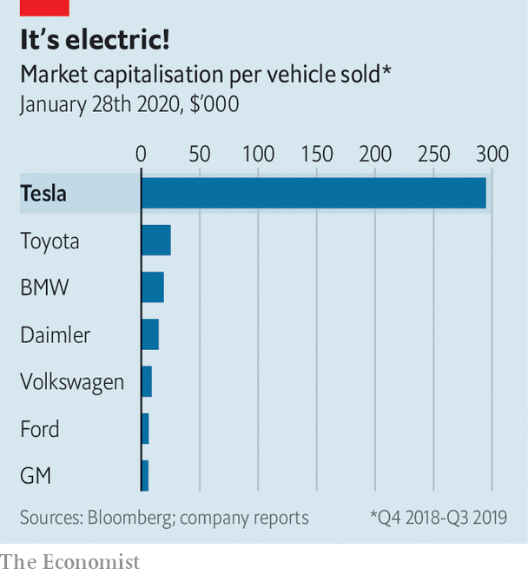

If all goes to plan, reckons Morgan Stanley, a bank, Tesla will be making 2m vehicles a year by 2030 and its operating margin over the next decade will average 8.3%. That would put it close to the current output and profitability of both BMW and Daimler (at least before their margins began to be squeezed by heavy investment in electrification, both to catch up with Tesla and to meet European emissions rules).

But then why is Tesla worth twice as much? For one thing, its electric-car technology leaves rivals in the dust. It is also unencumbered by the legacy of a business based on internal combustion engines, which, reckons UBS, another bank, could make it the world’s most profitable carmaker. Jefferies, one more bank, points out that a stronger balance-sheet (should it in fact strengthen) would allow Tesla to start thinking beyond merely making cars. It speculates that the firm may confirm it is working on a project to develop a “million mile” battery, which will set a new standard for energy density and lifespan.

Its ambitious expansion nevertheless faces many challenges of the car industry: spiralling labour costs, warranty issues, cut-throat competition as rivals (including go-getting Chinese ones) close the technology gap. For the time being, Tesla may bask in a Big Tech valuation, predicated on its disruption of carmaking. Investors appear keener than ever to condone its joyride. But if recurring profits do not materialise, expect them to confiscate the keys. ■

This article was downloaded by calibre from <https://www.economist.com/business/2020/02/01/tesla-is-proving-itself-as-a-carmaker>

|  |  |  |  |
| --- | --- | --- | --- |
| Previous | Articles | Sections | Next |

|  |  |  |  |
| --- | --- | --- | --- |
| Previous | Articles | Sections | Next |

#### Deferred gratification

# Airbus agrees to pay €3.6bn to settle a bribery case

Prosecutors can still go after individuals, but their record is poor

Feb 1st 2020 |



ON JANUARY 28TH Airbus agreed to pay Britain’s Serious Fraud Office and its French and American counterparts €3.6bn ($4bn) to settle a bribery case, pending court approval. The penalty relates to alleged payments to third-party consultants in several markets. Under a deferred prosecution agreement the planemaker will face no formal charges. Though prosecutors may pursue individuals, no British dpa has so far led to a conviction.

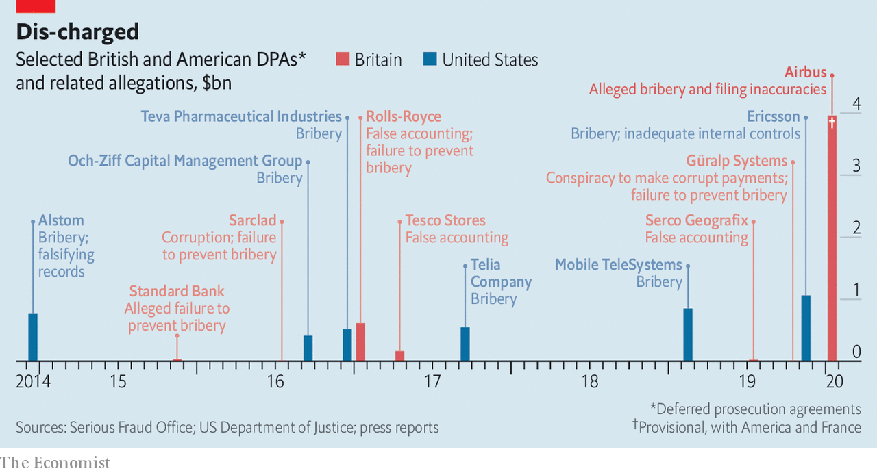

This article was downloaded by calibre from <https://www.economist.com/business/2020/02/01/airbus-agrees-to-pay-eu36bn-to-settle-a-bribery-case>

|  |  |  |  |
| --- | --- | --- | --- |
| Previous | Articles | Sections | Next |

|  |  |  |  |
| --- | --- | --- | --- |
| Previous | Articles | Sections | Next |

#### Not for sale

# Luxury groups ponder ways to get rid of their unsold inventory

Other than slashing prices

Feb 1st 2020 | PARIS

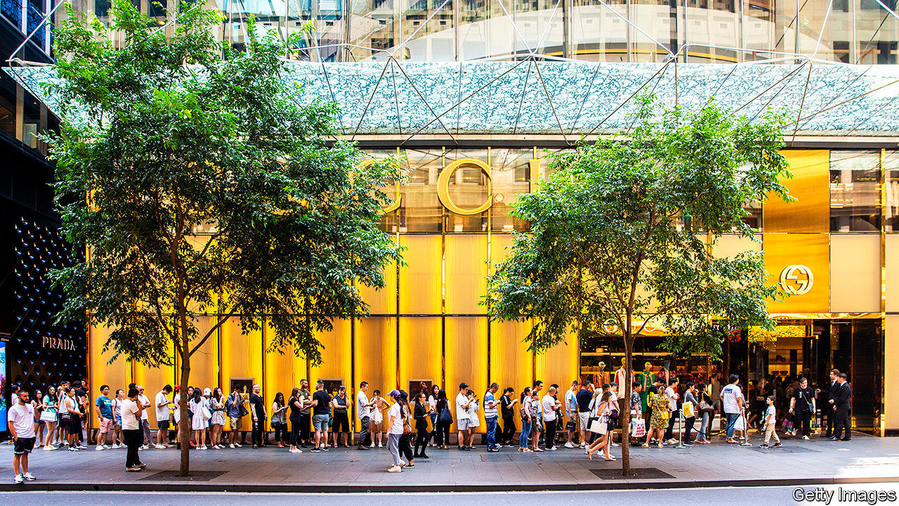

EVERY FROCK sold by the likes of Gucci or Givenchy is billed as a must-have that season. But, it turns out, some are more must-have than others. For all the hype they generate, even leading fashion brands struggle to shift much more than half their wares at full price. Whom to sell to once fickle fashionistas have moved on to the next trend? The luxury world is desperately searching for new ways to find a worthy closet for this unwanted inventory.

Dealing with “end-of-season” merchandise is a particularly thorny problem for luxury brands. Offering discounts to offload ageing wares is a time-tested trick among retailers. But cutting prices to clear the shelves is a bad look for labels whose raison d’être is to exude exclusivity.

Chic brands used to bin last year’s garb quietly rather than sell them cheap. That changed after July 2018, when Burberry, a British purveyor of upscale macs, faced a furore as it disclosed having destroyed $38m of bling (it claimed incinerating them was a way of generating energy). France will ban the practice entirely by 2023.

Luxury groups are loth to reduce production, given that goods can be sold for ten times what they cost to make. But putting up “Sale!!!” signs is considered uncouth. Plus, says Luca Solca of Bernstein, a broker, “you have to weigh cash made from discounted sales with the damage done to the value of the brand.” Prada, a posh Italian label, said last year it would end all in-store discounts.

Some brands’ offerings are so timeless—a Hermès handbag, say—that seasonality is not an issue. Others manage to get rid of old stuff by offering discreet “sample sales” to staff and their friends. Many of the duds used to end up on the internet, sold cheaply on sites like Yoox and Saksoff5th.com (though labels now see more potential to sell online at full price).

None of this will be enough to get rid of an outmoded collection—or diminish the pile of unsold items that analysts expect as a result of the coronavirus, which will force Chinese travellers to cancel shopping trips. To really shift stocks, brands now look to outdoor malls that group together “factory outlets”. The likes of Bicester Village, an hour’s ride from central London, resemble what a Chinese tourist thinks a quaint European village ought to look like, crossed with an airport shopping concourse. The shops are full of the stuff famous brands could not sell at full price elsewhere. Goods typically sell for 70% of high-street prices.

The concept is booming. Out of an estimated €281bn in personal-luxury sales last year, €37bn were in such physical off-price stores, according to Bain, a consultancy. The figure has shot up by 85% in five years. But using the outlets for anything beyond liquidating inventory—for example by stocking them with cheaper, second-tier collections—is a way to dent a brand’s cachet permanently, warns Mr Solca. Best to keep only the most questionable styles and weirdest sizes in stock, and to push a brand’s real aficionados to Regent Street or Avenue Montaigne.

Two things may come to the rescue of exasperated inventory liquidators. The first is the rise of second-hand-clothes sales online: expect to see many “used” frocks on offer that are in fact brand new. The second is “up-cycling”, when an unsold dress gets trimmed, combined and dyed into a new fabulous outfit. For luxury brands, these two trends are unmissable.■

This article was downloaded by calibre from <https://www.economist.com/business/2020/02/01/luxury-groups-ponder-ways-to-get-rid-of-their-unsold-inventory>

|  |  |  |  |
| --- | --- | --- | --- |
| Previous | Articles | Sections | Next |

|  |  |  |  |
| --- | --- | --- | --- |
| Previous | Articles | Sections | Next |

#### Bartleby

# From the cradle to the Grove

Business lessons may not always apply to government

Feb 1st 2020 |

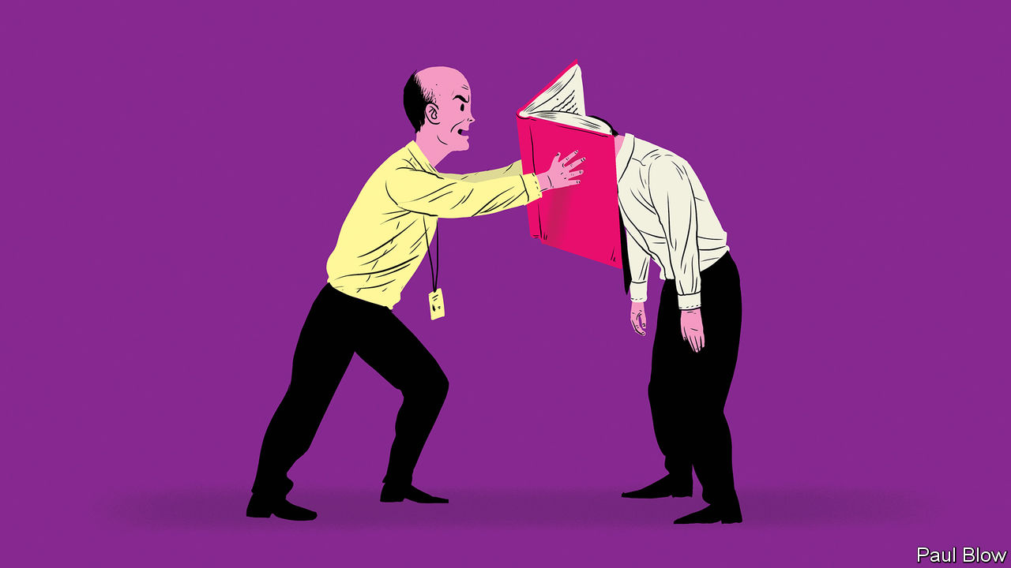

MANY PEOPLE have a favourite book that they like to hand out to friends and colleagues, ranging from Doris Lessing’s feminist bible “The Golden Notebook” to Ayn Rand’s libertarian saga “The Fountainhead”. The chosen tome of Dominic Cummings, a special adviser to Boris Johnson, Britain’s prime minister, is rather more specialist. It is “High Output Management” by Andrew Grove, the late chairman of Intel, a chipmaker.

As management books go, Mr Cummings made an excellent choice—Grove’s text is clear, practical and free of both pomposity and jargon. Any manager could benefit from his insights into issues such as planning and performance reviews. The book has been popular in Silicon Valley ever since it was first published in 1983.

But how much use will the book be to British civil servants, or indeed any government official? At Intel, Grove’s goals were clear: to produce the most powerful, reliable microprocessors at the lowest possible cost. The market reinforced efforts to meet these goals every day. A competitor might always produce a better, cheaper product (hence the title of another Grove book, “Only the Paranoid Survive”).

Even though they involve management, governments are not businesses. They are rarely engaged in manufacturing. The services they offer are not usually being provided in a competitive market. And the outputs they produce are notoriously hard to define.

Take the provision of welfare benefits. A government might choose to aim at a whole range of targets. The provision of benefits at the lowest administrative cost; ensuring that no genuine claimant goes without food or shelter; reducing fraud; making the application system as simple and transparent as possible; setting the level of benefits so that applicants are encouraged to seek work; and so on. Some of these targets might be incompatible with others. Politicians may choose to prioritise one but they will come under pressure if they fail to meet another: if fraud rises, say, or if claimants are left destitute. So civil servants may be forced to chase all the goals simultaneously (more like the modern-day notion of “stakeholder capitalism” than the shareholder focus Grove represents).

Nor can one rely on everyone to pursue the targets that politicians set. In the 1980s the British government changed the definition of unemployment in a number of ways that reduced the claimant count. But the result was a rise in the number of people on sickness benefit. The doctors who attested to the sickness claims were not under the direct control of ministers. Many were sympathetic to claimants at a time of rapidly rising joblessness.

The theme which runs through Grove’s book is the “breakfast factory”: a restaurant that serves the customer with an egg, toast and coffee in the most efficient fashion. But running a government is a lot more like operating a café where some customers are vegan, others are gluten-intolerant, some want mint tea, and the staff treat the enterprise as a workers’ co-operative and (possibly to their boss’s dismay) refuse to take money from patrons.

Where Grove does on occasion stray into public policy, it is easy to see where his approach falls short. He compares the way that American embassies assess visas with manufacturers testing components. The vast majority of visas are processed without fuss, so why not test a sample rather than every single application, and reduce the time wasted by staff and applicants? Politicians would be extremely reluctant to take such a line, in case a single terrorist entered the country on an unchecked visa. Grove’s analysis of America’s criminal-justice system suggests that the main constraint is a lack of prison places. At no point does he consider whether, in a country which has long locked up more people proportionately than anywhere else, prison is the most effective way of dealing with crime.

This does not mean that government can learn nothing from business. But the idea that businesspeople will automatically translate their success into government has been proved false by a host of examples, from Silvio Berlusconi in Italy to Rex Tillerson, head of ExxonMobil turned America’s secretary of state. They pull levers and find that nothing moves the way they expect.

It won’t do civil servants any harm to read “High Output Management”. But it is not a road map for managing government. At least the officials can be grateful for small mercies: Mr Cummings isn’t making them read “The Fountainhead”.

This article was downloaded by calibre from <https://www.economist.com/business/2020/02/01/from-the-cradle-to-the-grove>

|  |  |  |  |
| --- | --- | --- | --- |
| Previous | Articles | Sections | Next |

|  |  |  |  |
| --- | --- | --- | --- |
| Previous | Articles | Sections | Next |

#### A court of public opinions

# Facebook unveils details of its content-oversight board

The social network prepares to hand decisions about contentious content to an independent arbiter

Jan 30th 2020 | MENLO PARK

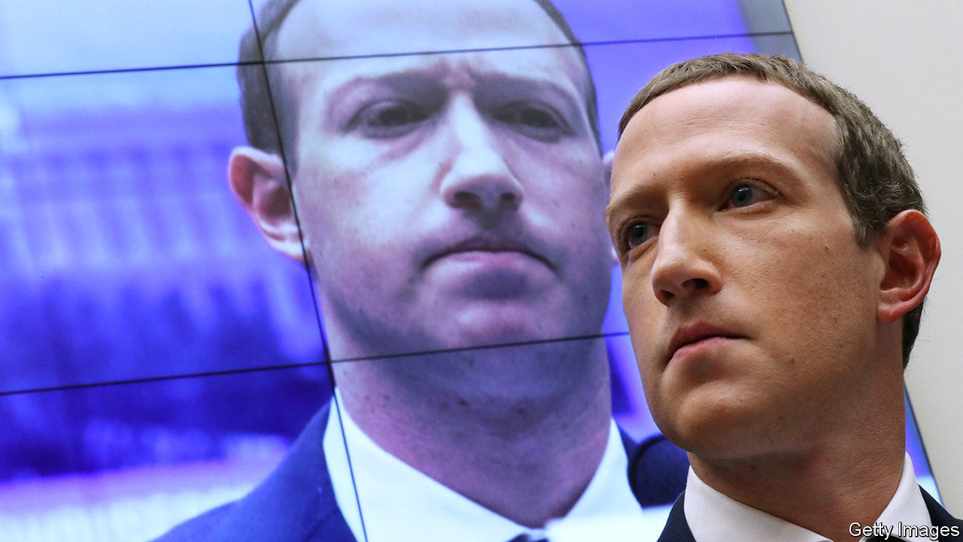

IN NOVEMBER 1999 the Internet Corporation for Assigned Names and Numbers (ICANN), which oversees the web’s address book, held its inaugural annual gathering. Two decades later the online world faces another constitutional moment, this time courtesy of a company which has profited from the internet’s stupendous growth—and is blamed for many of its ills, from privacy abuses to the spread of disinformation. On January 28th Facebook unveiled a draft of the bylaws of what it calls an “oversight board”: an independent group of experts charged with the power to review—and overturn—decisions by the firm’s army of content moderators. The world’s largest social-media conglomerate hopes to have the body up and running in a few months.

Some hope the entity will evolve into an online ombudsman—perhaps even a “supreme court” for other big Western internet platforms—to oversee not just content moderation, but data-gathering and algorithm design. Others view it as no more than Facebook’s figleaf: an attempt to forestall real regulation and palm off responsibility for controversial posts. What should users, regulators and investors make of it?

The board certainly looks like a serious effort at institution-building—something “no firm has ever done before”, in the words of Kate Klonick of St John’s University School of Law in New York, who was allowed to play fly on the wall as the board’s contours were drawn up. Facebook hired a (majority-female) team of 12 people, mostly lawyers, to oversee the body’s creation. Some used to work at the White House and the UN; others came from media firms and consultancies. Over the past year they solicited input from more than 2,500 people at 60-odd workshops around the world.

The result is unique: a sort of regulatory startup. The board will have its own staff of 30-40, budget (Facebook has earmarked $130m over six years) and a trust to manage it all. Facebook will appoint the first three co-chairs, who will then recruit other members (for a total of 40, each serving a twice-renewable three-year term). The board will have its own website to receive and review appeals. These can be lodged by users of Facebook (and of Instagram, its photo-sharing app) who feel their post has been unfairly removed and not restored. If the company itself is having trouble deciding whether to restore content, it too can file “emergency requests”.

Each submission triggers a 90-day process. The emergency requests will be handled faster: in 30 days. If the board agrees to hear a case, a group of five members (who will remain anonymous for security reasons) consults experts and makes a decision, which it must present in plain language. Facebook has a week to comply with a ruling (and can apply it to selfsame content elsewhere on the network). The board can also make “policy recommendations”, such as amending Facebook’s “community standards”. Though these are non-binding, the firm will have to explain itself publicly if it chooses to ignore them.

Internet-governance nerds have questions aplenty. Will users and authorities deem the board legitimate? Much will hinge on the geographic and biographical diversity of its initial members, reckons Ms Klonick. Will it have the capacity to deal with appeals? The board is expected to consider no more than a few dozen cases a year, compared with 3.4m posts Facebook declined to restore in the first quarter of 2019 alone (not counting spam, see chart). Some fear that Facebook could flood it with emergency requests to distract from inconvenient ones for the company.

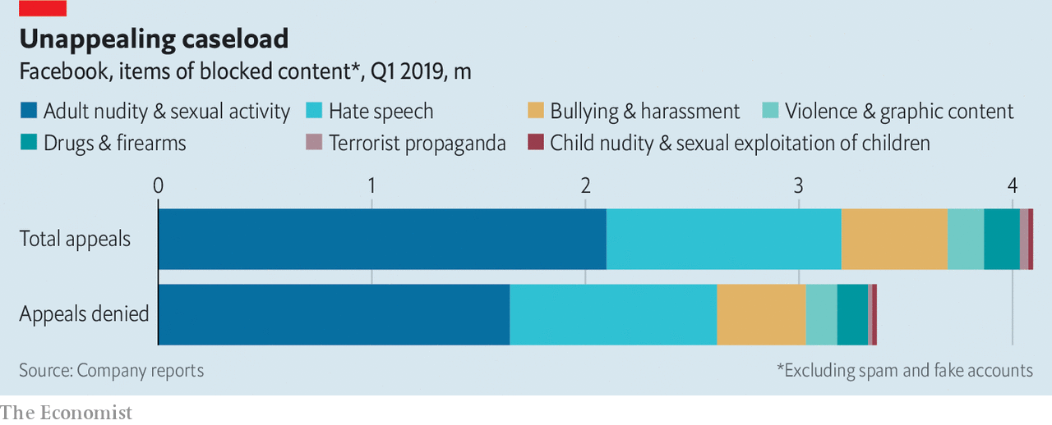

Most important of all, how powerful and independent will Facebook allow the board to become? And how will it affect the firm’s business? The answer is not very and not much—for now. The board’s decisions will be based not on real-world laws but on the community standards, which are vague. Initially it will only rule whether individual pictures and posts ought to have been taken down, though the company promises to extend the board’s ambit to entire Facebook pages and groups and also to whether certain posts should be up in the first place, once the technical infrastructure is in place. If this makes the social network seem more salubrious, it may lure more corporate advertisers, the fount of Facebook’s revenues (which grew more slowly last quarter than ever before).

Things would get more complicated were the board granted a say on how Facebook gathers data or designs algorithms. The company does not rule out the possibility. But Nathaniel Persily of Stanford Law School argues that broadening the board’s remit too far, too fast, could be tough. Unlike for content, he observes, no proven judicial model exists for reviewing algorithms. More cynically, Dipayan Ghosh of Harvard University, who once worked at Facebook, doubts the firm would ever accept limits on the data it collects or what content its algorithms show in the Facebook newsfeed.

The last set of unknowns concerns how others, notably governments and rival platforms, will react. If Big Tech takes up Facebook’s invitation to sign up to its creation, it could indeed turn into a court of appeal for cyberspace. This looks unlikely in the near term: why would a Google let someone else tie its hands? Some governments, for their part, may see the board as competing with official efforts to regulate speech online. However, both could yet find the nascent entity useful: a complement to government action and, if pressure on internet firms to moderate content mounts, a substitute for bodies they would otherwise need to convene themselves.

A lot rests on how the oversight board turns out in practice. This will take time to assess. Even 20 years after its birth ICANN is a work in progress; just look at the controversy over the recent $1bn sale of .org, a domain mostly used by charities, to a private-equity firm. At a time when the internet is torn between its non-commercial roots and its hyper-commercial present, Facebook’s experiment is worth pursuing. ■

This article was downloaded by calibre from <https://www.economist.com/business/2020/01/30/facebook-unveils-details-of-its-content-oversight-board>

|  |  |  |  |
| --- | --- | --- | --- |
| Previous | Articles | Sections | Next |

|  |  |  |  |
| --- | --- | --- | --- |
| Previous | Articles | Sections | Next |

#### Schumpeter

# Clayton Christensen’s insights will outlive him

The Harvard professor made lasting contributions to the field of disruptive innovation

Feb 1st 2020 |

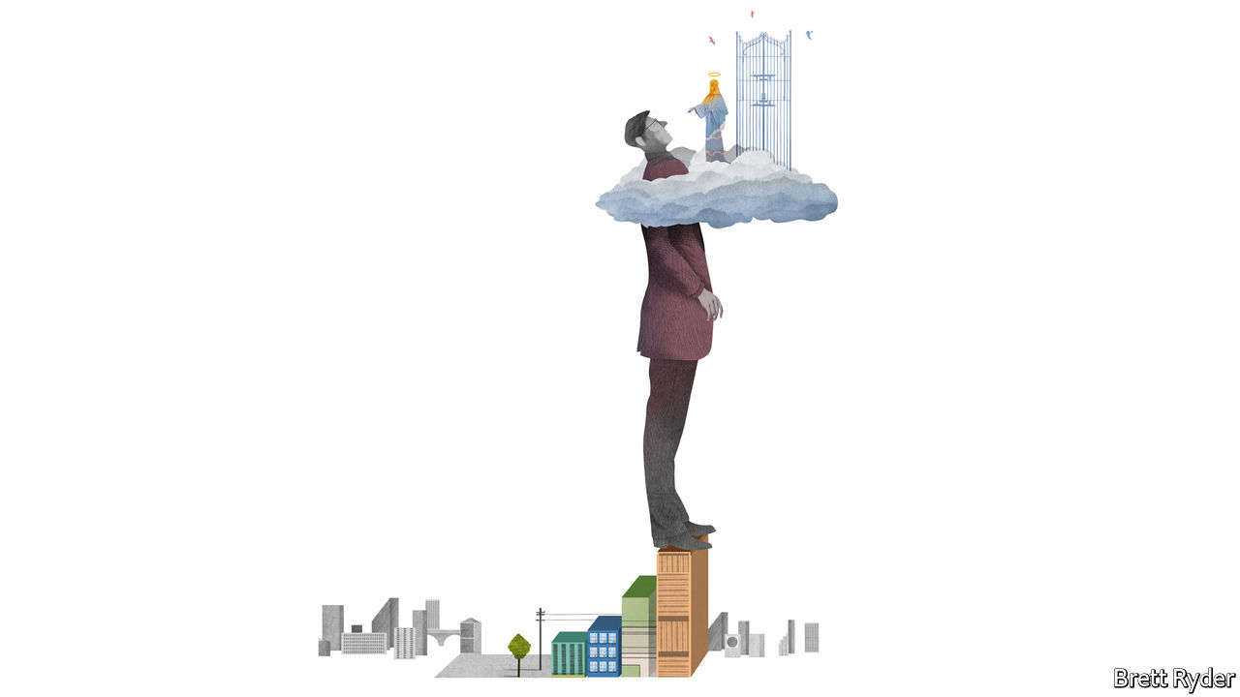

“WHEN I DIE and they’re going to interview me outside of heaven to decide whether...to let me in,” Clayton Christensen once told an Economist conference, “I’m going to start by saying ‘I’ve got some questions for you first’.” Mr Christensen, who died of leukaemia on January 23rd, aged 67, was endlessly seeking answers. The most important, to the question “why do great firms fail?”, inspired “The Innovator’s Dilemma”. The book, published in 1997, popularised the idea of disruptive innovation. It made the Harvard Business School professor the most influential management thinker of his time.

He disliked the term “guru”. It sat awkwardly with him, as he sat awkwardly on stage: a lanky two-metre-tall Mormon who laced conversations with exclamations like “Holy Cow!” and knotted his fingers together as if trying to stop his enthusiasm from bounding out. He was the antithesis of Silicon Valley’s self-promoters who, often in his name, turned innovation and disruption into the most overhyped words in business. Still, unlike most management theories, which live and die like fruit flies, his will outlast him.

Its compelling simplicity caught the zeitgeist just as the disruptive power of the internet was taking hold. It was not wholly new. As management thought goes, disruptive innovation is no double-entry book-keeping, or even Joseph Schumpeter’s “creative destruction” (on which it was partly built). But it has stood the test of time so far. In a pleasing symmetry, a business insight that grew from research on, among other things, the impact of mini-mills on the steel industry would apply generations later to the impact Harry’s razors are having on an incumbent brand like Gillette.

In a nutshell, Mr Christensen’s insight was that it is not stupidity that prevents great firms from foreseeing disruption but rather their supreme rationality. They do “the right thing”, focusing on better products for their best and most profitable clients, often to the point of over-engineering (how many Mach and Fusion blades does a chin need?). But that is “the wrong thing” if it blinds them to the threat from poorly capitalised upstarts offering cheaper stuff in markets too obscure to worry about. Such threats can swiftly turn existential if the rivals move upmarket and go for the jugular.

At the time the insight was radical. To business schools it had seemed obvious that big firms had the resources, the labs and the boffins to out-innovate anyone. “The Innovator’s Dilemma” challenged that complacency. It was also inspirational. It gave startups the confidence to believe that even the best-run incumbents could be overthrown. That may be why Apple’s Steve Jobs and Amazon’s Jeff Bezos were fans—and, once they disrupted their markets, why they stayed eternally vigilant, even paranoid.

Mr Christensen had his critics. One historian at Harvard University, Jill Lepore, wrote a New Yorker article in 2014 lamenting the Christensen-inspired “blow things up” style of disruption spreading through corporations, schools, universities, hospitals and newspapers. She also said some evidence from the industries he had studied did not support his claims.

“Mr Disrupter”, as his colleagues called him, did himself no favours by sometimes acting as if he had a monopoly on disruptive wisdom. Even devotees such as Ben Thompson of Stratechery, a tech newsletter, point out that for years Mr Christensen shrugged off Apple’s iPhone as just a fancy mobile phone, because it did not neatly fit his notion of disruption as a frugal, bottom-up process (he later conceded it perhaps disrupted the laptop). He felt the same way about Tesla, which he once brushed off as a luxurious irrelevance, and Uber, which started off neither more bare-bones nor cheaper than taxis. Both may end up rocking the car industry. The internet has made it easier to provide both the high end and low end of the market with superior services at the same cost.

Look around, though, and signs of disruptive innovation are widespread. In India Mukesh Ambani’s Jio, a mobile network offering cheap, high-speed data, has upended the telecoms market—albeit with oodles of cash from Reliance Industries, India’s most valuable company. In America, e-commerce-enabled, direct-to-consumer brands, from razors (Harry’s) to eyewear (Warby Parker) to mattresses (too many to name), are giving traditional retailers sleepless nights.

The difference is how incumbents are responding, guided by Mr Christensen’s counsel. Richard Lyons of the University of California, Berkeley, calls it “the disruption risk-management system”. Some big firms buy up the competition before it hurts them, as Google did with YouTube, Facebook did with Instagram and WhatsApp, ExxonMobil did with XTO, a fracking firm, and Danone did with non-dairy brands such as Alpro. Some take stakes in potential disrupters to keep an eye on them: GM invested in Lyft, now a listed ride-sharing company, and two other carmakers, Daimler and Geely, have taken stakes in flying-taxi firms. Others, such as Apple, have managed to disrupt themselves from within.

## A towering figure

Some of the defining business trends of the past decade are, in other words, infused with Christensenian thinking, which has itself gone from disruptive to ubiquitous. In other ways, however, Mr Christensen remained an iconoclast. He was scathing about data’s ballyhooed ability to predict the future. When he arrived at heaven’s gate, he said, one of his first questions to St Peter would be: “Why did you only make data available about the past?” He was wary of accepted measures of success, such as fame. Life, he insisted, should be judged by the impact it has on individuals; at its best management could be “the most noble of professions”, but only if it assisted others in learning and growing. And he preferred not to give answers, but to help people work things out for themselves. The concept of disruptive innovation was just such a pedagogic aid—and an elegant one. Mr Lyons speaks for many when he says “We will always remember the beauty.” ■

This article was downloaded by calibre from <https://www.economist.com/business/2020/02/01/clayton-christensens-insights-will-outlive-him>

|  |  |  |  |
| --- | --- | --- | --- |
| Previous | Articles | Sections | Next |

|  |  |  |
| --- | --- | --- |
| Business | Sections | Science and ... |

Finance and economics

Asset management: Privacy and its limits

.

Investment banking: Turntable

.

Poverty and privacy: Hidden costs

.

Inflation in the euro area: A fuller figure

.

Free exchange: Rummaging in the toolbox

.

Finance internship

.

|  |  |  |
| --- | --- | --- |
| Business | Sections | Science and ... |

|  |  |  |  |
| --- | --- | --- | --- |
|  | Articles | Sections | Next |

#### Privacy and its limits

# Everyone now believes that private markets are better than public ones

But when an idea is universally held it often pays to be cautious

Feb 1st 2020 |

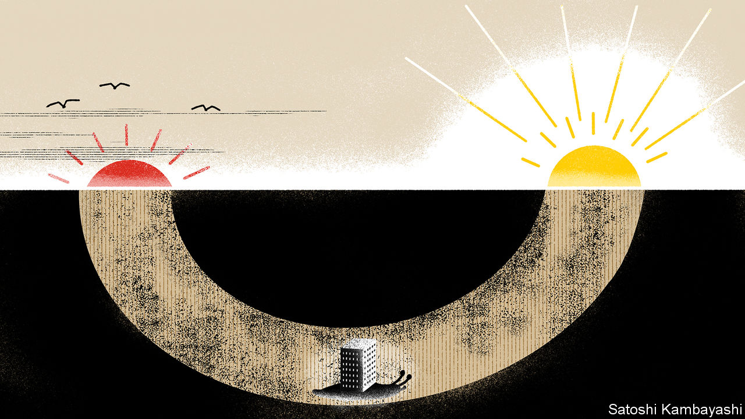

THERE WAS a time when a sure way to establish a reputation as a campus sage was to bang on about the “dialectic”, or the action of opposing historical forces. Sooner or later somebody will apply the term to asset management. The industry is not short of would-be sages. And it has historical forces of its own to contend with. Over the past decade there has been a dramatic shift towards “passive” funds. They track publicly listed stocks or bonds that are liquid—that is, easy to buy or sell. The most popular funds are huge, run by computers, widely held and have low fees.

This passive boom has spawned its antithesis—niche, run by humans, secretive, thinly traded and high-fee. Institutional investors are rushing headlong into private markets, especially into venture capital, private equity and private debt. The signs are everywhere. A large and growing share of assets allocated by big pension funds, endowments and sovereign-wealth funds is going into private markets—for a panel of ten of the world’s largest funds examined by The Economist, the median share has reached 23% (see chart 1).

Worldwide, pools of private capital, including private equity and private debt, as well as unlisted real-estate and hedge-fund assets, grew by 44% in the five years to the end of 2019, according to JPMorgan Chase. A different way to capture the scale of the private party is to look at the quartet of Wall Street firms that specialise in managing private investments for clients—Apollo, Blackstone, Carlyle and KKR. Their total managed assets have risen by 76% in the past five years, to $1.3trn. They have long specialised in buy-outs and property. More recently they have grown in private-debt markets, too—in total their funds’ credit holdings have hit $470bn.

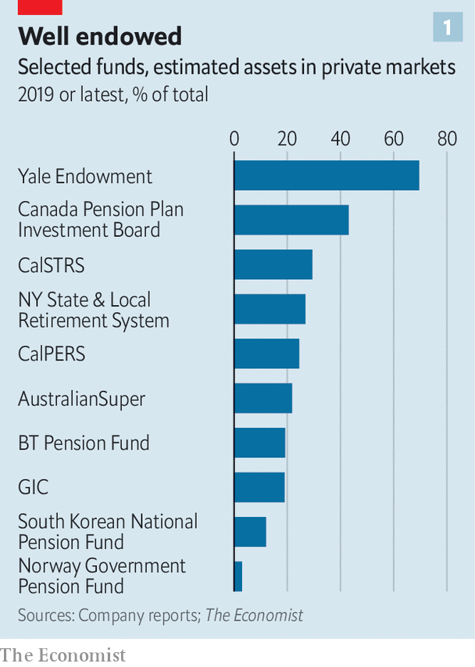

Venture capital (VC), another part of the private universe, is feverish. SoftBank’s Vision Fund, a $100bn private-capital vehicle backed by Saudi Arabia’s sovereign-wealth fund, has funnelled cash into fashionable, unlisted startups. Other institutions have vied with it to write big cheques for Silicon Valley’s brightest new stars. Already some of these bets have gone awry. WeWork, an office-sharing deity-turned-dud, had to cancel an initial public offering (IPO) in 2019 after public-market investors balked at its valuation. This week Casper, a loss-making firm that sells mattresses on the web, announced that the value it is seeking at IPO is below its $1.1bn valuation at its previous funding round.

The flood of capital into private markets ultimately rests on the belief that they will outperform public ones. There is evidence for this—in the past the best-run private-capital managers have beaten the returns from public markets, even after generous fees. And there are grounds to believe that this was no statistical fluke. Private capital, say its boosters, reduces “agency costs”. These arise wherever somebody (the principal) delegates a task to somebody else (the agent) and their interests conflict. Consider the public markets—no one has a big enough stake to make it worthwhile to monitor firms, which as a result get complacent or indulge in short-term earnings management to the detriment of the long term. Private capital, which is closely held in a few hands, is supposed to get around such agency problems.

Yet every investment craze is liable to overreach, blindness to risk and misallocated capital. Recent converts to the private world, dazzled by the historical returns, may not fully appreciate the hazards. The capital washing into San Francisco’s venture-capital industry has bloated both the value of pre-IPO companies and the egos of founder-managers. The big concern is that a shift from public to private capital merely swaps one set of agency conflicts (shareholders v company managers) for another (shareholders v private-asset managers).

## Where Yale goes the world follows

Private capital was once a fringe interest. So what changed? The growth in passive investing has made public markets less comfortable for midsized companies. They are not big or liquid enough to be in baskets of leading stocks, such as the S&P 500 or the FTSE 100, that are tracked by giant low-cost index funds. A generation ago a promising startup would typically go for an IPO within four years. Now the remaining active investors in public markets are less willing to take a punt on small firms.

Regulation has played a role, too. Legislation in the mid-1990s made it easier to set up large pools of private capital in America. Meanwhile the costs and hassle of being a public company have grown. After the financial crisis of 2007-09 new rules made it costlier for banks to lend. Even before that, America’s biggest banks preferred to lend to consumers and blue-chip firms than to midsized firms. There was a gap in corporate credit that needed to be filled.

There has also been an intellectual revolution among investors, led by the endowments of large American universities, which in the 1980s began to devote a growing share of their funds to private assets. David Swensen, at Yale, was at the forefront of this approach. The idea was straightforward. Because life-insurance funds, university endowments and sovereign-wealth funds have obligations far into the future, they can take a long-term view. They can sacrifice the liquidity of public markets for the better returns promised in private markets—where data are hard to come by; where assets are complex and value is hard to appraise; and where finding the right opportunities takes patience.

Few investors admit it, but there are other, sly benefits to private-equity funds. They can pile on more leverage in order to boost returns. Some pension schemes and insurers are forced to sell public shares at the wrong time, when markets tank, either to comply with solvency rules or because trustees panic. That is not possible when your money is locked up in private funds with lifespans of a decade.

Since the 1990s a growing band of investors have followed the Swensen formula and moved into private markets in order to capture higher returns. Measuring those can be tricky. How public companies fare is no mystery—just check the market prices. But stakes in private-capital partnerships are not traded continuously. Data are hard to collect. Funds do not begin or end at set times; they have “vintages”. Investors only really know how they have fared once a fund is liquidated. Until then managers have a lot of discretion over how assets are valued. They are notoriously prone to using metrics that flatter performance. One trick is to borrow against equity yet to be called in the early stages of a buy-out. Another is to claim to be a top performer by picking your best vintage.

Nonetheless the academic literature has concluded that private equity is not all smoke and mirrors. A landmark study in 2005 by Steven Kaplan of the University of Chicago and Antoinette Schoar of MIT introduced a metric called PME (public-market equivalent) to gauge the merits of private capital. A recent comprehensive study based on this technique—by Mr Kaplan together with Robert Harris, of the University of Virginia, and Tim Jenkinson of Oxford’s Saïd Business School—finds that venture and buy-out funds on average did better than the S&P 500 index by around 3% a year after fees. The spread around that average is considerable. Investors in the top quartile enjoyed returns that were far higher than in public equity; investors in bottom-quartile funds did a lot worse.

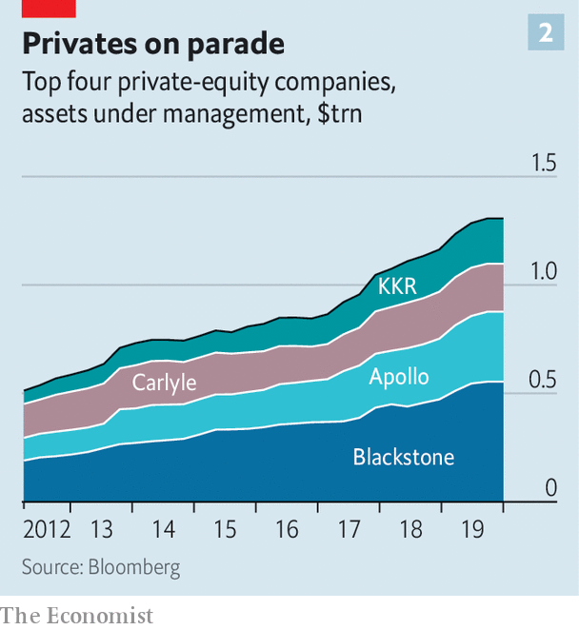

Better returns for investors reflect in large part better operating performance by the firms that most funds invest in. In the main, the academic literature finds that private-equity and venture-capital funds add value to the firms they own. They raise efficiency, revenue growth and profitability. The firms have better management habits than entrepreneur- or family-owned firms. Buy-outs lead to modest net job losses but big increases in both job creation and destruction. They spur greater efficiency by speeding up exit from low-productivity “sunset” firms and entry into more productive “sunrise” firms. VC backing spurs more innovation, patents and speedier product launches.

A fledgling business requires lots of attention. Patience and freedom to act are obvious virtues in venture capital. “A startup is like a sailing boat; it needs to tack quickly,” says Roelof Botha of Sequoia Capital, a VC firm. “It is better suited to the private markets.” In contrast, “a mature company is like an oil tanker and is better suited to the public markets.” Mature firms, though, sometimes need to quickly change direction too. That is hard to do in the unforgiving glare of the public markets. Anything that upsets the predictability of short-term profits is likely to frighten shareholders. Private equity can be more patient, because it has control. “We worry about the quarter-by-quarter performance only if it is symptomatic of a long-term problem,” says Joe Baratta of Blackstone.

The boss of a rival firm puts it bluntly. In private equity there is something called the 100-day plan. It sets short-term priorities (“quick wins”) for a newly acquired firm, identifies ways to raise cash quickly (to pay down the debts raised to acquire the firm) and plots the longer-term strategy. Imagine a CEO of a public company laying out such a plan on a conference call to analysts: “We’re investing in a brand-new IT system; we are putting up for sale the parts of the business we believe are not vital to our company; and we have hired some management consultants to carry out a strategic review of the other parts.” The response to this would be a run on the stock, he says.

The liberal use of debt juices up headline returns but it also helps tame the agency costs that dog public equity. A hefty interest payment each quarter is a spur to executives to cut costs and raise revenue. The bosses hired by private-equity firms to run companies are made to feel such pressures keenly. These managers are of relatively modest means, but they are required to co-invest in their firm’s equity. By stacking the firm’s capital structure with debt, a smallish investment from managers can be turned into a big slug of the total equity. Their stake is at risk should the firm falter.

Just as private firms are run better, say boosters, so private-debt markets operate in a way that is superior to public ones. In the 1980s buy-outs were financed by junk bonds. But the fuel for many private-equity deals today is leveraged loans, packaged by banks and sold to investors, and a kind of public-private hybrid. A broadly syndicated leveraged loan might have 75-100 buyers and be traded as much as a listed bond. A purely private bond might be sold to a handful of lenders or even just one. Speed is part of the appeal. If a private-equity firm can line up private-debt finance quickly it can steal a march on its rivals. Private-credit funds often prefer to be the sole debt-financiers of a deal, if they like the terms and judge the company a good risk. Should the loan sour it is easier to cut a deal that limits your losses when you are the only creditor. Once again, control—agency—is prized.

## Too far, too fast

The private-investment boom shows little sign of stopping. Low interest rates mean that a global hunt is on for higher returns. The boss of a big American state-pension scheme says he wants to allocate more to private investments in order to try to plug the pension scheme’s gaping funding deficit. Like many sovereign-wealth funds, South Korea’s National Pension Service has a target to raise its allocation to alternative investments, to 15% from 12% in 2018.

Yet anyone running a big investment organisation should worry about three things. First, as even more capital floods into private markets, returns will inevitably suffer. In their big study Mr Kaplan and his colleagues find that while buy-outs’ returns beat the S&P 500 in nearly all vintages before 2006, they have more or less matched public-equity returns since. Private-equity funds used to buy businesses that were much cheaper than listed firms. But the big beasts of private equity are becoming ever bigger. They have large fixed costs to cover: to meet those, there will be pressure to do deals that would not have passed muster in the past.

This pressure is already visible in venture capital. Very few new firms are world-beating. Lots of capital has gone to startups that are variations on established themes: enterprise computing; platforms that bring providers of services (taxis, lodgings, office space) and consumers together; and retail sales via the internet. As more and more capital seeks a piece of the action, the valuations of firms are inflated. “You have a lot of zero-sum expenditure,” says a Silicon Valley bigwig. “Think of all those subsidised taxi journeys from Uber and Lyft.”

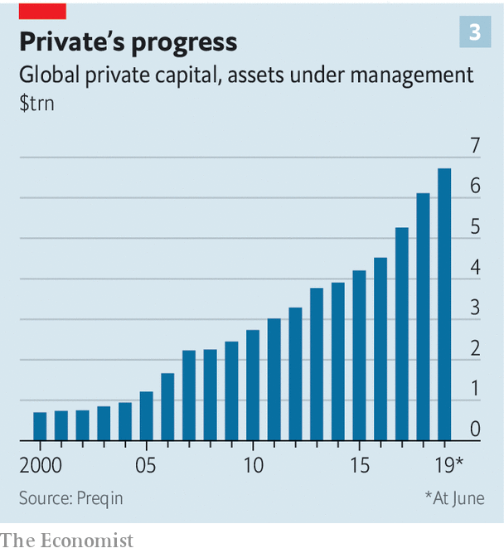

A second concern is liquidity. In principle, there are rewards for tying up money for five to ten years. It affords time for Silicon Valley to turn fledglings into global firms and for private-equity firms to transform sluggish businesses into world-beaters. But even long-horizon investors have ongoing demands on their cash, for example paying the beneficiaries of a pension scheme, meeting commitments to put fresh cash into buy-outs, or (for universities) paying for research grants and bursaries. It is a headache for investors to manage their liquidity needs when a large chunk of their assets are private and illiquid. Payment flows are unpredictable. And capital calls often come at the worst time: during recessions. It is only then that a lot of investors discover that they are less patient than they had believed themselves to be when liquidity was plentiful. Illiquid assets cannot easily be sold to take advantage of low prices in public markets, for instance during crises, when other investors are forced to sell.

The final concern is agency costs. Private capital may be a solution to the age-old agency problem between shareholders and company bosses. But it also creates another one between institutions (the limited partners) and the private-asset managers (the general partners) to whom they supply capital. Fees are high. And private-capital managers enjoy a great deal of discretion over how they value their assets and the timing of buying and selling decisions. Just as there are costs of monitoring the management of public firms there is a cost to monitoring your private-capital manager.



In some regards, private shareholders can be more lax. The 1980s buy-out boom was powered by a backlash against the imperial CEO, who was more interested in empire-building than profits. An irony is that the clubby nature of the venture-capital industry seems to have fostered a new kind of imperial founder-manager—whose behaviour is brattish, and who takes investors for granted, or even for a ride. The managers of VC firms “don’t want to piss the CEO off, because they can’t be badmouthed in startup circles,” says a Silicon Valley figure. So “you end up with a list of enablers at board level.” Agency costs are still alive and kicking.

## The limits of privacy

What will people make of today’s rush into private markets in a few years’ time? Perhaps it will prove itself a truly superior form of asset ownership. But it might also be revealed as a creature of sluggish growth and rock-bottom interest rates. A near-zero cost of risk-free capital allows for venture-capital-backed business models that are loss-making but have lots of potential to grow. Private equity, meanwhile, has thrived in an era of ever-lower borrowing costs, ever-higher asset values and low productivity growth. It is well suited to squeezing more juice from the corporate lemon. An era of rising interest rates and faster growth would surely be a harder test for private markets, as would a recession. But neither examination may have to be faced soon—or, at least, that is what a queasily large number of investors are banking on with ever more abandon.■

This article was downloaded by calibre from <https://www.economist.com/finance-and-economics/2020/02/01/everyone-now-believes-that-private-markets-are-better-than-public-ones>

|  |  |  |  |
| --- | --- | --- | --- |
|  | Articles | Sections | Next |

|  |  |  |  |
| --- | --- | --- | --- |
| Previous | Articles | Sections | Next |

#### Turntable

# Goldman Sachs bets the firm on a new identity

It wants to be more like its stodgier peers

Jan 30th 2020 | NEW YORK

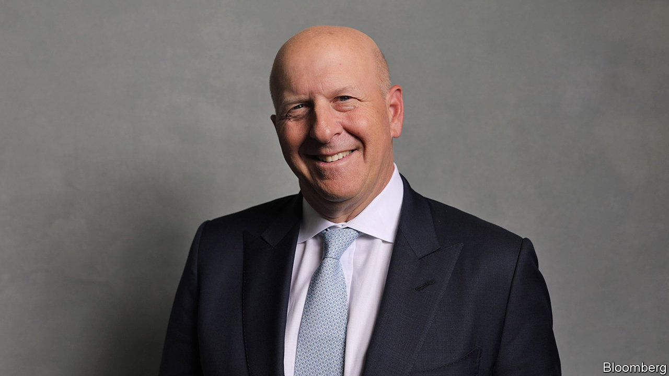

DAVID SOLOMON, the boss of Goldman Sachs, plans to spin discs at a party for the Super Bowl. Ahead of that performance DJ D-Sol took centre stage at the bank’s headquarters in Manhattan on January 29th. This was a new gig: he was laying out a fresh vision for Goldman at its first-ever investor day. Until recently its bosses did not deign to join earnings calls, set financial targets or host investor days. But a decade of malaise has made that imperious attitude untenable.

The mythology of Wall Street is built around the old Goldman playbook: mammoth deals, big bets and contrarian calls. But in post-crisis finance, glamour is out and stability is in. Services such as wealth management and retail and commercial banking used to weigh down the high-octane returns that investment banking churned out. Today, bank bosses see these businesses as steadying ballast. They smooth out profits and, by attracting low-cost funding, make investment banking more competitive. Goldman was slow to catch on; but now it wants to be more like its stodgier peers.

An investor who bought shares in Goldman in 2010 has had a disappointing decade. Back then its return on equity (ROE) was 11%, easily beating the 8% average for “bulge-bracket” American investment banks, a group including JPMorgan Chase and Morgan Stanley. By 2019 the average ROE was 9.7%, and Goldman’s was 9.2%. The share price has lagged both the stockmarket and other big banks (see chart).

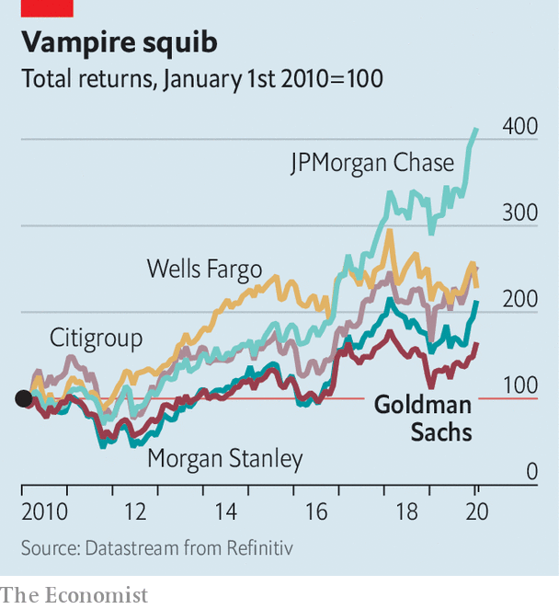

Goldman hopes to catch up by focusing on two goals. The first is to expand market share in services such as wealth management and to offer easy access to “alternative” investments in private equity, private debt and real estate. The second is to make the existing business more efficient. The bank’s chief financial officer, Stephen Scherr, sketched out how prosaic functions, like transaction banking—processing payments and managing cash for corporate clients—and running a digital consumer bank, could reduce funding costs because they attract deposits.

The bank has already taken steps to diversify. It launched Marcus, a digital consumer-lending and deposit-taking arm, in 2016. In 2018 it acquired Clarity Money, a personal-finance app, in order to broaden its retail offering. Last year it expanded its wealth-management services by acquiring United Capital, an advisory platform for wealthy (but not uber-rich) investors. The bank is consolidating all of its “alternative” investments into one client-facing arm.

Alongside Goldman’s goals come concrete targets. It wants to amass inflows of $100bn into alternatives in the next five years. It also hopes to collect $50bn in deposits in its transaction-banking business, a service that has not yet launched and of which Goldman itself is the first client. And it wants to increase the deposits in Marcus from $60bn to $125bn. The more wholesale funding is replaced by deposits, the more funding costs fall. All these businesses have become critical for banks wanting to be competitive in trading securities, including bonds and currencies. New regulations penalise trading desks that engage in complex activity.

Goldman also wants to be leaner by cutting $1.3bn of annual costs. JPMorgan and Bank of America have “efficiency ratios”—which measure the expenses associated with generating revenues—in the region of 55-60%. Last year Goldman’s was 68%. Diversifying and cost-cutting could push the ratio below 60%, says Steven Chubak of Wolfe Research, an equity-research firm.

Several hurdles complicate Goldman’s transition to a new business model. For all the talk of diversification, half of Goldman’s capital is locked up in its trading businesses, which earned a paltry 7% ROE in 2019. The adaptation of this business to the new regulatory regime has not so far been smooth. Goldman built an enormously clever and complex model to allocate capital requirements on a per-trade basis. But its rigidity meant the bank missed consistent business from regular clients, which is profitable overall.

The firm also awaits penalties for issuing $6.5bn-worth of bonds for 1MDB, a Malaysian investment vehicle from which $4.5bn vanished. The scandal has tarnished Goldman’s reputation; the fine, expected to be in the region of $2bn, will weigh on its profits.

All this will require managing cultural change. Half of the newest crop of analysts are women, and two-thirds from ethnic minorities—a shift from Goldman’s usual demographic. In September the Wall Street Journal reported tensions between the old guard and the new, with an eyebrow-raising 15% of partners expected to leave in 2019 (though Goldman says the attrition is normal). The challenge is to respond to the pressures that threaten Goldman’s profitability without spoiling the secret sauce that made it so successful. ■

This article was downloaded by calibre from <https://www.economist.com/finance-and-economics/2020/01/30/goldman-sachs-bets-the-firm-on-a-new-identity>

|  |  |  |  |
| --- | --- | --- | --- |
| Previous | Articles | Sections | Next |

|  |  |  |  |
| --- | --- | --- | --- |
| Previous | Articles | Sections | Next |

#### Poverty and privacy

# How digital financial services can prey upon the poor

Their data can be used to exploit as well as help them

Jan 30th 2020 |

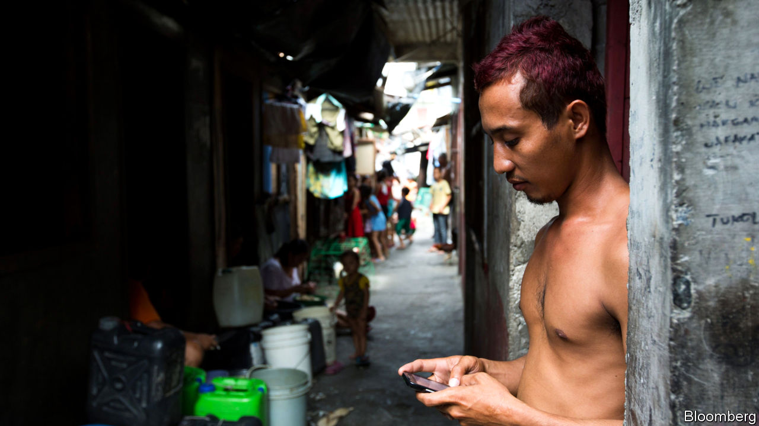

FOR THOSE seeking to help the worst-off in poor countries, the mobile phone has been a magic wand. Mobile-money accounts have helped deliver “financial inclusion”—making financial services accessible to the tens of millions with a phone but no bank account. But they have downsides too.

The most obvious way digital financial services harm poor people is by laying them more open to fraud. Research from 2016 cited in a new report by the Consultative Group to Assist the Poor (CGAP), a consortium of donors affiliated to the World Bank, found that in the Philippines 83% of people surveyed had been targets of mobile-phone scams, with 17% losing money. In Tanzania, 27% had been targeted and 17% fleeced; in Ghana, 56% and 12%.

For the most basic deceptions, a thief needs only a phone number. A text message might offer congratulations on winning a prize, requiring only a small contribution to unlock it. Your identity might be stolen to make you responsible for repaying a loan disbursed to somebody else. An impersonator might steal your mobile-money account when registering a new SIM card. Or your account’s security code—the PIN—might be leaked by a mobile-money agent (one of the millions of small traders whose business includes turning mobile money into hard cash).

The poor may be especially susceptible to such scams. They are more likely to be relatively new both to the online world and to formal financial services. And they are less likely to have smartphones with sophisticated security software.

It is not just money that can be stolen. So too can all the other data stored on a phone. Often, however, much has already been given away freely by its owners. Many “free” apps are in fact paid for in customer data. In every country people gaily sign away their rights to privacy by clicking consent buttons without having understood or even read what they are agreeing to.

Indeed, in financial services the implicit sale of personal data is seen as a way in which the poor can be “levelled up”. With low, unreliable incomes and few assets, they have been unable to borrow formally. Now lenders are learning to rely on other data to make credit judgments, notably payment records, such as from a mobile-money account, which can show a history of reliability.

But such data can also be abused. Predatory lenders and vendors might learn when a costly loan or product would be hard to refuse. Or an algorithm might (by design or accident) be biased against certain borrowers because, say, of their race or creed.

CGAP makes three policy recommendations. The first is to accept that the “consumer-consent” model is irretrievably broken, and to put the onus for looking after the data on the service-provider. The second is to give consumers full legal rights over their data, allowing them to view, correct and move them without charge. The third is to appoint “privacy representatives”, who, among other tasks, would check algorithms for signs of bias.

Many countries, from America to India, are looking at improving data-protection regulation. But CGAP’s suggestions seem very ambitious. “Free” financial services, such as those offered already by the Chinese giants, Ant Financial and WeChat, have an obvious appeal.

It is often assumed that the poor are relaxed about surrendering some privacy in return for access to borrowing and other services. In fact, concern about privacy is not a preserve of the rich. Research in India and Kenya has shown that even very poor borrowers would be willing to pay a higher interest rate—or join a much slower queue—for a loan that came with more guarantees that the data provided to the lender would be kept private. Persuading the tech giants that improved data security for the poor is in their business interests might be the best hope. But that will take a lot more work. ■

This article was downloaded by calibre from <https://www.economist.com/finance-and-economics/2020/01/30/how-digital-financial-services-can-prey-upon-the-poor>

|  |  |  |  |
| --- | --- | --- | --- |
| Previous | Articles | Sections | Next |

|  |  |  |  |
| --- | --- | --- | --- |
| Previous | Articles | Sections | Next |

#### A fuller figure

# The ECB considers counting owner-occupied housing in inflation

Unlike America’s, the euro area’s index omits the cost of owning a home

Feb 1st 2020 |

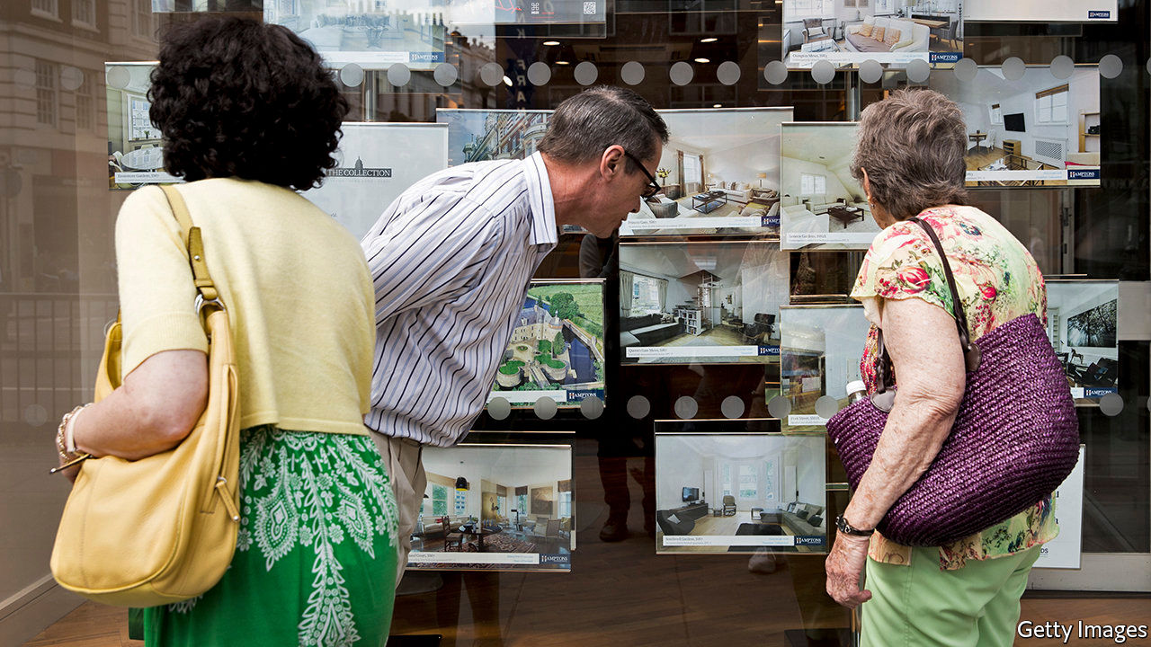

LIKE MANY good intentions, such as losing weight, the European Central Bank’s inflation target is largely aspirational. In 2003 it set itself a goal of below but close to 2%, but in the past five years inflation has averaged only 1%. That is partly why Christine Lagarde, the bank’s boss, began a review of the ECB’s monetary-policy strategy on January 23rd. The bank will ponder whether its target needs adjusting or its tools sharpening—and whether inflation figures capture prices accurately in the first place.

Consumer-price indices are meant to reflect the cost of typical baskets of goods and services. The euro area’s have a big omission. They capture rents paid by tenants, but not the costs of buying and owning property—even though two-thirds of people in the zone own their homes. As Benoît Cœuré, who until recently sat on the ECB’s board, pointed out, the bank’s chosen measure “captures only marginally the largest single lifetime expenditure of households”.

Housing is both an investible asset and, as a source of shelter, a consumable service. But isolating the cost of the service is tricky. American statisticians assume that homeowners rent their homes from themselves, and count the “imputed” rent in consumer prices. This has a weight of 11.5% in the index favoured by the Federal Reserve. Japanese and Swiss inflation figures also include owners’ housing costs. (So does headline inflation in Britain, but not the Bank of England’s target measure.)

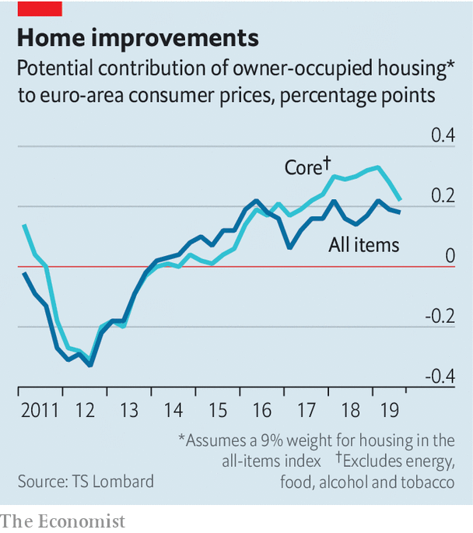

In fact, euro-area statisticians do calculate the cost of buying and owning a home. Adding it to price indices could raise measured inflation by 0.2-0.3 percentage points, notes Davide Oneglia of TS Lombard, an investment-research firm. That is nothing to sneeze at when official inflation is only 1.3%.

But the euro area’s version has its problems. It does not fully strip out land prices (roughly, the asset-price part) from those of buildings (the consumption bit). And unlike timely, monthly inflation figures, it appears only quarterly and after a long delay. In 2018 the European Commission and the ECB decided to leave it out of consumer prices.

The strategy review has revived the subject. Ms Lagarde wants to explain better the ECB’s policies to the public (who, surveys suggest, think inflation is higher than the official figure). On January 27th Yves Mersch, an ECB board member, urged the inclusion of housing costs.

Fixing the statistical problems would, as Ms Lagarde warned, take time. Incorporating housing costs would also raise questions about the bank’s target: nudging up the inflation measure without altering the target too would look like tipping the scales. As dieters know, there’s never an easy fix.

This article was downloaded by calibre from <https://www.economist.com/finance-and-economics/2020/02/01/the-ecb-considers-counting-owner-occupied-housing-in-inflation>

|  |  |  |  |
| --- | --- | --- | --- |
| Previous | Articles | Sections | Next |

|  |  |  |  |
| --- | --- | --- | --- |
| Previous | Articles | Sections | Next |

#### Free exchange

# Yield-curve control could prove a useful tool in the next recession

But it may not be potent enough by itself

Feb 1st 2020 |

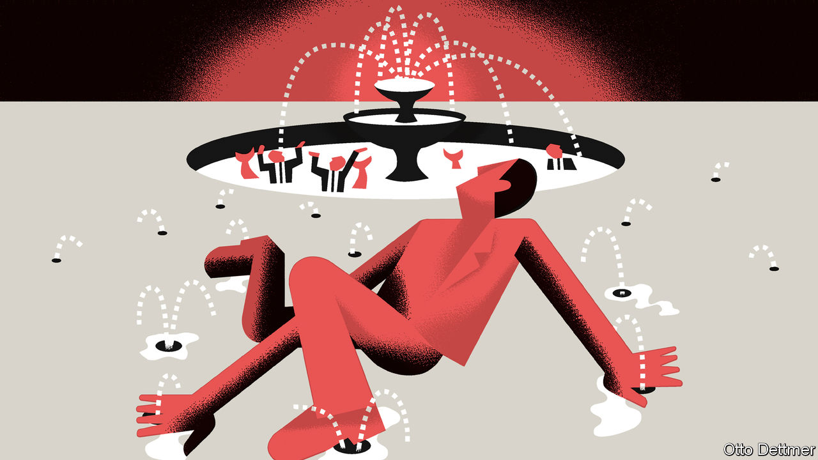

MANY HAZARDS complicate the job of Jerome Powell, the chairman of the Federal Reserve, from meddling presidents to pandemics. At the press conference following the Fed’s monetary-policy meeting on January 29th, he was grilled on its likely response to all of these. But Mr Powell’s biggest problem is a more enduring and global one: interest rates are stubbornly low. In recent months, members of the Fed’s Board of Governors have spoken about the need to prepare for future downturns. The Fed’s main policy rate will almost certainly be cut to zero, forcing it to rely once more on its “unconventional” tools. Mr Powell has said he is open to considering yield-curve control, a new approach borrowed from Japan. It is a promising innovation, but also a timid one, given the challenges the next recession will probably bring.

During the global financial crisis the hope was that when recovery arrived overnight interest rates—central banks’ preferred policy lever—would rise, restoring business as usual. In fact, despite a resilient global expansion, few rich-world countries have left zero behind. America, the most obvious exception, discovered last year that it could not sustain an overnight rate above 2%, even with low unemployment and a government-budget deficit approaching 5% of GDP. Some economists reckon low rates are only a minor inconvenience. In a recent lecture Ben Bernanke, a former Fed chairman, argued that the unconventional tools used during and after the crisis worked reliably and effectively, and could do so again. Others would prefer to have more powerful, and comprehensible, monetary policy ready for the next downturn.

The natural extension of interest-rate policy would be to cut overnight rates into negative territory, as central banks in Europe and Japan have already done. But the room for manoeuvre is limited. Economists worry that even modestly negative rates risk destabilising the financial system, as banks become reluctant to pass on interest-rate cuts for fear that depositors will yank their savings out. Fewer worries attach to quantitative easing (QE), the Fed’s unconventional tool of first resort, though it too has its downsides.

Before the crisis, the Fed traded bonds to keep overnight interest rates within a desired range. With QE, by contrast, bond purchases are an end in themselves. Rather than announce changes to rates, central bankers inform markets of the quantity of bonds they will buy (hence “quantitative”) with newly created money. When investors sell long-term government bonds to the central bank, the thinking goes, they use the cash they receive to buy other assets, such as corporate bonds or equities. Higher stock and bond prices in turn encourage firms to invest, boosting the economy.

Some evidence suggests that QE is subject to diminishing returns, however, and works best when credit markets are in crisis, which is not the case in most recessions. Asset-purchase programmes can also be difficult for investors to interpret. In 2013, for example, when the Fed signalled that it might curtail purchases, markets spasmed. In November Lael Brainard, a Federal Reserve Board governor, noted that the Fed’s announcements regarding QE often wrong-footed markets. This confusion may have put the Fed off using QE as aggressively as the economy required.

Yield-curve control would allow a central bank that has cut its overnight rate to zero to set rates for bonds of longer maturities. Keeping rates down at any horizon should stimulate investment and consumption, helping the economy. The Bank of Japan began its programme by targeting a yield of 0% for ten-year Japanese government bonds; an American version might begin by capping the rate for one-year bonds, then adding in longer durations as needed. No announcements regarding the buying or selling of bonds would be necessary; the Fed would simply transact in the bond market to keep yields on target, as it does for overnight rates. And this would be easier for markets to parse than tweaks to QE.

A commitment to defend interest-rate pegs unnerves some economists. Mr Bernanke warns that America’s government-bond market is so large and liquid that the Fed might have to purchase huge quantities of Treasuries to hit its target. But if markets found the yield-curve policy credible, the Fed might not need to buy many bonds at all; its commitment to intervene would deter investors from selling bonds at yields outside its target. And it might reinforce the central bank’s promises about the future path of short-term interest rates. The Bank of Japan, which conducted QE before switching to its yield-curve control policy, has kept yields at its desired level while buying fewer bonds than before.

Still, even successful yield-curve control could underwhelm. Long-term rates are already low, limiting the stimulus to be had from reductions. In Japan a pancake-flat yield curve has not pushed inflation up to the central bank’s 2% target, and low government-bond yields seem to be encouraging insurers and pension funds to load up on dangerously risky assets. Bolder change, like a shift to a higher inflation target, might offer a sustainable route away from low interest rates. But getting there might require more firepower than a central bank alone can muster.

## Bonds away

Government spending packs a powerful punch, and sustained low rates of interest are sapping political opposition to large budget deficits. Even so, American-style deficits worry economists, who fear that markets will eventually lose their appetite for bonds. Under yield-curve control, however, the central bank would in effect guarantee the government’s low borrowing costs.

America has controlled its yield curve before—in the 1940s, when the Fed held down the government’s borrowing costs during the second world war. Few economists would endorse such a strategy outside wartime. But yield-curve control cannot fight the next recession alone. Without bigger changes to monetary policy, it will need to be paired with fiscal stimulus. Blurring the line between monetary and fiscal policy may once again become imperative. ■

This article was downloaded by calibre from <https://www.economist.com/finance-and-economics/2020/02/01/yield-curve-control-could-prove-a-useful-tool-in-the-next-recession>

|  |  |  |  |
| --- | --- | --- | --- |
| Previous | Articles | Sections | Next |

|  |  |  |  |
| --- | --- | --- | --- |
| Previous | Articles | Sections | Next |

# Finance internship

The Economist invites applications for the 2020 Marjorie Deane internship

Jan 30th 2020 |

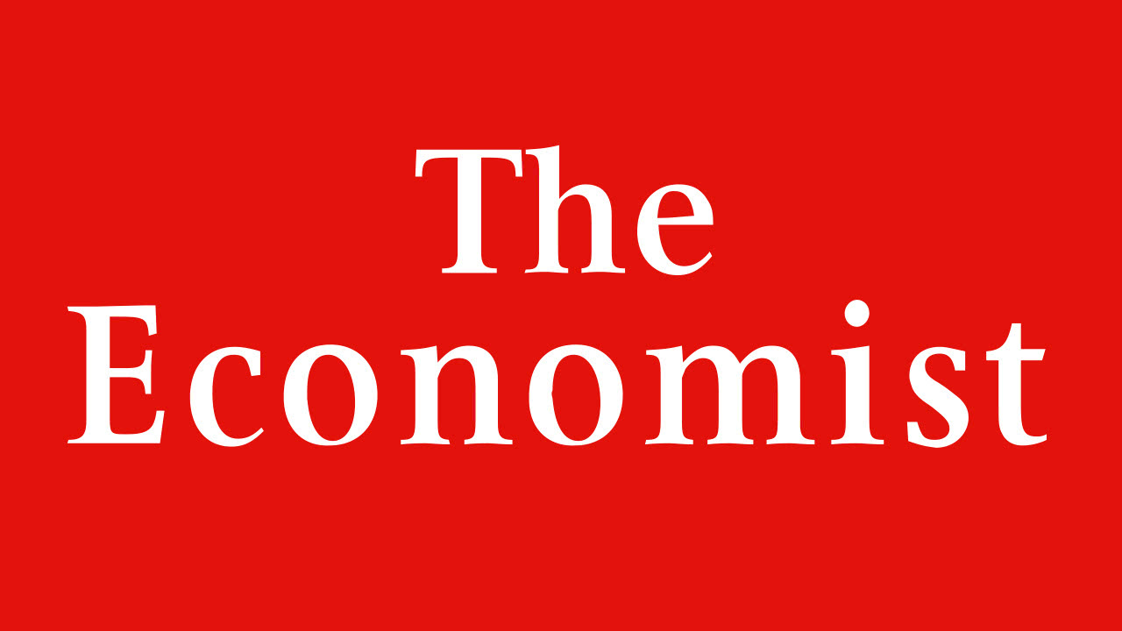

Paid for by the Marjorie Deane Financial Journalism Foundation, the award is designed to provide work experience for a promising journalist or would-be journalist, who will spend three months at the New York office of The Economist writing about business, finance and economics. Applicants are asked to write a covering letter and an original article of no more than 500 words suitable for publication in the Finance & economics section. Applications should be sent to deaneinternny@economist.com by February 21st. For more information, see [www.marjoriedeane.com](http://www.marjoriedeane.com)

This article was downloaded by calibre from <https://www.economist.com/finance-and-economics/2020/01/30/finance-internship>

|  |  |  |  |
| --- | --- | --- | --- |
| Previous | Articles | Sections | Next |

|  |  |  |
| --- | --- | --- |
| Finance and ... | Sections | Books and arts |

Science and technology

The arrest of Charles Lieber: No small matter

.

Entomology: More than meets the eye

.

Forensic science: Whendunnit?

.

Climate change: The methane hunters

.

Marine science: Cyborg Cnidaria

.

|  |  |  |
| --- | --- | --- |
| Finance and ... | Sections | Books and arts |

|  |  |  |  |
| --- | --- | --- | --- |
|  | Articles | Sections | Next |

#### The arrest of Charles Lieber

# An American chemist is suspected of illegal dealings with China

He denies the allegations, but is under arrest

Feb 1st 2020 | NEW YORK

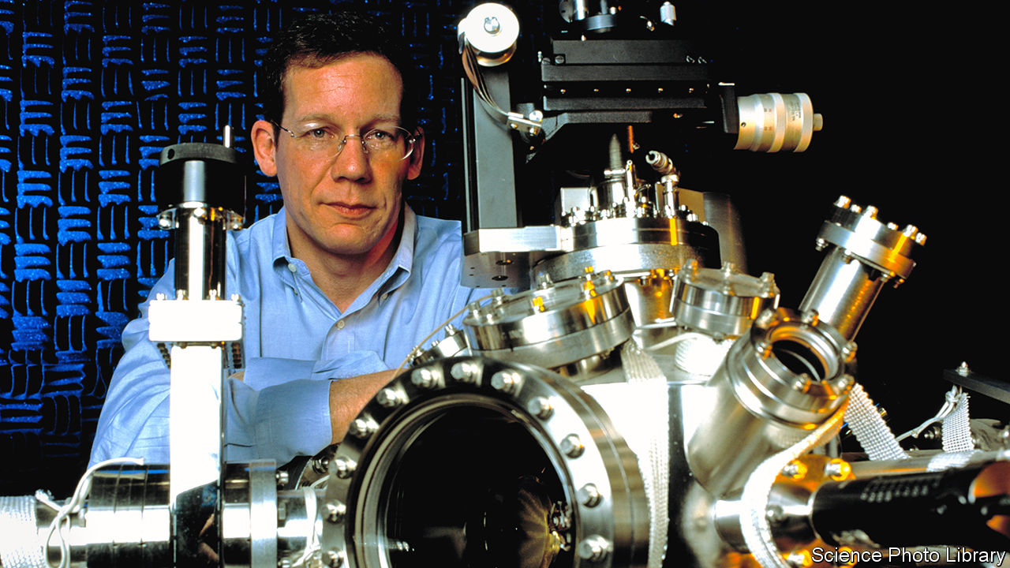

IN 2013 CHARLES LIEBER, a pioneer of nanoscience who is now the chairman of Harvard University’s chemistry department, visited the Wuhan University of Technology (WUT), in China, to celebrate the founding of a lab he was credited by that university with helping to establish and oversee: the WUT-Harvard Joint Nano Key Laboratory. It was a remarkable coup. WUT is an institution of little renown. Harvard is generally regarded as the top of the academic tree. And Dr Lieber, whose research has since become part of Elon Musk’s ambitious scheme to supercharge the human brain with nanotechnology, has been seen as a potential Nobel laureate.

Harvard’s officials had not, however, approved the laboratory and did not know about it until early 2015, according to the US Department of Justice. Nor did they know that while conducting his research with grants from the Department of Defence and the National Institutes of Health (NIH), Dr Lieber was, according to federal authorities, also being paid up to $50,000 a month by WUT, plus at least $150,000 in “living expenses”, as a prized recruit in China’s Thousand Talents programme to bring foreign scientists, and return Chinese expatriates, to that country’s research laboratories.

On January 28th agents of the Federal Bureau of Investigation (FBI) arrested Dr Lieber on a charge of lying to federal authorities after his having denied his alleged participation in the Thousand Talents programme. He was jailed pending a court hearing on January 30th. Harvard placed him on administrative leave and said it was co-operating with the authorities while conducting its own review. (Dr Lieber’s lawyer did not respond to a request for comment.) The Justice Department also announced charges against two Chinese nationals who had been in Boston ostensibly as researchers. One, a lieutenant in the People’s Liberation Army (PLA) who is now in China, allegedly worked on behalf of PLA officials and has been charged with visa fraud, conspiracy and making false statements to federal investigators. The other, who is under arrest, allegedly tried in December to smuggle to China 21 vials of material stolen from a teaching hospital.

By putting one of Harvard’s superstars in handcuffs, federal authorities seek to shock America’s research institutions into greater vigilance about collaborations with Chinese counterparts. At the least the arrest is expected to have a chilling effect on research partnerships between America and China after a decade in which they have flourished. Certainly, the Trump administration would not view that as a bad thing. The Justice Department has said that more than 90% of prosecutions for economic espionage since 2011 have involved a link to China. Christopher Wray, the FBI’s director, has lamented to Congress the “naïveté” of American academia, and has cited China’s “so-called talent plans” as a vehicle for the theft of research.

One concern of federal authorities, including investigators at the NIH, has been the establishment of “shadow labs” in China run by Thousand Talents recruits in parallel with their American-funded research. Those authorities may consider the WUT-Harvard Joint Nano Key Laboratory to be such a shadow lab. In an affidavit supporting the criminal complaint against Dr Lieber, the FBI, quoting emails between him and a professor at WUT, says that in 2012 he entered into a Thousand Talents agreement that promised, in addition to his personal compensation, 11m yuan ($1.74m) from WUT and the Chinese government for development of the joint laboratory, including the recruitment of talent.

The contract called for Dr Lieber to publish “high-level articles” in renowned journals and to host international conferences “in the name of Wuhan University of Technology”, and to guide young scholars and doctoral students, helping them publish in respected international journals. In January 2013, the affidavit says, he signed a five-year contract formalising Harvard’s co-operation in the joint lab, and obliging Harvard to host researchers from WUT for two months a year.

According to the FBI, officials from Harvard said Dr Lieber did not have the authority to sign such a contract. Those officials also said they eventually became aware of the joint laboratory, and that Dr Lieber was its director, in about early 2015. When confronted, Dr Lieber told Harvard officials that WUT “was using Harvard’s name and logo without his knowledge and consent”, the affidavit says.

In 2018, the affidavit says, Dr Lieber told investigators from the defence department that he was never asked to participate in the Thousand Talents programme, but that he “wasn’t sure” how China might describe him. The FBI also says he caused Harvard to report falsely to the NIH that he was not a participant in the recruitment programme (the NIH requires disclosure of such foreign payments to grant applicants). Meanwhile, the email traffic quoted in the FBI affidavit describes the payments to Dr Lieber going into a Chinese bank account set up on his behalf and, on occasions he visited Wuhan, given to him in cash.

In return for its association with Dr Lieber, Wuhan University of Technology may have burnished its reputation in nanoscience, and developed some young scholars in the field. The lab itself was meant to focus on “nanowire-based lithium ion batteries” for electric cars, per the contract Dr Lieber allegedly signed. In recent years Dr Lieber’s research has focused on “neural lace” technology, the still-nascent field that Mr Musk is looking to develop. Mr Musk’s own paper on the topic cites Dr Lieber as well as Chinese researchers who worked in his lab at Harvard.

It is not clear how much special insight Chinese researchers gained that they would not otherwise have had. Leading scientists routinely note that in such high-level research international collaboration is increasingly common, and can happen organically. Most research is published openly for all to see. It is not certain that Chinese largesse was required to pry open the wonders of a top laboratory at the world’s most prestigious university. But the Trump administration says that was precisely the goal of the Thousand Talents programme, and that university administrators and scientists have been asleep to the threat such recruitment programmes pose. If so, no longer. ■

This article was downloaded by calibre from <https://www.economist.com/science-and-technology/2020/02/01/an-american-chemist-is-suspected-of-illegal-dealings-with-china>

|  |  |  |  |
| --- | --- | --- | --- |
|  | Articles | Sections | Next |

|  |  |  |  |
| --- | --- | --- | --- |
| Previous | Articles | Sections | Next |

#### Entomology

# There is more to a butterfly’s wing than meets the eye

Far from being dead tissue, wings are sophisticated living organs

Feb 1st 2020 |



A BUTTERFLY’S WINGS can have many jobs besides keeping the insect aloft. They may be called on to attract mates, to warn potential predators to stay away, to mimic other animals or even to provide camouflage. All of these roles, though, depend on their colouration—which is unchanging. This plays into the idea that butterfly wings are dead tissue, like a bird’s feathers or a mammal’s hair. In fact, that is not true. For example, in some species males’ wings harbour special cells that release pheromones which attract females.

Nanfang Yu, a physicist at Columbia University, in New York, has been looking into the matter. One of his interests is the optical properties of biological materials. That has led him to study butterfly wings in more detail. And, in collaboration with Naomi Pierce, a butterfly specialist at Harvard University, he has now shown, in a paper published this week in Nature Communications, that butterfly wings are, indeed, very much alive.

Initially, Dr Yu and Dr Pierce wanted to know how the insects keep their body temperatures up without their wings overheating. Unlike birds and mammals, butterflies do not generate enough internal heat to run their metabolisms at full pelt. Instead, they rely on outside heat sources—usually the sun—to bring their bodies up to speed. But their wings, being thin protein membranes, have a limited thermal capacity. Those wings can therefore overheat quickly if the insects bask too long in sunlight, or, conversely, can cool down too rapidly if they are flying through cold air.

In their experiments, the two researchers used a laser to heat up spots on the wings of dozens of butterfly species, including the painted lady and the hickory hairstreak (pictured). When the temperature of the area under the laser reached 40°C or so, the insects responded within seconds by doing things that stopped their wings heating up further. These actions included a butterfly turning around to minimise its profile to the laser, flapping its wings or simply walking away.

Butterflies engaged in all of these heat-minimising activities even when the researchers blindfolded them. That suggested the relevant sensors were on the wings themselves. Dr Yu and Dr Pierce therefore searched those wings for likely looking sensory cells. They found some, in the form of neurons that resembled heat detectors known from other insects. They also uncovered disc-shaped cells that appeared, again by resemblance, to be pressure-sensitive neurons. They speculate that these are there to detect deformation of the wing—information an insect could use to control its flight pattern.

The third discovery Dr Yu and Dr Pierce made to contradict the “dead wing” hypothesis was that some butterfly wings have a heartbeat. Anyone who has looked closely at a butterfly will know that its wings have veins. These carry a bloodlike fluid called haemolymph. For a long time, entomologists thought the only role of the veins was, by being pumped full of haemolymph, to inflate the wings to full stretch after a butterfly emerged from its chrysalis. More recently, it was discovered that haemolymph continues to flow through the veins throughout the insect’s life. Dr Yu and Dr Pierce have now found that in male hairstreaks the haemolymph shows a pulse of several dozen beats per minute. The source of this pulse appears to be the scent pad, a dark spot on the wings that produces the female-attracting pheromones. Apparently, this “wing heart” acts as a pump that helps propel haemolymph through the scent pad.

In all their experiments simulating different environmental conditions, Dr Yu and Dr Pierce consistently found that, regardless of pigmentation, the living areas of a butterfly’s wings—which cluster around the veins and are presumably nurtured by them—were always cooler, by up to 10-15°C, than the lifeless membranes between the veins. The cause, they discovered, was that different parts of the wing are covered by different sorts of scales. In particular, scales over the scent pads are penetrated by tubes. This improves their ability to radiate heat away and helps keep the living parts of a butterfly’s wing alive.■

This article was downloaded by calibre from <https://www.economist.com/science-and-technology/2020/02/01/there-is-more-to-a-butterflys-wing-than-meets-the-eye>

|  |  |  |  |
| --- | --- | --- | --- |
| Previous | Articles | Sections | Next |

|  |  |  |  |
| --- | --- | --- | --- |
| Previous | Articles | Sections | Next |

#### Forensic science

# Fingerprints can now be dated to within a day of when they were made

Thus answering the question, “Whendunnit?”

Feb 1st 2020 |



SINCE THE first use of fingerprints to identify and convict a murderer, in 1892, detectives the world over have come to rely heavily on print evidence to build their cases against suspects. One limit on the value of fingerprints, though, is that it is hard to work out how old they are. This is a particular problem when a crime is committed somewhere that a suspect frequently and legitimately visits, such as a place of work. In this case exactly when a print was made might be crucial to establishing guilt or innocence. But it is information that science has, until now, been unable to provide with any accuracy.

As they write in Analytical Chemistry, Paige Hinners and Young Jin Lee of Iowa State University believe they can remedy this state of affairs. They knew from work conducted by other laboratories that the triglyceride oils contained in fingerprints change by oxidation over the course of time. That provides an obvious way to date prints. The problem is that the techniques which have been applied to analyse these oils are able to distinguish age only crudely. In practice, they can determine whether or not a print is over a week old, but nothing else.

Dr Hinners and Dr Lee wondered if higher precision could be obtained by thinking a bit more about oxidation. Oxygen molecules in the air come in two varieties. Most have a pair of atoms but some, known as ozone, have three. Though far rarer than diatomic oxygen, ozone is more reactive and also reacts in ways different from those of its two-atomed cousin. The two researchers therefore decided to focus their attentions on ozonolysis, as triatomic oxidation is known.

Triglycerides, as their name suggests, are three-tailed molecules. Each tail is a chain of carbon atoms, with hydrogen atoms bonded to the carbons. The chains are held together by bonds between the carbon atoms. These are of two varieties, known as single and double bonds. Single bonds are, in chemistry-speak, saturated, and double bonds unsaturated. By extension, molecules with one or more double bonds in them are also referred to as unsaturated, while those with only single bonds are called saturated.

Unsaturated bonds are more reactive, and it is here that ozonolysis does its work. Ozone breaks up triglycerides at their double bonds, with one or more of the ozone’s oxygen atoms becoming attached to the carbon chain, to create new chemical species. In principle, this should result in a gradual loss of unsaturated triglycerides and a concomitant rise in the reaction products of ozonolysis.

And that, in practice, is what Dr Hinners and Dr Lee found. They asked three volunteers to leave their prints on a number of glass slides. They then tested some of those slides immediately, using a sensitive analytical technique called matrix-assisted laser desorption/ionisation (MALDI) to produce a spectrum of the prints’ chemical contents. The other slides they left exposed to the air for between one and seven days, testing them at regular intervals.

As they suspected, as time progressed the ratio of saturated to unsaturated triglycerides in a sample rose, and so did the quantities of two characteristic products of ozonolysis—aldehydes and Criegee ions. On the basis of what is, admittedly, a small sample, Dr Hinners and Dr Lee therefore think that MALDI analysis of fingerprint residues should prove accurate enough to date to within 24 hours when a fingerprint under a week old was made—and thus whether it is associated with a crime temporally, as well as spatially.■

This article was downloaded by calibre from <https://www.economist.com/science-and-technology/2020/02/01/fingerprints-can-now-be-dated-to-within-a-day-of-when-they-were-made>

|  |  |  |  |
| --- | --- | --- | --- |
| Previous | Articles | Sections | Next |

|  |  |  |  |
| --- | --- | --- | --- |
| Previous | Articles | Sections | Next |

#### The methane hunters

# Using satellites to spot industry’s methane leaks

To help combat climate change

Feb 1st 2020 |

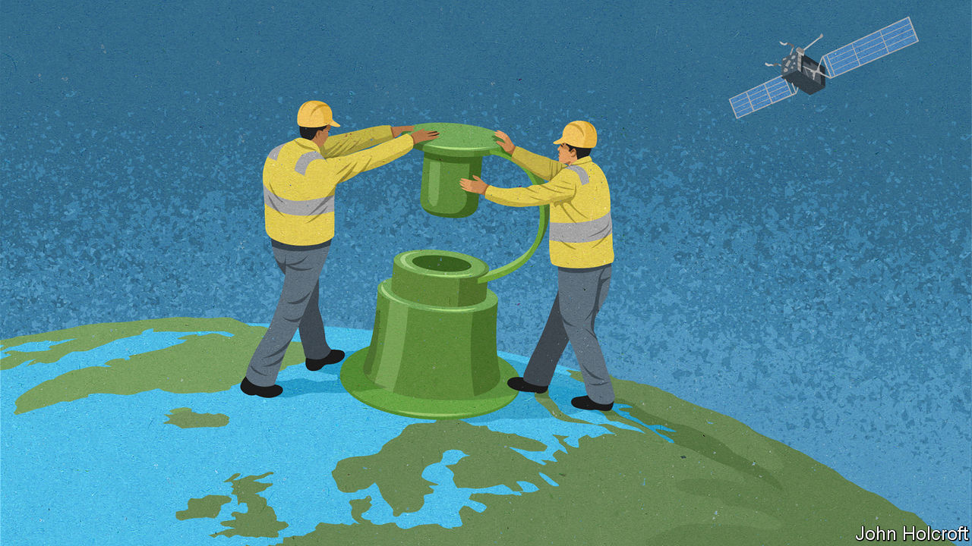

WHEN SCANNING for emissions from a mud volcano in western Turkmenistan in January 2019, a satellite called Claire came across a large plume of methane drifting across the landscape. The discharge appeared to originate from a gas pipeline at the nearby Korpezhe oil and gasfield. Two more large plumes were also spotted in the area, including one from a compressor station. The company operating the satellite, GHGSat, based in Montreal, passed details via diplomats to officials in Turkmenistan, and after a few months the leaks stopped. This largely unknown incident illustrates two things: that satellites can play an important role in spotting leaks of greenhouse gases and, rather worryingly, that the extent of such leaks is often greatly underestimated.

The reason for concern is that although methane, the main constituent of natural gas, does not linger in the atmosphere for anywhere near as long as carbon dioxide does, it is a far more potent heat-trapping agent. About a quarter of man-made global warming is thought to be caused by methane. And between a fifth and a third of the methane involved is contributed by the oil and gas industry.

The data from Claire suggested the leak in Turkmenistan had been a big one. To establish just how big, Daniel Jacob of Harvard University and his colleagues studied the images obtained by this satellite along with observations made of the area at the time by the Tropospheric Monitoring Instrument (TROPOMI), which is carried by an atmospheric research satellite operated by the European Space Agency. The results, published in Geophysical Research Letters in November 2019, concluded that between February 2018 and January 2019 the three leaks would have released, between them, 142,000 tonnes of methane. This made the Turkmenistani leak far bigger than the 97,000 tonnes of methane discharged over four months by a notorious blowout at a natural-gas storage facility in Aliso Canyon, California, in 2015, which is reckoned to have been the worst natural-gas leak yet recorded in America.

There have been other big leaks, too. Last year a group of researchers led by Ilse Aben of the Netherlands Institute for Space Research studied TROPOMI images of a blowout at a natural-gas well in Belmont county, Ohio. This began on February 15th 2018 and took three weeks to control. In a paper published in the Proceedings of the National Academy of Sciences in December 2019, Dr Aben and her colleagues calculated from the images that the blowout was responsible for the equivalent of a quarter of the annual oil and gas industry’s methane emissions in the entire state of Ohio.

Methane can be detected spectroscopically. Like other gases, it absorbs light at characteristic frequencies. With a spectrometer mounted on a satellite it is possible to analyse light reflected from Earth for signs of the gas. As with the satellites that carry them, spectrometers come in many shapes and sizes. TROPOMI can also detect the spectral signs of other polluting gases, such as nitrogen dioxide, sulphur dioxide and carbon monoxide. It rides in a large bird, the Copernicus Sentinel-5P satellite, launched in October 2017, and in all weighing 980kg. The detector has an extensive view, looking at a strip of Earth 2,600km wide with a resolution that means a single pixel in the image represents an area 7km by 3.5km.

Observing things more closely is the speciality of Claire. This 15kg “nanosat”, about the size of a microwave oven, was launched in June 2016 to measure carbon dioxide and methane emissions. With a field of view 12km wide and a resolution better than 50 metres by 50 metres, Claire can spot leaks from individual industrial plants. GHGSat aims to launch two more methane-hunting nanosats later this year.

Claire surveys industrial facilities on behalf of firms that want to monitor their emissions. GHGSat’s chief executive, Stephane Germain, says employing satellites to do this is more reliable than using terrestrial methods. In November he plans to roll out a new service. This will provide a digital image of Earth which users will be able to zoom in on to explore continually updated patterns and hotspots of methane emissions. The map will have an average resolution of 2km by 2km and be free to use—although if companies want to look at things more closely they will need to pay.

Other methane-hunting satellites are coming. These include one due for launch in 2022 by MethaneSAT, an affiliate of the Environmental Defence Fund, an American non-profit organisation. The 350kg satellite will cost $88m to build and put into orbit. It will scan an area of land 200km wide with a resolution of 1km by 1km. According to MethaneSAT, it will be the most sensitive to emission levels yet, being able to detect methane concentrations as low as two parts-per-billion. Data collected by the satellite will be publicly available.

Having a number of complementary eyes-in-the sky will be an important way to help reduce methane emissions. Although Donald Trump has proposed rolling back Obama-era requirements for oil and gas companies to detect and fix methane leaks, the gas has commercial value so it does not make business sense to waste it. On top of that, for firms seeking to burnish their green credentials, plugging leaks is one of the most effective things they can do to help combat climate change.■

This article was downloaded by calibre from <https://www.economist.com/science-and-technology/2020/02/01/using-satellites-to-spot-industrys-methane-leaks>

|  |  |  |  |
| --- | --- | --- | --- |
| Previous | Articles | Sections | Next |

|  |  |  |  |
| --- | --- | --- | --- |
| Previous | Articles | Sections | Next |

#### Marine science

# Half machine, half jellyfish. The latest thing in ocean exploration

Cyborg Cnidaria

Feb 1st 2020 |



CYBORGS, PART-MECHANICAL human beings such as the Cybermen in “Doctor Who”, are a long-established feature of science fiction. But the word itself is short for “cybernetic organism”, a definition not self-evidently limited to the mechanisation of humans. Extend it to part-mechanical animals and cyborgs already exist. They have been created in the form of insects that have had chips implanted in them to bring them under the whim of human controllers, who are thus able to direct the ways that their charges either scuttle or fly.

This week sees the idea extended still further. Nicole Xu and John Dabiri, a pair of researchers at Stanford University, in California, have announced in Science Advances the creation of the first cyborg jellyfish. That might sound a joke. But it opens the possibility of using jellyfish as cheap propulsion systems for underwater probes.

Dr Xu and Dr Dabiri picked, as the chassis for their cyborg, a common species called Aurelia aurita (pictured). Like all other members of the phylum Cnidaria, Aurelia lacks a brain. Its body being radially symmetrical, its nervous system is too. In particular, the opening and closing of its bell, which propels it through the water, can be triggered by any one of eight neural pacemakers distributed around the bell’s periphery.

After an extensive study of Aurelia’s electrophysiology, Dr Xu and Dr Dabiri were able to design an artificial pacemaker that hijacked this mechanism. It has a lithium polymer battery and a small processor chip to control the pattern of the electric current generated. The whole thing weighs about ten grams—a tenth of the weight of an adult Aurelia.

Using their artificial pacemaker, Dr Xu and Dr Dabiri were able to turbocharge a jellyfish’s progress through the water. They could speed it up to almost three times its normal velocity and, surprisingly, this required only twice as much energy as normal movement.

High-speed jellyfish are unlikely, of themselves, to be much use. But if a more sophisticated prosthesis can steer the animal as well as controlling its speed, then the technology of cyborg Cnidaria will be in business. Researchers elsewhere are trying to develop swimming robots for ocean exploration. Prototypes of these, however, require between 10 and 1,000 times as much energy as the device developed by Dr Xu and Dr Dabiri because a robot’s battery must provide propulsive power as well as running the control system. A cyborg gets its energy for propulsion by feeding.

A steerable cyborg jellyfish, fitted with instruments as well as a control pack, would therefore be a boon for marine scientists. Jellyfish go everywhere. Pick the right species and you could dive to the deepest parts of the ocean. Then, once the cyborg’s mission was accomplished, it could be steered back to the surface and its instruments—and the data they contain—recovered.

This article was downloaded by calibre from <https://www.economist.com/science-and-technology/2020/02/01/half-machine-half-jellyfish-the-latest-thing-in-ocean-exploration>

|  |  |  |  |
| --- | --- | --- | --- |
| Previous | Articles | Sections | Next |

|  |  |  |
| --- | --- | --- |
| Science and ... | Sections | Graphic detail |

Books and arts

Art and dissent: Pursued by a bear

.

Making movies: Forget it, Jake

.

Bygone civilisations: Secret gardens

.

Enigmatic fiction: Ghost in the machine

.

Johnson: A cup o’ kindness

.

|  |  |  |
| --- | --- | --- |
| Science and ... | Sections | Graphic detail |

|  |  |  |  |
| --- | --- | --- | --- |
|  | Articles | Sections | Next |

#### Pursued by a bear

# The many ways to censor cutting-edge art in Russia

Bullied by the state, Teatr.doc is now being targeted by ultraconservatives

Feb 1st 2020 | MOSCOW



ANASTASIA PATLAY thought something was amiss when she checked the young man’s ID. He seemed a couple of years below the strict 18+ requirement for this performance of “Out of the Closet”, a play adapted from interviews with gay men and their families. That restriction was not the choice of Ms Patlay, the director, but a demand of Russian federal law, which since 2013 has banned the “promotion of non-traditional sexual relationships” to minors. A photocopy of his passport, which Ms Patlay snapped on her phone, suggested he had recently turned 19. Perhaps she was being paranoid, but Teatr.doc, which specialises in verbatim dramas assembled from real-life documents and transcripts—and has long been described as “Russia’s most controversial theatre company”—had already had enough trouble from the authorities.

Her hunch was vindicated; the spectator was a plant sent by a far-right group. Shortly after the show began, he and his friend walked out to rendezvous with a dozen more agitators. Together they accused the theatre staff of illegally exposing children to “gay propaganda”. (The passport had been doctored; in reality, the youngster was 15.) Then they invaded the auditorium, stopping the play and shouting homophobic slurs. Police were called and a fight broke out; Teatr.doc complained about the invasion, the saboteurs that a minor had been admitted.

No charges were brought, but that sting last August turned out to be the start of a protracted ordeal for the Moscow-based company at the hands of ultraconservatives. Despite all the official pressure that Teatr.doc had suffered, this campaign was (and is) a new and different problem. It encapsulates the dual challenge of artistic censorship in Russia—which, as Vladimir Putin’s rule has progressed, has come to be enforced by freelance outfits as well as the state, and as much for supposedly moral reasons as over political dissent.

Teatr.doc was founded in 2002 by Elena Gremina and Mikhail Ugarov, husband-and-wife playwrights who were inspired by verbatim drama workshops in Russia led by the Royal Court theatre of London. Its shows elicited strong responses from the start, not only because of the content—subjects included homelessness, immigration and HIV—but also their style and everyday language. Productions that drew particular ire (and acclaim) included “September.doc”, in which actors read comments made in internet chat rooms following the Beslan school siege of 2004, and “One Hour Eighteen Minutes”, a reference to the time doctors were denied access to Sergei Magnitsky, a whistle-blowing lawyer, before he died in police custody. “They went after things that ail the society,” says John Freedman, a critic and translator of Russian drama, “and they did it in a way that was quite direct.”

Despite its quality, Teatr.doc only ever played in small venues. It has been obliged to find a new one three times in the past six years after leases were terminated, supposedly because of noise and safety complaints. Bomb scares have been reported at several performances, shutting them down, but no explosives have been found. Instead, police have exploited the scares to check audience members’ documents.

It might seem odd for the authorities to expend so much effort on niggling an experimental troupe. But as well as being a salutary demonstration of power, such treatment nudges the Kremlin’s opponents to rally round artists who can be caricatured as libertine extremists. Some alternative targets—pop stars, say—have higher profiles, but also followings too big to alienate. Teatr.doc is not the only cutting-edge company to have faced official harassment. Kirill Serebrennikov, director of the Gogol Centre theatre in Moscow, spent almost 20 months under house arrest as part of an ongoing embezzlement case.

## Saying the unsayable

In 2018 both of Teatr.doc’s founders died, leaving the company to be run by Ms Gremina’s son, Alexander Rodionov; many wondered if it would carry on. It did, but the intimidation continued—only in a new form. A month after the sting on “Out of the Closet”, protesters threw foul-smelling chemicals through the window during a performance of “War is Close”, a play about the conflict in eastern Ukraine. Again, no charges were brought. Instead, at the end of last year authorities launched an investigation of Teatr.doc following a complaint from an activist group called the National-Conservative Movement. It accused the theatre of disseminating LGBT propaganda, justifying terrorism in “War is Close”, and promoting drug use in another production. Staff were questioned; the theatre handed over the scripts of the plays for review.

Last month police said they would not bring criminal charges, in what Ms Patlay called a victory for “common sense”. But her adversaries have not gone away.

In this parallel censorship drive, far-right agitators have taken aim at several other shows and exhibitions. “Side by Side”, an LGBT film festival, has been picketed, as have art shows with religious themes. In 2015 the director of a Siberian opera house was forced out after his staging of Wagner’s “Tannhäuser” was deemed sacrilegious by Orthodox Christians. Such independent provocateurs are scarier than the authorities, says Ms Patlay, “because they are unpredictable and they are new”. She thinks they have been emboldened by the increasingly reactionary rhetoric of Russia’s politicians. And they appear to operate with the state’s tacit consent. “The lack of punishment for them and the inaction from police—it sends a signal that we are not defended.”

On the contrary, says Valentina Bobrova, the National-Conservative Movement’s founder. Outfits like hers may further the Kremlin’s bid to stoke a culture war between conservatives and those it portrays as radicals, but she insists the movement is privately funded and has no links with the authorities. She says she never had much hope that her complaint would close the company—and that it is not the likes of her but liberal voices that hold too much sway in modern Russia. “Teatr.doc is an enemy of our country that is working from within,” she says. “We cannot stay quiet and we decided to act.” She was behind the disruption of “Out of the Closet”, too. Her members are looking out for other signs of “anti-Russian” activity.

Ms Patlay worries about the effect of all this on the audience, who might conclude “that you have to be particularly brave to go to the theatre. And we don’t have the right to ask spectators to be brave.” As to whether Teatr.doc has managed to change Russian society, she is illusionless. “I don’t think the percentage of decent people has increased,” she accepts. “But those people who are still here, who haven’t emigrated, perhaps it is a support of some kind.” At the very least, she says, the company has shown it is possible to talk openly about things that others would rather hush up. ■

This article was downloaded by calibre from <https://www.economist.com/books-and-arts/2020/02/01/the-many-ways-to-censor-cutting-edge-art-in-russia>

|  |  |  |  |
| --- | --- | --- | --- |
|  | Articles | Sections | Next |

|  |  |  |  |
| --- | --- | --- | --- |
| Previous | Articles | Sections | Next |

#### Forget it, Jake

# It’s the making of “Chinatown”

Sam Wasson explores the dramas and tensions that created a classic

Feb 1st 2020 |



The Big Goodbye: Chinatown and the Last Years of Hollywood. By Sam Wasson. Flatiron Books; 416 pages; $28.99. Faber & Faber; £18.99.

WHEN THE camera pulls back, Jake Gittes is left standing there, slack-jawed, bathed in the cold blue city light. The girl is dead. The bad guy got away. A dreadful crime will go unpunished. There is nothing he can do about it. “Forget it, Jake,” someone whispers. “It’s Chinatown.”

The devastating final scene of “Chinatown” (released in 1974), one of the most famous in film history, only came together at the last minute. Roman Polanski, the director, and Robert Towne, the screenwriter, had argued about it for months. Mr Towne wanted to leave viewers with a sliver of hope, but Mr Polanski was adamant: “You have to show violence the way it is,” he insisted. The villain would get off scot-free, “just like most bad guys really do”.

Mr Polanski already knew something about violence. In 1969 his pregnant wife, the actor Sharon Tate, was brutally murdered by followers of the cult leader Charles Manson. “I don’t mean this unkindly,” Mr Towne later said, “but I think it was impossible for Roman to come back to Los Angeles and not end his movie with an attractive blonde lady being murdered.”

In “The Big Goodbye”, an absorbing account of the making of “Chinatown”, Sam Wasson profiles the creators of the neo-noir classic. For Mr Towne, the film was a homage to the Los Angeles of his childhood, a “haven of pastel and desert moods” before it was choked by smog and traffic. For Jack Nicholson (who played Jake), “Chinatown” was an aesthetic antidote to television, which he saw as a form of philistinism. And for the powerful producer, Robert Evans of Paramount—who had an average of two phones per room in his Beverly Hills mansion—“Chinatown” was a chance to show that artistic achievement and commercial success could go hand in hand.

Mr Wasson is a stylish chronicler of Hollywood politics, and sensitive to how off-screen events contribute to on-screen drama. “Chinatown” was the fruit of many collaborations, including an unsung writing partnership between Mr Towne and his college roommate, Edward Taylor. Conflict enlivened the production, too. When Mr Nicholson kept the crew waiting while he watched the final minutes of a basketball game, Mr Polanski smashed his television screen with a mop.

“The Big Goodbye” evokes the care that went into every frame, from the strict colour palette to the cinematographer’s limited use of zoom. Anthea Sylbert, the costume designer, dressed Faye Dunaway in vintage silk stockings from Paris, hoping that “they would tell [her] body something about the character and bleed their way into the performance.” Mr Polanski spent 40 minutes getting the perfect close-up of an ant crawling over Mr Nicholson’s face (“the costliest ant in human history”).

As Mr Wasson recounts, 1974 was a golden year for Hollywood. Paramount received a staggering 43 nominations for the Academy Awards, including 11 for “Chinatown” (although only Mr Towne took home an Oscar) and a best-picture award for “The Godfather Part II”. But in retrospect, this was the end of a cinematic heyday. More and more, the industry became commercially minded as film budgets swelled to pay for rising promotional costs and rocketing salaries. For its creators, too, “Chinatown” was a farewell. Evans soon lost his career and reputation to cocaine; Mr Polanski fled the consequences of his own crimes against a teenage girl.

Outsiders “pretend to be interested in how pictures are made”, F. Scott Fitzgerald once observed, but “they never see the ventriloquist for the doll.” “The Big Goodbye” is a captivating and revealing look at how the magicians of cinema really work. ■

This article was downloaded by calibre from <https://www.economist.com/books-and-arts/2020/02/01/its-the-making-of-chinatown>

|  |  |  |  |
| --- | --- | --- | --- |
| Previous | Articles | Sections | Next |

|  |  |  |  |
| --- | --- | --- | --- |
| Previous | Articles | Sections | Next |

#### Secret gardens

# The forgotten glories of Islamic civilisation

Justin Marozzi explores 15 cities, one for each century of the faith’s history

Feb 1st 2020 |

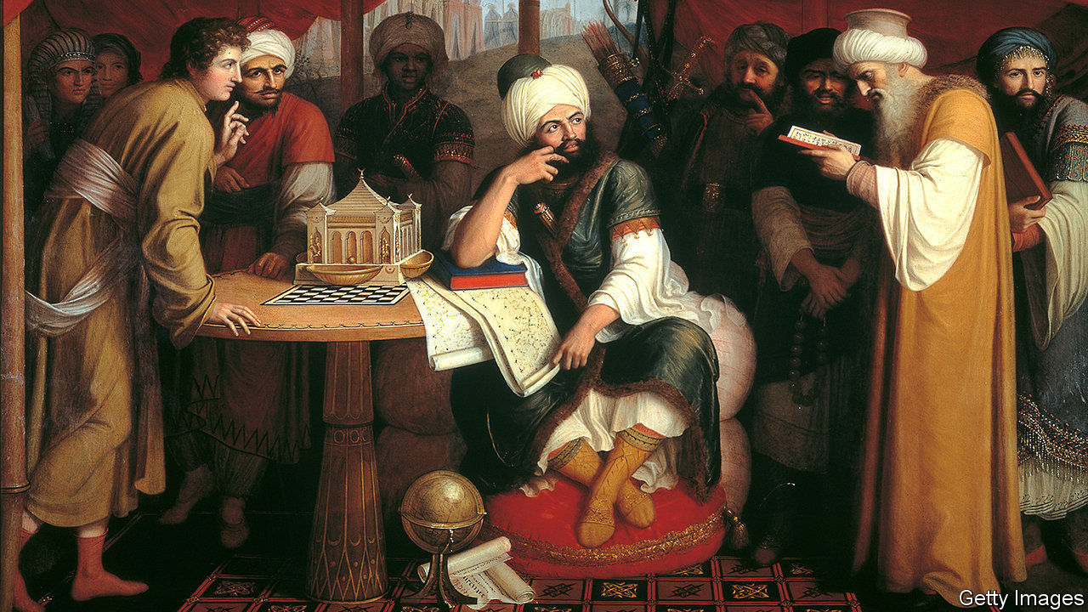

Islamic Empires. By Justin Marozzi. Pegasus Books; 512 pages; $35. Allen Lane; £25.

ISLAMIC CIVILISATION got off to a rocky start. Its first city, which lay in an arid Arabian desert, excluded non-Muslims and sentenced apostates to death. That inauspicious beginning makes the subsequent fecundity all the more startling. Within decades, its great metropolises aspired to reproduce paradise on Earth. In “Islamic Empires” Justin Marozzi, an Arabic-speaking writer, encounters 15 of them, one for each century of Islam’s history. His book is a relief from the often downbeat tone of literature about the region.

Damascus had a Christian majority when it became Islam’s capital three decades after the Prophet’s death in 632. Its caliph, Muawiya, adopted many of the natives’ ways. His treasurer, physician and favourite wife were all Christians; for a time Greek and Pahlavi remained the official languages. Leaders decorated their pleasure palaces with frescoes of bare-breasted women and bacchanalian feasts. Baghdad, founded in 762 and the world’s first circular city, was even more dissolute. True, Harun al-Rashid, its greatest caliph, memorised the Koran. But the life he led with his court poet, Abu Nawas, was so ribald that detractors called him commander of the unfaithful. Such permissiveness endured. The Ottoman sultan decriminalised homosexuality in 1858, a century before Britain.

These cities were as multinational, multi-ethnic, multilingual and multicultural as the empires they ruled. When Omar, the third Sunni caliph, conquered Jerusalem, he cleaned up the Temple Mount, which Christians had made a dung heap to symbolise Jewish degradation, and invited Jews back to pray with Muslims. The Arabic name for the city, Beit al-Maqdis, was adapted from the temple’s name in Hebrew, Beit Hamikdash (“Place of Holiness”). The pluralism set a precedent. Whereas Christian conquerors expelled Muslims and closed their mosques in Spain, Hungary and Greece, Muslim overlords welcomed other faiths.

Under Islam, Cordoba may have been Europe’s largest city (it also gave the continent deodorant and toothpaste). Istanbul, conquered in 1453, became the seat of the Orthodox patriarch and chief rabbi as well as of the caliph (though Hagia Sophia, a Byzantine cathedral, became a mosque). Shah Abbas’s new capital, Isfahan, had 29 churches and an Armenian cathedral.

This openness, Mr Marozzi says, made Islamic cities a “giant ideas laboratory”. After the arrival of paper in the eighth century, they opened madrassas, or academies, with vast libraries. Qarawiyin, founded by a woman in 859 in the north African city of Fez, is the world’s oldest continually surviving academic institution. According to Ibn Tudela, a 12th-century Jewish visitor to Baghdad, the caliph of the era read Hebrew. The third Mughal emperor, Akbar, launched a new universal creed, complete with an interfaith think-tank, the Ibadat Khana. Manicured parks studded emerald cities on the edges of deserts. Cairo’s roof gardens bloomed with orange groves. In the 16th century Babur was known as the Gardener King after planting ten parks in his city, Kabul.

As the threats from a resurgent West mounted, however, some rulers turned inward; the faithful grew defensive. Defeat and intolerance went hand in hand. Sultan Hossein, a shah of the Safavid dynasty, shut Christians and Jews indoors when it rained lest they contaminate Shias. He lost Isfahan to the Afghans in 1722 and was beheaded in his dazzling Hall of Mirrors. “Craters had replaced flowerbeds,” reflects Mr Marozzi as he wanders through what had been Kabul’s terraced gardens. “The heterogeneous has given way to the homogeneous.”

Mr Marozzi resists the impulse to say modern Islam has reverted to its harsh, intolerant origins. With their free trade, multinational populations, sybaritic excesses, showpiece museums and soaring architecture, his last two cities, Dubai and Doha, recall those of the heyday he mourns. The appetite for huge sports events, such as the football World Cup of 2022, testifies to their global ambitions. If only they could also recover Islam’s intellectual buzz. ■

This article was downloaded by calibre from <https://www.economist.com/books-and-arts/2020/02/01/the-forgotten-glories-of-islamic-civilisation>

|  |  |  |  |
| --- | --- | --- | --- |
| Previous | Articles | Sections | Next |

|  |  |  |  |
| --- | --- | --- | --- |
| Previous | Articles | Sections | Next |

#### Ghost in the machine

# J.M. Coetzee’s new novel has many doors, but no key

“The Death of Jesus” completes an enigmatic trilogy

Feb 1st 2020 |

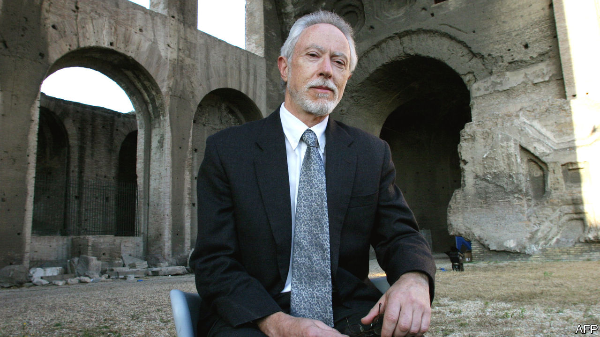

The Death of Jesus. By J.M. Coetzee. Harvill Secker; 208 pages; £18.99. To be published in America by Viking in May.

WHEN THE South African government condemned J.M. Coetzee’s portrayal of rape in “Disgrace” (1999) as racist, the charge ignored the way the story is refracted through the eyes of its central character, a white university lecturer sacked over an affair with a student. “Disgrace” was a #MeToo novel before its time, just as “Summertime” (2009), a book comprised of interviews with people who knew the late “John Coetzee”, was a prototype of what has since become known as “autofiction”. By the time pseudo-autobiographical game-playing had come into vogue, Mr Coetzee had embarked on an enigmatic project whose purpose is even harder to pin down.

His latest novel, “The Death of Jesus”, completes a trilogy that began with “The Childhood of Jesus” (2013). In that book, middle-aged Simón meets a lost boy, David, en route to a Spanish-speaking city populated by refugees who, like them, can’t remember who they are or where they come from (the state assigns their names). The story turns on David’s stubborn refusal to learn numbers in the conventional order. His arithmetical heresy forces Simón and his adoptive mother, Ines, to flee the authorities and—in “The Schooldays of Jesus” (2016)—to teach him at home.

David is ten when the tale resumes in the new book. His urge to represent a local football team, against Ines’s wishes, leads him to smear Simón as a child molester before running away. But soon the family are reunited when David falls mysteriously ill, and his talk of a “message” causes commotion at the hospital where he is confined.

As in previous volumes, the obvious question—where is Jesus?—generates suspense. The novels can be interpreted as a bid to dramatise the epistemic challenges of an encounter with the divine. Is David’s stubbornly irrational cast of mind a sign that he is anointed, or merely a child? The conundrum prompts the reader to reflect on how far those terms overlap.

Mr Coetzee’s tone is philosophical but not arid. The tender antagonism between David and Simón, left flat-footed by his precocious ward, brims with emotion, even comedy, which anyone who has ever tied themselves in knots answering a child’s whys will enjoy. When Simón attempts to console the boy by saying his illness is just bad luck, since “in ninety-nine cases out of a hundred” germs “fail to get in”, David upends the logic: “Simón says I am number one hundred, and number one hundred has to die.”

The characteristically concise present-tense narration creates a kind of crystalline opacity; “The Death of Jesus” is a novel with many doors, but no key. It is a remarkable achievement by a writer whose evolution, at the age of 79, continues to surprise. ■

This article was downloaded by calibre from <https://www.economist.com/books-and-arts/2020/02/01/jm-coetzees-new-novel-has-many-doors-but-no-key>

|  |  |  |  |
| --- | --- | --- | --- |
| Previous | Articles | Sections | Next |

|  |  |  |  |
| --- | --- | --- | --- |
| Previous | Articles | Sections | Next |

#### Johnson

# Is Scots a language, or merely a dialect?

It is as much a political question as a linguistic one

Feb 1st 2020 |

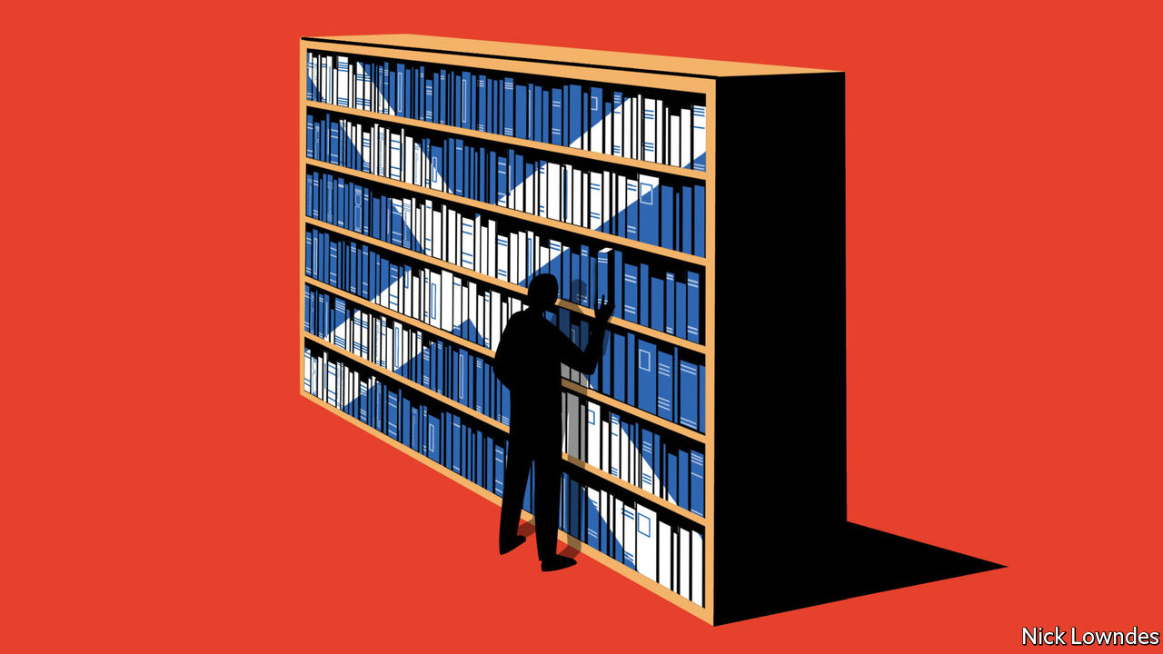

AS THEY CLEARED their heads after Burns Night on January 25th, having celebrated their national poet with whisky and haggis, another hangover loomed for Scots in less than a week’s time. A majority of them rejected Brexit in the referendum of 2016, whereas a majority in the United Kingdom overall supported it. Scotland is now leaving the European Union against its will—prompting a renewed call for Scotland, in turn, to leave the UK.

Naturally, the case for independence plays up characteristics that differentiate Scotland from England. Among them is language, which diverges from the talk south of the border in two main ways. One is Gaelic, a Celtic language impenetrable to outsiders (it is related closely to Irish and Manx but only distantly to English), which, however, is spoken only by around 50,000 people, or about 1% of Scotland’s population. The bigger difference is Scots—though quite how different it is remains a matter of debate.

As soon as you cross over from England, syntax and pronunciation change sharply. While the dialects of northern England have much in common with each other, the break at the border is stark. Because of that, some observers think Scots is not a dialect of English but a distinct (if related) language. The pro-independence Scottish National Party affirms as much in its manifestos.

Pronunciation is not enough to make Scots a language, or the Geordie English spoken in the north-east of England would be one, too. But it also has its own vocabulary, which goes beyond the well-known “aye, bonnie lass” of films and television. Scots descends from Northumbrian, one of the dialects of Old English; standard southern English descends from a dialect farther south. Scots retained Old English words that southern English lost, such as “bannock”. It was more influenced by Norse, in words such as gate (street) and kirk (church). It also has words from Gaelic, not just loch and whisky but quaich (a kind of bowl)and sonse (good luck). It has its own Norman French borrowings, not shared with English, such as douce (sedate, sober).

Still, vocabulary does not make a language either. More fundamental still is grammar—and here, Scots stands out again. Its speakers say “I’m going to my bed” whereas Englishmen say simply “to bed”. “Dinnae” is a Scots version of “don’t”. “Div” commonly replaces the auxiliary verb “do”. There are past-tense forms such as jamp (jumped), and irregular plurals like een (eyes) and kye (cows).

The Scots Syntax Atlas, free online, also shows how Scots varies internally. If you find a long-missing item, you might say “there it is” in English. But while, in other contexts, “it is” contracts to “it’s”, you can’t say “there it’s!”—save in a belt of Scotland running roughly from Kilmarnock to Edinburgh. People in that belt are unlikely to say “so apparently himself is joining us for dinner,” while northern, highland and some island Scots do.

There is no consensus among professional linguists as to whether, in aggregate, these features make Scots a language, or merely a dialect. Geoffrey Pullum, an Englishman at the University of Edinburgh, leans towards language status. Despite his expertise (and living in Scotland), he “simply cannot understand two Scots-speaking workers when they are chatting with each other”. He emphasises those grammatical differences, as well as the long literary history of Scots.

David Adger, a Scot at Queen Mary University of London (and, like Mr Pullum, a specialist in syntax), is unconvinced. He studies Scots as one among many varieties of English. After all, people who speak it can vary their delivery from broad Scots to Scottish-accented standard English on a smooth continuum, depending on the circumstances.

This makes Scots and English different from, say, Danish and Norwegian. Speakers of those related tongues understand each other with few problems. But they are not in the habit of making transitions between the two—they speak one or the other. Politics is integral to the divide: Norwegian was consciously developed away from Danish as part of a push for independence.

As an old saying goes, “a language is a dialect with an army and a navy.” Recognition for Scots as a language may, ultimately, be clinched not by grammatical arguments but by political ones. In other words, proclaiming it to be a language to support Scottish independence may have little impact. But gain independence, and outsiders might take Scots seriously as a separate language, too.

This article was downloaded by calibre from <https://www.economist.com/books-and-arts/2020/02/01/is-scots-a-language-or-merely-a-dialect>

|  |  |  |  |
| --- | --- | --- | --- |
| Previous | Articles | Sections | Next |

|  |  |  |
| --- | --- | --- |
| Books and arts | Sections | Obituary |

Graphic detail

|  |  |  |
| --- | --- | --- |
| Books and arts | Sections | Obituary |

|  |  |  |
| --- | --- | --- |
| Graphic detail | Sections | Economic ... |

Obituary

Kobe Bryant: Love story

.

|  |  |  |
| --- | --- | --- |
| Graphic detail | Sections | Economic ... |

|  |  |  |  |
| --- | --- | --- | --- |
|  | Articles | Sections | Next |

#### Love story

# Kobe Bryant died on January 26th

The five-rings champion basketball player was 41

Feb 1st 2020 |



WHENEVER HE WAS asked why his whole life had been spent playing basketball, Kobe Bryant’s narrow eyes searched upwards, and his mouth trembled. The answer was simple, yet so complicated. It began with the orange ball, the smell of it, the feel of the pebbled leather grains and the perfect grooves under his hands; and its bounce, and the way it sounded different on concrete or polished hardwood. Then came the net, the shot slithering right through it with that triumphant springing whoosh, while he howled with joy. Then every movement of the game, the strategies, the dodging and feints, the squeal of sneakers on the court. Whatever had thrilled him as a child (watching his father, also a pro player, on TV, wearing his own little 76ers outfit, running and jumping along with him) still thrilled him when in 2016 he retired from the game. “Dear Basketball”, he wrote,

From the moment   
I started rolling my Dad’s tube socks   
And shooting imaginary   
Game-winning shots...   
I knew one thing was real:   
A love so deep I gave you my all.

“My all” meant training obsessively, like a maniac. He would go to the gym and shoot for hours, all day, all night. Hundreds of times, not just taking shots, but making them, running steps and patterns, practising shots off the rebound. I ran up and down every court/After every loose ball for you. He would ponder what would make his game unstoppable and then work backwards from there, building it piece by piece, move by move, repeatedly. Then, when the actual game arrived, it was all just muscle-memory. He perfected his own works of art: the jab-step-and-pause, using unexpected footwork to pass the defender, and the fadeaway, shooting while he jumped high and backwards from the basket.

For 20 seasons, a very long time to stay with one team, he played as a shooting guard for the Los Angeles Lakers. With them he won five NBA championship rings and was most valuable player in two finals. His 81 points at home against Toronto, in 2006, was the second-highest individual score recorded in league history. By the time he retired he had the third-highest points total, 33,643, overtaken only days ago by the game’s present leading star, LeBron James. His own stardom brought him in a salary of around $30m a year, allowing him to dress in Gucci and to keep house in a gated community in Newport Beach, California. It also brought sponsorship deals, such as the one with Nike, whom he asked to design shoes with heels and midsoles that could shave precious hundredths of seconds off his reaction time. For he didn’t care so much about money, points, or the fans’ applause; they could turn against him anyway, as they did after he was accused in 2003 of sexually assaulting a woman in Colorado, a case dropped but never cleared up. He cared about being the best, winning games. Simple and plain.

His obsession could make him by turns hustling, mean and dejected. When he joined the Lakers, his dream team, in 1996, traded from the Charlotte Hornets, he was only 17, the youngest player in the NBA. He had been picked for the pro leagues straight from his suburban high school and had lived as a boy in Italy, two things that made him odd. But he came in burning with self-belief. No babying for him; he was hard, focused, a lone artist, and much of that stayed. He called himself the Black Mamba later, an assassin-snake, ruthless in the strike. Unjust foul calls and lost play-off games—especially the finals against the Detroit Pistons and the Boston Celtics—threw him into misery and vows of revenge.

On the court, lithe and nimble, he wanted every game for himself. Team-mates thought him selfish, not passing enough and shooting far too much, missing more shots in his career than anyone in NBA history. He hit back at that, since at least he stayed with one team and didn’t go off somewhere else; he wanted the glory of winning the play-offs for the purple-and-golds, not just himself. Yet he so loved the ball that it just seemed drawn towards his hands. And he went on shooting, and shooting, not least because he sometimes saved a game with a fabulous floater in the final seconds. Besides, airballs too could look and feel good, good from trajectory to follow-through, on-line, on target. Some people thought Mozart had too many notes.

As in most love affairs, he had competition. One was Michael Jordan, the greatest basketball player of the era, the Buddha on top of the mountain and winner of six rings, whom he once asked for advice while he was guarding him. Another was Shaquille O’Neal, a charming giant who also played for the Lakers, but infuriated him because he little-brothered him and did not train like he did. (No one trained like he did.) To prove he was the best of basketball’slovers, he would go on playing when he was hurt, shooting left-handed when his right hand was injured, staggering on when ankles, knees and back were all sore. If he decided he was playing, no manager or coach could do anything about it. I played through the sweat and hurt/…because YOU called me.

He claimed to have no memory of the last game he played, though he scored 60 points in it from 50 shots. For a while his interests had been branching into multimedia, writing, film-making and setting up a Mamba Sports Academy in Thousand Oaks. But most of these still had basketball at the core. His longest film, “Muse”, was about his career, and an animated short based on “Dear Basketball” won an Academy Award. He gave motivating talks in America and Asia in which all his life-lessons were carried over from the court. At Thousand Oaks he coached his second daughter Gianna, among many others, in how to play his way.

With a lover’s impatience, he increasingly took helicopters to get to and from games, events, his office and the academy, in which case he might take Gianna with him. Carpe diem, seize the day, was his motto, learned at school in Italy; tempus neminem manet, time waits for no man. Bad weather would hardly deter him. ■

This article was downloaded by calibre from <https://www.economist.com/obituary/2020/02/01/kobe-bryant-died-on-january-26th>

|  |  |  |  |
| --- | --- | --- | --- |
|  | Articles | Sections | Next |

|  |  |  |
| --- | --- | --- |
| Obituary | Sections |  |

Economic Indicators

Economic data, commodities and markets

.

|  |  |  |
| --- | --- | --- |
| Obituary | Sections |  |

|  |  |  |  |
| --- | --- | --- | --- |
|  | Articles | Sections | Next |

# Economic data, commodities and markets

Feb 1st 2020 |

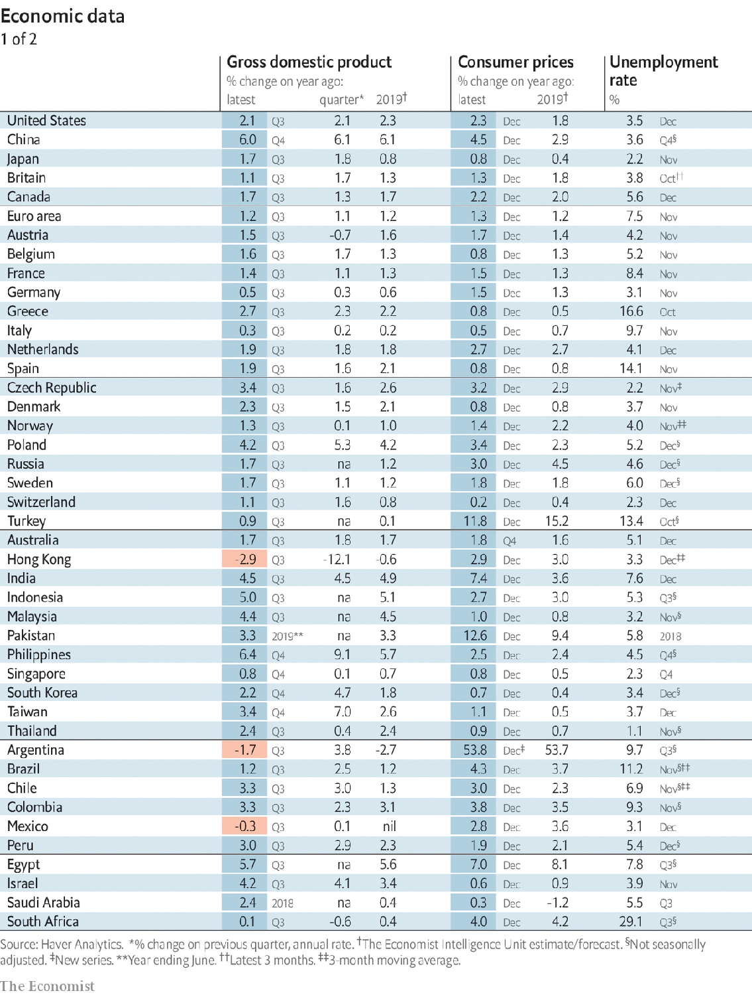

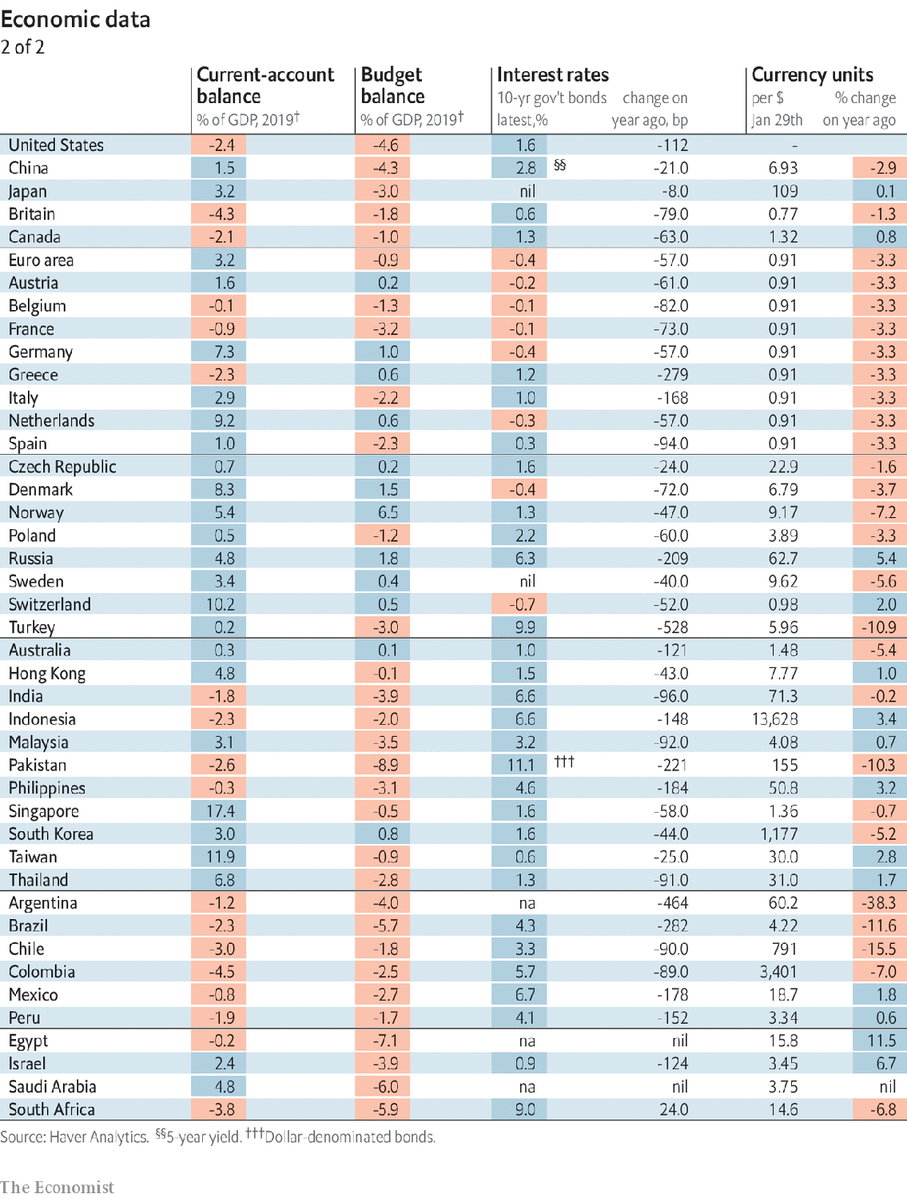

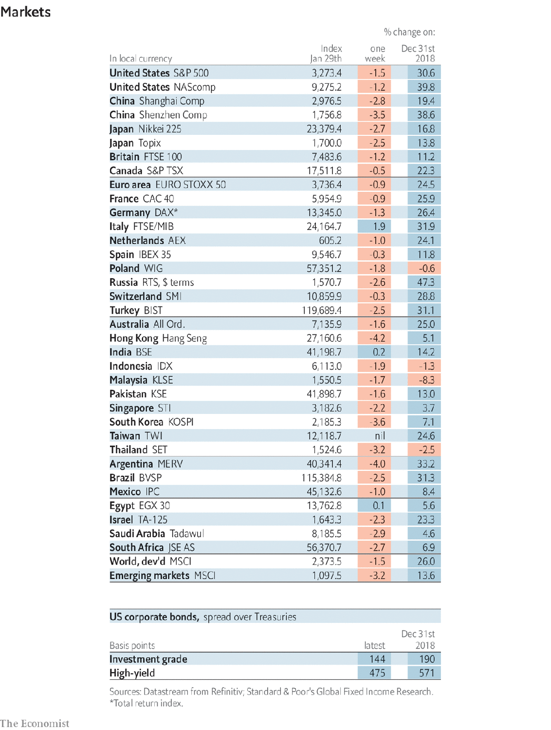

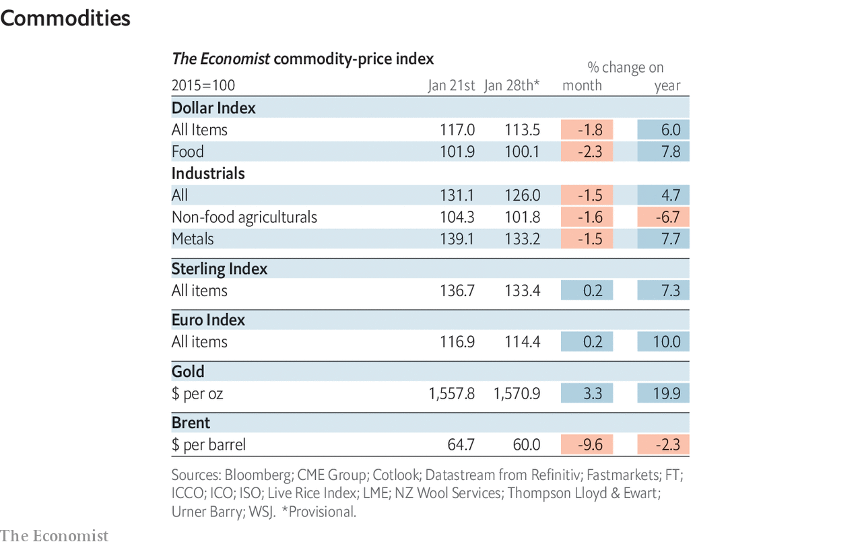

This article was downloaded by calibre from <https://www.economist.com/economic-indicators/2020/02/01/economic-data-commodities-and-markets>

|  |  |  |  |
| --- | --- | --- | --- |
|  | Articles | Sections | Next |